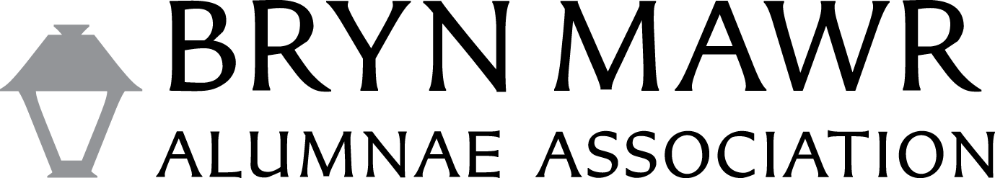
Executive Board Report

Report on Career & Civic Engagement Center | Alumnae/i Career Services
Board Representative – Cate Megley
Senior Associate Director for Alumnae/i Career Services – Becky Ross
Date: May 2021
As of May 6:

Mawrter Connect updates:
• 1,343 alums and 523 students have fully signed up in the community. Class of 2021 students will be converted to alum status in early summer.
• We are 78% of the way to our goal of 500completed sign-ups for this year (target date August 31, 2021).
• NEW Business Directory – A new feature from PeopleGrove: this is an opportunity for alumnae/i business owners to display their businesses within the Resources, Business Directory section of Mawrter Connect. This was just turned on in late April, so we are likely to promote it soon. You can read more about it on the About page for Mawrter Connect: https://mawrterconnect.brynmawr.edu/page/about(see the attached as well)
• There are currently 191 opportunities posted in the Jobs Board. We recently implemented a Jobs feed from Handshake, for jobs relevant to alums with at least a few years of experience, to increase the number of opportunities in the Mawrter Connect platform.

Our LinkedIn Bryn Mawr College Alumnae/i Group is just 6 people shy of 5,000 members!

The Alumni Learning Consortium webinars continue to attract a consistent audience with overall strong net promoter scores.

Reunion planning for August 6-8 is still underway, and Becky Ross is planning a panel discussion for Friday afternoon focused on purpose at work and in life. Three alums are lined up so far and we’ll be seeking a fourth. Becky will also offer a LinkedIn and Mawrter Connect networking best practices workshop on Saturday morning.

Purpose panel speakers:
• Vidya Ramachandran ’01 – Chemistry - https://www.linkedin.com/in/vidyaramachandran/
• Alice Goldsberry ’07 – Political Science - https://www.linkedin.com/in/alice-goldsberry-709a4346/
• Magda Pecsenye ’94 – Comparative Literature - https://www.linkedin.com/in/magdapecsenye/

