Session 2: Board Work
Slide 5
Frequency Distribution Table
Variable | f  (frequency) | %  (percent of data associated with each value) | Cf  (Cumulative frequency: Progressive total of frequency) | C%  (Cumulative percent: Progressive total of percent of data associated with cf)
Value (lowest)
Value
Value (highest) |  |  | =N | =100%
Total | =N (total in sample) | =100%

You work at an agency that serves families. Here is the number of children in each family unit for your caseload:
Family 1: 2 kids
Family 2: 3 kids
Family 3: 1 kid
Family 4: 1 kid
Family 5: 2 kids

Step 1:
1 child: I I (=2)
2 children: I I (=2)
3 children: I (=1)

Step 2:
Number of children | f | % | Cf | C%
1 | 2 | 2/5 = .4  .4*100= 40% | 2 | 40
2 | 2 | 2/5 =.4  .4*100 = 40% | 2+2 = 4 | 40+40 = 80%
3 | 1 | 1/5 =.2  .2*100= 20% | 4+ 1= 5 | 80+20=100%
Total | 5 | 40+40+20=100% | 5 | 100%

Finished product without math:
Number of children | f | % | Cf | C%
1 | 2 | 40% | 2 | 40
2 | 2 | 40% | 4 | 80%
3 | 1 | 20% | 5 | 100%
Total | 5 | 100%
Slide 15-16
Calculating a Mean (two ways)
Example 1
Mean = ΣX/N = Sum of sample ÷ Sample size

Number of kids in a family unit:
Family 1: 2 kids
Family 2: 3 kids
Family 3: 1 kid
Family 4: 1 kid
Family 5: 2 kids

ΣX = 2 + 3 + 1 + 1 + 2 = 9 = 1. 8
N 5 5

Mean =1.8
Average number of kids in a family unit for our sample is 1.8

Example 2
Mean = ΣX/N
Σ value*frequency ÷ Sample size

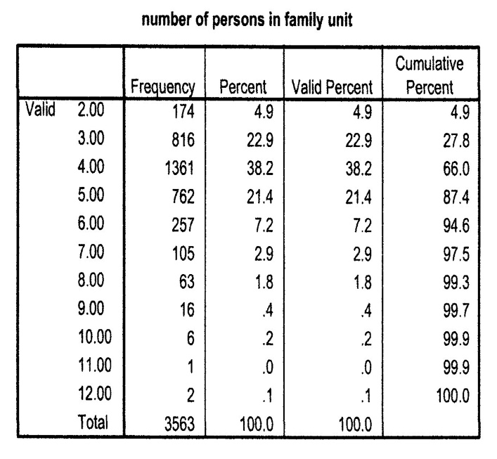
(2 in unit*174) + (3*816) + (4*1361) + (5*762) + (6*257) + (7*105) + (8*63) + (9*16) + (10*6) + (11*1) + (12*2)
3563

348+2448+5444+3810+1542+735+504+144+60+11+24 = 15070 = 4.23
3563 3563

Slide 27
Standard Deviation
Example 1
Mean = 30
SD = 2.5
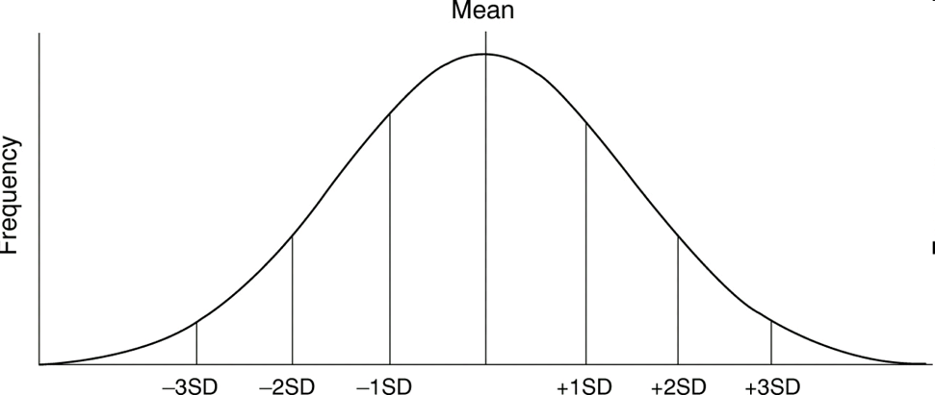
30-(2.5*3) 30-(2.5*2) 30-2.5 30 30+2.5 30+(2.5*2) 30+(2.5*3)
22.5 25 27.5 30 32.5 35 37.5
Example 2
Mean = 30
SD = 5
30-(5*3) 30-(5*2) 30-5 30 30+5 30+(5*2) 30+(5*3)
15 20 25 30 35 40 45

