Corrected Answer Supplement for Measures of Central Tendency and Variability

- Corrected responses for Smith and Bryn Mawr
Smith:
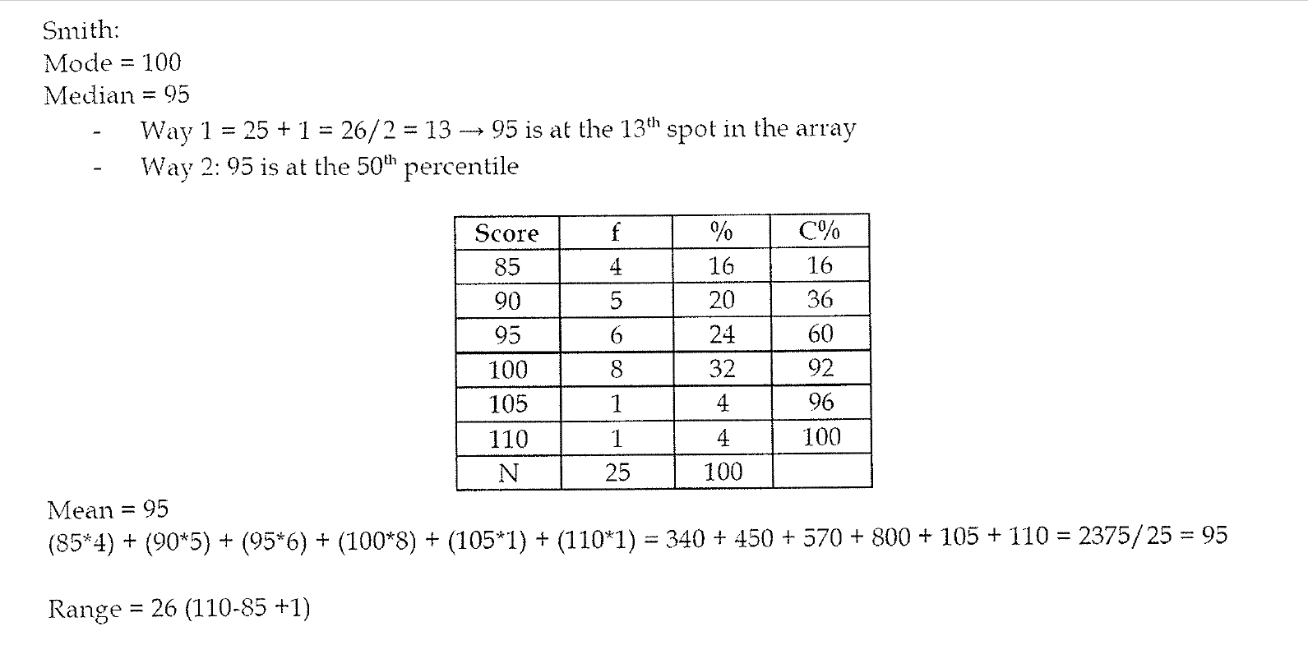
IQR = 100-90=10

Bryn Mawr:
Mode = 100
Median = 105
- 13th spot in the array or look at the 50th percentile
Mean = 95
- 2375/25 = 95
 | Score | f | % | C%
 | 85 | 1 | 4 | 4
 | 90 | 1 | 4 | 8
 | 95 | 1 | 4 | 12
 | 100 | 8 | 32 | 44
 | 105 | 7 | 28 | 72
 | 110 | 7 | 28 | 100
Total |  | 25 | 100
Range = 110-85 =25 + 1= 26
IQR = 110-100 = 10

4) Length of Calls at Crisis Centers w/ corrected interquartile range
IQR = 10-3=7

