Session 3: Board Work

Key:
Slide 15 (Pg 1)
Slides 22-25 (Pg 2)
Slides 29-30 (Pg 3)

Standard Deviation
Slide 15
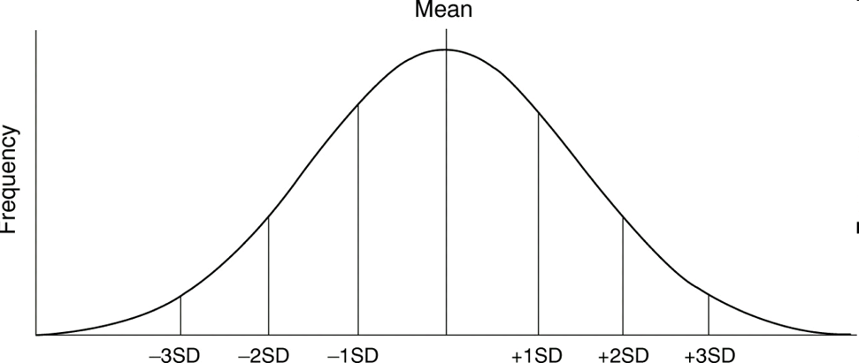
x̅ -(3*SD) x̅ -(2*SD) x̅ -SD x̅ x̅+SD x̅+(2*SD) x̅+(3*SD)
Note: x̅=Mean

Example of replacing “place holders” with mean and SD
Mean = 30
SD = 5
30-(5*3) 30-(5*2) 30-5 30 30+5 30+(5*2) 30+(5*3)
15 20 25 30 35 40 45

Slide 22
Z-Scores
Adrian:
x= 36
Mean = 32
SD= 3

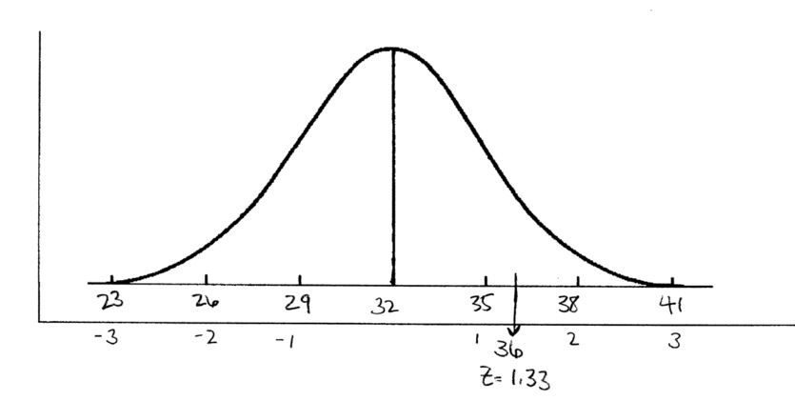
<_______50%_____>
Z= (x- x̅)/SD
Z = (36-32)/3
Z = 1.33

Slide 24-25
Find 1.33 on the z-table (it is positive so we know the % will be to the right (above) the mean). -> associated % = 40.82%
50% + 40.82% = 90.82%

Slide 29
Student A:
x= 30
Mean = 32
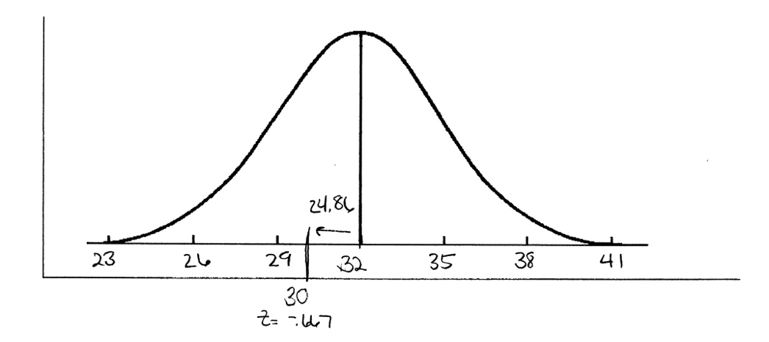
SD= 3

<_________50%______>

Z= (x- x̅)/SD
Z = (30-32)/3
Z = -.67
Find .67 on the z-table (it is negative so we know the % will be to the left (below) the mean). -> associated % = 24.86%
50% - 24.86% = 25.14%

Slide 30
Student B:
x= 4.5
Mean = 5
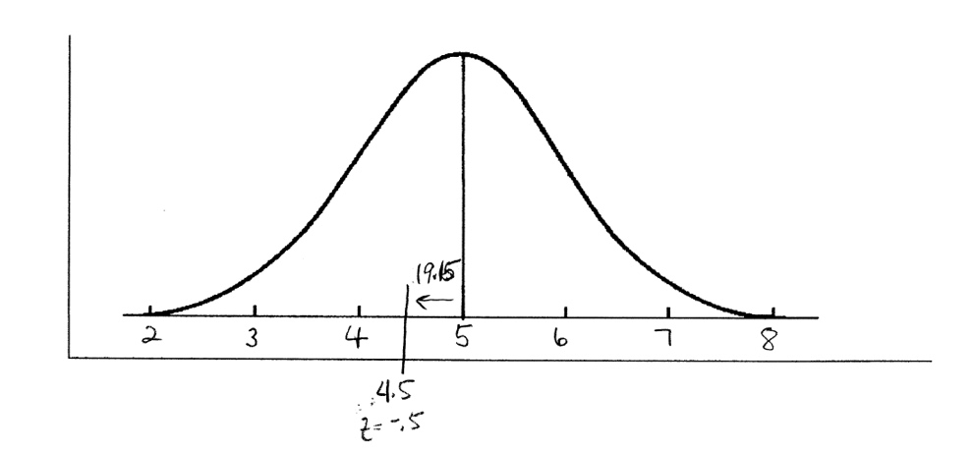
SD= 1

<_________50______>

Z= (x- x̅)/SD
Z = (4.5-5)/1
Z = -.5
Find .5 on the z-table (it is negative so we know the % will be to the left (below) the mean). -> associated % = 19.15%
50% - 19.15% = 30.85%

