Guided Practice
Confidence Intervals
Formulas:
95% Confidence Interval
Low Pt: Mean - [1.96 x Standard Error] High Pt: Mean + [1.96 x Standard Error]

99% Confidence Interval
Low Pt: Mean - [2.58 x Standard Error] High Pt: Mean + [2.58 x Standard Error]

Language to interpret CI:
We can be (insert percent)% confident that the true population mean falls between (insert lower point) and (insert upper point).

Practice:

Rosenberg Self Esteem Scale
Average Score: 20
SE: 1.5

Calculate a 95% and 99% Confidence Interval

Hypothesis Testing: Comparing Means

You started a therapy group for students at your school aimed to improve self-esteem. You want to know if there is a different mean self-esteem score for those that participate in individual counseling alone and those that are also participating in group therapy to see if the combined therapies are more effective.

Group Therapy:17
Individual Counseling Only: 15
Group SD: 1.1

Formula:
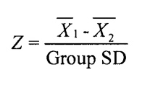
Steps:
- State null hypothesis
- State research hypothesis (2- or 1-tailed)
- Draw rejection level curve
- Select statistical test and compute test statistic
- Make decision about whether to accept or reject H0
- Determine if relationship is meaningful (not a statistical question!)

Using a .05 one-tail test, determine if there is a difference in means.

Step 1 & 2: State Null & Research Hypothesis

Step 3: Draw rejection level curve

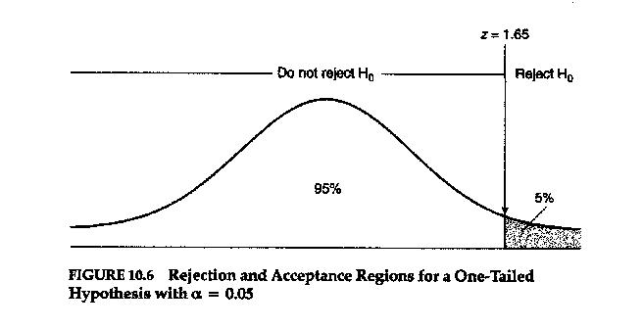
Z=0 (no difference)
45% (from the center of the curve)

Step 4: Select statistical test and compute test statistic
Difference in means:
Group Therapy:17 Individual Counseling Only: 15 Group SD: 1.1

Step 5: Make decision about whether to accept or reject H0
You can either use the p-value method OR critical z-value method. They will get you the same result.

Using the p-value method: (calculated p-value needs to be less than critical p-value)
Critical p-value of .05
Look at z-table for associated % to calculate p-value:

Using the critical value method: (calculated z-score has to be greater than critical z-value for a .05 on-tail test)
Critical z-value of 1.65

Z=0 1.82
45% 46.56%

Step 6: Determine if relationship is meaningful (not a statistical question!)

Group Practice:

Answer the same question, but use a .05 two-tail test.

Using a .05 two-tail test

Step 1 & 2: State Null & Research Hypothesis

Step 3: Draw rejection level curve
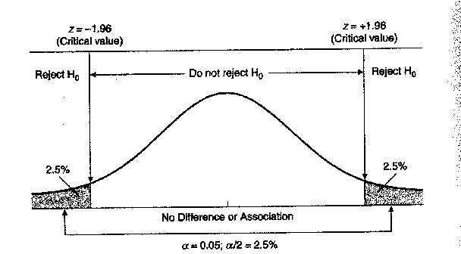
Z=0 (no difference)
47.5% (from the center of the curve 47.5% (from the center of the curve)

Step 4: Select statistical test and compute test statistic
Difference in means:
Group Therapy:17 Individual Counseling Only: 15 Group SD: 1.1

Step 5: Make decision about whether to accept or reject H0
You can either use the p-value method OR critical z-value method. They will get you the same result.

Using the p-value method: (calculated p-value needs to be less than critical p-value)
Critical p-value of .025 (have to split .05 in half for a two-tail test)
Look at z-table for associated % to calculate p-value:

Using the critical value method: (calculated z-score has to be greater than critical z-value for a .05 on-tail test)
Critical z-value of 1.96

Step 6: Determine if relationship is meaningful (not a statistical question!)

