RIP II Session 5

Class 4 Review:
- Pg 1: Confidence Intervals
- Pg 2: Difference in Means
Class 4 New Content:
- Pg 3: Type I & Type II Error
- Pg 4: Chi-Square Test

Confidence Intervals
Practice Question:

You are writing a report for the community outreach program in which you received grant funding to provide group bereavement services in the Philadelphia School District. Based on a sample of 100 students you are planning to report on the number of sessions participants attended.

Mean number of sessions attended for the sample: 10
Standard Error: 1.2

Calculate a 95% Confidence Interval:

95% Confidence Interval
Low Pt: Mean - [1.96 x Standard Error] High Pt: Mean + [1.96 x Standard Error]
Low Pt: 10 – (1.96*1.2) High Pt: 10 + (1.96*1.2)
Low Pt: 10 – 2.35 High Pt: 10 + 2.35
Low Pt: 7.65 High Pt: 12.35

We are 95% confident the true mean number of sessions for students participating in the bereavement program is between 7.65 and 12.35 sessions.

Formulas:
95% Confidence Interval
Low Pt: Mean - [1.96 x Standard Error] High Pt: Mean + [1.96 x Standard Error]

99% Confidence Interval
Low Pt: Mean - [2.58 x Standard Error] High Pt: Mean + [2.58 x Standard Error]

Language to interpret CI:
We can be (insert percent)% confident that the true population mean falls between (insert lower point) and (insert upper point).

Hypothesis Testing with Difference in Means

You work for a community advocacy agency working to shut down the trash incinerator in a local neighborhood. You have the average rates for asthma for children in the zip code where the neighborhood is located as well as the average rates for asthma for the neighboring area. Does the neighborhood (neighborhood 1) have significantly higher rates of asthma compared to the second neighborhood?

Neighborhood 1: .094 (9.4% of those in neighborhood 2 have asthma)
Neighborhood 2: .077 (7.7% of those in neighborhood 2 have asthma)
Group SD: .008

Complete a one-tail .05 test.

- What is your null and research hypothesis?

H0: There is no difference in mean asthma rates between the two neighborhoods.
HR: Neighborhood 1 has higher mean asthma rates than neighborhood 2.

- Identify your rejection region/critical value.

CV for a one-tail .05 test: 1.65
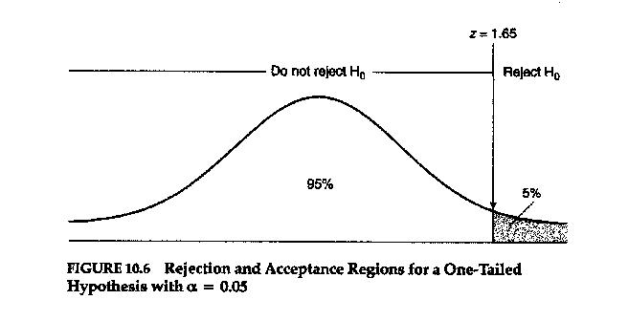
Z=0 (no difference)
45% (from the center of the curve)

- Calculate your test-statistic.

Z = .094-.077 = .017 = 2.12
.008 .008
- Compare the test-statistic to your critical values. Based on your results, do you reject or accept your null hypothesis?
2.12 > CV of 1.65
This indicates we can reject the H0 and support our research hypothesis that neighborhood 1 has significantly higher asthma rates than neighborhood 2.

Formulas:

Z = X̅1- X̅2
Group SD

CV = 1.65 for a 1-tail, .05 test
CV = 1.96 for a 2-tail, .05 test
CV = 2.33 for a 1-tail, .01 test
CV = 2.58 for a 2-tail, .01 test

Type I & Type II Error – Practice

Example based on our comparing means practice problem from last class:

.05 one-tail test:
H0: There is no relationship between group therapy and self-esteem scores (there is no difference in the mean scores)
HR: (1-T) Those that also participated in the group therapy will have higher self-esteem scores compared to those that only participated in individual therapy.

Our calculated z-value of 1.82 was greater than the critical z-value of 1.65, so we were able to reject our null hypothesis.

.05 two-tail test:
H0: There is no relationship between group therapy and self-esteem scores (there is no difference in the mean scores)
HR: (2-T) Those that also participated in the group therapy will have different self-esteem scores compared to those that only participated in individual therapy.

Our calculated z-value of 1.82 was less than the critical z-value of 1.96, so we accepted/failed to reject our null hypothesis.

Chi-Square Test Practice
You want to understand if there is an association between being in foster care and graduating college.

Crosstabulation
 | Graduate college: 0  (0= did not graduate college) | Graduate college: 1  (1= graduated college) | Total
Foster Care: 0 Observed  (0= not in foster care)  Expected | 79  135 | 148  92 | 227  227
Foster Care: 1 Observed  (1= in foster care)  Expected | 152  96 | 9  65 | 161  161
Observed  Total  Expected | 231  231 | 157  157 | 388  388

Chi-Square Test
 | Value | Df | Asymp. Sig  (2-tailed) | Exact Sig  (2-sided) | Exact Sig  (1-sided)
Pearson Chi-Square  Continuity Correction  Likelihood Ratio  Fisher’s Exact Test  Linear-by-Linear Association  N of Valid Cases | 16.507  16.182  16.465  16.503  388 | 1  1  1  1 | .000  .000  .000  .000 | .000 | .000

- Step 1: State null hypothesis
- Step 2: State research hypothesis (2- or 1-tailed)
- Step 3: Identify critical values & determine direction
  - Critical value will be used to help determine statistical significance
    - Relate to the normal curve -> rejection region
  - Identify the direction of the relationship -> Look at Chi-Square Output
- Step 4: Compute test statistic using SPSS
  - Chi-square statistic 0=no relationship between variables
  - Larger the value of chi-square, the stronger the relationship
  - Compare chi-square statistic to critical chi-square value
- Step 5: Make decision about whether to accept or reject H0
  - Statistical significance
  - Did we predict in the right direction( for one-tail test)?

Two-Tail .05 Test
Step 1 & 2:
H0:
HR (2-t):

Step 3:
Look at the formula sheet for critical value for 2-tail .05 test

Look at the output for the 1-1(yes-yes) to determine the direction.

Step 4 & 5:
Look at the “Pearson chi-square test” row for our chi-square test statistic.

Compare the chi-square value to the critical value. (To be significant, we need our chi-square value to be greater than the critical chi-square value.)

You can also compare the p-value to the critical p-value. (To be significant, we need our p-value to be smaller than the critical p-value.)

