Research Informed Practice II
Spring 2022

Final Project, Part 3: Descriptive Statistics, Study Results, and Tables.

Part 3 includes two sub-parts: (A) Running your analysis using SPSS to get descriptive statistics and regression results and (B) Putting your results in tables.

Part A: Run your Results – Get your SPSS Output for Research Project

In this assignment, you will run descriptive statistics and run your regression model. To do both of these tasks, go into the public shared class data folder and get the appropriate data set (adolescent; brfss; cds; psid).

If you are using a subgroup (for most of you this will not apply and you can skip to “To get descriptive results…”) …
If you are using any type of subgroup, make sure you use the “Select If” function – discuss this with your instructor/TA. For example, if you are looking at sexual activity or drinking, limit your sample to those who are of a proper age. If you are looking at whether or not a female uses the pill, limit your sample to females.
To get descriptive results…
If you are running an OLS regression (I/R level DV), do not include your excluded/reference groups in your analysis. You will get descriptive and OLS results at the same time. It is important that your excluded/reference groups are not included in the model so it can run properly.
If you are running a logistic regression (nominal level DV) you must run BOTH an OLS and a logistic regression. When getting your descriptive statistics, it is ok to include all your variables in the model because it will not affect your regression results. However, when you run your logistic regression, it is important that your excluded/reference groups are not included in the model so it can run properly. After running the OLS regression to get your descriptive results, you will need to run a logistic regression to get your regression results. Directions and examples of the logistic output start on page 4.

Part A:
- Steps for OLS Regression analysis (and getting descriptive statistics for everyone): Page 2
- Steps for Logistic Regression (after you follow directions on pg 2 for descriptives): Page 4
Part B:
- Directions for Tables: Page 6

For both OLS and logistic regression…
To get these descriptive results after you have gotten into your data set(adolescent19 or brfss2019 or cdsfor2022 or psid1999to2019), go to Analyze, Regression, Linear. Next, put in your dependent variable and your independent/control variables. This will look something like the following:

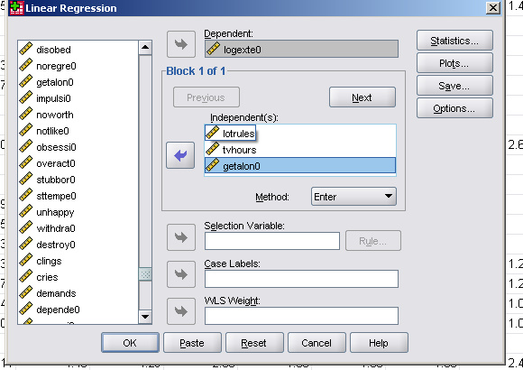
Now go to Statistics at the top right corner, click on Descriptives (as seen below), then click on
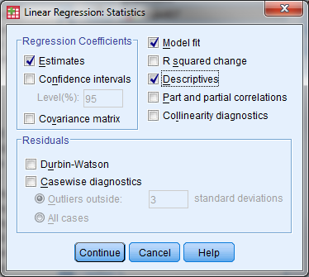
Continue, then OK. Once you click on OK, you will get your descriptive results. See examples below.

You need the SPSS tables below to create the Descriptive Statistics Table and the Regression Table
(note: the regression results can only be used if you have an I/R level DV) for your paper. You will create tables in your Word Document with the appropriate information from the SPSS output.
Descriptive Statistics
 | Mean | Std. Deviation | N
nat log exter behav probls ind | 3.1097 | .22135 | 1641
family has lots of rules | .49 | .500 | 1641
Number of hours/day TV on at home | 5.2977 | 3.55942 | 1641
PCG:Child oft/somtms trble get along | .16 | .371 | 1641

Model Summary
Model |  | R | R Square |  | Adjusted R Square |  |  | Std. Error of the Estimate
1 |  | .460ª | .212 |  | .210 |  |  | .19668
ANOVA^{b}
Model |  |  |  | Sum of Squares |  |  | df |  |  | Mean Square |  |  | F | Sig.
1 |  | Regression |  | 17.023 |  |  | 3 |  |  | 5.674 |  |  | 146.681 | .000ª
 |  | Residual |  | 63.321 |  |  | 1637 |  |  | .039
 |  | Total |  | 80.344 |  |  | 1640
a. Predictors: PCG:Child oft/smts not get along, family lots of rules, #hours /days TV on at home
- Dependent Variable: nat log exter behav probls ind
Coefficientsª
Model |  |  |  |  |  | Unstandardized Coefficients |  |  |  |  | Standardized Coefficients |  |  |  | t |  | Sig.
 |  |  |  |  |  | B |  |  | Std. Error |  | Beta |  |  |  |  |  | Sig.
1 | (Constant) |  |  |  |  | 3.020 |  |  | .010 |  |  |  |  |  | 294.262 |  | .000
1 | family has lots of rules |  |  |  |  | .020 |  |  | .010 |  | .046 |  |  |  | 2.091 |  | .037
1 | Number of hours/day TV on at home |  |  |  |  | .007 |  |  | .001 |  | .110 |  |  |  | 5.013 |  | .000
1 | PCG:Child oft/somtms trble get along |  |  |  |  | .264 |  |  | .013 |  | .443 |  |  |  | 20.191 |  | .000

For those running an OLS regression analysis (I/R level DV) …
You are finished with the SPSS part of this assignment. You should save your output as we have learned to do with the computer assignments.
If you are running a logistic regression analysis (nominal level DV) …
You are NOT done with SPSS yet. You must now run a logistic regression following the directions below.
In SPSS, go to Analyze, Regression, Binary Logistic and enter your variables in the same way you did to get your descriptive results.
Do not include excluded/reference groups in your analysis.
In this regression, I am examining some predictors on whether or not the child is withdrawn. The logistic regression results are below.
Case Processing Summary
Unweighted Casesª |  | N | Percent
Selected Cases | Included in Analysis | 2169 | 60.9
Selected Cases | Missing Cases | 1394 | 39.1
Selected Cases | Total | 3563 | 100.0
Selected Cases | Unselected Cases | 0 | .0
Selected Cases | Total | 3563 | 100.0
a. If weight is in effect, see classification table for the total number of cases.

Model Summary
Step | -2 Log likelihood |  |  | Cox & Snell R Square |  | Nagelkerke R Square
1 | 1153.104ª |  |  | .007 |  | .017
Variables in the Equation
 |  |  | B |  | S.E. |  | Wald | df | Sig. | Exp(B)
Step 1 |  | agebirth | .010 |  | .016 |  | .412 | 1 | .521 | 1.010
 |  | avginc | -.106 |  | .046 |  | 5.382 | 1 | .020 | .899
 |  | chblack | -.103 |  | .227 |  | .204 | 1 | .651 | .902
 |  | chhisp | 1.556 |  | .517 |  | 9.059 | 1 | .003 | 4.741
 |  | chasian | -18.621 |  | 29474.885 |  | .000 | 1 | .999 | .000
 |  | chracoth | -.078 |  | .348 |  | .051 | 1 | .822 | .925
 |  | Constant | -2.395 |  | .430 |  | 31.059 | 1 | .000 | .091
 |  | Constant | -2.395 |  | .430 |  | 31.059 | 1 | .000 | .091

Note: If you get a coefficient and standard error estimate that looks like “chasian” above (with b= -18.621 and SE= 29474), there is something wrong with the variable. The problem is probably too few observations for that variable and not enough variation in the variable. You will need to drop the variable and run the regression again.

You should save your output as we have learned to do with the computer assignments.
Part B: Your Tables and Results for Paper
To complete Part 3 of the final project, please create the following:
- Two results tables for your paper – a Descriptive Statistics Table and a Regression Table (see materials on the Moodle site)
- A narrative paragraph describing your sample using the information in your descriptive table.
- A narrative paragraph describing your regression results. Interpret model significance, R² (OLS) or Cox & Snell and Nagelkerke values (logistic), and selected b-coefficients (OLS) or odds ratios (logistic).
- The PDF of your SPSS output.

