Chem 104
PLI #1
July 11, 2022
Ch. 12 – Solids

- Tungsten has a body-centered cubic crystal structure. Using a metallic radius of 139 pm for the W atom, calculate the density of tungsten.

- The crystal structure of lithium sulfide (Li₂S), is pictured here:
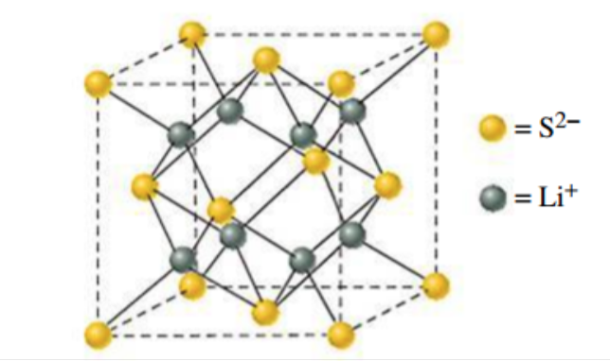
The length of the unit cell is 5.88*10² pm. For this structure, determine
  - The number of formula units in the unit cell
  - The density of Li₂S

- Calcium metal crystallizes in a face-centered cubic unit cell. The density of the solid is 1.54 g/cm³. What is the radius of a calcium atom?

- The melting points of NaF, NaCl, NaBr, and NaI are 988, 801, 755, and 651°C respectively. Can you explain this trend?

- Without calculations, explain how you would expect the lattice energies of LiCl(s), KCl(s), RbCl(s), and CsCl(s) to compare with the value of -787 kJ/mol determined for NaCl.
Hint: assume the enthalpies of sublimation of the alkali metals are comparable in value. Which atomic properties from Ch. 9 should you compare?

- Determine the lattice energy of KF(s) from the following data:
ΔH_{f}°[KF(s)] = -567.3 kJ/mol; enthalpy of sublimation of K(s) = 89.24 kJ/mol; enthalpy of dissociation of F₂(g) = 159 kJ/mol; I₁ for K(g) = 418.9 kJ/mol; EA for F(g) = -328 kJ/mol.

- From this list of terms—electrical conductor, insulator, semiconductor—choose the one that best characterizes the following materials:
Stainless steel
Solid sodium chloride
Sulfur
Germanium
Seawater
Solid iodine

- Which of the following substances, when added in trace amounts to silicon, would produce a p-type semi-conductor? Explain.
Sulfur
Arsenic
Lead
Boron
Gallium Arsenide
Gallium

- The conductivity of an intrinsic semiconductor increases with increasing temperature. How can this be explained?

- Diamond-based semiconductors are currently of enormous interest in the research community. Although diamond itself is an insulator, the addition of a dopant will narrow the band gap. One semiconductor system has diamond with boron as a dopant. Is this a p- or an n-type semiconductor?

- Molecular solids, network solids, and amorphous solids all contain atoms that are joined together by covalent bonds. However, these classes of compounds are very different in overall structure and this leads to different physical properties associated with each group. Describe how the overall structures of these classes of solids differ from each other.

- Construct a phase diagram for O₂ from the following information:
Normal boiling point – 90.18 K
Normal melting point – 54.8 K
Triple point – 54.34 K at a pressure of 2 mm Hg.

Very roughly estimate the vapor pressure of liquid O₂ at -196°C, the lowest temperature easily reached in the laboratory. Is the density of liquid O₂ greater or less than that of solid O₂?

- Shown here is a portion of the phase diagram for phosphorous. 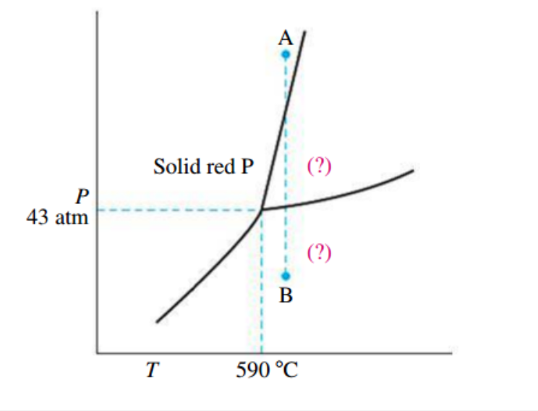
  - Indicate the phases present in the regions labeled with (?).
  - A sample of solid red phosphorous cannot be melted by heating in a container open to the atmosphere. Why?
  - Trace the phase changes that occur when the pressure on a sample is reduced from point A to B, at constant temperature.

