Some practice problems for pedigree analysis & probability:

1. Karen and Steve each have a sibling with sickle-cell anemia, an autosomal recessive disorder. Neither Karen nor Steve nor any of their parents have sickle cell anemia, and none of them have been tested to see if they are carriers of the mutant allele. Based on this information, calculate the probability that if this couple has a child, the child will have sickle-cell anemia. (Problem adapted from Campbell, *Biology*)
2. The pedigree below traces the inheritance of alkaptonuria, a autosomal recessive biochemical disorder. Affected individuals are unable to metabolize a substance called alkapton, which colors the urine and stains body tissues. Annotate this pedigree with the genotypes of each individual. (Problem adapted from Campbell, *Biology*)

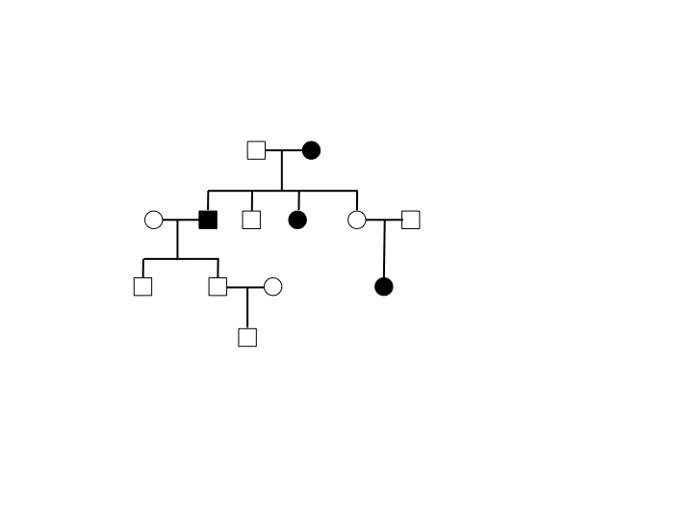

1. Jane and John are anxious to start a family, but are concerned about the transmission of Duchenne muscular dystrophy (DMD), an X-linked recessive disorder that results in progressive muscle degeneration and generally causes death by the age of 20. Jane has a younger brother who has DMD, and John had a male first cousin on his father’s side of the family (John’s aunt’s son) who also had the disease. No other family members are known to be affected.
   1. Draw a pedigree of the families of Jane and John, indicating genotypes for as many of the individuals in the family as you can.
   2. What is the probability that John will pass a mutant allele of the DMD gene to his offspring?
   3. What is the probability that Jane is heterozygous for the mutant DMD allele?
   4. What is the probability that Jane and John will have a son who is affected with DMD?
2. Gaucher disease is autosomal recessive disorder caused by a chronic enzyme deficiency. Howard has a sister who has Gaucher disease, and Bernadette’s grandmother’s brother also had this disorder; no other members of their families are known to be affected. Howard and Bernadette ask their genetic counselor to determine the probability that they will have a child with Gaucher disease.
   1. Draw a pedigree of this family, indicating genotypes for as many of the individuals in the family as you can.
   2. What is the probability that Howard is heterozygous for the mutant Gaucher allele?
   3. What is the probability that Bernadette is heterozygous for the mutant Gaucher allele?
   4. What is the probability that Howard & Bernadette will have a child with Gaucher disease?