Sample problems on genetic mutation

This document contains a some sample problems to give you practice analyzing genetic mutation. Remember: if there is a term or concept you aren’t familiar with, you can always look it up! An answer key is provided in a separate document, but you should give these problems your best effort BEFORE looking at the answers.

**Question 1**:

Substitution of one base pair for another can result in a ____________ mutation that results in the conversion of an amino acid specifying codon to a termination codon.

1. nonsense
2. chromosomal
3. frameshift
4. missense
5. deletion

**Question 2:**

A spontaneous mutation usually originates as an error in:

1. mitosis
2. meiosis
3. DNA replication
4. transcription
5. translation

**Question 3:**

One codon for leucine is CUC. How many different amino acids could possibly result from single-base substitutions?

1. 3
2. 4
3. 5
4. 6
5. 7

**Question 4:**

Which of the following is **unlikely** to be true of a frameshift mutation?

1. These mutations result in shifting the reading frame of the codons.
2. These mutations are produced by insertion or deletion of base pairs.
3. These mutations create a new codon sequence that codes for a different kind of protein used by the cell.
4. These mutations create a new stop codon.
5. These mutations create a new codon sequence that codes for a protein with no functional use.

**Question 5**: This problem encourages you to think about the consequence of different types of mutations. (This one requires a little effort… you’ll need a copy of the genetic code to solve it.)

The normal sequence of a particular protein is given here, along with certain mutant versions of it. For each mutant, explain what **ONE** mutation occurred in the coding sequence of the gene.

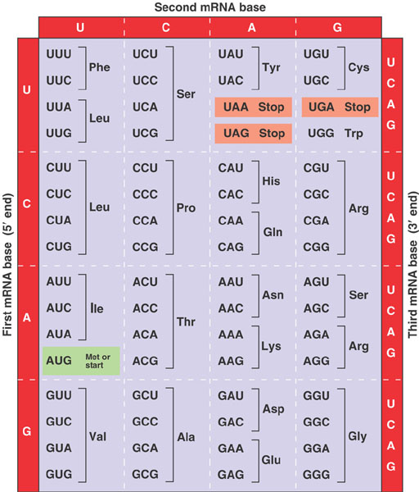

Normal: Met-Gly-Glu-Thr-Lys-Val-Val-…-Pro

Mutant 1: Met-Gly

Mutant 2: Met-Gly-Glu-Asp

Mutant 3: Met-Gly-Arg-Leu-Lys

Mutant 4: Met-Arg-Glu-Thr-Lys-Val-Val-…-Pro

**Question 6**: This problem extends from a previous practice problem I gave you. The sequence below represents the mRNA of a very short prokaryotic gene. The start codon is underlined and in bold, and the stop codon is underlined.

5'- CGGAG**AUG**CACCUGAGCGGCUAUCCAUAGCGUUAUCC -3'

When translated, this mRNA makes the following protein:

Met-His-Leu-Ser-Gly-Tyr-Pro

1. The following transcript is generated as a consequence of a mutation in this gene. What kind of mutation has occurred?

5'- CGGAGAUGCACUGAGCGGCUAUCCAUAGCGUUAGCC -3'

1. What is the consequence of this mutation on the protein produced? Hint: You may want to examine this sequence for start and stop codons.
2. The codon 5'-CCA-3' specifies the amino acid proline. What change(s) to the original DNA sequence would generate a silent mutation at this position?