Sample problems on genetic mutation

This document contains a some sample problems to give you practice analyzing genetic mutation. Remember: if there is a term or concept you aren’t familiar with, you can always look it up! An answer key is provided in a separate document, but you should give these problems your best effort BEFORE looking at the answers.

**Question 1**:

Substitution of one base pair for another can result in a ____________ mutation that results in the conversion of an amino acid specifying codon to a termination codon.

**nonsense**

**Question 2:**

A spontaneous mutation usually originates as an error in:

**DNA replication**

**Question 3:**

One codon for leucine is CUC. How many different amino acids could possibly result from single-base substitutions?

**6; changing the first C to U = Phe, A = Ile, G = Val; changing the U to C = Pro, A = His, G = Arg; changing the final C to any of the other nucleotides will not have an effect.**

**Question 4:**

Which of the following is **unlikely** to be true of a frameshift mutation?

**These mutations create a new codon sequence that codes for a different kind of protein used by the cell.**

**Question 5**: This problem encourages you to think about the consequence of different types of mutations. (This one requires a little effort… you’ll need a copy of the genetic code to solve it.)

The normal sequence of a particular protein is given here, along with certain mutant versions of it. For each mutant, explain what **ONE** mutation occurred in the coding sequence of the gene.

Normal: Met-Gly-Glu-Thr-Lys-Val-Val-…-Pro

Mutant 1: Met-Gly

Mutant 2: Met-Gly-Glu-Asp

Mutant 3: Met-Gly-Arg-Leu-Lys

Mutant 4: Met-Arg-Glu-Thr-Lys-Val-Val-…-Pro

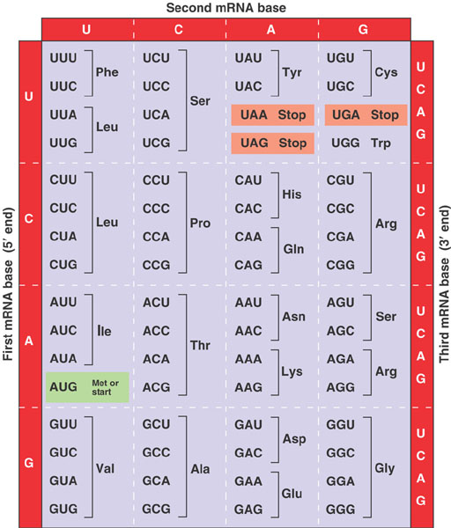

**Mutant 1: Nonsense mutation changing the Glu codon to a stop codon.**

**Mutant 2: Insertion of a G between the Glu and Thr codons, resulting in an Asp codon followed by a stop codon.**

**Mutant 3: Deletion of the first G in the Glu codon, resulting in a frameshift for three codons followed by a stop codon.**

**Mutant 4: A missense mutation, changing the Gly codon to an Arg codon.**

**Question 6**: This problem extends from a previous practice problem I gave you. The sequence below represents the mRNA of a very short prokaryotic gene. The start codon is circled and the stop codon is boxed.

5'- CGGAGAUGCACCUGAGCGGCUAUCCAUAGCGUUAUCC -3'

When translated, this mRNA makes the following protein:

Met-His-Leu-Ser-Gly-Tyr-Pro

1. The following transcript is generated as a consequence of a mutation in this gene. What kind of mutation has occurred?

5'- CGGAGAUGCA**\***CUGAGCGGCUAUCCAUAGCGUUAGCC -3'

## A deletion of a C, which should located where the asterisk is.

1. What is the consequence of this mutation on the protein produced? Hint: You may want to examine this sequence for start and stop codons.

**The consequence is that the next codon is now a stop codon, resulting in premature termination of translation.**

1. The codon 5'-CCA-3' specifies the amino acid proline. What change(s) to the original DNA sequence would generate a silent mutation at this position?

**Changing the third position in this codon to T (U), G or C would all result in silent mutations.**