Cancer Genetics Case Study – Part I
adapted from case study written by Janet A. De Souza-Hart,
School of Arts & Sciences, Massachusetts College of Pharmacy & Health Sciences

Background and pedigree construction:

A tumor-like growth has been identified in the adrenal gland of a 17 year-old male named Lee. You are a pediatric oncologist who is treating Lee. In order to gather information, you collect a detailed family history from his parents.

- Lee has a sister (Leah, age 10) and a brother (Luke, age 6). Both are healthy.
- There is no history of cancer on Lee’s father’s side of the family; neither his dad, Brian, nor his paternal grandparents have developed cancer.
- Lee’s mother, Grace, was diagnosed with bilateral breast cancer last year at age 35.
- Grace has three older siblings. Neither her brother Greg (42) nor her sister Greta (40) have developed signs or symptoms of cancer. A second brother, Geoff, died of leukemia at age 8.
- Greg has fraternal twin daughters, neither of whom has developed signs or symptoms of cancer.
- Grace’s father, Roger, died of a soft tissue sarcoma at age 35. Grace’s mother, Renee, is still living and is in good health with no signs or symptoms of cancer.
- Roger’s mother died of a brain tumor at age 30. Roger was her only child.

- Using the information above, draw a detailed pedigree for this family that includes all of the available information.

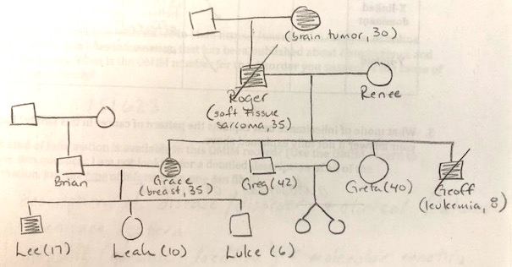

The genetics of cancer:

Cancer is typically a disease associated with older individuals, with greater than 90% of new cancers diagnosed in individuals older than 45. The pattern of cancer observed in this pedigree and the ages of the affected individuals makes you suspicious that this family harbors an inherited genetic mutation leading to the high frequency of cancer in young people.

- Complete the table below to determine the most likely mode of inheritance for cancer in this family.

mode of inheritance | possible | possible but unlikely | not possible | brief rationale
autosomal recessive |  | X |  | all affected parents with affected child would have to be a carrier, which is unlikely for a rare mutation
autosomal dominant | X |  |  | most likely because there is a vertical transmission pattern; affected children have affected parents
X-linked recessive |  | X |  | all sons of an affected mother would have to be affected (Luke is young - could still be affected; affected fathers should not pass the trait to their sons; not likely that Renee is a carrier for this rare mutation
X-linked dominant |  |  | X | all daughters of an affected father would have to be affected; affected sons would have to have an affected mother
Y-linked |  |  | X | females are affected, so not Y-linked

- What mode of inheritance best explains the pattern of cancer in this family? Explain your answer if not fully explained above.

Most likely autosomal dominant, because of the reasons stated above.

Based on these analyses, you have convinced yourself that the cancers in Lee’s family have a genetic cause. You use this knowledge to search genetics databases, and you identify five genetic disorders that could be associated with Lee’s adrenal cancer. The clinical and genetic characteristics of these five genetic disorders are shown in the table below:

genetic disorder | OMIM # | gene(s) involved | clinical manifestations
Multiple endocrine neoplasia | 131100 & others | MEN, RET or CDKN1B | Tumors of the parathyroid/pituitary glands & pancreas; kidney stones, hypertension, fatigue, vomiting, nausea.
Carney complex type I | 160980 | PRKAR1A | Changes in skin pigmentation (brown spots), heart tumors, endocrine tumors (thyroid, testes, ovaries); symptoms commonly begin in teens/early adults.
Li Fraumeni syndrome | 151623 | TP53 | Breast, bone & soft tissue cancers are common. Cancers of blood-forming tissues & adrenocortical carcinomas are possible.
Neuroblastoma | 256700 | K1F1B & others | Most often begins in children under age 5. Tumor originates in adrenal gland but can also form in nerve tissue of abdomen, chest & pelvis, & metastasize to bone, liver & skin.
Von-Hippel-Lindau syndrome | 193300 | VHL | Tumors & cysts in various tissues, including kidneys, pancreas, male genital tract, inner ear; non-cancerous blood vessel tumors.

- Based on the family history, what genetic disorder do you most suspect?

Li Fraumeni syndrome

- OMIM (Online Mendelian Inheritance in Man; https://www.omim.org/) is an online database which compiles information that has been published about human genes and genetic disorders. What is the OMIM number for the disorder you suspect is the cause of cancer in Lee’s family?

151623

- What kind of information is available in this OMIM record? (Use the OMIM record to answer this question; I am not looking for a detailed description of all of the information, just the type of information one can find!)

description of genetic disorder, clinical features, inheritance pattern, mapping (genomic location), molecular genetics, heterogeneity, animal models, etc.

- What gene is most often defective in individuals with this disorder?

TP53 (a tumor suppressor gene)

- When tumors from people diagnosed with Li Fraumeni syndrome are analyzed, both copies of the causative gene have mutations that eliminate gene function. Does this information fit with the conclusions you made in response to questions 2 & 3? Explain your answer.

The fact that both copies of TP53 are mutant in the tumors of Li Fraumeni patients suggests that this mutation is recessive at the cellular level… but transmission of the cancer syndrome in this family appears to be autosomal dominant. This is because when individuals inherit one mutant copy of TP53, this leads for a dramatically increased risk of developing cancer (close to 100%). Therefore, the RISK of developing cancer is dominant, even though the mutation itself is recessive (there need to be two mutant copies to start the cell on the pathway to cancer).

- At this time, neither Leah nor Luke show any signs or symptoms of cancer. Should you be concerned about them? Why or why not?

Yes… both Leah and Luke have a 50% chance of inheriting a TP53 mutation and being at high risk for developing cancer.

- When you discuss your findings with the family, they ask if you would recommend that Leah and Luke undergo genetic testing at this time. What are the pros and cons of conducting genetic testing on Leah & Luke?

pros: can do more proactive screening for cancer
can be informed regarding reproductive choices
other pros?

cons: knowledge of cancer risk could increase anxiety/worry
knowledge that you DIDN’T inherit mutation but sibling did
could lead to guilt
you can’t necessarily do anything to prevent cancer from developing
other cons?

