Week 2 Answer Key
- C: The genital stage starts in adolescence and lays the groundwork for future life relationships. As one enters adolescence, sexual identity and orientation begins to develop. Values regarding sexuality, views about the opposite sex, and the process of interacting with others on a more intense level occur. These more mature elements of relationship-building lay the foundation for future relationships, but not only from a sexual standpoint. Choice A, the Latent stage, occurs from age 6 to puberty, and it is a time when the child’s sexual energy becomes somewhat dormant. Choices B and D are not included in Freud’s model of human development.
- C: Carl Rogers placed much emphasis on reaching one’s greatest potential and the interplay between this potential and one’s perception of self. Erickson and Freud theorized that one must achieve certain developmental challenges before moving to the next level of human growth. Allport, on the other hand, believed one’s destiny depended on the possession of certain clusters of personality traits. Therefore, A, B, and D are wrong. Rogers focused on the concept that humans are driven by their own need to develop into the best person they are capable of becoming.
- D: Piaget is most known for his work on children’s cognitive development. He introduced the idea that children are not merely miniature adults; they go through a process of maturation during which different cognitive skills and abilities develop. He identified four stages of cognitive development through which children from move from concrete egocentric thinking to abstract, logical, and hypothetical thinking. This has implications for adults can reasonably expect from children. For example, children do not learn cause in effect until the concrete operations stage between the ages of seven and 11; a five-year-old who does not fully grasp the consequences of his actions is not being willful, he just has not learned that skill yet. Choice A is incorrect because Erickson is most known for his theory of development. Choice B is incorrect because Freud is most known for his work on personality and psychosexual development. Choice C is incorrect because Skinner is most known for his work on learning through operant conditioning.
- A: When using partializing techniques to help clients prioritize their treatment goals, Maslow’s hierarchy of needs is a useful theoretical construct. Maslow’s hierarchy conceptualizes human needs in the form of a pyramid with the most basic on the bottom and the most complex at the top. To build a strong and stable pyramid, you start at the foundation and move up as each level is completed. The base of the pyramid includes physiological needs like food, air, and water. The next level is safety, then love and belonging, followed by esteem. At the top of the pyramid is self – actualization. If a client is facing food insecurity and wants to make new friends, then food insecurity should be the priority. Choice B is incorrect because Ericksons stages of psychosocial development describe human development in terms of eights life stages, each defined by specific conflict that needs to be resolved to progress to the next stage successfully.
- C: Erikson devised eight stages of psychosocial development. He emphasized the importance of social context, asserting that family and environment are major contributors to child development. During maturation (65 years and above), ego integrity versus despair or is the struggle. Important life tests, such as child rearing and career, are being completed. Reviewing and evaluating how one’s life is spent and success over the course of one’s life provides a sense of fulfillment, while failure emerges if one is dissatisfied with accomplishments, which leads to depression or despair.
- B: Changing behavior through rewards for approximation of desired behavior is the correct answer. Skinner demonstrated that behavior could be learned by rewarding actions that are similar to the desired behavior. If one wants to teach a dog to Chase and catch an frisbee throwing to the end of a field the dog must be rewarded for sniffing the frisbee then grasping the frisbee and then catching when thrown 4 feet, then six, then 10. This process is called successive approximation. Choice an refers to a classical conditioning. Choice A he refers to superstitions, meaning that one can sometimes be confused as to which behavior is soliciting the reward. Some athletes wear the same pair of “lucky” socks each game, thinking this behavior leads to the reward of winning. In reality, the behavior that leads to the wind can be anything from practicing hotter to playing a team that is not highly skilled; therefore, the behavior is superstitious. D is a poor form of teaching a person to learn a new behavior because it may take much trial and error before perfection is achieved.
- D: Johnny is in the identify versus role confusion stage. This State takes place during adolescence and marks the transition from childhood to adulthood. It involves trying out new things and figuring out one’s place in the world. Successful completion of the stage results in a solid sense of identity. Failure to complete this stage results and uncertainty about one’s identity and role in society. Choice A is incorrect because trust versus mistrust takes place during infancy and involves learning to trust others. Choice B is incorrect because industry versus inferiority takes place during school-age and involves learning to take initiative and work toward goals. Choice C is incorrect because intimacy versus isolation takes place during young adulthood and involves learning to create and maintain fulfilling relationships outside the family of origin.
- B: Typically, when a question mentions psychosexual stages, it will be pertaining to Freud’s Stages of Development.
- D: Ego- based on reality; It is the moderator between the Id & Superego. Therefore, it’s personality traits involve logic and reason to pacify and compromise with the Id & Superego.
- C: Being the incorporation of parental and societal values and standards. The Superego can be considered our moral compass and it develops due to the moral and ethical restraints ( the societal values and standards) that is placed on us by our caregivers.
- A: 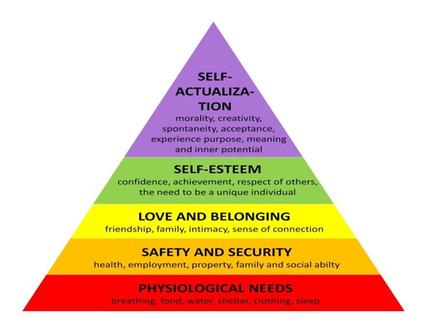
- C: Superego- internalized societal and parental standards of “good” and “bad” & “right” and “wrong”.
- A: Oral Stages- Ages 0-1.5; Gratifying activities are Nursing (eating, mouth movement, sucking, gumming, biting, and swallowing)
- B: Preoperational Stage- Once children acquire language, they can use symbols such as words or pictures to represent objects. Their thinking is still very egocentric though; they assume that everyone else sees things from the same viewpoint as they do. They can understand concepts like counting, classifying according to similarity, and past-present-future but generally they are still focused primarily om the present and, on the concrete, rather than the abstract.
- C: Industry versus inferiority is developmental stage that children go through during their school years, from age 6 until puberty this is when children learn to initiate projects follow through with them and feel proud of their accomplishments. To complete the stage successfully, children must be encouraged and supported in their endeavors. On the other hand, if their attempts to take initiative or criticize or restricted, children will doubt themselves and feel inferior to their peers. Choice A is incorrect because autonomy versus shame and doubt is the stage from age 1 to 3 when children start to become independent from the primary caregiver. Choice B is incorrect because intimacy versus isolation takes place during young adulthood when people develop committed intimate relationships outside of their family of origin. Choice D is incorrect because trust versus mistrust is the stage from birth to age one when babies develop the ability to trust others if their needs are met by their caregiver.

