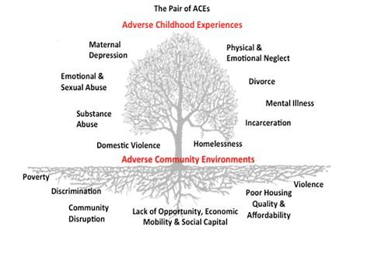
PAIR of ACEs Tree: Adverse Childhood Events and Adverse Community Environments

