Research Informed Practice I:

Final Paper Research Proposal Guidelines

Length: cover page + 8 to 10 pages content + reference page(s) + appendix/appendices with Instrument/Questionnaires etc.

Format: APA 7th Edition. For resources about the use of APA see link: https://owl.purdue.edu/ owl/research_and_citation/apa_style/apa_formatting_and_style_guide apa_changes_7th_edition.html

Dates for articles referenced/cited: within the past 10 years (if earlier articles, please see Professor to confirm)

General guidelines

A research proposal outlines a research plan. Students will NOT be asked to execute their research plan.

In the research proposal, students will learn to propose a study advancing knowledge in the area of trauma-informed social work as it relates to their focus of practice (macro or clinical) and population of interest.

Proposals will describe a quantitative research plan.
Students interested in developing qualitative research proposal writing skills can apply to the Qualitative Research Methods doctoral seminar or the MSS elective in Advancing Skills in Evaluation for Clinical and Macro Practitioners, as part of their elective class plan.

Some students may feel overwhelmed by the brevity of the proposal and its strict guidelines. We trust that this is a useful exercise to socialize first semester students to professional social work practice. Social work is a documented profession, thus, writing with clarity is critical for social worker’s development and the care of clients. Additionally, many social workers must follow writing guidelines across forms, applications, and charts. Lastly, as students master the critical thinking and writing skills required for this assignment, they will come to realize that these are useful to complete other classes’ assignments, enhancing their performance across the curriculum.

Writing a research proposal is an iterative process. Students cannot expect to write the proposal linearly; each section will evolve in parallel as they gain a greater understanding of the research development process.

Research proposal structure

Title page
1 page APA 7th edition.

Section  1 page | 1: Specific Aims  This section is a brief summary of your whole proposal. After reviewing the Specific Aims section, a reader should clearly understand:  - what do you want to study (specific topic, constructs, and variables);  - your research problem in the context of your population of interest (e.g., veterans, immigrant children, mothers, etc.);  - the main theory grounding your research approach;  - why does that problem warrant additional research;  - by which research approach (e.g., exploratory, clinical research) and method will you study this issue (e.g., survey research);  - what aims do you specifically propose to achieve in your study;  - finally, and only if possible, the potential hypothesis that you will test in your research.  The specific structure of the section is:  1st paragraph: What is your topic, which should be a trauma-related topic in the context of your specific population as it relates to your focus of practice (macro or clinical). Briefly define your main variables and describe your population. Describe the scope of your problem in your population of interest (e.g., prevalence of PTSD among refugees).  2nd paragraph: Briefly summarize what is known about your topic of interest (this second paragraph is developed after completing the Background Section).  3rd paragraph: Describe what research methods will you use for your study (this paragraph is developed after you complete the Methods section of your proposal). The paragraph ends with the following statement: “The specific aim/s of this research project is/are:”  4th paragraph: List up to two specific aims. If you are able to state hypothesis linked to each Specific Aim, list these in this section.  5th paragraph: If you have room left, you can close this section listing the social work/social justice/policy/etc. implications related to your study.
Section 2: Background
Up to 2 pages | This section outlines what is known about your area of research as it relates to your focus of practice (macro or clinical) and population of interest. You will learn more about how to write this section in the session with Library Services on, “Writing a Literature Review.”  For the literature review, you will need to review and include information about the following topics:

- Primary sources reporting demographic data related to your population of interest (e.g., US Census Bureau). You can use up to two primary sources for this information.

- Primary sources reporting epidemiological data related to your main trauma- related variable/s of interest (e.g., prevalence) in your population of interest. You can find these data in health, research, advocacy or other related sources (for example, CDC). You can use up to two primary sources for this information.

- Primary sources describing previous research about your topic of interest. Include only peer-reviewed publications. Your review could be positive or negative, depending on the quality of this research. For example, you can then point out limitations/recommendations from an article that you plan to address in your research proposal. Please use at least three and up to 10 primary sources for this section which includes research articles from peer reviewed journals. You may include additional sources of references from agency reports, white papers, etc. This would make your references more than 10 sources if you include these additional sources, no problem.

- At least one paragraph integrating points (a), (b), and (c), and highlighting gaps in previous knowledge that justify the need to do your research.

Section 3: Conceptual Framework

Up to 1 page
In the conceptual framework section of your proposal, you will connect your area of research with a theory informing this area of inquiry. You can use a trauma theory in this section, and if there is not a specific trauma theory applicable to your area of interest (for example, war refugee trauma), you can combine it with one additional theory for a total of two integrated theories articulated within one conceptual framework informing your approach.

This section includes the operationalization of the variable/s in your study, which should be aligned with the theoretical framework informing your proposal.

In writing this section, you will connect your proposal’s specific aims, variables and their operationalization, with the theory informing this area of research.

Section 4: Methods

Up to 4 pages
This section is composed of three sub-sections:

- Measurement/s
- Sampling/study participants
- Recruitment/Data Collection

Measurement/s: In this sub-section you will write about the way in which you will
write about the way in which you will measure the variable/s you conceptualized in the Conceptual Framework section.

You will describe the standardized scales that you propose to use, including information about its potential sub-scales (or sections), items, scoring, and application to your population of interest. You will also include information about the scale reliability and validity. All this information should be supported by references.

Sampling/study participants: In this section you include detailed information of who will participate in your study (inclusion criteria), and who will not participate (exclusion criteria). You will also include information about your sampling strategy.

Recruitment/Data Collection: In this sub-section you will describe how will you actually collect the data for your study (including the study design), and describe when, where, and by whom will your data be collected. You will mention information about your consent process, and about the qualifications and training of the research assistants helping with your project (if any).
Section 5: Conclusion
Up to 1 page
- What are the limitations of your proposed study?
- What do you recommend for further study? (This is where you can include a qualitative approach).
- What were the implications of these findings to social work? Provide one implication for practice, one implication for research and one implication policy. (This is based on the potential impact of the findings from your study, and how the study may inform and influence social work on these 3 levels).
References
As needed | APA style references of cited bibliography

Appendices/Attachments
Please include here a copy of the instrument, if possible. You can also decide to include a link to the instrument or submit a separate Appendices/Attachments document with your paper. The length of this section will not count against your maximum length of the paper, which is 11 pages.

You can also include a glossary of terms and refer to the Appendix or Attachment, which my help with space in terms of in-depth description of terms.

You may not have complete information like the example below, but please submit as much as possible and available to you.

] Note: Please label each Appendix/Attachment. For example
Attachment I: Happiness Sale

Subjective Happiness Scale
Appendix/ Attachment: Subjective Happiness Scale

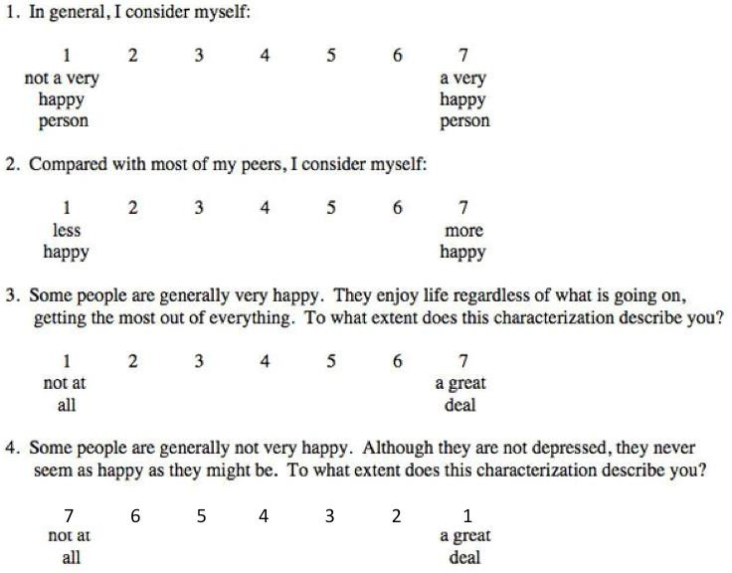

AUTHOR
Dr. Sonja Lyubomirsky

WHAT THE QUESTIONNAIRE MEASURES
The SHS is a 4-item scale of global subjective happiness. Two items ask respondents to characterize themselves using both absolute ratings and ratings relative to peers, whereas the other two items offer brief descriptions of happy and unhappy individuals and ask respondents the extent to which each characterization describes them. The SHS has been validated in 14 studies with a total of 2,732 participants. Data has been collected in the United States from students on two college campuses and one high school campus, from community adults in two California cities, And from older adults, as well as from students and community adults in Moscow, Russia. Results have indicated that the SHS has high internal consistency, which has been found to be stable across samples. Test-retest and self-peer correlations have suggested good to excellent reliability, and construct validation studies of convergent and discriminant validity have confirmed the use of this scale to measure the construct of subjective happiness.

SCORING
Add up your scores for the four questions and divide the total by four. That answer is your “subjective happiness score.” Answers range from 1 to 7. Question 4 is “reverse coded” with a descending sequence.

INTERPRETATION
The average score runs from about 4.5 to 5.5, depending on the group. College students tend to score lower (averaging a bit below 5) than working adults and older, retired people (who average 5.6). If you’re past college age, and your happiness score is lower than 5.6, then you’re less happy than the average person. To put it another way, more than 50 percent of people in our age group rate themselves higher on the scale. If your score is greater than 5.6, then you’re happier than the average person. Of course, what the “average person” is for you will depend on your gender, your age, your occupation, ethnicity, etc. But what’s important to remember is that no matter what your score is, you can become happier.

KEY REFERENCES
- Lyubomirsky, S., & Lepper, H. S. (1999). A measure of subjective happiness: Preliminary reliability and construct validation. Social Indicators Research, 46, 137-155.
- Lyubomirsky, S., & Ross, L. (1997). Hedonic consequences of social comparison: A contrast of happy and unhappy people. Journal of Personality and Social Psychology, 73, 1141-1157.
- Lyubomirsky, S., & Ross, L. (1999). Changes in attractiveness of elected, rejected, and precluded alternatives: A comparison of happy and unhappy individuals. Journal of Personality and Social Psychology, 76, 988-1007.
- Lyubomirsky, S., & Tucker, K. L. (1998). Implications of individual differences in subjective happiness for perceiving, interpreting, and thinking about life events. Motivation and Emotion, 22, 155-186.
- Lyubomirsky, S. (2001). Why are some people happier than others?: The role of cognitive and motivational processes in well-being. American Psychologist, 56, 239-249.

