RIP II- Midterm Review Questions
Spring 2020

Question #1- Frequency Distribution Tables, Measures of Central Tendency & Variability

You collect the following data on families living in the neighborhood served by your social work agency. You are exploring whether the families would benefit from a community child care center, and have been asked to provide summary data on the number of children in these families.

FAMILY | NUMBER OF CHILDREN
A | 6
B | 6
C | 0
D | 7
E | 8
F | 4
G | 4
H | 6
I | 0
J | 6

- What level of measurement is number of children?

- Construct a frequency distribution table for number of children indicating the frequency, cumulative frequency, percentage and cumulative percentage.

- What percentage of respondents has four children?

- How many respondents have eight children?

- How many respondents have six or fewer children?

- What percentage of respondents has six or fewer children?
- What percentage of respondents has more than seven children?

- Calculate the mean, median and mode for number of children.

- Examining the mean and the median together, do you find any evidence of outliers in the sample?
- What is the range?
- What is the interquartile range?
- Why would someone report the interquartile range instead of the range?
- What would the standard deviation tell us about the sample?

Question #2- Understanding the Normal Curve

For each set of values, determine whether the distribution is normal, has a positive skew, or a negative skew. If positive or negative, are the outliers high or low values?

- Median- 45,000 Mode- 46,000 Mean- 89,000

- Median- 10 Mode- 11 Mean – 10.5

- Median- 3.1 Mode- 3 Mean- 1.4

- Median- 500 Mode- 500 Mean- 800

Question #3 - Using the Normal Curve to Determine Percentages and Percentiles

The average verbal SAT score for undergraduate social work students is 600, with a standard deviation of 80.

  - Draw the normal curve and label it out to + and – 3 standard deviations.

  - What percentile would someone be in if they scored 680?

  - What percentile would someone be in if they scored 790?
  - What percentile would someone be in if they scored 550?
  - What percentage of students scored between 600 and 760?
  - What percentage of students score between 520 and 680?

  - What percentage of students score between 600 and 700?

Question #4- Hypothesis Testing with Z Scores (comparing means)

Part 1- You would like to determine if there is a statistically significant difference between Rosenberg Self-Esteem scores for parents of children with disabilities and parents of typically developing children. You believe that parents of children with disabilities will score lower on the self-esteem scale. You collect data and find that the mean score for parents of children with disabilities is 20, and the mean score for parents of typically developing children is 15. The group standard deviation is 2.5.

- What is the level of measurement for the self-esteem scale variable?

- What is the null hypothesis?
- What is the 1 tailed research hypothesis for the above scenario?

- Would you reject or accept the null hypothesis for a .05, 1 tailed test?
- What type of error could you have made for the .05 test?
- Would you reject or accept the null hypothesis for a .01, 1 tailed test?
- What type of error could you have made for the .01 test?

- Based on the .05, 1 tailed test, did you find support for your research hypothesis? Why or why not?

Part 2- You have noticed that it seems that children in one-parent households attend fewer group counseling sessions at your agency than children with two-parent households. You are curious whether there is a statistically significant difference between the two groups; you collect data on the number of sessions attended for children in one-parent households and children living in two-parent households. You determine that the mean sessions attended for one-parent household is 7 and for children living in two-parent households is 12. The grouped standard deviation is 5. You assume a normal distribution for your variables.

- What is the level of measurement for the variables in this scenario?

- What is the null hypothesis?
- What is a two tailed research hypothesis for this scenario?
- What is a one-tailed research hypothesis based on the above scenario?
- Would you reject or accept the null hypothesis for a .05, 1 tailed test?
- What type of error could you have made?
- Did you find support for your research hypothesis? Why or why not?

Question #5- Reading Tables

Answer the following questions based on the table on the next page.

  - What percent of women were widowed after 1982?
  - What percent of men had an elementary school education only?
  - What does this table tell us about the differences in marital status between men and women in the sample?
  - If we wanted to determine whether there is a statistically significant difference between the high school graduation rate for men and women, could we do so from the information on this table alone? If yes, what information would you use? If no, what additional information is needed?
  - Look at the mean and median poverty ratios for men and women at the bottom of the chart. What is an explanation for why the mean values for 1992 are higher than the median values for 1992? What does this tell us about the distribution for this variable?

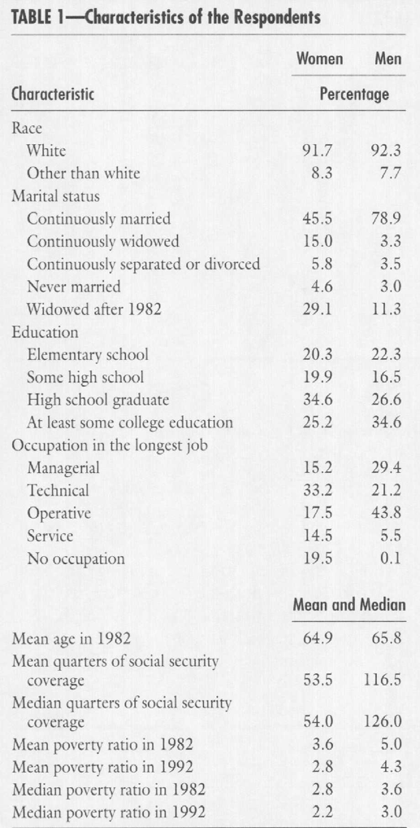
Question #6- Confidence Intervals

Use the following mean values and standard errors to determine confidence intervals:

Variable Mean Standard Error
Cost of monthly rent $1200 70
Hourly earned wage $9.80 .75
Years of sobriety 5 .079
  - Calculate the 95% confidence intervals for each of the three variables above.

  - Calculate the 99% confidence intervals for each of the three variables above.

  - What could we say about the 95% confidence interval in comparison to the 99% confidence interval?

  - With a 95% confidence interval, what is the chance that we are wrong with our estimate? What about the 99% confidence interval?
  - Why are confidence intervals expressed as a range, rather than a single estimated population mean?

Question #7- Hypothesis Testing with Chi Squares

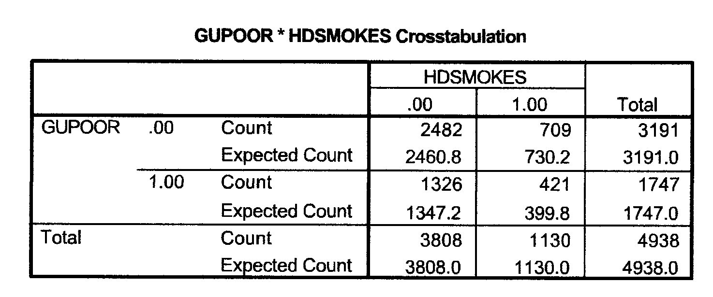
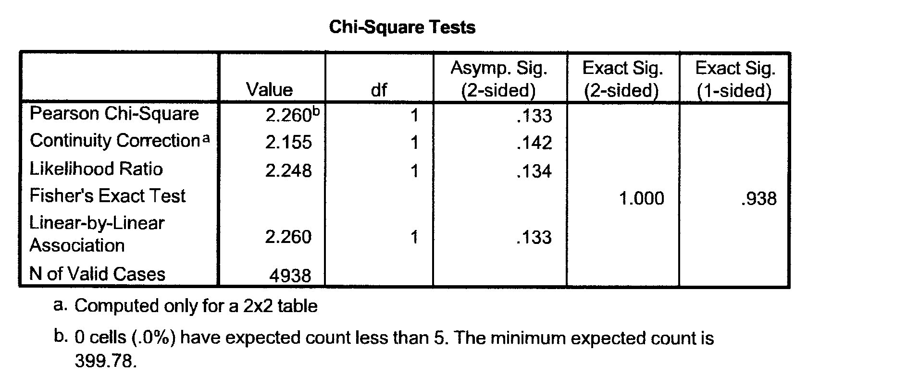

You are curious about whether there is a relationship between an adult smoking and growing up in poverty. Examine the chi-square results above to answer the following questions:

  - What level of measurement are the two variables?

  - What is the null hypothesis for this test?
  - State a one tailed research hypothesis for this scenario.

  - In the sample, how many people grew up poor and smoke?

  - How many people in the sample smoke? How many do not smoke?
  - How many people grew up poor? How many did not grow up poor?
  - What is the direction of the relationship between growing up poor and the head of household smoking? Explain how you determined this.
  - What is the chi-square value shown in the SPSS print out?

  - Will you reject or accept the null for a two tailed .05 test with one degree of freedom?

  - What type of error could you have made?

  - In a research report, would you report the direction of the relationship between the variables? Why or why not?

ANSWERS

Question #1- Frequency Distributions, Measures of Central Tendency & Variability

- Ratio

Number of children | Frequency | Percent | Cumulative frequency | Cumulative percent
0 | 2 | 20% | 2 | 20%
4 | 2 | 20% | 4 | 40%
6 | 4 | 40% | 8 | 80%
7 | 1 | 10% | 9 | 90%
8 | 1 | 10% | 10 | 100%
TOTAL | 10 | 100%

- 20% have four children
- 1 respondent has 8 children
- 8 respondents have 6 or fewer children
- 80% of respondents have 6 or fewer children
- 10% have more than 7 children
- Median- 6 Mode- 6 Mean- (0*2) + (4*2) + (6*4) + 7 + 8 = 47/10= 4.7
- The mean is lower, suggesting a negative skew.
- 8-0 +1 = 9
- 6-4 =2
- when there are outliers in the data
- tells us about the variability of values from the mean within the sample

Question #2- Understanding the Normal Curve

  - The mean is much higher than the median or the mode, which suggests a positive skew and high value outliers.

  - The mean, median and mode are all close to the same value, suggesting a normal distribution.

  - The mean is lower than the median and mode, suggesting a negative skew with low value outliers.

  - The mean is higher than the media and mode, suggesting a positive skew and high value outliers.

Question #3 - Using the Normal Curve to Determine Percentages and Percentiles

- 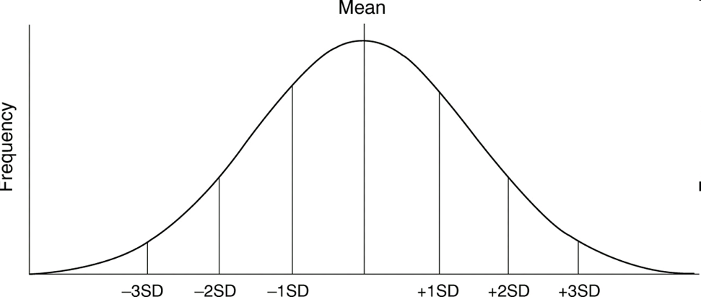
360 440 520 600 680 760 840
- Because the mean is 600 and the standard deviation is 80, we can use the Empirical Rule Chart. 34.13% score between the mean and 1 standard deviation unit above the mean. We add that to the 50% of scores below the mean to determine that the percentile for someone who scores 680 is 84th percentile.

- Find the z score. 790-600/80 = 190/80 = 2.375

A z score of 2.375 corresponds to 49.11% of the curve from the mean.

50 + 49.11 = 99.11

99th percentile

- Find the z score. 550-600/80 = -50/80 = -.63

A z score of -.63 corresponds to 23.57% of the curve from the mean.

50 – 23.75 = 26.25

26th percentile

- Use the empirical rule. 47.72% score between the mean and two standard deviation units above the mean.

- Use the empirical rule. 68.26% score between 520 and 680 (one standard deviation unit below and above the mean).

- Find the z score. 700-600/80 = 100/80 = 1.25

A z score of 1.25 corresponds to 39.44%

39.44% of students scored between 600 and 700.

Question #4- Hypothesis Testing with Z Scores

Part One:
- The self-esteem scale is an I/R variable.

- There is no relationship between parents and scores on the self-esteem scale.

- Parents of children with disabilities will score lower on the self-esteem scale than parents of children who are typically developing.

- 20-15/2.5 = 5/2.5 = 2
Since 2 is greater than the critical value of 1.65 for a 1 tailed test, we have found a significant relationship but our research hypothesis was predicting a negative relationship when we have in fact found a positive relationship (parents of children with disabilities scored higher on the self esteem scale than parents of children who are typically developing).

- We accept the null hypothesis because we predicted in the wrong direction, so if we are wrong, we would have made a Type 2 error. (If we had predicted in the right direction, we would have rejected the null hypothesis and could have potentially made a Type 1 error).

- The test statistic (z) is 2 (see D above). 2 is less than the critical value of 2.33 for a .01 1 tailed test. Therefore, we accept the null for a .01 1 tailed test.

- We accepted the null, so if we are wrong, we would have made a Type II error.

- Based on the .05 test, we rejected the null which means there is a statistically significant difference between the scores for the two groups. However, our prediction was that parents of children with disabilities would score lower on the test, and they actually scored higher. Therefore, we do not find support for our research hypothesis, because we predicted the wrong direction.

Part Two:
- Parental status is a nominal variable. Number of counseling sessions attended is a ratio scale or I/R variable.

- There is no relationship between parental status and number of counseling sessions attended.

- Children in one and two-parent households attend different numbers of group counseling sessions.

- Children in two-parent HH attend more group counseling sessions than one-parent HH.

- 12-7/5 = 5/5 = 1
1 is lower than the critical value of 1.65 for a .05, one-tailed test. Therefore, we accept the null hypothesis.

- We accepted the null, so if we are wrong we made a Type II error.

- Because we accepted the null hypothesis, we did not find support for our research hypothesis.

Question #5- Reading Tables

- 29.1%

- 22.3%

- Far more men in the sample are married, and more women than men are widowed.

- We do not have enough information on the table. We can see that there is a difference between the groups- 34.6% of women graduated high school, compared to 26.6% of men in the sample. However, in order to determine whether this difference is statistically significant, we would also need the grouped standard deviation.

- The mean values for 1992 are higher than the median values. Means are higher than medians when there is a positive skew to the distribution and high value outliers for income that “pull” the mean, or average, higher for the sample.

Question #6- Confidence Intervals

A. 95% confidence intervals:

Monthly rent: lower limit: 1200 - (1.96*70) = 1200 - 137.20 = 1062.80
High limit: 1200 + (1.96*70) = 1200 + 137.20 = 1337.20
I am 95% confident that the monthly rent in the population is between
$1062.80 and $1337.20.

Hourly wage: lower limit: 9.80 - (1.96*.75) = 9.80 - 1.47 = 8.33
higher limit: 9.80 + (1.96*.75) = 9.80 + 1.47 = 11.27
I am 95% confident that the hourly wage in the population is between
$8.33 and 11.27.

Years of sobriety: low limit: 5 - (1.96*.079) = 5 - .15 = 4.85
high limit: 5 + (1.96*.079) = 5 + .15 = 5.15
I am 95% confident that value in the population for years of sobriety is
between 4.85 and 5.15 years.

B. 99% confidence intervals:

Monthly rent: lower limit: 1200 - (2.58*70) = 1200 - 180.60 = 1019.40
High limit: 1200 + (2.58*70) = 1200 + 180.60 = 1380.60
I am 99% confident that the monthly rent in the population is between
$1019.40 and $1380.60.

Hourly wage: lower limit: 9.80 - (2.58*.75) =9.80 - 1.94 = 7.86
higher limit: 9.80 + (2.58*.75) =9.80 + 1.94 = 11.74
I am 99% confident that the hourly wage in the population is between
$7.86 and $11.74.

Years of sobriety: lower limit: 5 - (2.58*.079) = 5 - .2 = 4.8
higher limit: 5 + (2.58*.079) = 5 + .2 = 5.2
I am 99% confident that value in the population for years of sobriety is
between 4.8 and 5.2 years.

C. With the 95% confidence interval, we are less confident about our estimates, but they are more precise.

D. With a 95% confidence interval, there is a 5% chance that we are wrong. There is a 1% chance that we are wrong with a 99% confidence interval.

- Confidence intervals are expressed as a range because we are making estimates about the population based on sample statistics and theoretical sampling distributions. We cannot know the true population mean, so the range expresses the tentative nature of this prediction.

Question #7- Hypothesis Testing with Chi Squares

- Both are nominal, as is required for a chi-square test.

- There is no relationship between growing up poor and smoking.

- There are a number of possible correct options, including:
  - People who grow up poor are more likely to smoke as adults than people who did not grow up poor.
  - People who grow up poor are less likely to smoke as adults than people who did not grow up poor.
  - People who smoke are more likely to have grown up poor than people who do not smoke
  - People who smoke are less likely to have grown up poor than people who do not smoke.

- Look in cell D. The count is 421 people who both grew up poor and currently smoke.

- 1130 people smoke. 3808 people do not smoke.

- 1747 people grew up in poverty. 3191 people did not grow up poverty.

- Look in cell D. The observed frequency “count”is 421, and is higher than the expected frequency (expected count) of 399.8. This suggests a positive relationship.

- 2.260. Look on the SPSS print out (second box) for the Pearson chi-square value.

- The chi square value is less than the critical value for a .05 test, and the p value (look in the SPSS print out for “Asymp. Sig.” in the Pearson chi-square row) of .133 is greater than .05. Therefore, we would accept the null hypothesis.

- We accepted the null, so if we are wrong we have made a Type II error.

- You would not report the direction because the relationship between the variables is not statistically significant. Direction is only reported when we can reject the null hypothesis. Our research hypothesis is not supported.

