Final Review Research Informed Practice II
In-Class
You are a community outreach worker and have been tasked with a project to start an educational program on alcohol misuse for High School students. You want to do some initial research on factors that contribute to the amount of alcohol community members consume so you can build your program appropriately.
- Correlation: You start by wanting to understand the relationship with global self-concept and how many drinks someone has per day. You expect there to be a negative relationship between global self-concept and alcohol consumption.
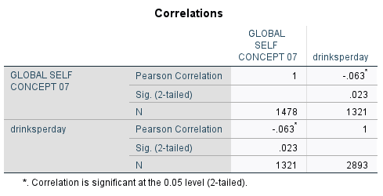
  - Identify the null and research hypothesis.
  - Identify and interpret the correlation coefficient (strength/direction).
  - What do the results indicate for your hypotheses?

- OLS Regression: After you find a significant, negative, relationship in the correlation you decide to run a regression and incorporate additional variables. You have included global self-concept, if a child feels alone (reference: child does not feel alone), if parents are divorced (reference: parents are not divorced), marijuana use (reference: child has never used marijuana). You hypothesize that global self-concept will continue to demonstrate a negative and significant relationship with number of drinks per day.
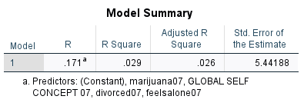

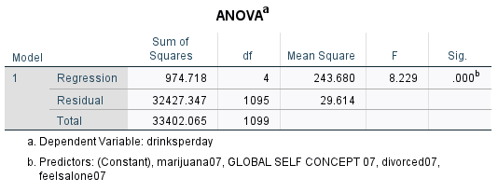
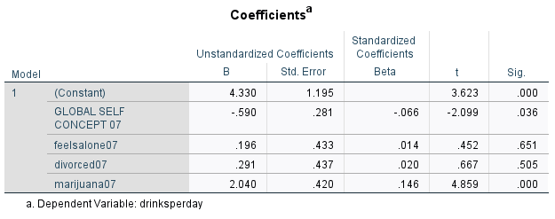
  - Is your overall model significant?
  - Interpret your adjusted r-square value.
  - Which of your independent variables is significant? At what level?
  - Interpret your significant b-coefficients.
  - Are you able to support your research hypothesis?

- OLS Regression with Log DV: You decide to use the log of global self-concept as your dependent variable to better understand parenting factors that contribute to a child’s global self-concept.

Model Summary
Model | R | R Square | Adjusted R Square | Std. Error of the Estimate
1 | .133ª | .018 | .015 | .16733
a. Predictors: (Constant), Parental Warmth Scale, closetomother, closetofather

ANOVAª
Model |  | Sum of Squares | df | Mean Square | F | Sig.
1 | Regression | .616 | 3 | .205 | 7.339 | .000^{b}
1 | Residual | 34.217 | 1222 | .028
1 | Total | 34.834 | 1225
a. Dependent Variable: logsel07
b. Predictors: (Constant), Parental Warmth Scale, closetomother, closetofather

Coefficientsª
Model |  | Unstandardized Coefficients |  | Standardized Coefficients  Beta
Model |  | B | Std. Error | Standardized Coefficients  Beta | t | Sig.
1 | (Constant) | 1.244 | .034 |  | 37.002 | .000
1 | closetofather | .014 | .010 | .041 | 1.421 | .155
1 | closetomother | .025 | .014 | .053 | 1.845 | .065
1 | Parental Warmth Scale | .030 | .008 | .110 | 3.869 | .000
a. Dependent Variable: logsel07

  - Is your model significant?
  - Interpret your b-coefficients that are significant at or below a significance level of .1.

- Logistic Regression: From the OLS regression you see the most significant predictor is marijuana use so you want to better understand what risk and protective factors contribute to marijuana use so you can incorporate this into your program development. You select the following variables: Rosenberg Self-Esteem Scale, Parental Warmth Scale, Number of times per week the child is praised, Child is female (reference: non-female). You hypothesize that as parental warmth increases, likelihood of using marijuana will decrease. You also hypothesize that the more frequently a child is praised, the less likely they will be to have used marijuana.
Omnibus Tests of Model Coefficients
 | Chi-square | df | Sig.
Step 1 | Step | 30.445 | 4 | .000
Step 1 | Block | 30.445 | 4 | .000
Step 1 | Model | 30.445 | 4 | .000

Model Summary
Step | -2 Log likelihood | Cox & Snell R Square | Nagelkerke R Square
1 | 767.165ª | .035 | .058
a. Estimation terminated at iteration number 5 because parameter estimates changed by less than .001.

Variables in the Equation
 |  | B | S.E. | Wald | df | Sig. | Exp(B)
Step 1ª | ROSENBERG SELF-ESTEEM SCALE 07 | -.337 | .212 | 2.531 | 1 | .112 | .714
Step 1ª | parentalwarmth07 | -.287 | .128 | 5.028 | 1 | .025 | .751
Step 1ª | times in past wk praised the child | .122 | .026 | 21.273 | 1 | .000 | 1.130
Step 1ª | child is female | .044 | .185 | .057 | 1 | .018 | 1.045
Step 1ª | Constant | .365 | .824 | .197 | 1 | .658 | 1.441
a. Variable(s) entered on step 1: ROSENBERG SELF-ESTEEM SCALE 07, parentalwarmth07, times in past wk praised the child, child is female.

- Is your overall model significant?
- How much variation of the dependent variable is your model explaining?
- Identify your significant independent variables.
- Interpret your significant Odds Ratios/Exp(B).
- Can you support your two hypotheses?

Answers
- Correlation
  - Identify the null and research hypothesis.
    - H0: r=0 (no relationship between global self concept and drinks per day)
    - Ha: r<0 (negative relationship between global self-concept and drinks per day – as global self-concept increases, drinks per day will decrease)
  - Interpret the correlation coefficient (strength/direction).
    - R= -.063
    - Weak, negative relationship.
  - What do the results indicate for your hypotheses?
    - Significant p-value means we can reject our null hypothesis.

- OLS Regression
  - Is your overall model significant?
    - Look at ANOVA table, significance level for F-test indicates the model is significant at all levels.
  - Interpret your adjusted r-square value.
    - 2.6% of the variation in drinks per day is explained by the model.
  - Which of your independent variables is significant? At what level?
    - Global self concept @ .05 level
    - Marijuana use at all levels
  - Interpret your significant b-coefficients.
    - For each unit increase on score for global self-concept measure, our model predicts a .59 decrease in drinks per day.
    - Those who have used marijuana are predicted to drink 2.04 more drinks per day compared to those who have never used marijuana.
  - Are you able to support your research hypothesis?
    - Yes, global self-concept was significant and we predicted in the correct direction.

- OLS Regression with a Log DV
  - Is your model significant?
    - Yes, the model is significant at all levels.
  - Interpret your b-coefficients that are significant at or below a significance level of .1
    - Those who report a relationship that was close with their mother are predicted to have global self-concept scores 2.5% higher compared to those that did not have a close relationship with their mother. This is significant at the .1 level.
    - For each unit increase on the parental warmth scale, our model predicts a 3% increase in global self-concept score.

- Logistic Regression
- Is your overall model significant?
  - Yes, looking at the Omnibus Test of Model Coefficients, our model is significant at all levels.
- How much variation of the dependent variable is your model explaining?
  - According to Cox & Snell, 3.5% of the variation in using marijuana is explained by the model. According to Nagelkerke, 5.8% of the variation is explained.
- Identify your significant independent variables.
  - For each unit increase in parental warmth score, our model predicts someone is 24.9% less likely to have ever used marijuana. This is significant at the .05 level.
  - For each additional time per week a child is praised, our model predicts they have a 13% increase in using marijuana. This is signficant at all levels.
  - Our model predicts those who identify as female are 4.5% more likely to use marijuana compared to those who are not female identifying. This is significant at the .05 level.
- Interpret your significant Odds Ratios/Exp(B).
  - For each unit increase in parental warmth score, our model predicts someone is 24.9% less likely to have ever used marijuana. This is significant at the .05 level.
  - For each additional time per week a child is praised, our model predicts they have a 13% increase in using marijuana. This is signficant at all levels.
  - Our model predicts those who identify as female are 4.5% more likely to use marijuana compared to those who are not female identifying. This is significant at the .05 level.
- You can support your hypothesis about parental warmth, but not child praise because you predicted a negative relationship, but found a positive relationship.

