Scalar FAQ
__________

Q: How do I keep the text annotations aligned with their respective images?
A: At the bottom of the WYSIWYG (what you see is what you get) editor, you will see the following:
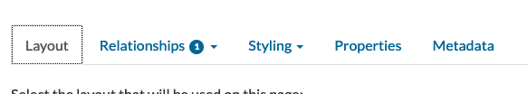

- Click on the Styling tab. You will see some options:

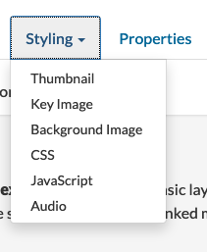

- Click on CSS. You will then see the following:

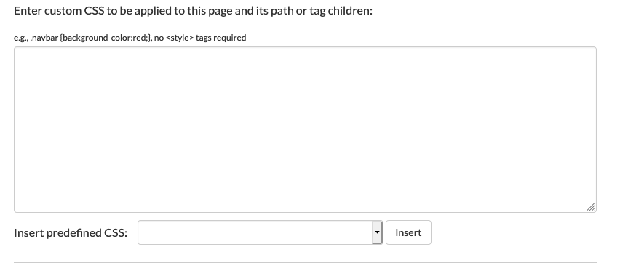

This is where you can input any custom CSS. (Don't worry, you won’t have to do any custom css if you don’t know how.) At the bottom of the box, you can see a bar titled "Insert predefined CSS." We’ll be using the option here to add the CSS that will fix your issue. If you click on the options, you’ll see the following:

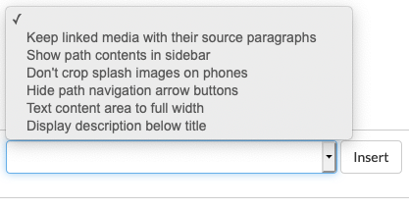

Click on “Keep linked media with their sources paragraphs,” then make sure you click the “Insert” button. This will add the CSS code to the box. What this code is doing is making sure to add some space after the text.

Click on "Save and View," and your issues should be fixed.

__________

Q: Bold font style isn't "applying." I have bold selected, but the text doesn't render that way.
A: This issue is not specific to Scalar and happens anytime you copy and paste text into a website editor. By doing this, you bring the format from, say, Google Docs, so if you try to format the text in the Scalar editor, the formatting won't show. The way to resolve this is to select all the text once you have copied it into the Scalar editor and click the "T" button with the "x".
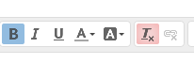
This will clear the formatting. You should now be able to click on the "B" button to make the text bold.

__________

Q: Regarding annotations, we discussed credit for images, and using non-copyright images, but where should the information for the actual words come from? Some of my annotations, if I recall correctly, have at least a few notes in the back of the book, and I mean I surely can dig up information on the internet on the topics, but does the annotations page require citation? Are there restrictions on sources (beyond general guidelines) I should use for filling them out?
A: Basically, you should find this information where you need to find it through standard research. Some (most?) things for the annotations will be essentially matters of encyclopedic knowledge. Others may require you to dig into some journals, databases, or reference materials. That said, I realize some options may not be available when studying remotely. On the other hand, the Libraries have been working hard to make things accessible. Random websites that aren’t reputable should be avoided, and Wikipedia, as you know, is highly problematic, but sometimes the endnotes on there can get you to good information. And generally, you shouldn’t be quoting, but rather paraphrasing, unless there’s something very specific you need to feature in your annotation. Then be sure to include a bibliography at the bottom of your page with all your sources.

__________

Q: How do I add descriptions to images?
A: If you go to the media page of an image (e.g., https://ds-exhibits.swarthmore.edu/scalar/the-20th-century-russian-novel-/a-statue-of-the-greek-goddess-of-love-and-beauty-aphrodite), then click the edit pencil in the top right, you can add/change that information.

If you’re going back to edit an image description, you can reach the media pages by clicking on the image itself on the annotations page:

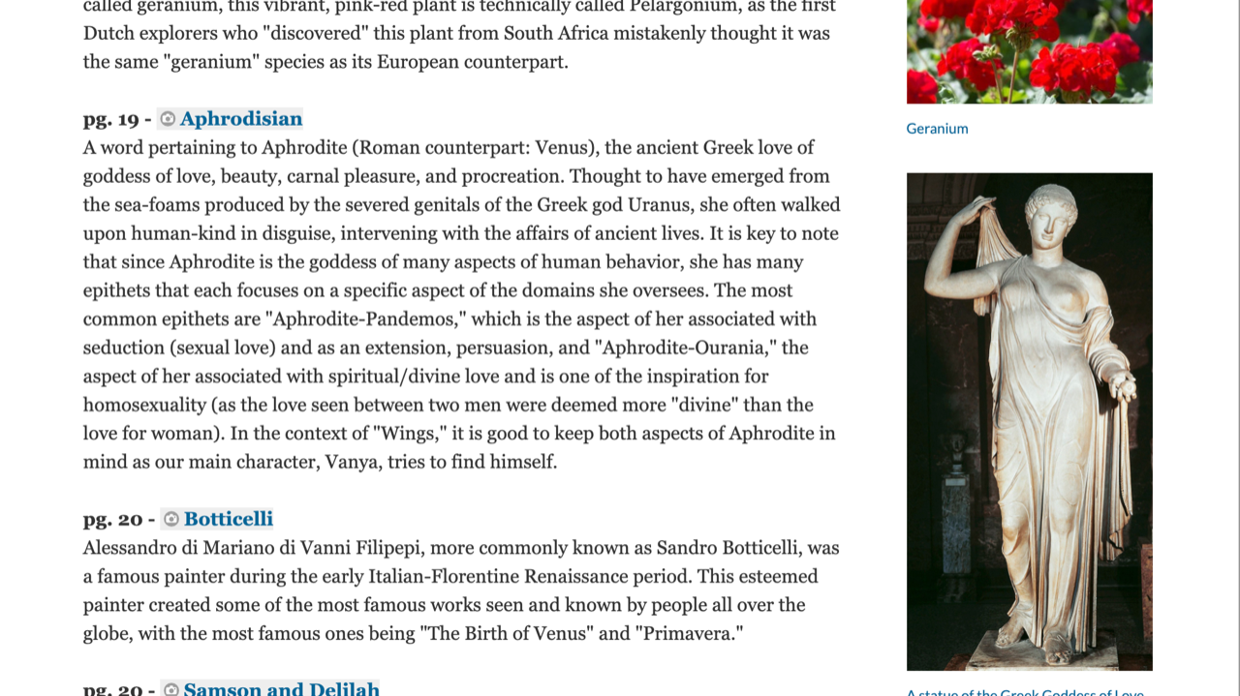

Otherwise, you’ll simply add this information when you’re adding the page (i.e., creating a media page by linking to a URL).

__________

Q: My images aren’t lining up with my images even when I add the CSS code. [Or I’m experiencing some other formatting issue.]
A: This is most likely happening when you copy text from a Google Doc. There is a way to copy text from a Google Doc to a website editor that could bypass some of the formatting issues that come when you copy text from a Google Doc. If you are using cmd-c cmd-v to paste and copy your text into the editor, you can instead press "cmd-shift-v" to paste. Adding "shift" copies the text without the formatting. This means that any formatting done in Google Docs (bold, italics, etc.) will not transfer, and you will have to add the formatting with the site editor. It will not solve all issues but most of them.

__________

