# Plan Your Community of Inquiry Approach

Using the table template below, choose the ways in which you plan to create a community of inquiry in your class. Make sure to have at least one option for each type of presence (teaching, cognitive, social).  See some suggestions below.

|  |  |  |
| --- | --- | --- |
| **Presence** | **Strategies** | **Daily/weekly/other** |
| **Teaching** | *Write your strategies here* | *Will this happen daily/weekly?* |
| **Cognitive** |  |  |
| **Social** |  |  |

Express to your students via a short message to your class (via your introduction video, a Moodle discussion forum, or email) a brief description of your Community of Inquiry plan for the class and how you’ll use your time together during the course to foster a sense of shared discovery. The table template is for your internal planning purposes.

Some possibilities include:

**Teaching Presence: Teaching presence is defined as the design, facilitation, and direction of cognitive and social processes for the purpose of realizing personally meaningful and educationally worthwhile learning outcomes. Teaching presence includes designing and administering learning activities, establishing and maintaining an active learning community, and providing direct instruction.**

* Create an introductory video of yourself for your students that includes personal information.
* Provide clear expectations on how students can reach you synchronously and asynchronously.
* Create learning pathways for students with clear signposts and time management suggestions.
* Clearly explain how assignments relate to the learning objectives and how you will grade them.
* Include early low-stakes activities to make students comfortable with technology.
* Use a variety of formative assessments (e.g., polls, quizzes, discussion posts, reflective writing assignments) and provide ample timely, actionable, and substantive feedback.
* Be present in discussion forums, sharing personal meaning or focusing discussion, if appropriate.
* Check in with students regularly and reach out to those who fall behind.

**Social Presence: Social presence is the ability of learners to project their personality and affect into the community of inquiry, thereby presenting themselves as ‘real people’. Over the term, students develop a social identity, have increasingly purposeful communications, and build relationships. This progression from personal to purposeful relationships increasingly focuses on group cohesion in online courses. Designing and implementing a “social space” for interpersonal communication and collaboration can strengthen social presence for adult virtual learners.**

* Have students post profiles or introductory videos with personal interests.
* Set expectations for acceptable interactions and model behavior.
* Publish a guide to “netiquette” as part of the course materials.
* Encourage both peer-to-peer and peer-to-instructor connections.
* Use short videos to introduce the course, different topics and tech how-to.
* Use audio and video for feedback on student assignments.
* Make solo or small group scheduled office hour visits a graded assignment.
* Design discussion boards to maximize student interaction and leadership.
* Have team-based, collaborative or problem-solving activities.
* Develop peer-review assignments with clear rubrics for grading.

**Cognitive Presence: Cognitive presence is the extent to which learners can construct and confirm meaning through practical inquiry, sustained reflection and critical discourse in a community of inquiry.**

* Clearly communicate to students what they will learn in class.
* Provide different content forms (print, video, audio) and a variety of assignments (solo, group, written, audio-visual, practical, reflective) to demonstrate learning.
* Provide many low-stakes formative assessment opportunities.
* Provide peer-review opportunities with clear rubrics for assessment.
* Connect current learning content to previous content/learning and potential future relevance.
* Encourage multiple perspectives and support diverse points of view in online discussions.
* Provide opportunities for group online brainstorming, such as designing concept maps together.
* Develop clear grading rubrics to indicate the quality of different answers and their scoring.
* Post examples of completed assignments.
* Have students create or find relevant materials and post them to the class as resources.
* Provide frequent opportunities for feedback and testing.

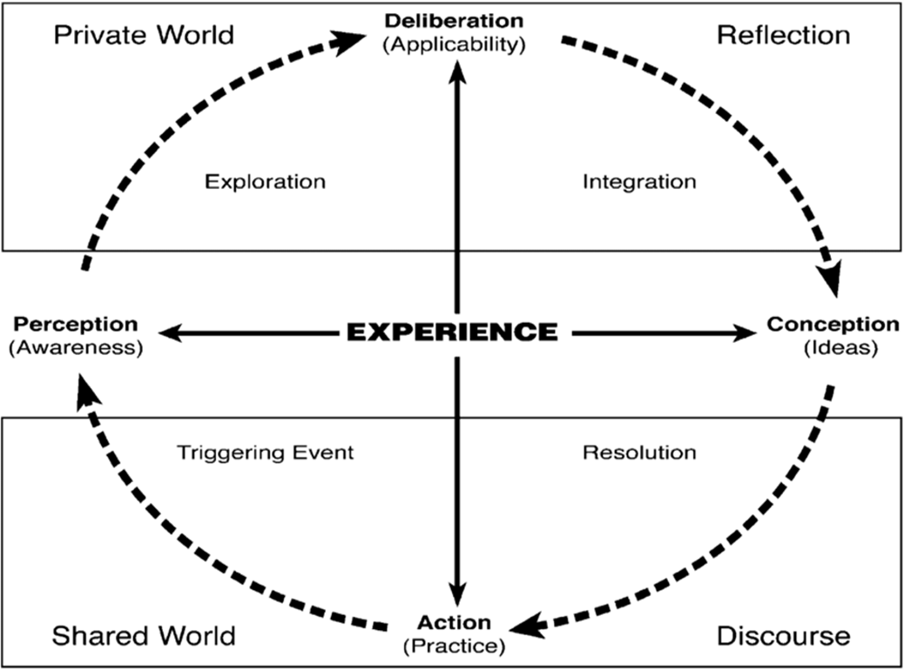

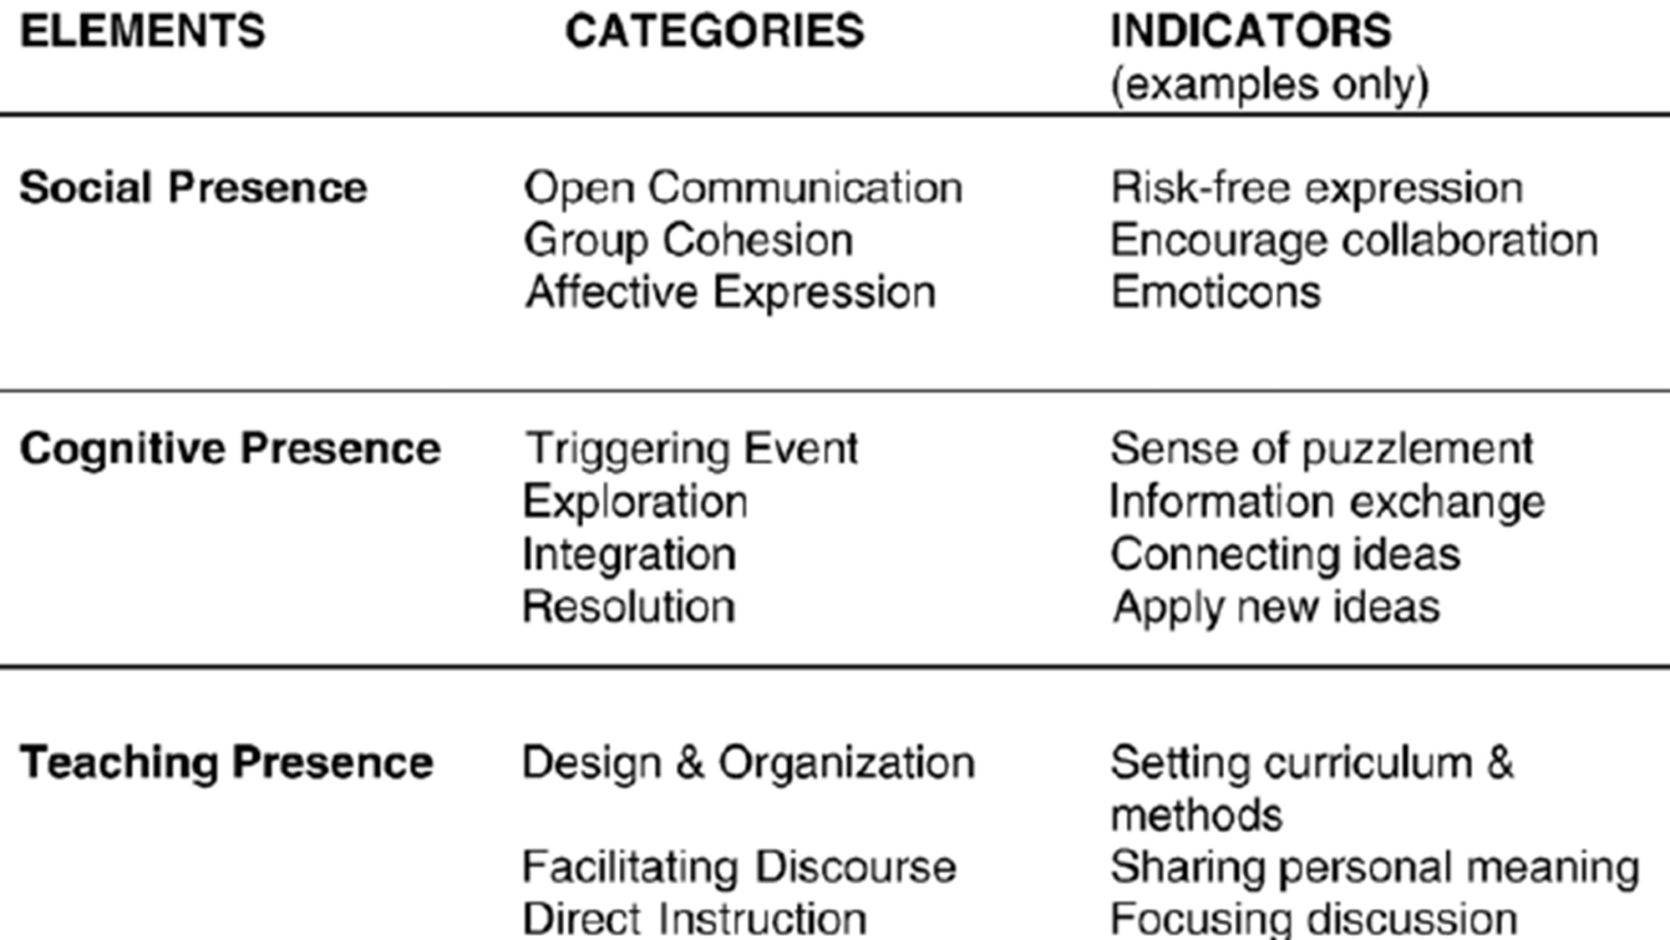

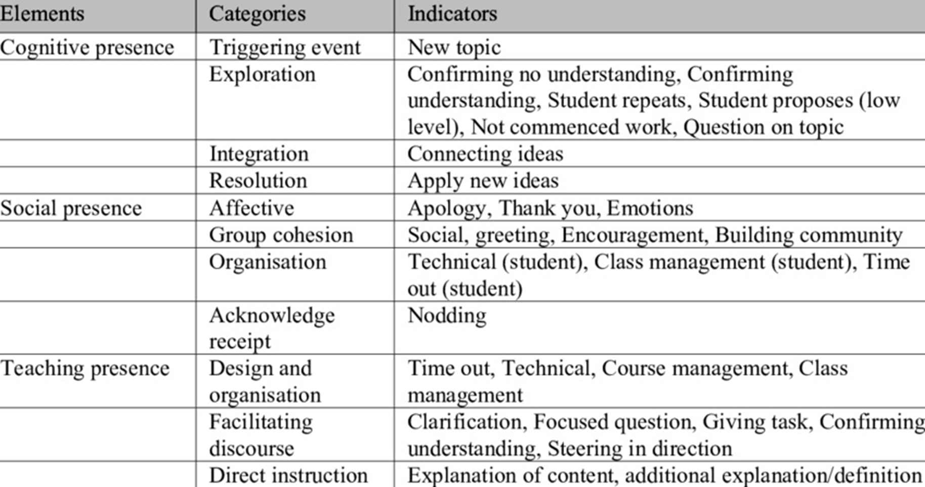

Sources:

Anderson, T., Rourke, L., Garrison, D. R., Archer, W. Assessing Teaching Presence in a Computer Conference Environment. Journal of asynchronous learning networks, 2001; 5(2), 1-17

Garrison, D. R. Online Community of Inquiry Review: Social, Cognitive, and Teaching Presence Issues. Journal of Asynchronous Learning Networks. 2007; 11(1):61-72.

Garrison, D. & Arbaugh, J.B.. (2007). Researching the community of inquiry framework: Review, issues, and future directions. Internet and Higher Education. 2007; 10. 157-172.

Kreijns K, Van Acker F, Vermeulen M, Van Buuren H. Community of Inquiry: Social Presence Revisited. E-Learning and Digital Media. 2014; 11(1):5-18.