Should Whirlpool pay taxes?
peoplestribune.org/2014/01/whirlpool-pay-taxes
Rev. Edward PinkneyJanuary 1, 2014

Rev. Pinkney (center) at PGA protest against corporate redevelopment of Benton Harbor, MI which is creating greater poverty.
PHOTO/DAYMONJHARTLEY.COM
BENTON HARBOR, MI— The question is: should Whirlpool pay taxes and water bills? Benton Harbor residents must pay taxes and water bills. Why shouldn’t Whirlpool, with its annual 2012 corporate sales of $12 billion, pay?
Whirlpool is headquartered in Benton Harbor but it does NOT pay any taxes or water bills to Benton Harbor.
Recently, Benton Harbor City Commissioners voted 5-3 to reject Benton Harbor’s Emergency Manager’s deficit elimination plan, which includes a $2.3 million loan from the state which the city is forced to borrow to pay their bills. Commissioner Marcus Muhammad said he could not support the city taking on more debt. “You can’t cut your way out and you can’t borrow your way out of debt,” he said. These are two basic principles of finance.
Mayor James Hightower and City Commissioners Duane Seats and Sharon Henderson, all strong Whirlpool supporters, want the city of Benton Harbor to take out a $2.3 million dollar loan so Whirlpool will not have to pay their fair share of taxes and water bills. These three were the only ones to support this $2.3 million loan. They did NOT support the city income tax (on the ballot in November, 2013) which would have produced $3.5 million to pay off the city’s debt, and forced the corporations to pay a fair share. Benton Harbor residents must now pay this debt.
In addition, Whirlpool is collecting so many tax credit’s that it may never have to pay taxes (but you and I must pay.) Bloomberg News reported that Whirlpool has more than “$550 million in stockpiled business tax credits” that can be used to offset its future income or taxes. This is at the expense of the people. This deal gets sweeter. The tax credits can be carried over from year to year for the next twenty years.
Whirlpool should pay taxes. Whirlpool is among the wealthiest, greediest corporations in the world. Somebody needs to ask the Whirlpool Corporation and Mayor Hightower how they can sleep at night. Mayor Hightower continues to support and enable the greed at Whirlpool at the expense of Benton Harbor residents. Because of his corporate collusion, he joins all of the giant corporations who are directly responsible for the severe poverty in the city of Benton Harbor .
When you give power to the corporations and government, it will be used for whatever they want, not for what the people want.
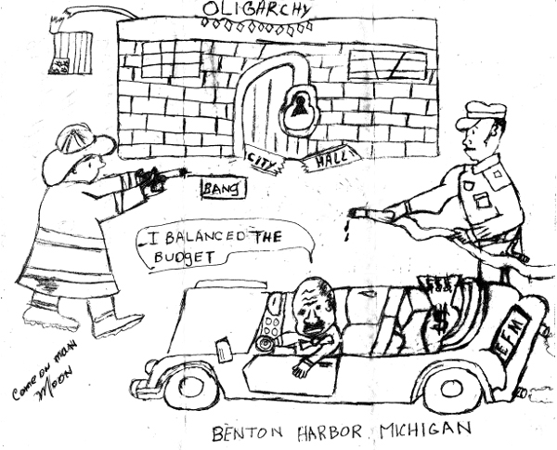

A Tale of Two Cities: An Income Tax in Benton Harbor?
Renu Zaretsky
Display Date
October 4, 2017

This month and next, the Tax Hound looks at Benton Harbor and Detroit, Michigan. How are two troubled cities using tax policy to sustain or revitalize themselves?
In an effort to attract desperately needed tourist dollars, Benton Harbor, Michigan, is home to an annual triathlon. But when my husband I were planning our trip there this summer (he’d compete, I’d watch) our neighbors had some advice: “When you go, don’t hang out in the actual city. Try St. Joseph,” the town next door.

Once there, I understood. Benton Harbor’s roads were in bad shape. Its sidewalks and green space suffered from neglect. There wasn’t much retail and few good hotels or restaurants. Race attendees parked in town and headed straight to the staging area. Once the race ended, many drove straight to St. Joseph to dine or relax on the beach.
Benton Harbor sits on Lake Michigan and on the St Joseph River. Despite those advantages, it is a classic case of a failing Midwestern industrial city. It has been in financial distress for years and is the poorest city in Michigan. Its population is down to 9,919 from a peak of over 19,136 in 1960. The median household income is about $18,000, and 50 percent of its residents live in poverty. An emergency financial manager controlled the city from 2010 to 2014.
Since 2015, Benton Harbor has received $1.6 million through Michigan’s “Financially Distressed Cities, Villages, and Townships” grant program. It has used the funds to improve its water and public safety systems, manage blight, and better appraise property.
Now, the Mayor and city council want to put a new local income tax on the November ballot, joining 22 other Michigan cities with a similar levy. The tax would augment those state grant dollars to improve city services and infrastructure. Residents and businesses would pay a 1 percent income tax. Non-residents would pay 0.5 percent tax on income they earn in the city. There are no studies to indicate how much revenue the tax would raise, though a town of similar population raised about $1 million from a comparable levy in 2015.
At first, I thought, “Great idea!” East Lansing voters will consider such a measure next month to help fund its public pensions. But an income tax needs a reliable tax base and willing payers. Does Benton Harbor have either?
In 2013, the city’s residents rejected a similar income tax proposal, 667 to 543. This year, a poll conducted by the local chamber of commerce finds that 89 percent of its members are opposed to the levy. Some say it will only drive the remaining business to neighboring cities that don’t tax income. Like, say, St. Joseph.
Case in point: Benton Harbor’s largest employer is the Whirlpool Corporation. It has been in town since 1911 and at its peak employed 2,400 people in the city. It has long since shuttered its manufacturing operations, but between 2010 and 2016 spent $155 million to renovate and build two facilities in Benton Harbor that are home to over 1,500 corporate and engineering employees. It also made a corporate donation of $3.8 million to support city services. (The emergency financial manager used the money to fund the police pension plan.)
In exchange, the city council, led by Mayor Marcus Muhammad, awarded the company a 12-year, $3.8 million property tax abatement. Whirlpool won’t pay Benton Harbor property taxes again until 2024.
Mayor Muhammad may be regretting that deal. In 2016, he said “If (Whirlpool) were paying taxes on all of their properties, that would feed the general fund and make the city itself more financially stable with more tax revenue to provide better city services.”
The new income tax would be an effort to make up some of that lost revenue. But unsurprisingly, Whirlpool is no fan. A corporate spokesman said that if the income tax passes, “We will certainly avoid creating any future jobs in Benton Harbor and instead focus on relocating jobs elsewhere in the area….”
So Benton Harbor may be damned if it does, and damned if it doesn’t. It needs revenue to support municipal services, but its shrinking tax base might get even smaller if an income tax passes. What it really needs is new businesses, not new taxes.
The dilemma illustrates, rather painfully, club theory in economics: There’s a point at which there are benefits to belonging to a club of a certain size. Benefits begin to diminish once club membership grows too large. Likewise, a member won’t see benefits until the club is large enough. Benton Harbor was a nicely sized club in 1960. Given today’s financial and demographic trends, it may be a club whose dues are just too high, even without a tax hike.
Could Benton Harbor consolidate with another jurisdiction? Perhaps, but would residents want to give up their local identity? Would another jurisdiction want to have Benton Harbor join its club?
These are tough questions to answer, let alone act on. They make completing a triathlon look easy.

Benton Harbor Just Passed A City Income Tax
November 17, 2017 | Filed under: Taxes and tagged with: Taxes
I lived in Benton Harbor city for 2 years then I lived in a house on the city line for 6 years. currently I live less than 5 miles from the city limits. Benton Harbor is home to the world headquarters of Whirlpool corporation and has a population of around 10,000 people. Benton Harbor has struggled financially since, well….at least my entire lifetime.
Benton Harbor was a manufacturing town and at its height in 1960 had a population of around 20,000 people. Since the 60s the city has had a gradual decline as manufacturing jobs left the area. In 2010 the state of Michigan stepped in and appointed an Emergency Financial Manager (EFM) to assess and resolve the fiscal crisis the city was in at the time. The EFM essentially had power greater than that of the mayor and the city council. Although the city is no longer running deficits and its books are in order, city pensions are still underfunded and the city has substantial debt. Falling property values have also greatly reduced the tax base in the city. Virtually all growth that has occurred in Benton Harbor over the last decade has included generous tax abatements of 10 – 12 years. While main street in Benton Harbor was repaved with roundabouts added and landscaping along the path, the rest of Benton Harbors streets have been neglected.

The Proposal:
The proposal for the city income tax is to levy an income tax on all Benton Harbor residents of 1% of their income and 0.5% of income on everyone who works in Benton Harbor, but does not live in Benton Harbor. 100% of this tax would go to funding road repairs. It is estimated that this tax would bring in $2 million of revenue per year. Benton Harbor city currently has a budget of around $7 million, with this passing the city budget effectively increases by 28%. Here’s the text of the proposal:
“Shall Ordinance No. 071717-1 adopting the Uniform City Income Tax Ordinance, which imposes an annual rate of tax on corporations and resident individuals of 1% and on non-resident individuals of .5% effective January 1, 2018 be approved?”

Benton Harbor Roads:
The Ohio DOT states that pavings costs are approx. $120,000 per lane mile for 2 lane roads. If this is the case, then $2 million per year would be able to pave roughly 16 lane miles per year, or 8 miles of 2 way streets. With this amount of progress it would only take a few years for Benton Harbor streets to show a massive improvement. Michigan in general has horrible roads, and the roads in Benton Harbor are far worse than most cities. Exhibits A – E:
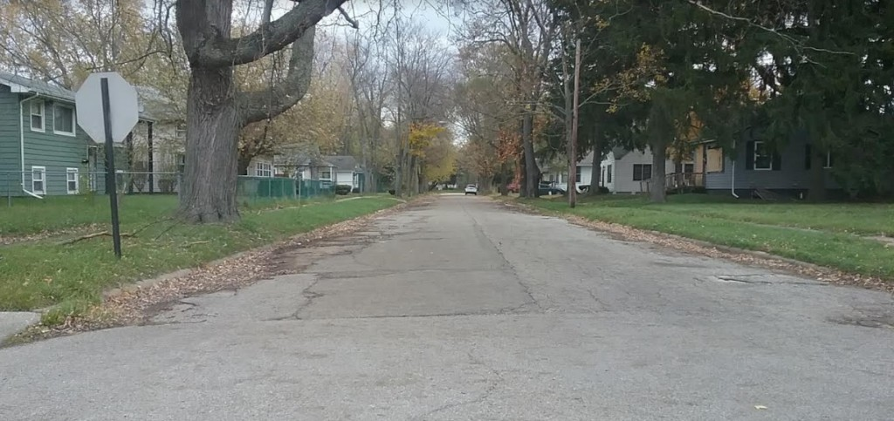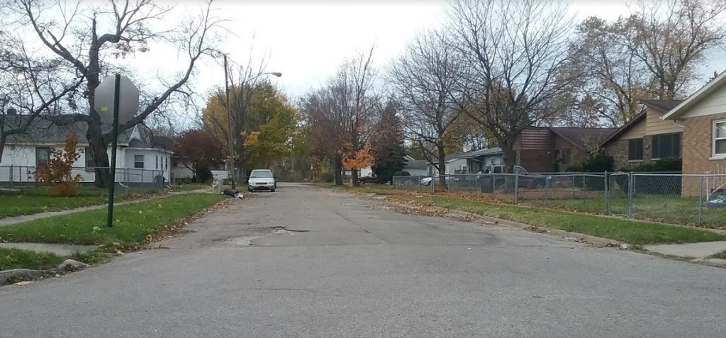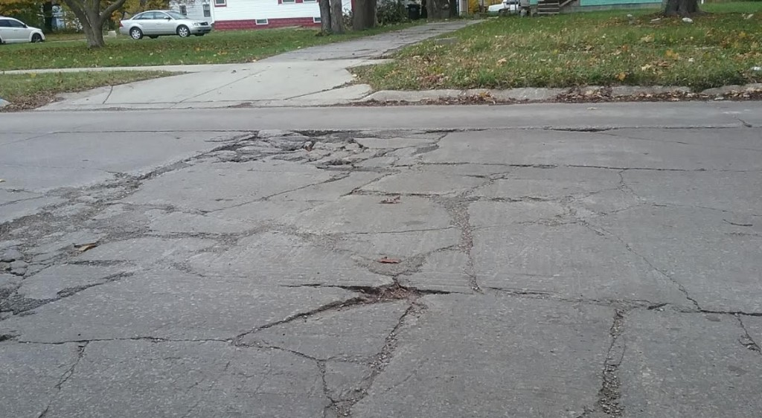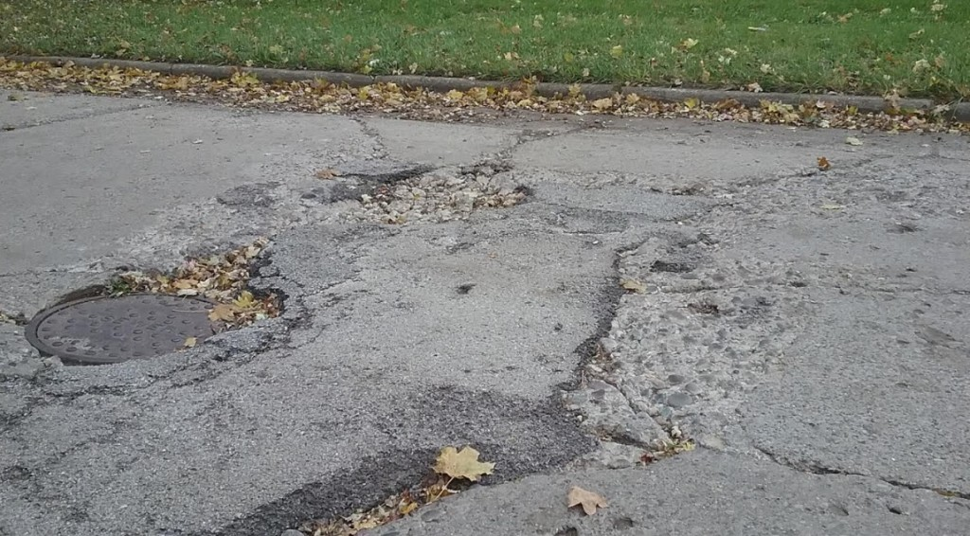
These are pictures I was able to easily take while driving around. These are not cherry picked and are a fair representation of the roads in Benton Harbor. There are some roads in better repair, but there are also some roads where you think you might destroy your car going down that are worse than these images.

The Vote:
The vote was very close, the city income tax passed 511 to 490. This means that 1,001 people voted on this issue. In last years presidential election Benton Harbor had 3,402 votes with a total of 9,966 voters on the rolls. I’m shocked that there wasn’t higher turnout due to how important this issue is. Less than a third of the presidential vote and barely 10% of total registered voters.

Benton Harbor Taxes:
So why pass an income tax, why not just levy a special assessment on property taxes? Well, Benton Harbor city already has the highest property tax rates in Berrien County MI. Property in Benton Harbor city and in Benton Harbor school districts has a millage rate of 43.81 mills, which amounts to $2,190.50 per year for a home valued at $100,000. For anyone living in such a high tax district, I would highly recommend checking out this book on lowering your property taxes, which details how to file assessment appeals. For a non primary residence home, the tax bill would be $3,120. In Benton Harbor the median household income is $18,085 with a poverty rate of 50.3%. The median property value is $47,800. Currently only 22 of Michigan’s 279 cities levy an income tax.

Whirlpool:
Just up the road from the city is the Whirlpool World Headquarters. In 2016 Whirlpool finished a massive $68 million campus in Benton Harbor City to consolidate workers that were in rented spaces all across the greater Benton Harbor / St. Joseph area. Whirlpool received a $3.8 million tax abatement for building this campus (and then donated $3.8 million to Benton Harbor City). In 2024 Whirlpool will start paying taxes on this campus, with estimated revenue of $300,000 per year.
Here’s where the income tax comes into play. Whirlpool employs 1,350 white collar workers at this campus. These are mostly high paying jobs and mostly employees that do not live in Benton Harbor city. If the average pay is $60,000 per year, then from these 1,350 workers, each worker paying an income tax of $300 per year will net the city $405,000, roughly 20% of what Benton Harbor is expecting to net from this tax.
Jeff Noel, Whirlpools VP of communications and public affairs stated before the tax passed “If the tax is levied, we will need to explain to hundreds of employees why we just moved them into the Riverview building or the Benton Harbor Tech Center so they could be taxed at a higher rate than if they had not moved. ” He also stated: “It goes without saying that we will certainly avoid creating any future jobs in Benton Harbor and instead focus on relocating jobs elsewhere in the area,” Noel stated. “In fact we have begun looking at ways to alter our plans for a couple of properties located in the city of Benton Harbor and are working on ways we can relocate or avoid location of employees to reduce the unfairness this tax will have on them.”
What will be interesting to see is if Benton Harbor will use the money on road funding as promised, or if the money will ultimately go towards something else. The city could theoretically designate all the income tax money to road funding, but then divert money currently being spent on roads from the general fund to other items and still be holding to the promise that all income tax funds are going to roads.
Do you live in a city with an Income Tax? What were the results?

