GS 204 - 2023. Structural Geology
Basic geometric attitude measurements: LAB #1

NAME:_________________________________________DATE:________________________

You should have read the pre-lab handout before lab.

1. Give two examples of a planar geologic feature (foliation) you could measure.

2. Name and describe two angles that would uniquely define the geometry of a plane?

3. What is a structure contour (a.k.a. strike line)?

4. Sketch the planar measurements given on the next page (a) through f)) using standard strike and dip symbols. Example in box is for a strike and dip of 045º/45º, or dip direction and dip of 45º→135º. The right-hand rule is always utilized when recording and documenting strike and dip.

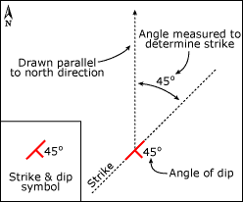

- Dip and Dip Direction: 45º→135º ……reads as Dip Angle (45º) towards Dip Direction (135º).
- Strike and Dip: 045º/45º SE ……reads as strike of (045º) and a dip of (45º) towards the SE quadrant of the map area (bottom right). The SE qualifier is not always used.
- If an orientation example on the next page is not possible, (e.g., if the qualifier for the strike and dip measurement doesn’t conform to the inferred dip direction – if example above was given as: 045º/45º NW) cross the orientation out and explain why it’s impossible.
- Translate the given orientations into an alternative notation (e.g., if dip and dip direction is given, translate and record the measurement into strike and dip, and vice versa).
- Sketch the strike (long line) and dip (tick mark) onto a NS-EW reference frame (assume North is at the top of the page).
a) 38→250 b) 79→185

c) 061/14 SW d) 333/22 NE

e) 79→054 f) 045/6 SE

5. Why are geologic maps important?

6. Describe what factors control the outcrop pattern of a geologic unit as it appears on a geologic map?

7. What is the geometric relationship between the mapped geologic contact of a horizontal rock formation and a topographic contour line?

8. What does a mapped geologic contact look like of a vertical unit, regardless of local/regional topography?

9. For each of the map snippets below (there are 5 total), state qualitatively which way you think the bedding dips and record if you think the beds are steep, shallow, vertical, or horizontal (all maps are referenced so that north is at the top of the page). Start by using the topographic contours to identify ridges and valleys and then determine which way the creeks in the valley flow (i.e., the up- and down-stream direction). Then, use the way that the stratigraphic contacts cross the valley to determine the dip direction. For each map, it is sufficient to state that “the bedding dips to the east” or “the bedding dips to the SW”.

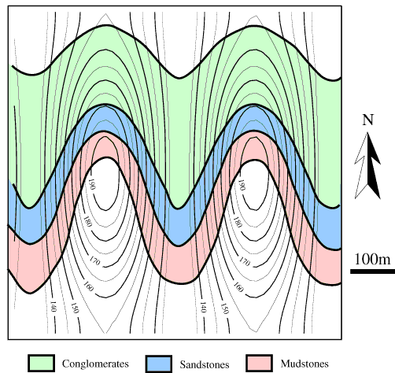

10. Both the figures below are true-scale cross sections (no vertical exaggeration) drawn perpendicular to the strike of the dipping layers. Labelled are the stippled beds true thicknesses (T), vertical thickness (V), outcrop width (OW), and dip angle (θ).
OW
OW

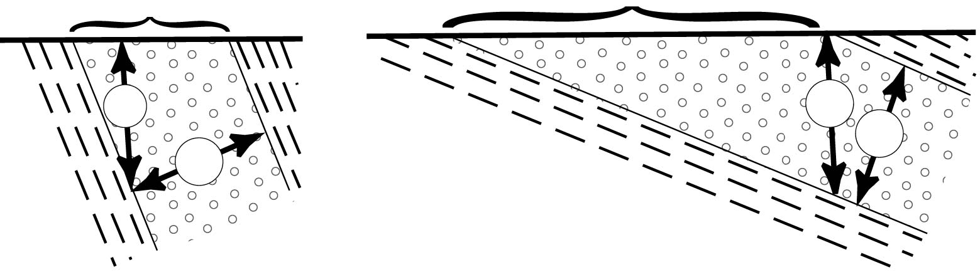
θ
θ
V
T
V
T

i) Can the true dip be measured with a protractor directly off these diagrams? Why or why not?

ii) If the outcrop width and dip angle are known, how would you calculate the true thickness? You will need basic trigonometry for this. Draw a sketch and show the trigonometric formula.

11. For the following block diagrams, sketch in the bed geometry (yellow band exposed on block surface) on each of the other exposed sides of the block. For each block side that you sketch, indicate whether one would see a true dip or an apparent dip (an apparent dip is an observed dip that is less than the actual dip) of the bed if observing that side of the block head on (looking perpendicular to that face of the block).

12. What is needed to draw a strike line (a.k.a., a structure contour)?

13. What is needed to calculate a dip angle from the outcrop pattern of a uniformly dipping planar feature?

14. Three Point Problem: Determine the attitude of the given uniformly dipping plane from the three known points of different elevation and map coordinates (show all your work). Record the attitude in strike/dip, and dip → dip direction.

Point Elevation (m)
A 300
B 150
C 500

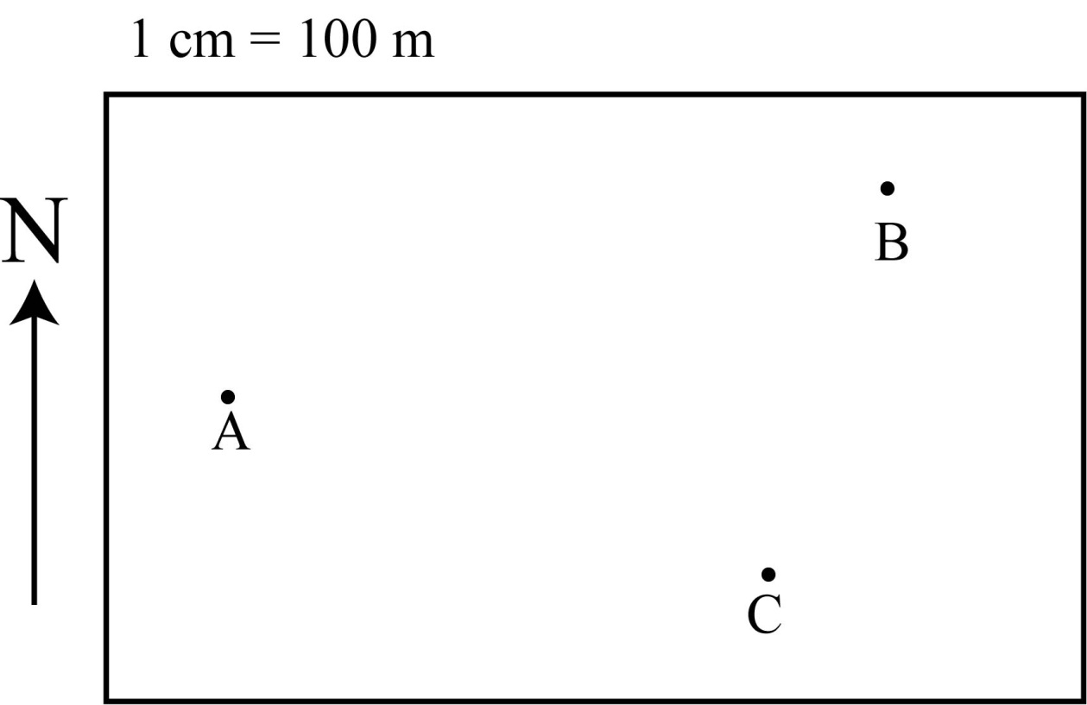
15. Determine the orientation of the marker bed below (thick black line) (record in terms of strike/dip, and dip → dip direction). Draw a cross section perpendicular to the strike of the bed (you pick the location of the section – but make sure to draw in the section line on your map), which shows the marker bed. The map is at a 1:20,000 scale. Enjoy!

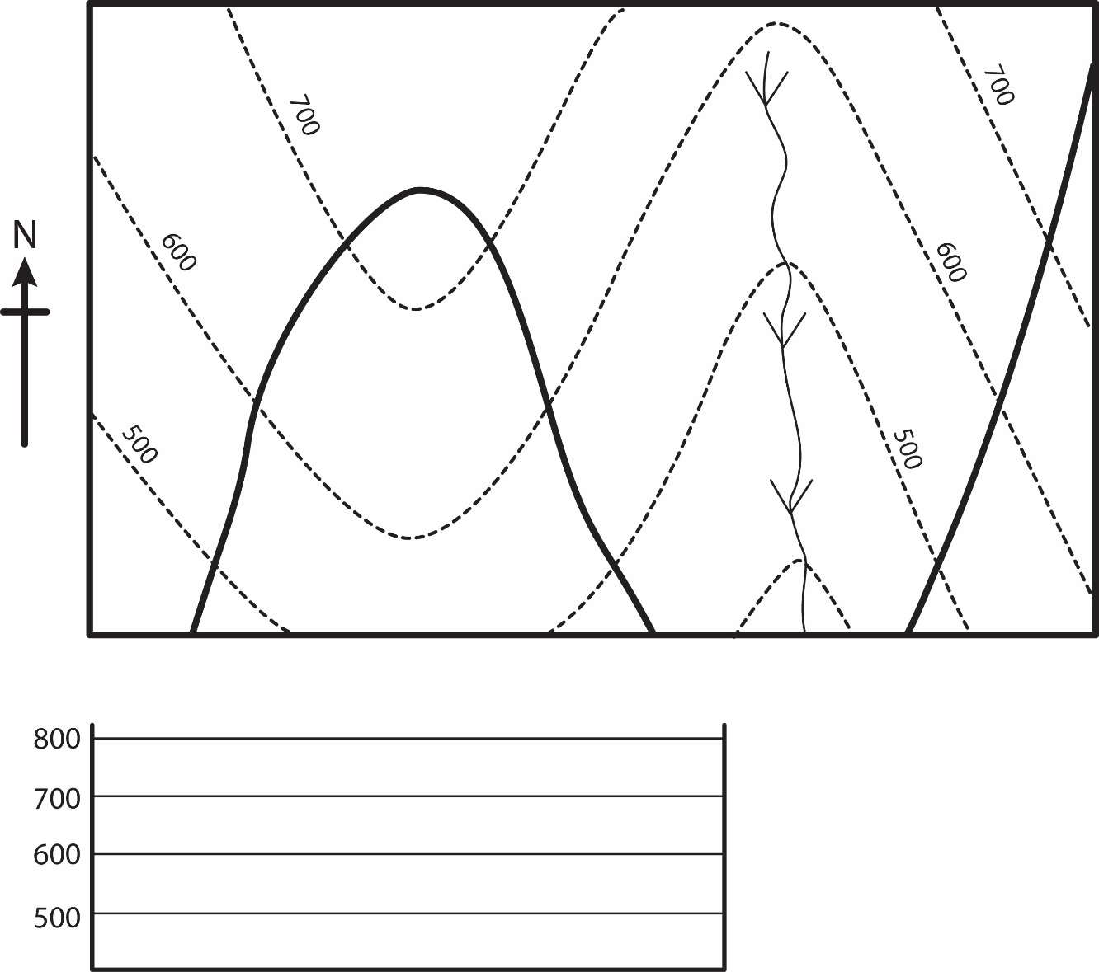
Stream
16. The map below has a scale of 1:50,000.
  - What is the area of the region depicted by the map (give your answer in km²)?

  - Assign elevation values to every contour line on the map assuming a contour interval of 20 m (contour lines with hatches on them represent areas of depression – so in from them the elevation should be going down, though the first hatched contour has the same elevation is the upslope contour that surrounds it).
  - The X indicates a location of a point on the northwest margin of a vertical igneous dike with planar sides. The dike is 500 m thick, and both of its margins have a strike of 045º. Sketch the contacts between the dike and the country rocks, and color the areas where igneous rocks would crop out.
  - A horizontal, 20 m thick coal bed occurs in this region. The base of the coal bed has an elevation of 20 m. Shade in the areas where you would find outcrops of the coal horizon.

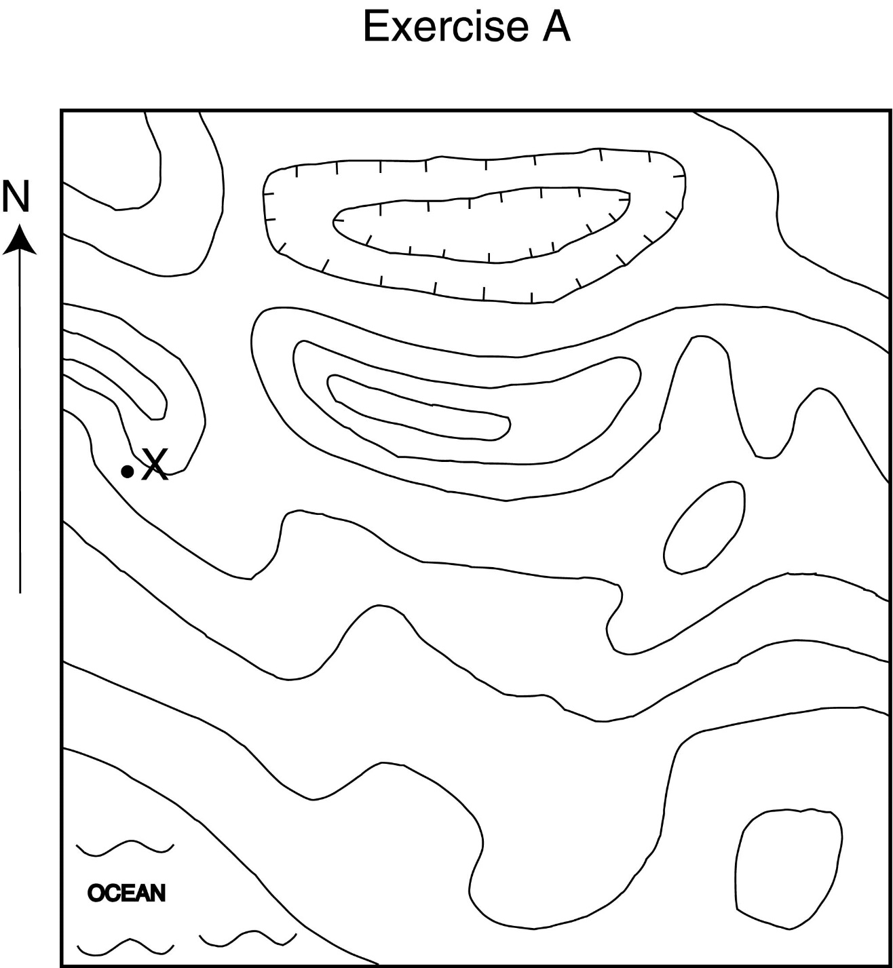

17. Sketch the following on the provided contour map below (simply give a predicted best possible solution to what you THINK the outcrop pattern would look like – i.e., sketch the beds with a single line thickness across the entire map area, beds will cross one another):
a) A bed going through point A, striking north, and dipping 45º.
b) A vertical bed going through point B with a strike of 30º.
c) A bed going through point C, striking south, and dipping 5º.
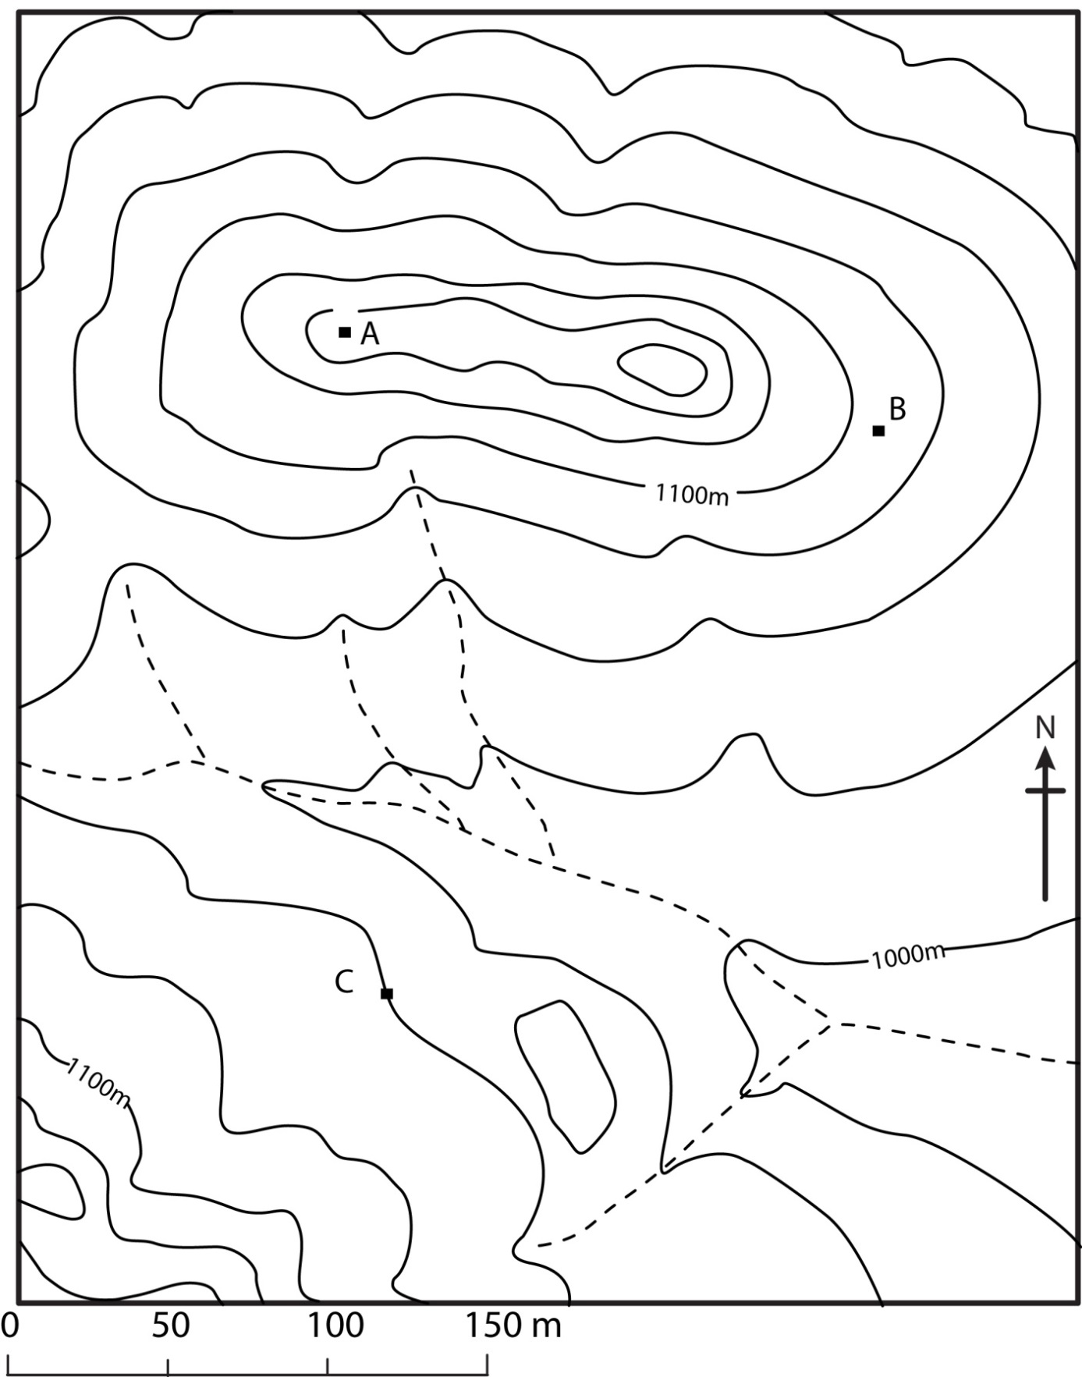
β angle of projection
α‘ apparent dip
α true dip

