Biochem Practice Problems—amino acids and peptides KEY
(let me know if you think that there are any errors or if anything is unclear!)

Amino acid | pK₁ | pK₂ | pK_{R}
Glycine | 2.34 | 9.60 | ---
Alanine | 2.34 | 9.69 | ---
Valine | 2.32 | 9.62 | ---
Leucine | 2.36 | 9.60 | ---
Isoleucine | 2.36 | 9.60 | ---
Methionine | 2.28 | 9.21 | ---
Proline | 1.99 | 10.60 | ---
Phenylalanine | 1.83 | 9.13 | ---
Tryptophan | 2.83 | 9.39 | ---
Asparagine | 2.02 | 8.80 | ---
Glutamine | 2.17 | 9.13 | ---
Serine | 2.21 | 9.15 | ---
Threonine | 2.09 | 9.10 | ---
Tyrosine | 2.20 | 9.11 | ---
Cysteine | 1.96 | 8.18 | ---
Aspartic acid | 1.88 | 9.60 | 3.65
Glutamic acid | 2.19 | 9.67 | 4.25
Lysine | 2.18 | 8.95 | 10.53
Arginine | 2.17 | 9.04 | 12.48
Histidine | 1.82 | 9.17 | 6.00

- We discussed in class that most proteinaceous amino acids have chiral centers at their alpha carbon. (Proteinaceous amino acids refers to an amino acid that occurs in protein structures. Note that there can be other molecules that fit the definition of “amino acid”.)
  - Draw the amino acid that is not chiral. Include the one and three letter abbreviation for this amino acid.
G Gly

  - Which amino acids have chiral centers around their ß-carbons (this would be the carbon connected to the alpha-carbon that is part of the R-group)?
Isoleucine, threonine
  - Draw these amino acids at pH 8.0 and categorize as non-polar/hydrophobic, polar (uncharged), positively charged, or negatively charge. Label each with its one and three letter abbreviation.

- Which amino acid is this titration curve for? Explain briefly. On the right, draw the titration curve for aspartate/aspartic acid.
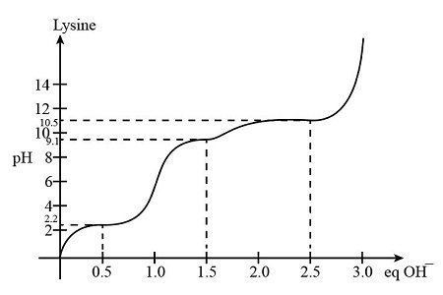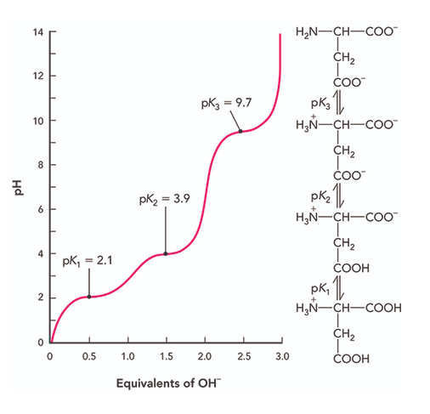
We and look at the three pH values indicated on the y-axis (3.2, 9.1, and 10.5). Given that there are three inflection points, we know that there are three titratable groups. We know that the carboxylic acid group should titrate around pH 3 and the amino group around 9. That leaves the third group of pH 10.5, which corresponds to the pK_{R} of lysine.

- For each pair of free amino acids listed below, indicate which one is more polar.

  - S V. Serine—valine is a non-polar amino acid while serine has a hydroxyl group as part of the R group (otherwise they are pretty chemically similar)

  - R I Arginine—Arginine has a polar and charged side chain while isoleucine is nonpolar.

  - V A Alanine—Although they are both nonpolar, valine has a more methyl groups and therefore more non-polar character.

  - C S Serine—The C-O bond in serine is polar while the C-S bond in cysteine is not.

  - Y W Tryptophan—While these are both aromatic sidechains, the OH in tyrosine give the ring some polar character.

- Using the table on the first page, calculate the PI of the following amino acids:

  - Y 5.89 (2.83+9.39)/2

  - L 5.98 (2.36+9.6)/2

  - R. 10.76 (9.04 + 12.48)/2

  - D 2.77. (1.88+3.65)/2

- Consider the following peptide:
  - What is the sequence of this peptide using the one-letter abbreviations? (Hint—consider the proper order for listing the amino acids.)

(N term) FNVDL (C term)

  - What is the overall charge on this peptide at pH 7.0? pH 12.0?

pJ 7.0 (calculate as drawn) -1
pH 10.0--- -2 (we’ll lose the proton on the N term)

  - What is the pI of this peptide? 3.0 (ish)

4. (all pKA values: amino group of phe 9.13, Carboxy group asp 3.65, carboxy group leu 2.36) Average the two groups that surround where the peptide is neutral, (3.65 +2.36)/2 = 3.0

This is how we will do these calculations by hand, but we can get better estimates with a pI calculator because the values in the table are for the free amino acids in solution, and as we discussed, the chemical environment within the peptide can shift the pK values a bit.)

- Draw the structure of the peptide MASHY at pH 8.0. (I picked pH 8 so we would be sure about the protonation state of the histidine.)

