Intermediate French (FRENB003)
Bryn Mawr College & Haverford College Fall 2025
Instructor: Julien Suaudeau
E-mail: jsuaudeau@brynmawr.edu (During the week, I will respond to all email communication within 24 hours, between the hours of 9 am and 5 pm. Please plan accordingly if/when you have a homework or assignment-related question)

Phone: 610-526-6561
Class time: 9:10 am – 10 am MWF in Old Library 104 + Mandatory TA session (TBA)
Office hours: M 11:30 am – 12:30 pm and F 10 am – 11 am (OL 149)
Our class is mask-friendly


Course structure

This course is a yearlong course that meets three days a week. Those three classes are supplemented by a mandatory extra hour with a TA. Both semesters (FRENB003 and FRENB004) are required for credit. The course is 100% French-speaking.


Bienvenue en Français Intermédiaire !
The purpose of French 003 is to review and build upon the grammar & vocabulary learned in 001-002 or other elementary French courses, and to increase your proficiency in the five communication modes of interpretive listening, interpretive reading, presentational speaking, presentational writing, and interpersonal communication. This course will also strengthen your understanding of French history, French arts, cultures and politics. Finally, it will reinforce your understanding of France’s cultural, religious and ethnic diversity, while deconstructing stereotypes about the French society and the francophone world. You will read texts from French literature and cultural media, watch a francophone movie, and podcast/present/write in French.

All classes will be conducted in French to enhance your communication skills. Your active participation (through one-on-one activities, table and class discussions, debates, but also writing assignments) will increase your confidence as a French speaker while sharpening your knowledge of French and francophone issues.

How to succeed in this course:
It is essential that you study the material assigned before you come to class and that you review the same material after each class. You are expected to come to class with a sharp awareness of the material, whether it is vocabulary, grammar, or culture, as the daily lesson will blend together new and previously-learned material. Develop the habit of only speaking French in class, and outside of class with your instructor. When you have a question about homework, assignments, deadlines, etc., always use French in your email or during office hours. Your willingness to express yourself in the target language will be reflected in your participation grade. Use office hours as an opportunity to go over a difficult part of the lesson, or just to practice your conversation skills. This will improve your interpersonal communication and writing skills at a quick rate.



In addition to getting ready for class, it is essential that you seek out real-world sources to apply your growing knowledge. Find a French YouTube channel that deals with your interests/hobbies. Listen to the French radio and watch French news clips online. Identify a few French personalities (in entertainment, media, politics, sports) and follow them on social media. Find a French singer/band and immerse yourself in their work. Start a journal/blog in French and write about cultural/personal experiences. The textbook and classwork will provide you with a strong, traditional base for building up your grammar and vocabulary, but only this real-world training will turn your acquisition of French into an authentic experience. Overall (textbook study and “authentic” homework), you should dedicate at least one hour every day to practicing your French. In world languages, the gold standard for measuring proficiency is your ability to communicate beyond the walls of the classroom.

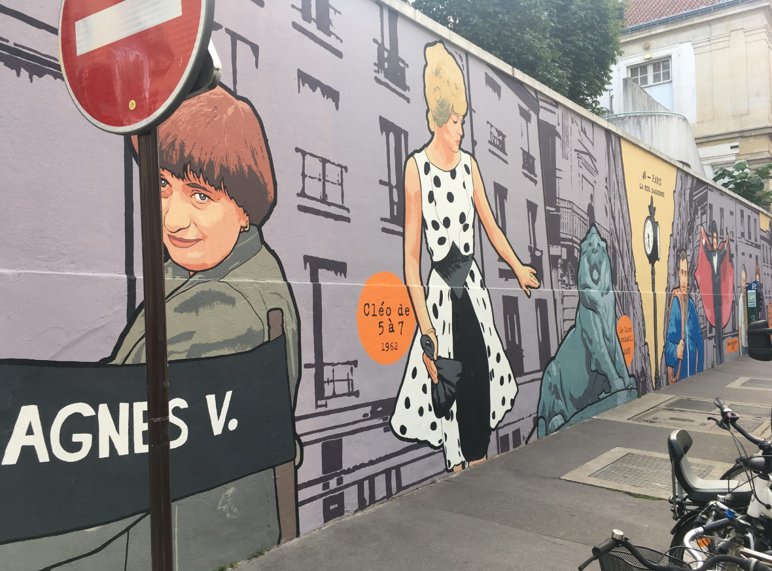
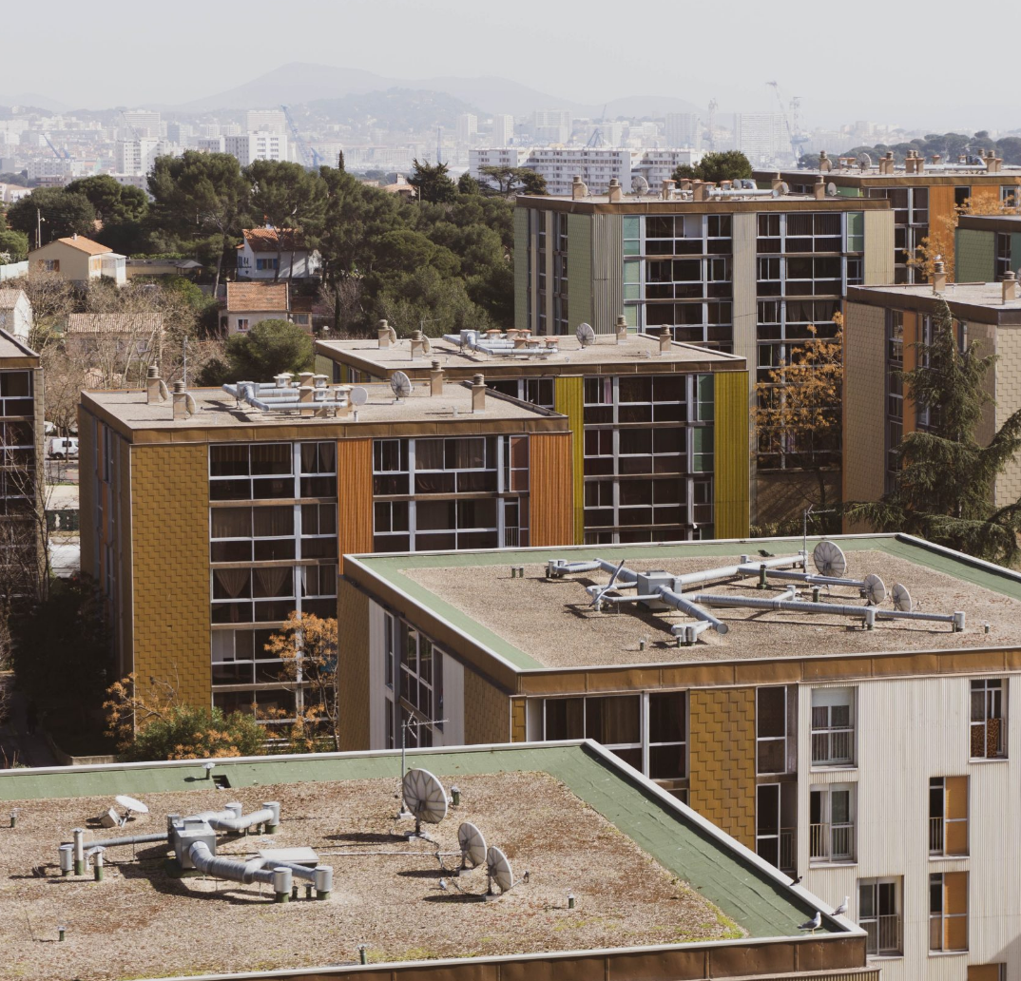
Course Materials
- On dit quoi ? This is your online textbook and roadmap for both semesters. It is made up of 14 units (7 for the fall, 7 for the spring), with all that you need to know about learning goals, grammar, vocabulary, culture, as well as detailed information about assignments and classroom activities.
- Course Moodle page: this is where you will be able to access the workbook pages and answer key, as well as the unit test and final exam files. You will also be able to check your grade.
- Kuessipan, by Naomi Fontaine (2018). The book is available in the pocketbook format at the BMC bookstore. Do not purchase until Friday, 9/5
- You will also watch and study the film Kuessipan, based on the book, by Myriam Verreault. Have your BMC/HC credentials ready, click on this streaming link, and follow the directions to Panopto.

A handful of “authentic” resources

Media

http://brut.live
http://savoirs.rfi.fr/fr/recherche/rubrique/apprendre
http://www.francetvinfo.fr/images/videos/
https://lesjours.fr/les-jours-en-clair/
http://www.france24.com/fr/
http://www.lemonde.fr
http://www.lefigaro.fr

Podcast

https://www.youtube.com/channel/UCYovIdNq6WAZDRf93KVaa6Q

YouTube channels

https://www.youtube.com/user/EnjoyPhoenix
https://www.youtube.com/user/ptitenatou
https://www.youtube.com/user/UnMondeAuFeminin
https://www.facebook.com/coucoulesgirls/?fref=ts
https://www.youtube.com/user/MonsieurDream

TikTok

https://www.tiktok.com/@zazemistan?lang=fr

BMC resources

French tutors are available upon request. For non-curricular needs, the department of French and Francophone Studies also offers a peer-leadership program, in which Juniors and Seniors mentor Sophomores and Freshmen. Please contact me if you are interested in this program.

Online resources

Coordinator of Access Services: Deborah Alder, dalder@brynmawr.edu, for students who need accommodations in this course due to the impact of a learning, physical, or psychological disability. You are also encouraged to meet with me privately, early in the semester, to discuss your concerns. Early contact will help to avoid unnecessary inconvenience and delays.


Attendance policy and acceptable use of technology in the classroom
- Class attendance is mandatory for the sessions with your instructor as well as for the TA session. Attendance will be taken during every class. Your goal should be perfect attendance and punctuality. You are expected to be in class on time, and to come prepared. Tardiness will lower your grade – three “tardies” will equal one absence, and excessive tardiness will be counted as an absence. Since much of class time is devoted to partner and group activities, your presence is necessary for your own progress but also for your classmates’ success.
For an absence to be excused (for instance, due to illness), you must provide the instructor with an excuse respecting the Honor Code via email in a timely manner. If an Internet connection issue prevents you from attending a class, you must notify your instructor as soon as your connection is repaired.
After 2 unexcused absences, your final grade in the course will be lowered by 1 percentage point per absence. For instance, if you earn a 93% (A-) in the class but have 4 unexcused absences (penalty of 4 percentage points), you will receive a 89% (B+) in the course. Students with more than 5 unexcused absences risk failing the class.
- All tests and exams must be taken as scheduled unless you have documentation from the Dean’s Office requesting an alternate test time. Only in the case of serious illness, exams will be rescheduled immediately upon the student's return to class.

- Table française at Bryn Mawr
- The Table française will meet twice a week at New Dorm Dining Center: ??? and Wednesday from 12 pm – 1 pm. Although those meetings are not part of the curriculum, they are an excellent opportunity to practice your oral skills in a low-pressure environment.

- Intermediate level students are required to attend at least three times this semester: once in September, once in October, once in November or December.

TA session (quatrième heure)
- The TA session is part of the course; attendance is mandatory, and absences and degree of participation will be communicated to your instructor, with the same consequences on the final grade. The goal of the TA sessions is to provide an opportunity for you to experiment with the grammar and vocabulary explained in the book and by the instructor, as well as a place to explore a wide range of language drills. Every other week, you will complete the grammar section of unit exams during the TA session. As a rule, you should attend the same session every week.


- Grading Weights
Participation: 10%
Workbook (cahier de travail) homework: 10%
Authentic homework (oral conversations): 15%
Podcast on Kuessipan (with a partner): 5%
Oral presentation on Kuessipan (with a partner): 5%
Bi-weekly responses on Kuessipan: 5%
Creative writing: 10%
Unit exams: 25% (5% each)
Final exam: 15%

Participation
This component takes into account a number of variables, including but not limited to 1) your willingness to engage in classroom activities (warmup posts, conversation, but also written assignments), 2) your cooperation in group and pair work, and 3) your respect and attitude towards the class and your peers. Do not be afraid to make mistakes: even when you are not familiar with the relevant grammar structure or vocabulary, find a way to express yourself. The only mistake you can make is not to participate.

Homework
Homework is made up of 3 components: textbook study and reading assignments (not graded), workbook exercises (three times per week, to be turned in at the end of each unit, graded), and “authentic” assignments (once a week, graded). Before each class, prepare the assignments mentioned at the end of the previous class. If you have questions about a homework assignment, do not wait until the night before to ask. Email your instructor several days ahead of time or make an appointment during office hours. If the question is not specific to your personal work and may benefit your classmates, you can also ask for further explanations during class. All assignments are posted on On dit quoi ? in the Devoirs section of each unit.

Grammaire et vocabulaire
This homework will be assigned on a daily basis (MWF) but will not be checked by your instructor. By completing these grammar and vocabulary assignments, you will get ready for the next class (short-term goal) and build up knowledge that will be assessed throughout the semester (long-term goal).

Cahier de travail (workbook)
These may be writing, listening, or reading assignments that will help you reinforce what you learned in class. This part of your homework should be turned in by email (Word, PDF) or as a Google doc as per the weekly schedule, Tuesday, and Thursday by 12 pm. With the answer key provided by your instructor, you will self-correct your work, identifying your errors, and share your corrections with your instructor no later than 9 am the day after the homework is due. Week 1 workbook assignments are for training purposes only.

Here’s the rubric for authentic homework, by decreasing order of importance:
- How original and personal is the work?
- How spontaneous (non-rehearsed) does the expression feel?
- How relevant is the response to the prompt?
- How dynamic and fluid is the exchange of information?
- How accurate is the vocabulary and how correct is the grammar?

From week 2 onwards, les devoirs authentiques (authentic homework) will be shared with your partner and your instructor every third Wednesday by the end of the day, as a recorded conversation between two students. The conversation should consist of free-flowing speech (as opposed to rehearsed or read). You may use bullet points, but the objective of this assessment is to express yourself in a non-rehearsed setting and to practice pronunciation. The more spontaneous, original, and creative the exchange, the higher your grade will be. Grades of the two students involved in the conversation may differ based on spontaneity, originality, and relevance to the subject matter. The conversation should be recorded on Zoom or a similar software, then submitted by email as an audio/video file.

There is a firm deadline for submitting homework and corrections: 11:59 PM on the due date. Late assignments will receive a 70% if they are submitted within the next 12 hours. Beyond 12 hours, you will receive a 0%.


Écriture créative (creative writing)
Throughout the semester, we will read Kuessipan, by Innu author Noemi Fontaine. The book draws on the multiple connections between place and identity. During the first week, you will pick a specific place on the BMC or HC campus. Then, three times during the semester, you will go back to your chosen place and write about how it echoes your identity, using the vocabulary and grammar learned in class to create precise descriptions of what changes and what stays the same. You will submit a written draft (100 words) at the end of week 3, week 7, and week 11. The pieces will be reviewed by your instructor (not graded), and you will submit your final draft as one document at the end of the semester.

Here’s the rubric for this assignment, by decreasing order of importance:
- How precise and comprehensive are the descriptions?
- To what extent are you making use of the vocabulary and grammar learned in class?
- How correct are the spelling and the grammar? Are you using the instructor’s feedback to improve both?
- How much do we learn about the chosen place and about how you feel connected to it in each piece?
- How strong and coherent is your global production?

Bi-weekly responses
Guided reading questions on Kuessipan will be assigned on On dit quoi ? for the second Friday of each unit. Answer two questions for each assignment, using evidence from the assigned pages. Each answer should be about 100-word long.

Présentation orale sur le film
With one or two partners, you will give a presentation on one of these aspects of the film: plot; characters; themes; cinematography/editing/sound design. An example of previous student work is available on Moodle.

Podcast sur Kuessipan (ou composition)
With one partner, you will create an 8 to 12-minute podcast on Kuessipan.
The podcast is a conversation with your partner. Built around sound clips from the film, it will explore how the narrative structure and the cinematography of Kuessipan deconstruct the stereotypes on Innu people. It should be designed as a creative, organic, personal journey through the film, and include the following components:

- Voice (your conversation)
- Audio clips from the film
- Music clips

Your work will be assessed based on 1) the strength (evidence-based) of your arguments 2) the incorporation of film analysis tools to your analysis 3) the originality/range of your initial question and of your analysis 4) the flow of your conversation and the overall balance between the audio components 5) the richness and depth of your vocabulary 6) the quality of your grammar. An example of previous student work is available on Moodle.


Examens (Exams)
You will have a take-home exam to complete after each unit (5 exams total). The grammar section will be completed during the TA session as a paper exam. The rest of the exam, including the written composition, will be submitted as a Google doc or a Word document on OneDrive (no PDFs), including the composition. There is no midterm exam. The final exam, to be scheduled during finals week, will cover chapters 1-5.

Honor Code
Use of any automatic translation software will be considered an offense against the Honor Codes of both Bryn Mawr and Haverford. Sources (printed, internet) must be acknowledged in essays and presentations. Group work is encouraged in many aspects of this course but your essays are expected to reflect your own ideas and your own work. For that reason, we ask that you do not have your writing checked by private tutors, family members, or other students inside or outside 001. For questions related to the honor code, consult the website: http://www.brynmawr.edu/honorcode/
For all written assignments, make sure you set the language of your word processing software on “French”

Grading scale

94-100% A 4.0
90-93% A- 3.7
87-89% B+ 3.3
84-86% B 3.0
80-83% B- 2.7
77-79% C+ 2.3
74-76% C 2.0
70-73% C- 1.7
67-69% D+ 1.3
63-66% D 1.0

A note on AI

The use of ChatGPT or any other platform or tool to generate ideas or written content (not including spelling/grammar check when specifically allowed), or to produce any other material is prohibited in this course.

This policy is for the following reasons:
- This class is designed to improve your world language skills, including presentational writing ; if you’re not writing, you’re not improving.
- Using AI opens up academic honesty issues, both because it raises the question of whether the work is “your” work, and also because tools like ChatGPT rely on taking uncredited material from scholars and writers.
- Using AI does not produce reliably accurate results.
- ChatGPT has serious negative environmental aspects, particularly in relation to water usage.
- Open AI has exploited workers from the global south, especially workers in prisons and refugee camps, and workers in Kenya, the Philippines, Colombia, and elsewhere.

Programme du semestre

Dates are subject to modification during the semester. A detailed schedule is available on On dit quoi ? for each unit and at the end of the book. Dates are indicated in French format: DD/MM.
Week | Unité
1-2 | Unité 1 : Consommation, environnement, socialisation  Examen 1 à soumettre le 14/9 avant midi
3-4 | Unité 2 : Villes, banlieues, campagnes  Écriture créative : fragment 1 à soumettre avant le 19/9 à 16h  Examen 2 à soumettre le 28/9 avant midi  28/9 à 19h : projection de Kuessipan
5-6 | Unité 3 : Kuessipan  Présentations orales  Podcast à soumettre le 10/10 avant la fin de la journée
11/10 au 19/10 | Vacances d’automne
7-8 | Unité 4 : Visages de la jeunesse  Écriture créative : fragment 2 à soumettre avant le 24/10 à 16h  Examen 3 à soumettre le 2/11 avant midi
9-10 | Unité 5 : Tous connectés  Examen 4 à soumettre le 16/11 avant midi
11-12 | Unité 6 : Info et infox  Écriture créative : fragment 3 à soumettre avant le 21/11 à 16h  Examen 5 à soumettre le 30/11 avant midi
13-14 | Révisions pour l’examen final
15 | Examen final (self-scheduled)  Écriture créative : version finale à soumettre avant le 12/12 à 23h59

