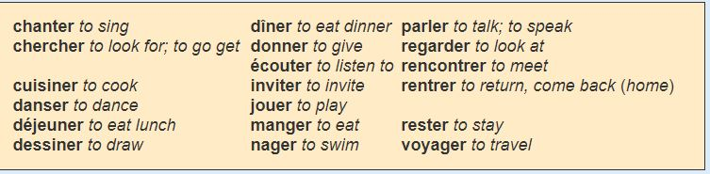

Les verbes en ER
- Chanter : to sing
- Chercher : to look for
- Cuisiner : to cook
- Danser : to dance
- Déjeuner : to eat lunch
- Dessiner : to draw
- Dîner : to eat dinner
- Donner : to give
- Écouter : to listen to
- Inviter : to invite
- Jouer : to play
- Manger : to eat
- Nager : to swim
- Parler : to talk, to speak
- Regarder : to look at
- Rencontrer : to meet
- Rentrer : to return, to come back home
- Rester: to stay
- Voyager: to travel

