Cities Senior Seminar
FALL 2024, 7-9pm

Whole group:  Carpenter Library 25 | Small Groups:  Hurley: Carpenter Library B13  McDonogh: Carpenter Library B15  Restrepo: Carpenter Library B17
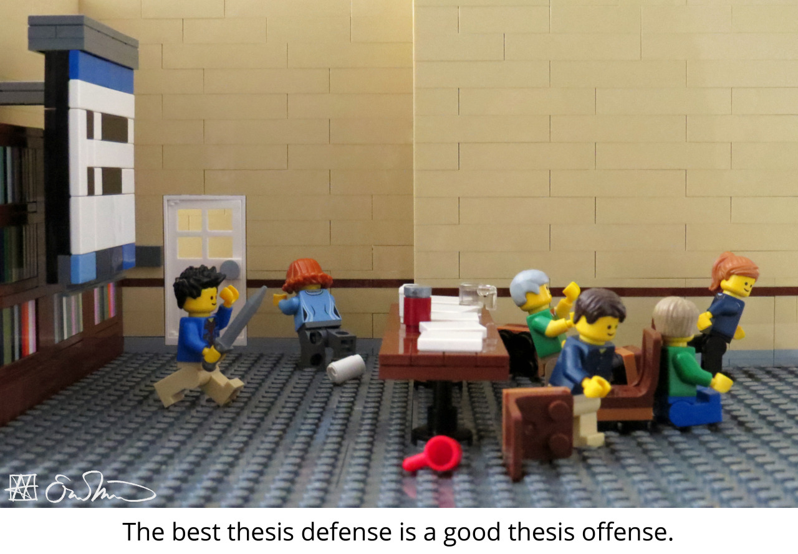

Instructors:
Jennifer Hurley | Gary McDonogh | Lauren Restrepo
jhurley@brynmawr.edu | gmcdonog@brynmawr.edu | lrestrepo@brynmawr.edu
W 10 – 12pm OL220 | W 10 – 12pm OL237 | M 3-5pm in OL215

LEARNING GOALS
The senior thesis is a keystone experience of the Cities major. It is an opportunity to develop your thoughts and interests on an urban or spatial topic that requires bringing together concepts and skills learned over your previous three years. The seminar guides you through the process of research, analysis, drafting, and presentation, helping you to develop a coherent and persuasive argument in writing (and designs for architectural theses).
Although your thesis journey is unique, the path you take will be shared: the senior conference stresses the collaborative nature of writing, drawing on continuing feedback, from peers as well as faculty advisors, becoming integrated into a long-term writing process. This semester, you will make the transition from paper writer to author. It is a process that involves posing a good, probing question, finding and interpreting evidence that is as nuanced and messy as the real world itself – and then working to ‘connect the dots’ and present a sustained, carefully constructed argument in a way that is clear, fresh, and engaging.

ASSESSMENT
Assessment is based on your final thesis, but we also consider how each student arrived at the final text. This includes participation in seminars, collaboration with others, and the development of your own process. There will be a self-assessment at the end of the semester.

Attendance is required and deadlines are fixed. This is necessary to ensure that drafting and
peer workshops can occur on schedule. For those observing religious holidays, accommodations should be requested in advance.

COURSE POLICIES
Accessibility
Bryn Mawr College is committed to providing equal access to students with a documented disability. Students needing academic accommodations for a disability must first register with Access Services. Students can call 610-526-7516 to make an appointment with the Coordinator of Access Services by emailing accessservices@brynmawr.edu to begin this confidential process. Once registered, students should schedule an appointment with me as early in the semester as possible to share the verification form and make appropriate arrangements. Please note that accommodations are not retroactive and require advance notice to implement. Any student who has a disability-related need to tape record this class must first speak with the Coordinator of Access Services and to the instructors. Because of laws within the State of Pennsylvania, class members need to be aware that this class may be recorded. More information can be obtained at the Access Services website http://www.brynmawr.edu/access_services/

Academic Integrity
All work is ultimately collaborative, the product of reading, viewing, listening, and even writing with others. Moreover, there are norms to recognizing the collective nature of producing knowledge through citations. Bryn Mawr College takes very seriously any occasion of plagiarism. This can be defined as the presentation of a work (ideas or words from the Internet, a peer, a published article, etc.) of another as one's own, both literally and conceptually. Be extremely careful in your research so that you do not inadvertently copy information without crediting the source. When in doubt, cite. You are required to cite websites and generative AI sources. All courses in art and architectural history follow the citation forms described in the Chicago Manual of Style. Other Cities courses follow American Psychological Assocation (APA) citations forms. If plagiarism is detected, we ask that you report yourself to the Bryn Mawr Honor Board.
Generative AI tools
You may use AI programs (e.g., ChatGPT) to help generate ideas and brainstorm, but the writing you submit must be your own (i.e. you should nevercopy and paste AI output into your writing). Note that the material generated by these programs can be inaccurate, incomplete, or otherwise problematic, including false citations. Please also beware that the use of AI may stifle your own independent thinking and creativity. Any use of generative AI should be a starting point and involve independent verification of information generated by trusted, cited sources. Any plagiarism or other form of cheating via AI will be considered a violation of the Bryn Mawr Honor Code.

Confidentiality
To ensure a safe and supportive learning environment for all, please respect confidentiality and privacy regarding social media postings pertaining to class. It is not permitted to post or share on-line images of the class and recordings of class lectures and discussions without explicit permission.

You are also not permitted to share any personal information or intellectual property (including writing) of course participants through social media, any on-line platform, or with any AI software without explicit consent. Any of these actions will be considered a violation of the Bryn Mawr Honor Code.

Title IX
Bryn Mawr is committed to fostering a safe and inclusive living and learning environment where all can feel secure and free from harassment. All forms of sexual misconduct, including sexual assault, sexual harassment, stalking, domestic violence, and dating violence are violations of Bryn Mawr’s policies, whether they occur on or off campus. Bryn Mawr faculty are committed to helping to create a safe learning environment for all students and for the College community as a whole. If you have experienced any form of gender or sex-based discrimination, harassment, or violence, know that help and support are available. Staff members are trained to support students in navigating campus life, accessing health and counseling services, providing academic and housing accommodations, and more.

The College strongly encourages all students to report any incidents of sexual misconduct. Please be aware that all Bryn Mawr employees (other than those designated as confidential resources such as counselors, clergy, and healthcare providers) are required to report information about such discrimination and harassment to the Bi-College Title IXCoordinator. Information about the College’s Sexual Misconduct policy, reporting options, and a list of campus and local resources can be found on the College’s website: Bryn Mawr Sexual Misconduct Policy

SCHEDULE AT A GLANCE

Date | Meeting | Topic | Assignment
Week 1: Sept 3 | Whole class | Introductions | 9/5: Research question, working title, preliminary  bibliography
Week 2: Sept 8 | Primary advisor groups | Methods and primary sources | 9/12: Research methods statement + research schedule, list of primary sources  9/15: IRB documents to primary
Week 3: Sept 15 | Whole class | Literature review and  citation mapping | 9/19: Literature Review  Notes and prelim work
Week 4: Sept 22 | Whole class | Outlines | 9/26: Full draft outline
Week 5: Sept 29 | Individual meetings | Literature reviews, revised outlines, and data collection | 10/2: Literature review  with revised full outline and preliminary thesis statement
Week 6: Oct 6 | Primary advisor groups | Peer writing  workshop (lit review and outline)
Week 7: Oct 20 | Whole class | Public speaking  workshop | 10/24: Draft of one empirical chapter
Week 8: Oct 27 | Whole class | First-round presentations, part 1 | 10/27: Presentation slides of analysis in class
Week 9: Nov 3 | Whole class | First-round presentations, part 2
Week 10: Nov 10 | Individual meetings | Holistic check-in and feedback | 11/12: Full draft due for peer review
Week 11: Nov 17 | Secondary advisor groups | Peer-review workshop,  part 1
Week 12: Nov 24 | Secondary advisor groups | Peer-review workshop,  part 2
Week 13: Dec 1 | Public Presentations |  | 12/1: Presentation slides
Week 14: Dec 8 | Whole class | Formatting, final  questions
Final Thesis Due Thursday, Dec 11 by 5pm (Grading begins Monday, December 15 at 9am)

