Title

<<see p2-3 for BMC and HC college seals>>

Name
A.B. Candidate in Growth and Structure of Cities, May 2025
Bryn Mawr College / Haverford College
Written in partial completion of the Growth and Structure of Cities Major
15 December 2024

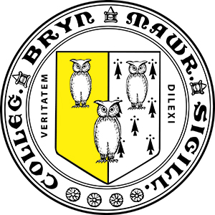

HC Students: feel free to copy the table below (with clean formatting for both seals)



