ARTD B140 Approaches to Dance: Themes and Perspectives
Bryn Mawr College | Dance Program
Fall 2026
Friday 11:40–2:00 PM | Music Room, Goodhart Theater
Instructor: Tammy Carrasco
Email: tcarrasco@brynmawr.edu
Office: Goodhart Hall, 104B
Office Hours: By appointment (in person or Zoom)
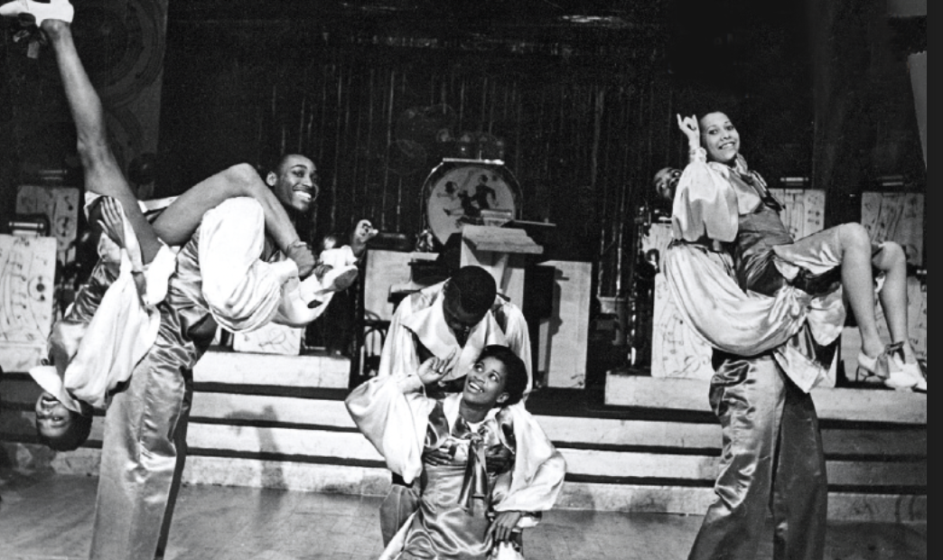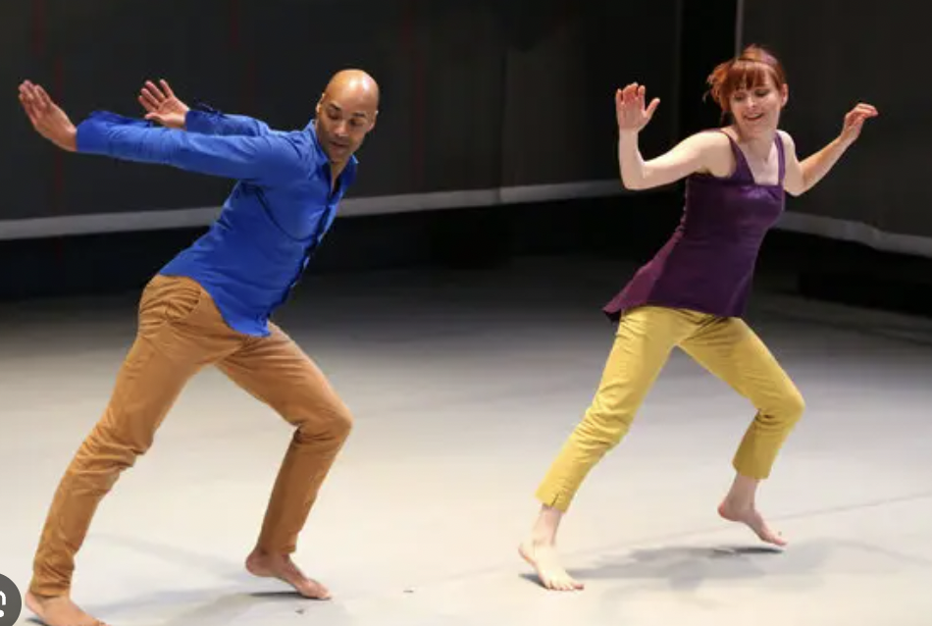

COURSE NOTICE: THIS COURSE, SYLLABUS, AND COURSE OUTLINE IS SUBJECT TO CHANGE Please remain flexible and check email and Moodle regularly for updates.
Some of the language in this syllabus is inspired by previous iterations of the course taught by Dr. Lela Aisha Jones and Linda Caruso Haviland.

DESCRIPTION: This course introduces students to dance as a multi-layered, significant and enduring human behavior that ranges from art to play, from ritual to politics, and beyond. It engages students in the creative, critical, and conceptual processes that emerge in response to the study of dance. It also explores the research potential that arises when other areas of academic inquiry, including criticism, ethnology, history and philosophy, interact with dance and dance scholarship. Lectures, discussion, film, video, and guest speakers are included.
Critical Interpretation (CI)
Rather than attempting comprehensive coverage, this course offers multiple entry points into dance history, theory, and practice. These “touches” are meant to spark curiosity and invite deeper exploration. Because we have limited time and expansive material, the course outline may shift in response to class needs and discussions. Some topics will inevitably be left behind or gaps made visible; students are encouraged to pursue their interests further in final projects.
To study dance is to study the body as moving culture. This course acknowledges the impossibility of universal truth and invites students to navigate paradox, difference, and uncertainty with care. Vulnerability, curiosity, and mutual respect are foundational to this learning space.
PREREQUISTES:
No prior dance experience is required. Students should bring:
- Willingness to move
- Openness to embodied ways of knowing
- Curiosity about how bodies produce meaning in culture
- Readiness to work in community

LEARNING OBJECTIVES:
By the end of the course, students will be able to:
- Critically engage with dance scholarship, media, and performance
- Express ideas through writing, movement, and dialogue
- Experience dance theory and history through reading, observation, and participation
- Develop bodily awareness and appreciation
- Synthesize personal discoveries in relation to course content and discussion
- Offer and receive constructive peer feedback
- Read dance as a reflection of culture, politics, and human experience
- Translate embodied experience into language
- Reflect on one’s position within a diverse learning community

INTEGRITY INSPIRATIONS (adapted from Dr. Lela Aisha Jones’ syllabus, which was inspired partially by NJAEP community agreements):
- Listen to understand. Respond thoughtfully and with rigor.
- Get comfortable with discomfort.
- Be present and on time for class.
- Give and get grace. Meet people where they are and let there be room for mishaps, forgetting, forgiveness, and revamping. Be generous.
- Respect the ideas of others and offer useful feedback.
- Check in with you. Where are you? How are you entering, being with, and exiting the community? Be present and compassionately accountable with yourself and the collective.
- Refrain from using technology unless otherwise indicated. Written note-taking is encouraged.
- Come dressed to engage in dance. Wear clothing that you feel fully comfortable moving in.
- Engage fully in the physical, verbal, energetic, and intellectual aspects of class.
- Be courteous. Refrain from private conversations during class or interruptions when others are articulating ideas or engaged.

ASSESSMENT PHILOSOPHY: UNGRADING
This course uses an ungrading approach. This means that your learning is not evaluated through points, averages, or hidden criteria. Instead, assessment is based on student reflection, evidence, and growth over time. Ungrading is not about lowering standards; it is about student-motivated learning, accountability, and making learning visible.

Ungrading asks you to:
- take responsibility for your learning
- reflect honestly on your engagement and development
- use feedback as information, not judgment
You will still receive:
- clear expectations for assignments
- feedback on your work
- guidance on how to deepen your thinking and practice

You will not be graded on:
- having the “right” interpretation
- performing expertise you do not yet have
- constant confidence or fluency

Assessment will be based on:
- engagement with course materials
- willingness to think, question, and revise
- attentiveness to movement, relation, and context
- care in contributing to a learning community

There will be a mid-term self-assessment with teacher response (written or in-person) and a final self-assessment. Your final self-assessment, which includes proposing a final grade, will be supported by evidence from your work. If the final grade proposed by the student does not align with the professor’s graded assessment, the professor will invite (through email) a conversation with the student about the grade. It is up to the student to follow-up with the professor about engaging in further dialogue about final grades before the conclusion of the semester.

REQUIRED COURSE MATERIALS:
- Course specific notebook
- Writing utensils
- Water bottle
- Clothing that is comfortable to move in (sometimes we will move, sometimes we won’t)
- Comfortable shoes to dance in or socks

COURSE EXPECTATIONS:

- Commitment to Class Discussion: Everyone is expected to attend each class prepared to engage verbally on the homework and to carry dialogue. This course requires an extensive amount of in class discussion as a learning tool and seeks to engage students in a meaningful learning experience through peer-led conversation. Thus, it is your responsibility to read and watch the course materials in their entirety prior to the class time and come prepared to engage and process aloud with one another. Participation in class discussion is critical to the course. As a seminar-style course, students are expected to arrive to each class prepared with questions and topics to posit to peers and lead discussions on readings and assigned viewings.

- Close Reading Notes: students are expected to engage in close reading strategies with reading and viewing assignments and come to class with their close reading notes, prepared for discussion in small or large groups. Reading notes also includes questions you have about the reading. For more info on close readings, see the “Close Reading” description on the Moodle.

- Weekly assignments: Most every week there is a method of reflection due, either in the form of a synthesizing journal writing, Critical Reading Response Form (CRR), Worksheet, or emergent assignments that may be spontaneously assigned throughout the course. It is your responsibly to keep up with these assignments. The objective of these assignments is to enhance your engagement with the material, increase accountability, prepare you for class discussion, and invite a synthesizing moment of course materials and your responses, questions, or interests you encounter. These assignments are designed to be completed as they are assigned, therefore late assignments for this type of work will not be accepted. Congratulations! You made it to the first stop on the syllabus safari. Please email me a picture of a baby koala.

- Midterm Essay and Final Project: These culminating projects bring writing and experience together in creative ways. You will be invited to present your central ideas to the class in addition to submitted work. See full assignment details on Moodle. These involve one round of peer feedback for one revision. An embodied component is not required but encouraged as an aspect of the presentation.

- Embodied Engagement: this course involves a movement component sporadically throughout the semester. Embodiment is one’s ability to physicalize ideas, literal actions, sensations, emotions, etc. This degree of involvement in dance studies requires a willingness to be willing or “game” to try something new and present with the body. This also means that you show up to class rested and prepared to move, and in clothing that permits comfortable and safe movement.

- Reading Presentations: Each week, one student will present a reading assigned for that class period with a printed handout for the group, the contents of which will also be copy/pasted into a running google document. At the beginning of the semester, students sign up for a week or reading that works best for them. The presentation includes a summary of the reading, 3-4 resonant quotes, and 3-4 discussion questions for the group. For more details on the assignment and link to the google doc, see Moodle.

COURSE ACTIVITIES (ATTENDENCE REQUIRED)

Lunar Retreat (Fringe Arts, Philadelphia Fringe Festival)
When: Friday, Sept 11, 6:45p/7pm/7:15p (your exact time tbd)
Where: Pearlstein Gallery, Drexel University, 3401 Filbert St, Philadelphia, PA 19104

Philadelphia Museum of Art
Date/time: Friday, Oct 2 11:30-3pm (this is slightly longer than our usual class time. Let’s talk if you have conflicts)
Where: Philadelphia Art Museum
How: group travel by Tammy’s car or personal car (we’ll discuss more in class)

Compagnie Hervé Koubi (Penn Live Arts)
Date/Time: Friday, Nov 20, 7:30pm or Saturday, Nov 21 (in discussion with the class)
Where: Penn Live Arts, Annenberg Center for Performing Arts
How: group travel by train + walk

COURSE POLICIES

ATTENDANCE: As per dance program policy, for courses that meet once a week, students are permitted two (2) absences over the course the semester without any impact on the final grade. Every absence after the allotted two affects the final grade by 1/3 of letter grade. For example, a 3rd absence could move a final grade from an A- to a B+. Two (2) Late Arrivals count as one absence as do two Early Departures, unless otherwise discussed with the professor. More than three (3) absences constitute a failing grade in this course. Students are required to email the professor prior to an absence.

This is a “you had to be there” kind of course. The meaningful content of the course occurs in class, as do amendments to the course outline. The media viewed in class is not always easily available; thus, missing class means missing visual information as well as class discussion and kinesthetic experiences. Even if you are absent, you are responsible for what transpired during class time. If you anticipate absences, email the professor prior to class time. Attending class means you are present in the fullest sense of the word, prepared, available, and ready to engage. Congratulations! This is the 2nd stop on your syllabus safari. Please send me a few words that describe how you’re feeling about the course.

INJURY: students with injuries that prevent full class participation for more than one week should consult with the professor to consider the feasibility of course completion or alternative options.

ILLNESS: students should not attend class if they are sick. If you are able to come to class but have symptoms, consider wearing a mask. Masks are not required. Students who miss class due to illness may be asked for a doctor’s note.

PHYSICAL CONTACT: Dance is an art form of the body. There are many forms of feedback from the instructor that may help students grow throughout the semester, for example: verbal suggestions, visual example, and sometimes direct touch. This course may include movement exercises that prompt physical contact between students with consent. It is possible that relevant arrangements can be made when necessary, but it may not always be possible to make variations. If you are not comfortable with physical contact, please contact the professor early in the semester. There are typically modifications that can be made.

DRESS AND HYGIENE: Please remove baseball caps and hats, unless otherwise noted with the professor prior to class. I recommend that you dress in layers to accommodate temperature changes. Socks can be slippery. Be prepared to dance barefoot, at times. Sometimes shoes will be permitted. Please take note of your personal hygiene for movement classes.

ACCOMODATIONS STATEMENT
(language has been adapted from the Project/shift-Refocus resource page)

The Dance Program faculty at Bryn Mawr College are committed to creating courses that are inclusive in their design. If you encounter barriers, please let the professor know immediately to see if a design adjustment needs to be made or if an accommodation might be needed to overcome the limitations of the design, materials, or requirements of the course. The Dance Program is happy to consider creative solutions as long as they do not compromise the intent of the assessment or learning activity. Students are also welcome to contact the disability service office to begin this conversation or to establish accommodations for this or other courses. The Dance Program and faculty welcome feedback that will assist in improving the usability and experience for all students.

Bryn Mawr College is committed to providing equal access to students with a documented disability. Students needing academic accommodations for a disability must first speak with Access Services. Students can email accessservices@brynmawr.edu to request an appointment to begin this confidential process. If eligible for accommodations as per Access Services, students should schedule an appointment with the professor as early in the semester as possible to share their verification form and make appropriate arrangements. Please note that accommodations are not retroactive and require advance notice to implement. More information can be obtained at the Access Services website. (http://www.brynmawr.edu/access-services/)

Sourced from the Bryn Mawr College website: https://www.brynmawr.edu/inside/offices-services/access-services/faculty/sample-syllabus-statement-accessibility

AI USE POLICY

Process, Authorship, and Creative Responsibility
This course recognizes that AI tools (such as ChatGPT, Grammarly, Copilot, and similar platforms) are part of the contemporary academic and professional landscape. You are permitted to use AI in limited and transparent ways that support — rather than replace — your own thinking, writing, and learning. The full intellectual labor of this course must remain yours.

Guiding Values
This course values process over product, embodied inquiry, critical authorship, and intellectual and creative risk-taking. AI should not flatten your voice, outsource your ideas, or short-circuit the learning that comes from struggle, revision, and experimentation.

Productive Uses of AI (Encouraged With Care)

You may use AI as a tool for:
* Language support and editing
(clarity, grammar, flow — similar to a writing tutor)
* Research navigation
(help defining keywords or theories, locating general background information)

AI may support your workflow, but it should not determine your artistic or intellectual direction. In all cases, you are responsible for verifying accuracy and making final decisions about content.

Uses That Undermine Learning (Not Allowed)
You may not use AI to:
- Write full assignments or substantial portions of submitted work
- Produce scholarly concepts, thesis statements, analyses, or critical arguments you present as your own
- Replace close reading notes and responses, research, or reflections
- Produce creative or critical work that is meant to reflect your personal thinking
- Paraphrase sources to avoid citation

If AI produces content that becomes central to your submission, the assignment no longer reflects your work.

Disclosure as Creative Practice
If AI meaningfully shapes your process, you must include a brief AI Process Note at the conclusion of your submission explaining:
- What tool you used
- How you used it
- Where human decision-making, revision, and authorship entered the work
This is not a penalty — it is part of practicing transparency and critical digital literacy.

Accuracy, Ethics, and Accountability
AI systems can generate inaccurate, biased, or fabricated information. You are responsible for:
- Verifying sources
- Citing properly
- Maintaining ethical research and creative practices
- Ensuring originality

Failure to disclose AI use when it meaningfully shaped your work may be treated as academic dishonesty.

Why This Matters
This course prioritizes learning how to think, move, write, and create in ways that are responsive, critical, and contextualized. Over-reliance on AI risks disconnecting you from your own creative voice and thinking process. Assignments emphasize responses as drafting for future writing, discussion, and reflection to keep the weight of the course grounded in your labor and in your view, your perspectives, and your interests. These are orientations that AI cannot access.

When in Doubt: Ask
If you are unsure whether a use of AI aligns with the goals of this course, ask before submitting. Curiosity and transparency are part of the learning process.

*Note: some of the AI statement for this syllabus was written with ChatGPT. I submitted a final draft text with: review this text for grammar and spelling. The output found no spelling errors but did help re-organize a few statements. The output also made three suggestions to revise sentences for conciseness. One suggestion made no sense for this course, another messed up comma use but reduced some words that I adopted, and the last one I used (reduced repetition). It then offered to re-write it more formally, which then sent me down a rabbit-hole of time-consuming considerations. I returned to this version and had regrets about use of my time.

Grading Scale:
A (Excellent) excelled beyond expectations of the course, all assignments submitted on time and gave full attention with masterful execution.
A-(Excellent-) excelled in all elements of the course, all or almost all assignments turned in on time and gave full attention with masterful execution.
B+(Very Good) did very well in almost all elements of the course, all or almost all assignments turned in on time and gave clear attention and aware execution.
B(Good) did well in almost all elements of the course, all or almost all assignments turned in on time, appeared present in class with aware execution.
B-(Good-) did well in around 75% of the elements of the course, all or almost all assignments turned in on time, appeared mostly attentive in class with aware execution.
C+(Satisfactory+) did well in around 70% of the elements of the course, some assignments turned in on time with moderate awareness and average execution.
C-(Satisfactory-) did well in around 65% of the elements in the course, some assignments turned in on time and gave moderate awareness and average execution.

