TAPHONOMY: Dead and Fossilized

GOALS
- Pristine fossils (i.e., intact specimens with soft tissue and no remineralization) are worth the most points; you lose points for disarticulated or remineralized specimens and casts or molds of fossils.
- There are bonus points for:
  - The highest diversity (most types of organisms, including encrusters)
  - Most fossils total, including encrusters
  - Highest number of fossils with soft tissue
  - A specialized collection (more than five specimens of one fossil type)

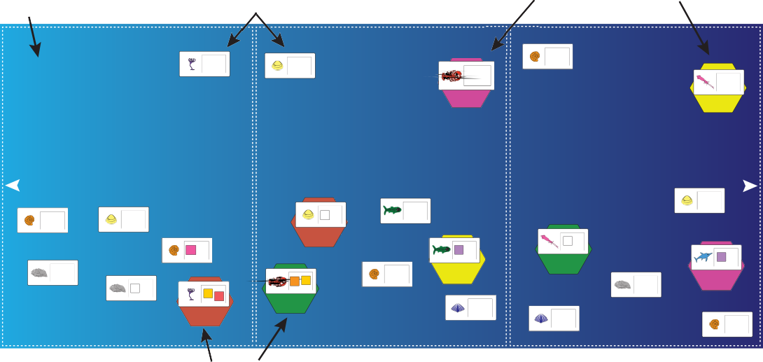
Game board
(marine ramp)
(pristine)
(pristine)
Ammonite
Crinoid
Clam
10 points
Lobster
10 points
10 points
Squid
This is where the action happens!
Happy Medium!
20 points
They’ll never find me down here!
30 points
Benefits:
- Protected from acidification
Benefits:
- Partially protected from storm events
- Protected from acidification
GPS Tracker Player 4
Benefits:
- Anoxia can protect your fossil
- Protected from storm events
GPS Tracker Player 2
Dangers:
- Tsunamis can uncover and disarticulate your Dangers: Dangers:
specimen - Tsunamis can uncover and disarticulate your - Acidification can dissolve your carbonate shell
- Storms can uncover and disarticulate your specimen - Tsunamis can uncover your specimen specimen - Erosion can uncover your specimen - Erosion can uncover your specimen
- Erosion can uncover your specimen - Decay of soft tissues - Decay of soft tissues
- Decay of soft tissues - Remineralization can affect your specimen - Remineralization can affect your specimen
- Remineralization can affect your specimen (shell and bone) (shell and bone)
(shell and bone) Clam
Fish
Clam
10 points
Ammonite
Clam
E
20 points
10 points
10 points
10 points
Squid
Ammonite
GPS Tracker Player 3
BUR
Fish
BIO
STL
30 points
Ichthyosaur
10 points
20 points
STL
Oyster
GPS Tracker Player 1
30 points
Ammonite
Lobster
10 points
GPS Tracker Player 2
Oyster
10 points
Oyster
E BUR
GPS Tracker Player 4
DIS
Crinoid
20 points
10 points
10 points
BUR
DIS
10 points
GPS Tracker Player 1
Brachiopod
Brachiopod
GPS Tracker Player 3
10 points
Ammonite
10 points
SHALLOW RAMP
INTERMEDIATE DEPTHS
DEEP BASIN
10 points
DEEP BASIN
INTERMEDIATE DEPTHS
SHALLOW RAMP
Untagged organisms
GPS tagged organisms

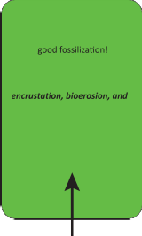
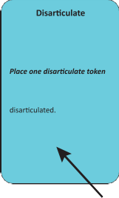
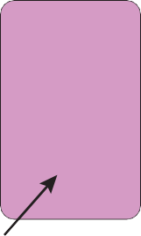

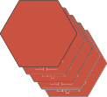

Anoxia
Oxygen levels drop in the Deep Basin Environment, favoring

With no oxygen, the organisms are safe from decay,
being scavenged or eaten for the next 2 rounds (i.e., for the next 2 rounds none of those cards will aﬀect the organisms in the Deep Basin).

Some pesky lobster came along and tore your organism apart!

on an organism OR remove an encruster. Squids, ammonites, and brachiopods cannot be
This card cannot be played on a buried organism.
Collaborate
Let’s work together!

Collect another player’s GPS tagged fossil but you both get the full points from that specimen.
BUR
CM
DIS
E
RM
STL
BUR
BUR
BUR
BUR
DIS
E
DIS
E
RM
BIO
STL

GPS Tracker PGlaPySeTrr3acker
PGlaPySeTrr3acker PGlaPySeTrr3acker
PGlaPySeTrr3acker Player 3

GPS Tracker PGlaPySeTrr4acker
PGlaPySeTrr4acker PGlaPySeTrr4acker
PGlaPySeTrr4acker Player 4
Discovery Cards
Environmental
Event Cards
Taphonomy Cards
Taphonomy Cards
Discovery Cards
Environmental
Event Cards
Taphonomy Cards
Environmental
Event Cards
Discovery Cards
Environmental
Event Cards
Discovery Cards
Taphonomy Cards

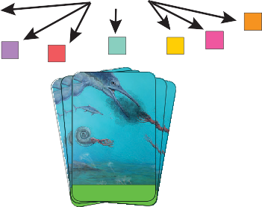
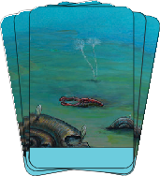
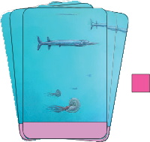
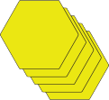
GPS tagged organisms (buried & modified)
Tokens
CM
E
BIO
STL
RM
BUR
DIS
CM
STL
BUR
BUR
E
BUR
CM
BIO
BUR
Environmental Event Cards
BUR

Taphonomy Cards
BIO
Discovery Cards
E
BUR

GPS Tracker PGlaPySeTrr2acker
PGlaPySeTrr2acker PGlaPySeTrr2acker
PGlaPySeTrr2acker Player 2
LAND
OPEN OCEAN


GPS Tracker PGlaPySeTrr1acker
PGlaPySeTrr1acker PGlaPySeTrr1acker
PGlaPySeTrr1acker Player 1
RM
BUR
DIS
BUR

GPS Trackers Playing Cards (Taphonomy, Enviromental Event, and Discovery card packs)

GAMEPLAY

Introduction: You are a paleontological time traveller whose mission is to create the best fossil collection for your Institution’s Museum collection.
- You are traveling back to the Early Jurassic with 10 GPS trackers.
- Your mission is to tag desired organisms and do everything you can to protect your specimens from factors that would reduce their chances of becoming preserved in the fossil record. These are known as taphonomic factors.
- When you are back in the present, you have to go find your specimens and build your collection. Watch out for other time travelling paleontologists who might want to steal your specimens!

The Set Up (4 players)
- Each player gets 10 GPS trackers of a particular color and 1 lobster, 1 crinoid, 1 vampire squid, 1 brachiopod, and 1 ammonite.
- The rest of the organisms are placed on the board as indicated by the “Board at the Start of the Game” figure. Note that the number of organisms in play will change depending on the number of players (i.e., 4 Players = 60 organisms, 3 Players = 55 organisms, 2 Players = 50 organisms).

The Board at the Start of the Game


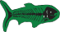 Fish (1x)
Crinoid (1x)  Ammonite (2x)  Oyster (5x)  Clam (4x)
Brachiopod (2x)
 Ichthyosaur (1x) 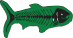 Fish (1x)  Lobster (1x)  Ammonite (2x)
 Oyster (5x)  Clam (3x)

Brachiopod (2x)

 Ichthyosaur (1x) 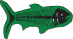 Fish (1x)
Vampire Squid (1x)
 Ammonite (2x)  Clam (3x)
Brachiopod (2x)

Each Player gets: 1 lobster, 1 crinoid, 1 vampire squid, 1 brachiopod, and 1 ammonite.
Tag organisms with their GPS trackers and place them on the board in one of the 3 Environments (Shallow Ramp, Intermediate Depths, or Deep Basin)

First Era - Early Jurassic, Setting up your fossil specimens!
- Tag your specimens with your GPS trackers and assign them to a marine environment (Shallow Ramp, Intermediate Depths, or Deep Basin). Think of this as drafting your team.
- When you place each specimen, roll the dice (or use a random number generator: 1-6) and consult the “Possible Ways to Die” box to see how your creature died. In this round order doesn’t matter, so whenever you are ready to kill and place your organisms, go for it! If your organism is lost to the fossil record in their death, you DO NOT get your GPS tracker back.
- If you are playing with 4 people, there are 60 organisms total; untagged fossils may be able to be collected in the last Era of the game.

RM Remineralized
E Encrusted
BIO Bioeroded
Possible Ways to Die
*Roll a die (or random number generator) to see how your organism dies.
- Delicately Eaten - Your organism became someone's lunch, but they were a picky eater!
  - Place one soft tissue lost token on your organism (if applicable).
- Eaten and Digested - Your organism got digested and pooped out! This process removes soft tissue and disarticulates the specimen but skeletons and shells survive.
  - Place one disarticulate token AND one soft tissue lost token on your organism (if applicable).
  - Squids and lobsters are removed from board (lost from the fossil record).
- Peaceful Death - Your organism dies of old age and falls to the seaﬂoor
  - No alteration of specimen.
- Attacked - Your organism got in a ﬁght and was ripped in half (disarticulated)!
  - Place one disarticulate token on your organism (if applicable).
- Anoxia - The waters have lost all their oxygen, your organism dies and falls to the seaﬂoor.
  - No alteration of specimen.
- Thermal stress - It’s getting hot in here! Your organism dies of heat exposure.
  - No alteration of specimen.
*** A disarticulated fossil or a fossil without soft tissue is worth less points in the ﬁnal tally. ***
Tokens

BUR Burial

CM Cast/Mold only

DIS Disarticulated

STL Soft Tissue Lost

DANGERS BY ENVIRONMENT

LAND
OPEN OCEAN ->
<- LANDLAND
SHALLOW RAMP INTERMEDIATE DEPTHS DEEP BASIN
Anoxia
Tsunamis
Acidification
Storms
Erosion
Decay
Remineralization

Second Era - Early Jurassic: Protect your fossils from taphonomic factors!
- Each player starts this Era with a hand of 5 cards from a shuffled deck of “taphonomy” cards and 2 “burial” tokens. Players will “restock” their cards and receive two “burial” tokens at the beginning of each turn.
- The youngest player starts and then play proceeds around the table clockwise.
- Each player MUST PLAY 3 ACTIONS each turn (actions include placing a burial token or playing a card from their hand). When a card is played, put it in a discard pile. When there are no more cards to draw, shuffle and use the discard pile.
- Actions can be played on ANY ORGANISM ON THE BOARD (e.g., your organisms or someone else’s organisms).
- There is no limit to the number of burial tokens that can be placed on an organism, but this may become detrimental to discovering the specimen in the Final Era.
- Any player can sacrifice their turn (all three actions) to get a new hand of cards. In other words, you can discard all 5 cards and pick up 5 new cards, but you don’t get to play that round.
- At the end of the round (i.e., once each player has taken a turn) an “environmental event” card is drawn from a shuffled deck; these apply to EVERY SPECIMEN on the board but will have specific instructions about what organisms or environments are affected.
- The second Era consists of TWO Environmental Events (i.e., two rounds of play).

*After TWO Environmental Events, PAUSE PLAY. Each player holds on to their cards and tokens because they will be used again in the Fourth Era!

Third Era - Early Jurassic: Adopt some additional fossils!
- On the board there are numerous organism corpses that are “untagged” (i.e., they have no GPS tracker).
- Use your remaining 5 GPS trackers to “adopt” these specimens (going around the table, adopting one specimen at a time). Each person gets to adopt one animal on each turn, until the remaining (5) GPS trackers are used up.
- Specimens must be adopted “as-is” (i.e., they REMAIN IN THEIR CURRENT ENVIRONMENT with all of their tokens).
- Play will go in the same direction, clockwise, but shifts one player to the left (i.e., the person who went second, now goes first).
- Pro Tip: Check out the point value of the different organisms!

Fourth Era - Early Jurassic: Protect your fossils from taphonomic factors!
- This Era is played exactly as the Second Era but play shifts one player to the left (the order of players still goes clockwise).

Last Era - Present Day: Find your fossils!
- Back to the Future! Each player starts this Era with a hand of 5 cards from a shuffled deck of “discovery” cards. Players will “restock” their cards at the beginning of each turn.
- Play shifts one player to the left (the order of play still goes clockwise). If you are playing with 4 people, this should mean that each person has been first and last.
- Each player MUST PLAY 3 ACTIONS (i.e., cards) each turn.
- Note: Unless a “Fossils not exposed” card is played, specimens do not need to be “Quarried” before they are collected.
- Any 2 cards can be played together to collect an untagged fossil, or a GPS tagged fossil that belongs to the player. THIS COUNTS AS 2 CARDS/ACTIONS PLAYED.
- Any player can sacrifice their turn (all three actions) to get a new hand of cards. In other words, you can discard all 5 cards and pick up five new cards, but you don’t get to play that round.
- This Era proceeds until all tagged organisms have been found.
- After all the GPS tagged organisms have been found, a final round is played in case players have the cards to discover additional untagged fossils or steal fossils.

How do you Win the game?
- Take your fossil collection and tally all the points from your specimens (see score card). The Highest point collection wins.
- Rare fossils are worth more (but they are rare for a reason!)
- Damaged fossils lose points and you can get bonus points for a diverse fossil collection.

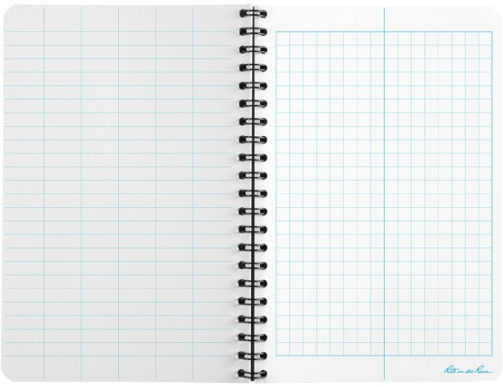

Score Card
Add the animals and their tokens to your score
card as you collect them in the Discovery Era.

Bonus Points:
Highest diversity (most different types of taxa including encrusters) = +6 points
Most fossils total, including encrusters = +6 points Highest number of fossils with soft tissue = +6 points Specialist (5+ specimens of one fossil type) = +10 points

Copyright © 2018 The Board of Regents of The University of Texas System
6
Animal | Base  Points | Encrusted  + 5 pts | Bioeroded  - 2 pts | Cast/Mold Soft Tissue  - 5 pts Lost - 5 pts | Disarticulated  - 2 pts | Remineralized  - 2 pts | Total  Points
ex:  Clam | 10 |  | - 2 | - 5 |  |  | 3
*A fossil is never worth negative points; the minimum a fossil is worth = 2 points

ORGANISM CHARACTERISTICS
Ichthyosaur: Vertebrate animal. Body is made up of soft tissues and bone. This organism can be disarticulated and remineralized but will not be affected by ocean acidification.
Fish: Vertebrate animal. Body is made up of soft tissues and bone. This organism can be disarticulated and remineralized but will not be affected by ocean acidification.
Lobster: Invertebrate animal. Body is made up of soft tissues and an exoskeleton. This organism can be disarticulated and remineralized but will not be affected by ocean acidification.
Crinoid: Invertebrate animal. Body is made up of minimal soft tissues (specimen does not lose points for losing soft tissue) and a skeleton made of calcite (a carbonate mineral). This organism can be disarticulated and affected by ocean acidification but does not remineralize.
Vampire Squid: Invertebrate animal. Body is made up of soft tissues. This organism cannot be disarticulated, remineralized, or affected by ocean acidification.
Ammonite: Invertebrate animal. Body is made up of soft tissues and a skeleton made of aragonite (a carbonate mineral). This organism can be remineralized and affected by ocean acidification but does not disarticulate.
Oyster: Invertebrate animal. Body is made up of soft tissues and a skeleton made of calcite (a carbonate mineral). This organism can be disarticulated and affected by ocean acidification but does not remineralize.
Clam: Invertebrate animal. Body is made up of soft tissues and a skeleton made of aragonite (a carbonate mineral). This organism can be disarticulated, remineralized, and affected by ocean acidification.
Brachiopod: Invertebrate animal. Body is made up minimal soft tissues (specimen does not lose points for losing soft tissue) and a skeleton made of calcite (a carbonate mineral). This organism can be affected by ocean acidification but does not get disarticulated or remineralized.
TWO episodes of sof t tissue loss OR TWO disarticulations = loss from the fossil record (Remove organism and GPS tracker from board)

Organism | Point Value | Tokens that Apply
Ichthyosaur   | 30 pts  (2 in play) | RM | STL BIO |  | DIS |  | E |  | BUR
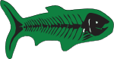  Fish | 20 pts  (3 in play) | RM | STL BIO |  | DIS |  | E |  | BUR
Lobster  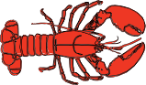 | 20 pts  (5 in play) | RM | STL BIO |  | DIS |  | E |  | BUR
Crinoid   | 10 pts  (5 in play) | CM | BIO | DIS |  | E |  |  | BUR
Vampire Squid | 30 pts  (5 in play) | STL |  |  |  |  |  |  | BUR
Ammonite  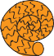 | 10 pts  (10 in play) | CM | RM STL |  | BIO |  | E |  | BUR
Oyster  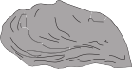 | 10 pts  (10 in play) | CM | STL BIO |  | DIS |  | E |  | BUR
  Clam | 10 pts  (10 in play) | CM | RM STL | BIO | DIS |  |  | E | BUR
Brachiopod   | 10 pts  (10 in play) | CM | BIO |  | E |  |  |  | BUR
TWO episodes of soft tissue loss OR TWO disarticulations = loss from the fossil record

POSSIBLE WAYS TO DIE (First Era)

- Roll a die to see how your organism dies
- If you don’t have dice, use a random number generator (1-6)
- In this round order doesn’t matter, so whenever you are ready to kill and place your organisms, go for it!
- If your organism is lost to the fossil record in their death, you DO NOT get your GPS tracker back.
- Delicately Eaten - Your organism became someone’s lunch, but they were a picky eater! Remove soft tissue (if applicable) only.
  - Place one soft tissue lost token on your organism.
- Eaten and Digested - Your organism got digested and pooped out! This process removes soft tissue and disarticulates the specimen, but skeletons and shells survive.
  - Place one disarticulate token AND one soft tissue lost token on your organism (if applicable).
  - Squids and lobsters are completely removed from board (lost from the fossil record).
- Peaceful Death - Your organism dies of old age and falls to the seafloor
  - No alteration of specimen.
- Attacked - Your organism got in a fight and was ripped in half (disarticulated)!
  - Place one disarticulate token on your organism (if applicable).
- Anoxia - The waters have lost all their oxygen; your organism dies and falls to the seafloor.
  - No alteration of specimen.
- Thermal stress - It’s getting hot in here! Your organism dies of heat exposure.
  - No alteration of specimen.

Remember: A disarticulated fossil or a fossil without soft tissue is worth less points in the final tally.
TWO episodes of sof t tissue loss OR TWO disarticulations = loss from the fossil record (Remove organism and GPS tracker from board)

TAPHONOMY CARDS (Second and Fourth Eras)

- Each player has a hand of 5 cards + 2 burial tokens, at the start of the round, each player refills their hand and gets 2 burial tokens
- A turn is composed of 3 actions
- Cards can be played on ANY ORGANISM on the board.
- When the draw pile is depleted, shuffle the discard pile and draw from it.
Disarticulate (20 Cards) - Some pesky lobster came along and tore your organism apart! Place one disarticulate token on an organism OR remove an encruster. Squids, ammonites, and brachiopods cannot be disarticulated. This card cannot be played on a buried organism.
Scavenge (20 Cards) - Some hungry fish came along and munched your organism, removing the soft tissue and disarticulating it. Place one disarticulate token and one soft tissue lost token on an organism, card cannot be played on a buried organism. Squids, ammonites, and brachiopods cannot be disarticulated; brachiopods and crinoids are not affected by soft tissue loss.
Burial (12 Cards) - An obrution event covers up your organism, protecting it from being eaten, scavenged, disarticulated, encrusted, and bioeroded. Multiple layers of burial can protect your fossil, but watch out, too much burial may inhibit discovery later on in the game. Place one burial token on an organism.
Decay (20 Cards) - Microbes attack and decay your organism’s soft tissues and exoskeleton (bones and shells are unaffected). Place one soft tissue lost token on an organism; card cannot be played on a buried organism. Brachiopods and crinoids are not affected by soft tissue loss.
Encrustation (8 Cards) - This little bryozoan wanted to piggyback and encrusted an organism’s hard parts (squid are immune). Place one encrusted token on an organism, card cannot be played on a buried organism. An encrusted fossil is worth more points in the final tally (the encruster counts as an additional organism). Encrustation can be removed by disarticulation or bioerosion.

Bioerosion (8 Cards) - Some sponge came along and drilled holes in your organism’s hard parts (squid are immune). Place one bioeroded token on an organism OR remove an encruster, card cannot be played on a buried organism. A bioeroded fossil is worth less points in the final tally.
Transport (12 Cards) - A soft current transports ONE of your organisms ONE environment deeper, but that organism is not disarticulated. This card cannot be played on a buried organism.
Fast Sedimentation (8 Cards) - Sedimentation rates speed up! Get a second turn (or make someone else take a second turn). Refill your hand (cards and burial tokens) before taking your second turn.
  - Remember: 1 turn = 3 actions

Slow Sedimentation (8 Cards) - Sedimentation rates slow down! Skip the rest of your turn (or make someone else skip theirs).
  - Remember: 1 turn = 3 actions
Acid Bomb (8 Cards) - Bombs away! A beaker full of acid is dropped on the ocean floor (i.e., identify a spot anywhere on the board). The pH drops in that area and acidic waters start to eat away at the FOUR CLOSEST ORGANISMS (regardless of whether or not they are affected). If they are a carbonate organism with no burial tokens, they are dissolved but leave a cast (place a cast/mold only token on these organisms). A burial token keeps you safe from the acid bomb (no alteration of organisms with 1 or more burial tokens) and non-carbonate organisms are unaffected.

Remineralization Bomb (8 Cards) - Bombs away! A beaker full of hot, diagenetic fluids is dropped on the ocean floor (i.e., identify a spot anywhere on the board). The chemistry of that area changes and affects the FOUR CLOSEST ORGANISMS (regardless of whether or not they are affected). Organisms with bones or a shell made of aragonite are remineralized, place one remineralized token on each affected organism. Burial tokens do not protect you!

Remember: A disarticulated fossil or a fossil without soft tissue is worth less points in the final tally.
TWO episodes of sof t tissue loss OR TWO disarticulations = loss from the fossil record (Remove organism and GPS tracker from board)

ENVIRONMENTAL EVENT CARDS (Second and Fourth Eras)

- One card played at the end of each round.
- The impacts of the event cards apply to all organisms on the board.
Anoxia (1 Card) - Oxygen levels drop in the Deep Basin Environment, favoring good fossilization! With no oxygen, the organisms are safe from decay, encrustation, bioerosion, and being scavenged or eaten for the next two rounds (i.e., for the next 2 rounds none of those cards will affect the organisms in the Deep Basin).
Acidification (1 Card) - Ocean pH drops and waters in the Deep Basin Environment start to eat away at carbonate organisms. Carbonate organisms with one burial token are dissolved but leave a cast (place a cast/mold only token on these organisms); those with 2 burial tokens are safe. If carbonate organisms are not buried, they are lost to the fossil record (i.e., remove the fossil and GPS tracker from the board); non carbonate organisms are unaffected.
Storm Event (2 Cards) - Look out, there’s a nasty storm! All organisms in the Shallow Ramp are moved one environment deeper AND disarticulated; all organisms at Intermediate Depths are moved one environment deeper ONLY. One burial token can prevent movement OR disarticulation (remove burial token); 2 burial tokens protect the organism from the storm completely (remove one burial token). If an organism is not buried and already disarticulated, they are lost to the fossil record (i.e., remove the fossil from the board).
  - FIRST: Place the disarticulation tokens on the affected organisms and remove any organisms that are lost from the fossil record.
  - SECOND: Remove the appropriate burial tokens.
  - FINALLY: Move the organisms to their new environment (unless protected by burial).

Tsunami (1 Card) - The Earth quakes and there’s a massive tsunami! All organisms in the Shallow Ramp and at Intermediate Depths are moved one environment deeper and disarticulated. All organisms in All Environments lose one burial token. 2 burial tokens DO NOT protect an organism. If an organism is not buried and already disarticulated, they are lost to the fossil record (i.e., remove the fossil and GPS tracker from the board).
- FIRST: Place the disarticulation tokens on the affected organisms and remove any organisms that are lost from the fossil record.
- SECOND: Remove the appropriate burial tokens.
- FINALLY: Move the organisms to their new environment.
Remineralization (2 Cards) - Diagenetic fluids are flowing through the sediment! Organisms with bones or a shell made of aragonite in All Environments are remineralized, place one remineralized token on each affected organism.
Erosion (3 Cards) - Currents are on the move! All organisms lose one burial token. If an organism is not buried, it is either disarticulated or loses soft tissue (player’s choice).

Decay (3 Cards) - Microbial attack! Microbes come and eat all the soft tissue from organisms in All Environments; bones, exoskeletons, and shells are unaffected. One burial token prevents decay; place one soft tissue lost token on all affected organisms.
Calm Seas (2 Cards) - Continue playing, no environmental disasters today!
Remember: A disarticulated fossil or a fossil without soft tissue is worth less points in the final tally.
TWO episodes of sof t tissue loss OR TWO disarticulations = loss from the fossil record (Remove organism and GPS tracker from board)

DISCOVERY CARDS (Final Era)

- Each player has a hand of 5 cards; at the start of the round, each player refills their hand.
- 3 cards MUST BE played each turn.
- Follow the directions on the card as to what organism(s) the card can be played on.
- Any 2 cards can be played together to collect an untagged fossil, or a GPS tagged fossil that belongs to the player (you cannot steal someone else’s tagged fossils). THIS COUNTS AS 2 CARDS/ACTIONS PLAYED.
- Unless a “Fossils not exposed” card is played, specimens do not need to be “Quarried” before they are collected.
- When a fossil is collected, take note of the organism type, damage, etc. on the “Score Card”; this makes addition and collaboration much easier.
Discover (6 Cards) - Long Weekend, yay! You find some time to go and do field work. Collect one of your GPS tagged fossils.
Discover (6 Cards) - Your local fossil hunting group wants to help you collect fossils, so you take them to your field site. Collect one of your GPS tagged fossils.
Discover (6 Cards) - A student wants to learn how to collect fossils, so you take them to your field site. Collect one of your GPS tagged fossils.
Discovery Mark (4 Cards) - Oh no! When you went to collect your specimen, you chipped it with you rock hammer! Collect one of your GPS tagged specimens but lose 2 points (-2).
Teaching Fail! (4 Cards) - You go to show a group of Girl and Boy Scouts how to collect a fossil, but the specimen breaks apart in your hand as you collect it! Collect one of your GPS tagged specimens or an untagged specimen but lose 2 points (-2)
Inspire the Youth! (3 Cards) – A high school group wants to learn about fossils, so you take them fossil hunting. Great news, they are really good at finding fossils! Collect two untagged fossils.
Win a Grant (3 Cards) - Congratulations, you got a grant! Collect 2 fossils (untagged fossils can also be collected); with this card, you cannot steal tagged fossils or fossils that have already been collected.
GPS tracker lost (5 Cards) - Someone (not saying who) lost the GPS tracker information! One of the fossils is now “untagged” (i.e., remove the GPS tracker) and now anyone with the right card could collect it on their turn!
Steal (2 Cards) - You thief! Steal a fossil that has a GPS tracker (on the board) or an untagged fossil. Play 2 steal cards to steal a fossil that has already been collected by someone else.

Collaborate (5 Cards) - Let’s work together! Collect another player’s GPS tagged fossil but you
both get the full points from that specimen.
  - If the players collaborating have spare GPS trackers, you can place them both under the specimen in your collection area. Alternatively, just make a note of the collaboration on the “Score Card”.
Fossils not exposed (3 Cards) - All organisms with a burial token are not exposed and so no one can collect them. This applies to all organisms on the board at the time of play (collected fossils are safe). This card lasts for the rest of the Era or until someone plays another “Fossil not Exposed” card.
Quarry (5 Cards) - Spend some time digging for fossils! Use this card to uncover an organism (i.e., remove one burial token). This card is not a discovery card but allows you to uncover an organism that has been buried.

NOTE: After all the GPS tagged organisms have been found, a final round is played in case players have the cards to discover additional untagged fossils or steal fossils.

SCORE CARD

- Tally the points from your collection, the highest score wins.
- For shared specimens (i.e., collaborations) all points, encrusters, damage etc. go to both players. Functionally, both players have an identical specimen.

Regular Points
- Ichthyosaur = 30 points
- Vampire Squid = 30 points
- Fish = 20 points
- Lobster = 20 points
- Crinoid = 10 points
- Ammonite = 10 points
- Clam = 10 points
- Oyster = 10 points
- Brachiopod = 10 points
- An encrusted specimen has an extra fossil (+1 for diversity), this encruster is worth 5 points. More than 1 encruster, will count for an additional 5 points but NOT for additional diversity (i.e., 1 encruster = +1 diversity and 5 points; 3 encrusters = +1 diversity and 15 points)
- If a fossil:
  - Is disarticulated = -2 points
  - Has lost its soft tissue = -5 points
  - Is damaged (bioeroded, remineralized) = -2 points (for each token)
  - Is only a cast/mold = -5 points
*A fossil is never worth negative points; the minimum a fossil is worth = 2 points

Bonus Points (if there is a tie, split points)
- Highest diversity collection: most different types of taxa including encrusters (you got the best representation of fossil diversity) = +6 points
- Most fossils total, including encrusters = +6 points
- Highest number of fossils with soft tissue = +6 points
- Specialist collection (5 or more specimens of one type of fossil) = +10 points

TERMINOLOGY USED (alphabetical)

Ammonite – an extinct invertebrate animal (a marine mollusk) that is related to living octopuses and squid; they look similar to the living Nautilus.
Aquatic – an organism that grows or lives in water.
Aragonite – a mineral composed of calcium carbonate; many organisms make their shells or skeletons out of this mineral. Aragonite has a different crystal shape than calcite and so acts differently.
Bioerosion – the breakdown of hard surfaces (shells, skeletons, and rocks) caused by living organisms.
Brachiopod – an aquatic invertebrate animal with hard shells on the upper and lower surfaces.
These can often look like clams at first, but their shell structure and internal body are quite different.
Bryozoan – small aquatic invertebrate animals that typically live in a colony. They are filter feeders that sieve food particles out of the water.
Calcite – a mineral composed of calcium carbonate; many organisms make their shells or skeletons out of this mineral. Calcite has a different crystal shape than aragonite and so acts differently.
Carbonate organism – an animal, plant, or single-celled life form that makes a structure (e.g., shell or skeleton) out of a carbonate mineral (e.g., calcite or aragonite).
Crinoid – marine invertebrate animals related to starfish and sand dollars.
Decay – to rot or decompose through the action of microbial organisms.
Diagenetic fluids – Fluids (e.g., waters) that cause a change in sediments (e.g., sand, mud, and gravel), minerals, shells, and rocks during and after becoming a rock (lithification).
Disarticulate – break apart or separate (usually bones, shells, or skeletons).
Encrustation – an organism that attaches to the surface of something forming a hard crust.
Erosion – the gradual destruction of something by physical or chemical action. In geology, erosion is the action that moves sediments (sand, mud, pebbles, etc.), rock, or dissolved material from one location to another location.
Fossil – the remains or impression of a prehistoric organism preserved in petrified form or as a mold or cast in rock.
Fossilization – (the process of) becoming a fossil (i.e., becoming fossilized).
Ichthyosaur – an extinct vertebrate animal that looks like a dolphin but is actually a large marine reptile.
Invertebrate – an animal that does not have (or has never developed) a vertebral column (e.g., a spinal cord or backbone). Examples include lobsters, crinoids, vampire squid, ammonites, clams, oysters, and brachiopods.

Marine – an organism that grows or lives in the ocean.
Microbe – a microscopic organism. In the game, the microbe breaks down the tissues of the organisms you are trying to fossilize during decay.
Microbial – relating to or characteristic of a microscopic organism.
Mineral – a naturally occurring chemical compound that has a crystal form.
Obrution – a rapid burial event
Organism – an individual animal, plant, or single-celled life form.
Remineralize – Under temperature and pressure atoms in a mineral are reorganized to form a new mineral.
Scavenge – seek out and consume dead organisms or tissues.
Sediments – sediments (e.g., sand, mud, and gravel)
(Soft) Tissue – the muscle, flesh, organs, and other tissues that are found in the body.
Taphonomy – the study of the transition (in all its details) of the remains of organisms from the biosphere into the lithosphere (i.e., from a living organism to a fossil).
Taphonomic factors – Conditions that alter an organism’s corpse between death and discovery, and affect its chance of being preserved in the fossil record (i.e., fossilized).
Tsunami – a long, high sea wave caused by an earthquake, submarine landslide, or other distur- bance.
Vampire squid – a small squid-like marine invertebrate animal.
Vertebrate – an animal that has (or has at some point developed) a vertebral column (e.g., a spinal cord or backbone). Examples include ichthyosaurs, fish, and humans.

BACKGROUND ON THE FOSSIL SITE
- If you want to include a reading about the actual fossil site this is based on, the Geology paper is pretty approachable and short (and also open access): A new Early Jurassic fossil Lagerstätte from Ya Ha Tinda, Canada (~183 Ma) (click title for hyperlink).
- If you want something a bit more approachable for new geologists, there are also several options for short news articles about the paper (click for hyperlinks): the Jackson School at UT Austin (with a little facebook video), The Calgary Herald, The International Business Times.
- Dr. Martindale gave a 1-hour public talk about the site at the Royal Tyrrell Museum of Paleontology; the recording of that can be found here: https://youtu.be/YU7JYdoinTA.
- A podcast about the game (from GSA 2018) can be found here: www.geosociety.org/ GSA/News/intern/GSA/News/sci-comm-intern.aspx

RESOURCES FOR FOSSIL ENTHUSIASTS
- The Paleontological Society: www.paleosoc.org
  - PaleoSoc Educational Material: https://www.paleosoc.org/educators/ educational-resources/
  - Connect with a local expert through the Paleontological Society: www.paleosoc. org/educators/regional-resource-people/
- Society of Vertebrate Paleontology: http://vertpaleo.org/
- Find rocks in your back yard with the Rock’d app (https://rockd.org/) or Macrostrat https://macrostrat.org/
- Skype a scientist (have your classroom connect with a scientist around the world): www. skypeascientist.com/
- PaleoPortal: http://www.paleoportal.org/
  - Want a Career in Paleo? Check out: http://paleoportal.org/index. php?globalnav=doing_paleo&sectionnav=careers&type_id=6
- Paleobiology Database: https://paleobiodb.org/#/
- HHMI’s Biointeractive: https://www.biointeractive.org/
  - Earthviewer: www.biointeractive.org/classroom-resources/earthviewer
- Jackson School Museum of Earth History
- Vertebrate Paleo Lab: www.jsg.utexas.edu/vpl/
- NonVertebrate Paleo Lab: www.jsg.utexas.edu/npl/
- UT Austin Outreach Resources: www.jsg.utexas.edu/npl/outreach/
- Fossils of Texas: www.txfossils.com
- Cincinnati Dry Dredgers: http://drydredgers.org/

All material for the game can be found at: https://doi.org/10.18738/T8/NQV2CU
A short (10 min) video about how to play the game can be found here: https://youtu.be/FnJae8uMN9Y

