TITLE: TITLE

by

ARLO BRANDON WEIL

A Senior Thesis submitted in partial fulfillment
of the requirements for the degree of
Bachelors of Arts
(Geology)
at Bryn Mawr College
2011

Thesis Adviser(s):
So and so

Dedicated to the memory of Ann Elizabeth Lea and Rolf Weil

ACKNOWLEDGMENTS
I would like to thank ………..
TABLE OF CONTENTS
dedication iii
ACKNOWLEDGMENTS iv
LIST OF FIGURES viii
LIST OF TABLES xii
LIST OF APPENDICES xiii
CHAPTER
- INTRODUCTION 1
References 18
- INSIGHTS INTO THE MECHANISM FOR OROGEN RELATED CARBONATE REMAGNETIZATION FROM GROWTH OF AUTHIGENIC Fe-OXIDE: A SEM AND ROCK MAGNETIC STUDY OF DEVONIAN CARBONATES FROM NORTHERN SPAIN 22
abstract 22
introduction 24
GEOLOGIC AND PALEOMAGNETIC BACKGROUND 29

LIST OF Figures
Figure
  - Cantabria-Asturias Arc structural geology map 4
  - Models of Cantabria-Asturias Arc formation 7-8
  - Comparison models of plate dynamics during Pangea amalgamation 12
  - Pangea reconstructions 14
  - Paleomagnetic data from Laurussia and Gondwana in a Pangea-A fit 16
  - Remagnetized carbonates associated with the Variscan-Alleghanian orogeny 25
  - Schematic structure map of CAA 28
  - Stereonet of site means and representative fold tests 31
  - Typical orthogonal projections showing remagnetization components held by CAA carbonates 33
  - Typical IRM acquisition curves 40

LIST OF TABLES
Table
2.1 CAA rock magnetic characteristics 35-36
  - Paleomagnetic and structural site information and statistical parameters from the CAA hinge zone 92-93

LIST OF Appendices
Appendix
- THE PROTEROZOIC SUPERCONTINENT RODINIA: PALEOMAGNETICALLY DERIVED RECONSTRUCTIONS F0R 1100 TO 800 MA 193

ABSTRACT 193
INTRODUCTION 195
ASSUMPTIONS AND METHODS 196
A REVIEW OF 1100-800 MA PALEOMAGNETIC DATA 198
LAURENTIA 198
BALTICA 204
CONGO AND SÃO FRANCISCO 206
KALAHARI 210
DISCUSSION 214
REFERENCES 217
B. Oroclines: A review 224

Introduction 224

CHAPTER I

introduction

The existence of several supercontinents has been identified over the Earth’s history, in which a majority of continental masses, or cratons, amalgamated and then stabilized, for a time, with little appreciable internal movement between cratons.

Figures

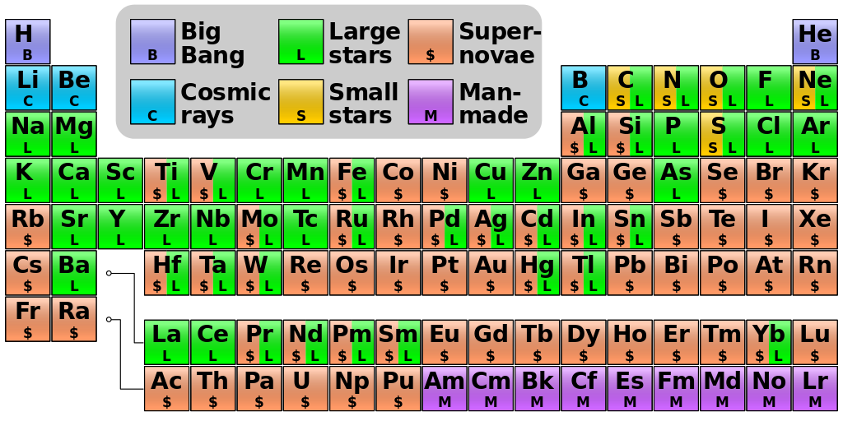
Figure 1. Origin of the elements on the periodic table, showing the important role the star life cycle plays.

Tables
Table 1. Count of upper-mantle xenoliths larger than 5 cm, in 1.5x3 m area
of exposed kimberlite on west side of trench

References
Beck, M., Tectonic rotations on the leading edge of South America: the Bolivian orocline revisited, Geology, 15, 806-808, 1987.

Brun, J.P. and J.P. Burg, Combined thrusting and wrenching in the Ibero-Armorican arc: a corner effect during continental collision, Earth and Planetary Science Letters, 61, 319-332, 1982.

Brun, J.P. and O. Merle, Strain patterns in models of spreading-gliding nappes, Tectonics, 4, 705-719, 1985.

Carey, S. W., 1955. The orocline concept in geotectonics. Proceedings of the Royal Society of Tasmania, 89, 255-288.

Cederquist, D.P., Paleomagnetism of Cambro-Ordovician carbonates from the Pennsylvania Salient: Syn-deformational remagnetizations confirm that folding is younger than most of the oroclinal bending. Masters of Science Thesis, University of Michigan, 1998.

Davis, D., J. Suppe and F.A. Dahlen, Mechanics of fold-and-thrust belts and accretionary wedges, Journal of Geophysical Research, 88, 1153-1172, 1983.

Davy, P.H. and P.R. Cobbold, Experiments on shortening of a 4-layer model of the continental lithosphere, Tectonophysics, 188, 1-25, 1991.

Eldredge, S. and R. Van der Voo, Paleomagnetic study of thrust sheet rotations in the Helena and Wyoming salients of the Northern Rocky Mountains. In: Schmidt, C.J. (ed.) Interaction of the Rocky Mountain Foreland and the Cordilleran thrust belt. Memoir - Geological Society of America. 171, 319-332, 1988.

Eldredge, S., V. Bachtadse and R. Van der Voo, Paleomagnetism and the orocline hypothesis, Tectonophysics, 119, 153-179, 1985.

