Introduction to GIS for Social and Environmental Analysis (CITY201)

Lab 4: Vector Data Model
Purpose of the lab: To introduce the principles of the vector data model and emphasize basic projection transformation, table, and vector data analysis operations.

1. Get Your Data

Using Catalog, delete the following folder from the Cities 201_Data folder in your workspace:

PA_TRI_new

That folder had the data in an ArcINFO coverage format, a format that is no longer supported in ArcGIS Pro. That data has been converted into a geodatabase, so you will need to download the new geodatabase from our Moodle page. The geodatabase plus a PDF file with metadata information is in a folder called “Lab 4 Data” in the Instructions set of our Moodle page. Download the Lab 4 Data folder to your GIS workspace and then Extract the folder as normal. Remember, download the FOLDER, not individual files.

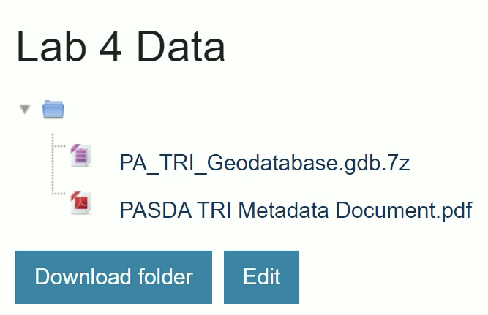

Now you will have to do a second round of extracting files, because the geodatabase had to be compressed before it could be uploaded to Moodle. After you extract the Lab 4 Data folder, the files inside will look like this:

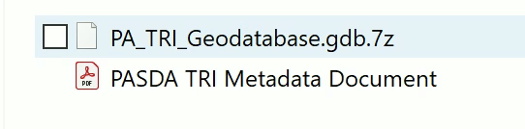

That file with the .7z extension is the compressed geodatabase folder. You must extract that file before you can use it in ArcGIS. Right click on that file name and select ‘7-Zip’ and then ‘Open archive.’
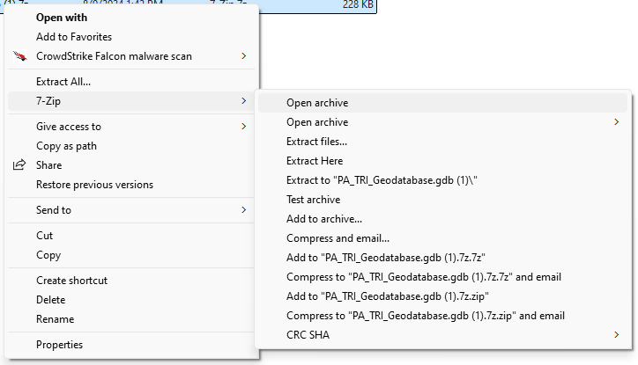

Click the Extact button on this screen, then choose an accessible destination for the extracted files:

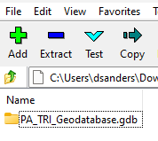

The PA_TRI_Geodatabase has information describing the locations and chemical release data for facilities listed on the Toxic Release Inventory (TRI) in 2022, an EPA-maintained database of facilities releasing toxics into the environment. For more information about this inventory, see: https://www.epa.gov/toxics-release-inventory-tri-program/what-toxics-release-inventory

For the data downloads page where the PA data came from, see:
https://www.epa.gov/toxics-release-inventory-tri-program/tri-basic-data-files-calendar-years-1987-present

Using Catalog again, copy the following shapefile from the Cities 201_Data folder over to your workspace:

Tiger/SEPA_zipcodes_22

2. Explore Your Data

Use your computer’s file explorer (not ArcGIS Catalog) to look in your workspace folder. You can see the zipcodes shapefile, composed of files ending .shp, .shx., .prj and .dbf.

You can also see the folder that comprises the pa_tri_utm geodatabase. Open the folder and see the individual files inside. A file geodatabase is stored as a folder of files. When you view the folder with Windows Explorer, apart from the .gdb extension, it looks like any other folder and you can view its contents. The folder contains cryptically named files that hold geographic data, attribute data, index files, .lock files, and a signature file, as well as other files. Each feature class or table in the geodatabase is stored in two or more files. By design, it is difficult, if not impossible, to tell which files make up any given dataset. You cannot view these files properly without using ESRI software.

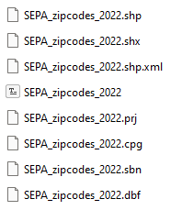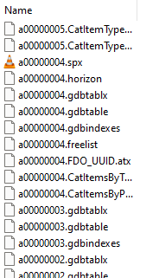

Open ArcGIS and preview the files inside the PA_TRI_Geodatabase in Catalog using both the Geography and Table modes.
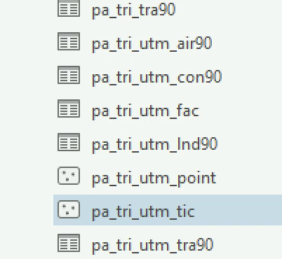
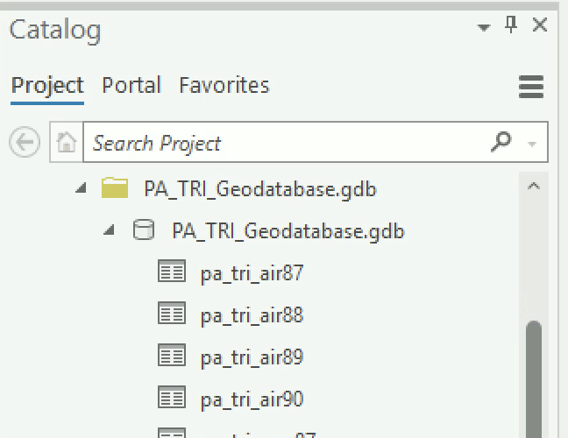

Catalog indicates that there are many tables contained in the folder pa_tri_geodatabase, but when you go to Windows File Explorer and look in the same folder they are not there! This is because these tables are contained in the geodatabase folder, but they cannot be seen directly using Windows File Explorer.

The names of the tables indicate what kind of data they contain. For instance, the table named ‘pa_tri_water22’ contains toxic release information for toxins released in Pennsylvania into water in 2022. The table named ‘pa_tri_stackair22’ contains toxic release information for toxins released from Pennsylvania facilities’ stacks into the air in 2022.

3. Transform Projections

Consider a situation in which we are interested in investigating the distribution of environmental risk associated with TRI facilities in southeast Pennsylvania. We will summarize air and water toxic release data and associate these data with zip codes, say to facilitate grouping people by similar address so that they can be contacted via mass mailings concerning environmental issues.

The first step is to reproject the zip codes data we will use to the UTM coordinate system. The SEPA_zipcodes_2022 shapefile is in geographic projection using NAD83 datum. Use ArcToolbox to reproject the SEPA_zipcodes_2022 shapefile to UTM. Call the new shapefile “SEPA_zipcodes_utm”. This zip codes layer contains all the zip codes that intersect any of the five counties in Southeastern Pennsylvania (Bucks, Chester, Delaware, Montgomery, Philadelphia). After you transform the shapefile’s projection, you will find the UTM file in your project geodatabase. Go back to instructions from Lab 2 if you need a reminder.

The pa_tri_facilities_utm layer is already in UTM so there is no need to transform it.

4. Using Spatial Selection to Eliminate Unwanted Data

The next step is to eliminate the data that is not necessary for the analysis at hand. This reduces processing time.

Insert a New Map to your ArcGIS Project and add the SEPA_zipcodes_utm and pa_tri_facilities_utm layers. To add the pa_tri_facilities_utm layer, you will have to use the Catalog or the Add Data button and navigate into the PA TRI geodatabase to select that individual file (you can’t add the entire geodatabase folder to your map).

Use Select by Location to select only those pa_tri_facilities_utm points that intersect zip codes. Go back to Lab 3 if you need a reminder on using the Select by Location dialogue box.

Use the Data->Export Features option to export only the selected pa_tri_utm points to a new shapefile called ‘sepa_tri_utm’ and add the new shapefile to ArcMap.

Remove pa_tri_facilities_utm from ArcMap. Your map and table of contents should look like something this:

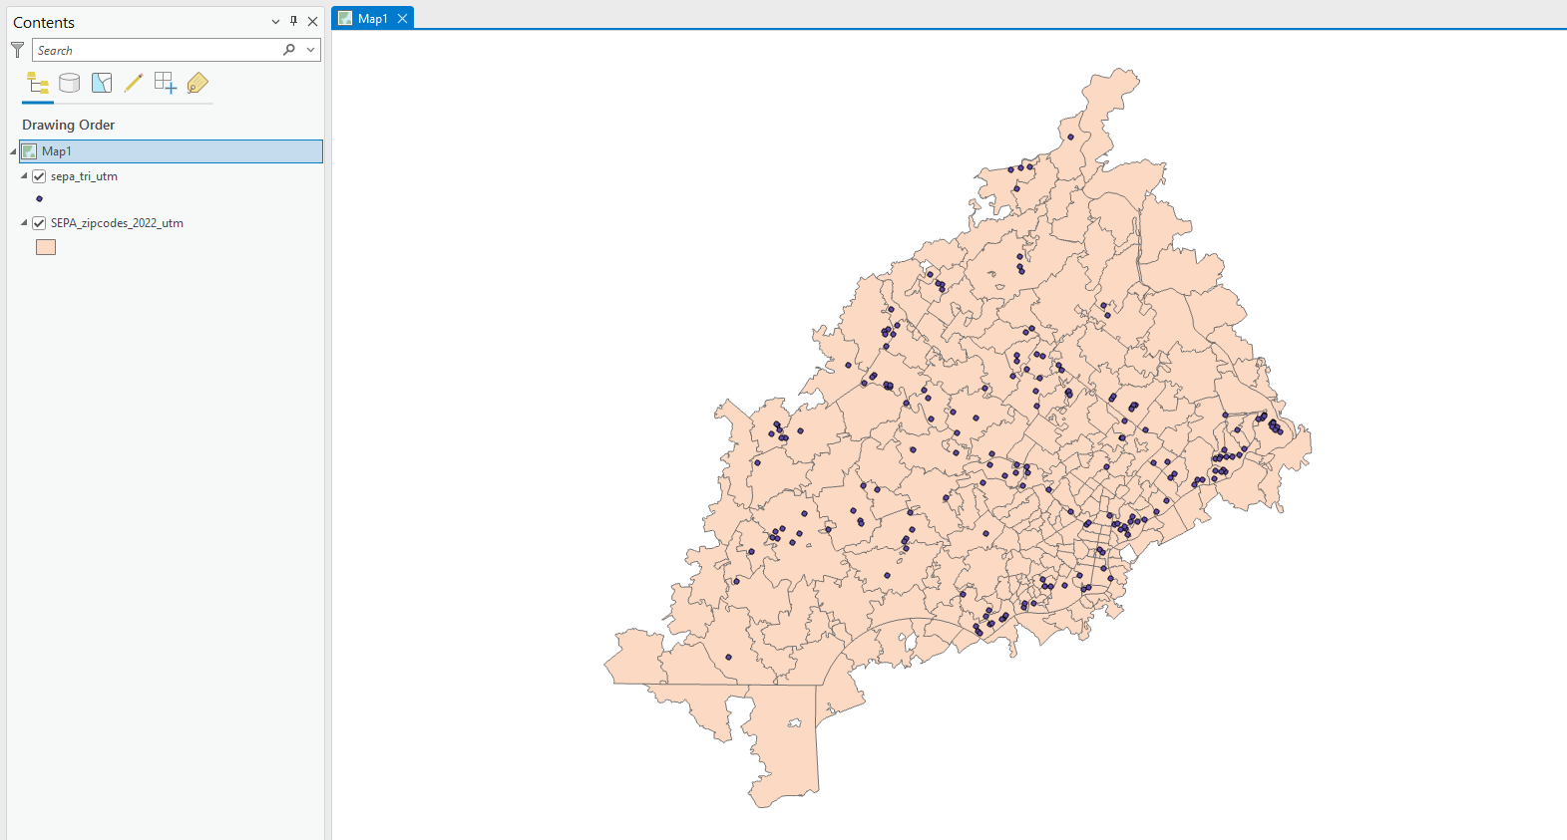

Open the attribute table for sepa_tri_utm – there should be 189 records. Note that the field ‘FRS_ID’ is a unique identifier for each TRI facility.

5. Summarizing One Field by Another: Pounds of Release by Facility

Here, we will summarize the total pounds of air releases for each individual facility.

Add the pa_tri_stackair22 table to ArcMap and open the table. This table contains 2022 data on air releases through TRI facilities’ stacks (as opposed to leaks or other ‘fugitive’ air releases).

Note that there are 3613records, far more than the number of TRI facilities in Pennsylvania. That’s because each record in this table represents an individual chemical released by an individual facility (i.e. one facility may release many different chemicals).

We are interested in the total pounds of release for each facility for all chemicals. To find this information, we need to sum the total pounds for multiple chemicals for each individual facility.

Note that the field ‘FRS_ID’ is a unique identifier for each facility. The field ‘Stack_Air_LbY’ is the ‘estimate of the total quantity (in pounds) of the chemical released as stack (point source) air emissions at the reporting facility’.

Right click on the FRS_ID field name and choose ‘Summarize’.

For each entry field below, enter the values indicated:

- Input Table: pa_tri_utm_air90
- Output Table: air_by_tri
- Statistics Field – Field: STACK-AIR-LBY
- Statistics Field – Statistic Type: Sum
- Case field: FRS_ID
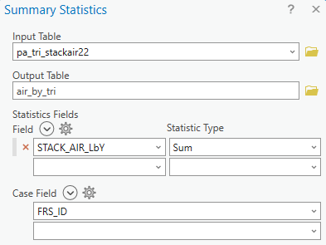
- This is the table ArcGIS will pull data from

- This is the name of the new table ArcGIS will create – it will go in the Project geodatabase

- This is the variable (table column) ArcGIS will use for calculations

- This is the type of calculation ArcGIS will do – click on the drop down menu to see other options

- This is the field that ArcGIS will use to group the calculations

SO, with these settings, ArcGIS will do the following: for each value in the FRS_ID field, ArcGIS will calculate a total sum (adding up) of all the values in the STACK_AIR_LbY field, giving us the total pounds of air releases by stack for each TRI facility.

Press OK. The new table appears in your Map’s Contents Pane.

Open the new table. There should be 1061 records. The total pounds of all chemicals released for each facility is reported in the field ‘Sum_STACK_AIR_LbY’.

6. Spatial and Attribute Joins to Link the TRI location, Zip Code location, and Release Data

Here, we will attach zip code information to each tri facility based on its location, so that we can ultimately summarize the total pounds of release per zip code.

Ok, now we’ll get back to our spatial join. Right click on the sepa_tri_utm shapefile and choose Joins and Relates🡪Add spatial Join

For each entry field below, enter the values indicated:

- Target Features: sepa_tri_utm
- Join Features: zipcodes_utm
- Output Feature Class: tri_in_zip
- Join Operation: Join on to one
- Match Option: Intersect
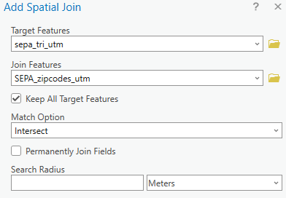
- This is the geography file that ArcGIS will attach new data to
- This is geography file that ArcGIS will pull data from to attach to (a)
- This tells ArcGIS how to behave if there are rows in the Target Features that don’t have a match in the Join Features
- This tells ArcGIS what kind of geographical relationship to use – click on the drop down menu to see other options

SO, with these settings, ArcGIS will do the following: for each point in sepa_tri_utm, ArcGIS will attach all of the fields from the SEPA_zipcodes_utm layer, choosing which rows to match together based on what zipcodes intersect with the TRI points.

Press OK. Open the attribute table of sepa_tri_utm shapefile and note that the zipcode attribute data (field ZCTA5CE20) are now appended onto the table. There should still be 189 records.

Now join the air_by_tri table onto the tri_in_zip shapefile table using the FRS_ID field as the join field for both tables. Note that it does not matter if you join the zip code data to the points first and then the air_by_tri table or if you join the air_by_tri first and then the zipcode data – in both cases you are adding data onto the points layer based on the TRI facility ID.

Open the attribute table for the sepa_tri_utm shapefile and confirm that this table now contains the TRI identifier, zip code, and total pounds of air release by stack for each TRI facility. There should still be 189 records.

7. Summarizing One Field by Another: Pounds of Release by Zip Code

Now, we’ll sum the total pounds of air release by individual zip code, as some zip codes contain multiple TRI facilities.

Open the sepa_tri_utm shapefile attribute table. Right click on the field name ’ZCTA5CE20’ and choose Summarize.
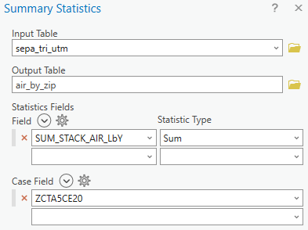
For the summary statistics, choose to sum the field ‘Sum_STACK_AIR_LbY’.

Call the new table ‘air_by_zip.’ Click OK.

The new table will appear in your Contents Pane.

With any of these dialogue boxes, it’s possible that you may see a caution triangle, and if you click on the triangle, you see a warning like this:
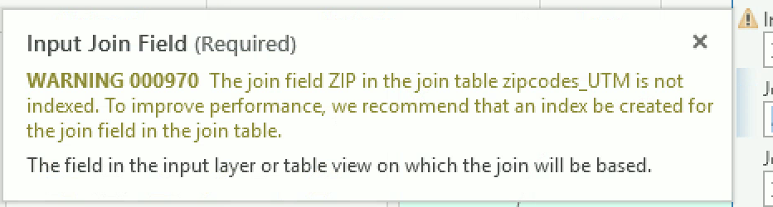

You can ignore this warning. Attribute indexes can speed up joins and other attribute queries on feature classes and tables. An attribute index is an alternate path used by ArcGIS to retrieve a record from a table. For most types of attribute queries, it is faster to look up a record with an index than to start at the first record and search through the entire table. But our datasets are not very large, so they work just fine with no indexes.

Open the new air_by_zip table. There should be 84 records. Remind yourself what the records and fields show you in this table.

Join the new air_by_zip table onto the zipcodes_utm shapefile attribute table using the ZCTA5CE20 field as the join field for both tables.

8. Mapping TRI Air Stack Releases by Zip Code

Export the SEPA_zipcodes_utm shapefile as a new shapefile called ‘zip_w_air’. Note that the purpose of this export is to generate a new shapefile with the joined fields as a permanent part of the attribute table of the shapefile, rather than as a temporary join.

Create a choropleth map of TRI air stack releases by zip code by assigning a color ramp to the field ‘SUM_air_by_tri.Sum_STACK_AIR_LbY’.

View the attribute table and sort the records by the SUM_air_by_tri.Sum_STACK_AIR_LbY field. You will see that the majority of zip codes have zero pounds of releases. There are only a handful of zip codes with very large release amounts.

Chloropleth map of TRI air stack releases by zip code (not normalized)
Note that some zipcodes are missing – why is this? Hint: do you have any null values in the attribute table? You should definitely not leave your map with weird gaps like this – how can you fix that?

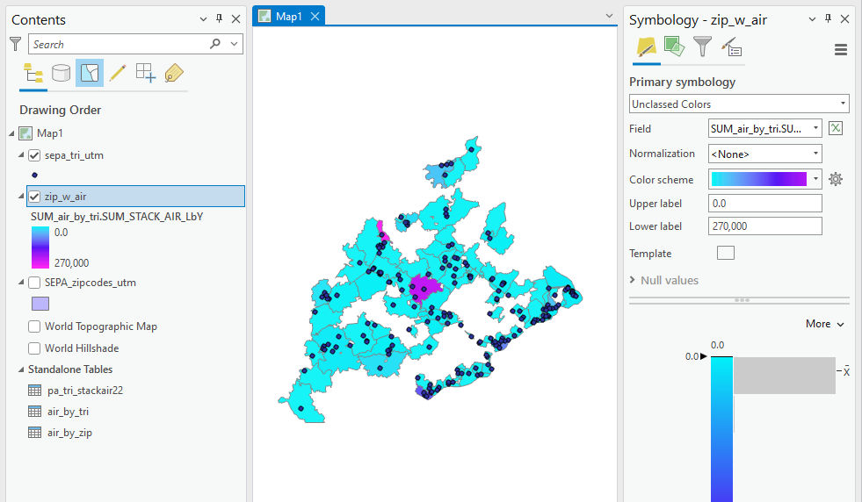
It may also make sense to map not only the total pounds of release per zip code but the pounds of release per unit area of zip code, since some zip codes are much larger than others. To do this, in the Symbology window normalize the SUM_air_by_tri.Sum_STACK_AIR_LB field by the ALAND20 (note that the units of area are in decimal degrees – derived from the original projection of the data - which is awkward but OK for the purpose of this exercise).

Chloropleth map of TRI air stack releases by zip code (normalized)

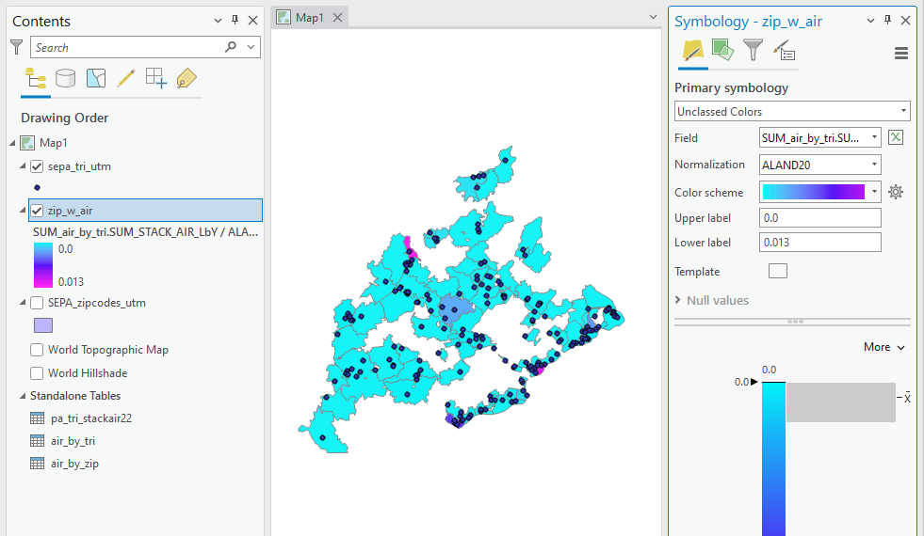
See ASSIGNMENT instructions on next page.
ASSIGNMENT

Lab #3-6: Must do 1 Full Lab Report & 3 Slim Lab Reports – your choice which is which

Objective
The objective of this assignment is to:

Identify zip codes that are within 500 meters of TRI facilities that:
1) Have over 10 lbs of total water releases for 1990, and
2) Are within 100 meters of a river in southeast Pennsylvania.

Deliverables
Turn in a report addressing this objective. This report should contain a map of the TRI facilities and zip codes that meet the above criteria. This map must be in UTM. This report should also contain a list of those zip codes (i.e. the zip code) and those facilities (i.e. the unique identifier listed in the TRI field).

Getting Started
Think about the order of your operations to complete this analysis and what data you will need to answer the question. The key to this lab is becoming familiar with the Select by Attributes and Select by Location dialog boxes. Note that the Select by Location box has options for selecting features by a variety of spatial relationships, including ‘Are within a distance of’ and ‘Intersect’.

Two tips:
  - I recommend that you save shapefiles at key points so that if you have to backtrack, you don’t have to go all the way back to the beginning of your sequence of queries.
  - Look at your resulting map – does it make sense? Does it look like you captured all zipcodes within 500 meters of one of your facilities?

Lab 4 Summary of Operations
Operation | Briefly describe what this operation does | List the steps to complete this operation
Table: summarize by field (Summarize one field by another)
Spatial Join for Point IN Polygon Overlay (join polygon table data to point table data)

Lab 4 will be graded with the following criteria (see General Lab Report instructions for more detail):

FULL REPORT
 | Pass | Good | Excellent
Objective
Clear statement of GIS analysis objective
Analysis Steps
Correct steps & understanding of GIS operations
Results
Clear summary of results that describes the patterns seen
Discussion
Limitations
Extensions
Decisionmaker applications
Tables & Figures
Map has required analysis features
Maps are in UTM projection
Map layout displays qualities identified in Map Design Checklist
Map includes appropriate features
GIS Operations Summary
Table is completed
Other Notes
Notes (see tracked changes below for more)
Grade

SLIM REPORT
 | Pass | Good | Excellent
Analysis Steps
Correct steps & understanding of GIS operations
Tables & Figures
Map has required analysis features
Maps are in UTM projection
Map design: overall composition
Map design: required elements
Map design: features included
Map design: colors and line weights
GIS Operations Summary
Table is completed
Other Notes
Notes (see tracked changes below for more)
Grade

