Introduction to GIS for Social and Environmental Analysis (CITY201)

Lab 8: Network Analyst
Purpose of the lab: To introduce the use of Esri’s Network Analyst extension to analyze real-world problems.

1. Get Your Data
Download the Lab 8 data folder from Moodle, unzip it, and add it to your lab folder (or add a folder connection). For this lab, it is vital that your data is visible within the “folders” section of the catalog, either as a folder connection or directly within your lab folder.

2. Enable the NetworkAnalyst license
ArcGIS Pro extensions, such as the Network Analyst extension, require special licensing to use. Fortunately, the college has 50 of these licenses, which you can enable as follows:
Project > Licensing > Configure your licensing options > Network Analyst > OK

3. Creating a File Geodatabase

A file geodatabase is used to store both spatial and non-spatial data. Every time you complete a lab, you are using a file geodatabase to store your data; your file geodatabase is identified in the catalog by this icon: . We will create a new new file geodatabase to store some data that we will use later in a network analysis.


Search for the “Create File Geodatabase” tool in the Geoprocessing pane. Set the File Geodatabase Location to your lab folder (Your lab folder is identified by this icon: ). Set the File GDB Name to “Streets Geodatabase,” and run the operation.

Return to the catalog. If you do not see the new File Geodatabase, right click on your lab folder and hit refresh. Your new geodatabase should come into view.
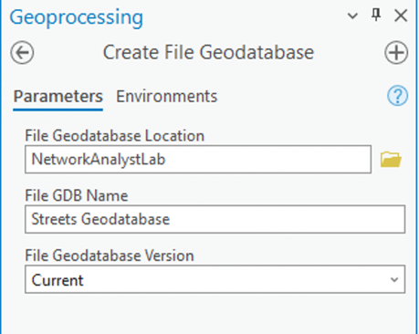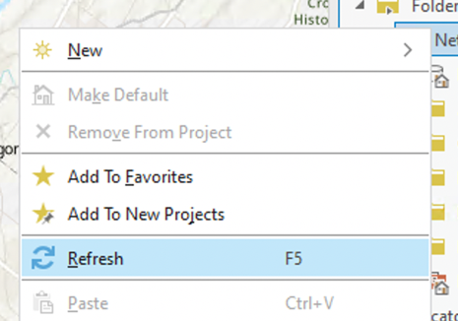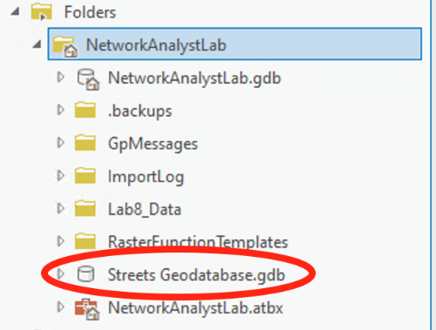

4. Creating a Feature Dataset
Recall that File Geodatabases store spatial data. A special type of spatial data is a Feature Dataset, which is used to contain a set of related spatial data that share a common coordinate system. The reason Feature Datasets are useful is because certain tools and operations in ArcGIS Pro are used on a collection of related files, including all network analyses.

To create a Feature Dataset inside Streets Geodatabase, right click on Streets Geodatabase within the catalog, click “New,” and click “Feature Dataset.” Name your new feature dataset “Streets_Dataset.” Set the coordinate system to UTM Zone 18—this is because the data that we insert into the Feature Dataset is in this coordinate system (remember: all data within a Feature Dataset must be in the same coordinate system). Run the operation, and find the new Feature Dataset in the Streets Geodatabase.
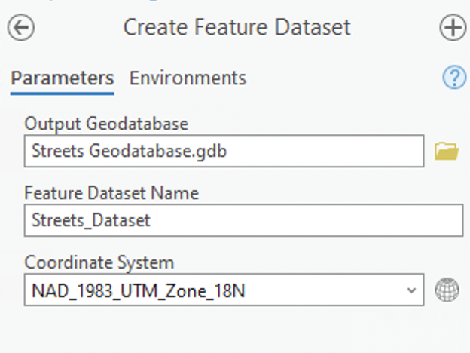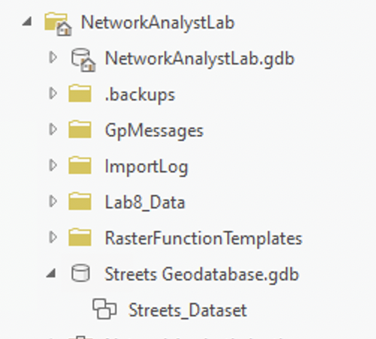

We now need to insert our streets into our feature dataset. Right click Streets_Dataset, select “import,” and click on “Feature Class(es).” Input the streets shapefile from the Lab8_Data folder and run the operation. Check back in the catalog to make sure you see the streets feature class inside the feature dataset.

5. Creating a Network Dataset
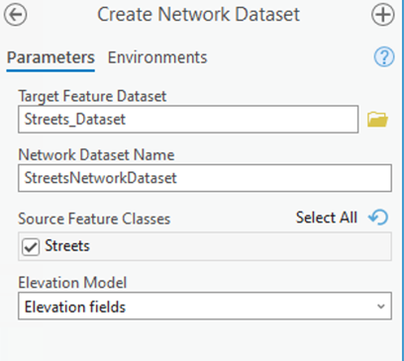
To perform a network analysis, we need to create a “Network Dataset,” which essentially turns elements of a Feature Dataset into edges and junctions of a network (edges are the lines that can be traveled on, while junctions are points that connect edges). For this lab, we will only be using streets for our network. However, you can imagine that a more complicated network dataset would include many source feature classes, such as train tracks, streets, pedestrian trails, and more.

To create the network dataset, go to Geoprocessing > “Create Network Dataset.” Set “Target Feature Dataset” to Streets_Dataset, and name the network “StreetsNetworkDataset.” From the “Source Feature Classes” pop-up, ensure that “Streets” is selected. You can then run the operation.

6. Modifying the Network Dataset
You may notice after creating the network dataset that it is immediately added to the map in the Contents pane. Before we work with our network dataset, we need to explore and modify some of the settings. However, we can only modify the settings when the network dataset is NOT on the map. Thus, remove that layer from the map.

In the Catalog, find the streets feature dataset and locate your new Network Dataset. Right click on it and open properties. Then, navigate to “Travel Attributes.” Click the three bars in the top-right corner and select “New.” You will notice that a new travel mode is created. For this lab, we will use two travel modes. One will be designed for pedestrians, and the other will be designed for busses. For pedestrians, we create a travel mode focused on distance on the street network, and for busses, we will create a travel mode that focusses on the time it takes to drive on the streets. We will ignore some of the more complicated details, such as the time it takes for a bus to make a left turn, but you can imagine how variables like that would be important in real-world scenarios. In Network Analysis terminology, we are saying that we want to use a distance cost for busses, and a time cost for pedestrians.

For the travel mode you just created, change “Type” to “Walking,” and rename the travel mode “Pedestrian Travel Mode.” (You can do this by selecting the three lines in the top-right corner.) Now, create a second travel mode and name it “Bus Travel Mode.” By default, the type will be set to driving.
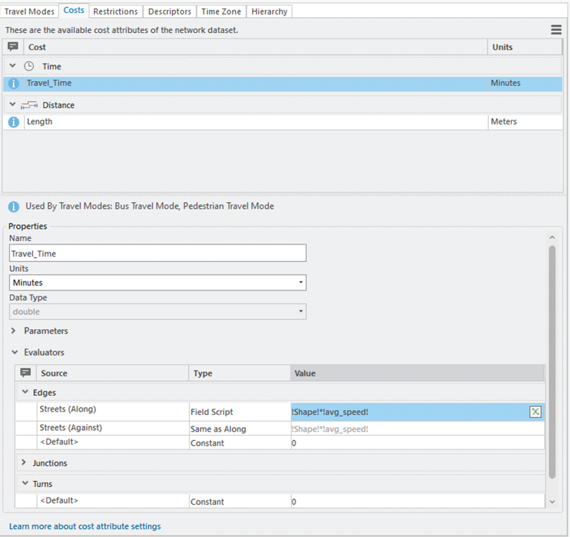
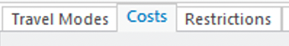
Great; we now have two travel modes. However, both have only the distance cost, length. While this is what we want for pedestrians, we need a time-based cost for busses. To do this, open the Costs pane by clicking “Costs” near the top of the properties window.

To create a time-based cost, click the three bars in the top-right corner and select “New.” The cost will automatically be set to a time cost since we already have a distance cost. Rename this new cost “Travel_Time,” then navigate to the Evaluators section. This is where we tell ArcGIS how to calculate travel time. For the “Streets (Along)” row, set Type to “Field Script.” Make sure that “Streets (Against)” is set to “Same as Along” in Type. We need to create an equation that calculates travel time for busses. You may remember from a physics class that Time = Distance/Speed. Fortunately, we have both a distance and speed field in the Streets attribute table. !Shape! tells us the length of each street segment in meters, and !avg_speed! tells us the average travel speed of a vehicle in meters/minute, meaning !Shape!/!avg_speed! will yield the travel time in minutes. Thus, under Value, enter “!Shape!/!avg_speed!” so that, when finished, your screen looks like the picture above.

We are almost done! Navigate back to “Travel Modes” and notice that “Time Cost” has automatically been filled in with “Travel_Time” for both travel modes. Great! Open up the Bus Travel Mode and change “Impedance” from Length to Travel Time. You can now click “OK” to save our changes to the Network Dataset. We are ready to move on to a Network Analysis. Go to Geoprocessing, search for “Build Network,” input our network dataset, and run the operation. Our newly built network is added to the map.

7. Performing a Service Area Analysis
A service area analysis is a type of network analysis similar to a buffer analysis. While buffers create polygons resembling distance as the crow flies, a service area analysis create polygons representing travel distance or time along a network.

To create a Service Area Layer, navigate to “Analysis,” click “Network Analysis,” and click “Service Area.” You will notice a new layer is added to the contents pane with multiple feature classes.
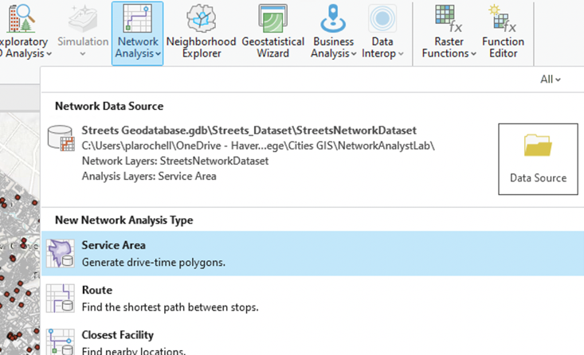
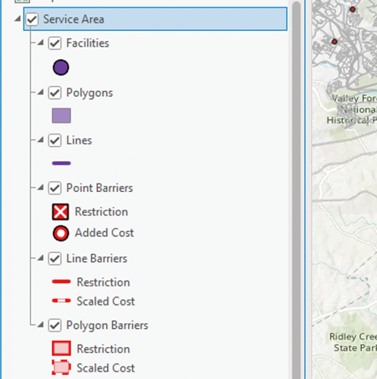

Facilities stores points we travel to or from.
Polygons stores output polygons representing travel distance or time from facilities.
Lines stores output lines representing travel distance or time from facilities. Note that, by default, service area analyses generate polygons, not lines.
Point Barriers, Line Barriers, and Polygon Barriers add additional impedance to traveling, but we will not use them for this analysis. A Polygon Barrier, for example, could be a school zone where travel speed is cut in half.

To run a service area analysis, we need to import facilities into the layer. Using the Catalog, insert “MontCo_Schools_utm” and “MontCo_Libraries_utm” onto the map. From the Schools layer, select Bryn Mawr College. In the Contents pane, click on the Service Area layer. From here, you will notice a “Service Area Layer” option appears on the ribbon bar. Any time you are working with a network analysis layer, you must click on the appropriate layer in the Contents pane to make this appear on the ribbon.

Open the Service Area Layer option on the ribbon, and click on Import Facilities. For Input Locations, add MontCo_Schools_utm. Ensure that “Use the selected records” is selected, as we only want to import Bryn Mawr College as a facility. Click “OK,” and look at the map. You should notice that BMC has been added as a facility to our Service Area Layer.

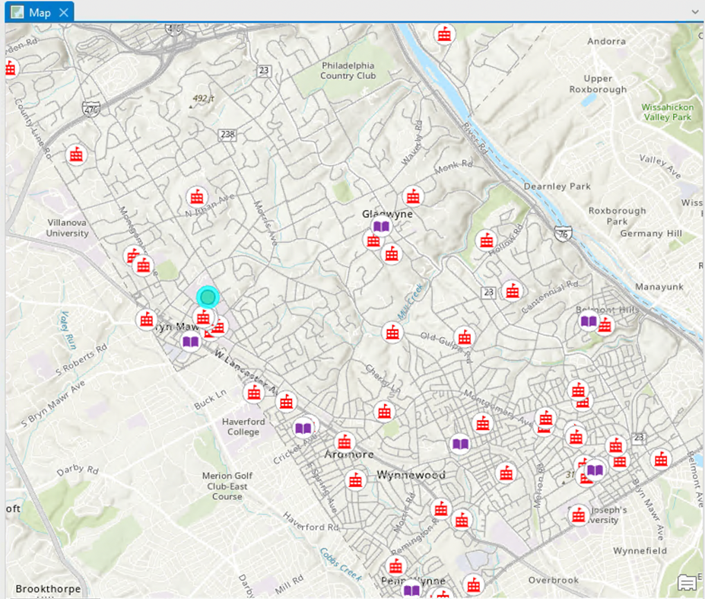
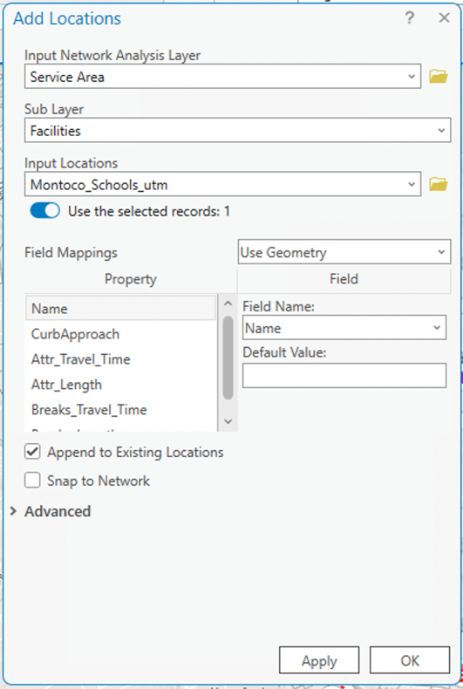

Return to the Service Area Analysis on the ribbon, and observe the “Mode” you are set to. For now, make sure you are using the Pedestrian Travel Mode. You will see a dialogue box labeled “Cutoffs.” These are the travel distances (in meters) that the analysis will use when generating service area polygons. Change Cutoffs to 800, 1600, 3200 (roughly ½, 1, and 2 miles, respectively). Next, click “Run.”

Cool! The map should now display three polygons that contain all points on our network that are either 800, 1600, or 3200 meters away from BMC. Recall, though, that this analysis uses the pedestrian travel mode. We can run the analysis again with our other travel mode, busses. Return to the Service Area Analysis, and change “Mode” to Bus Travel Mode. Since we set Impedance to our time cost, you will notice that cutoffs are automatically changed to time units. Let’s just use one cutoff of 5 minutes, and then run the operation. We should generate a single polygon that represents all areas on our network that a bus can reach in 5 minutes.
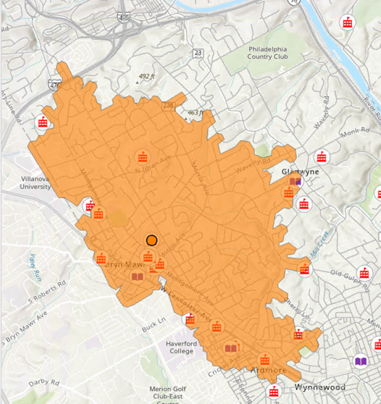
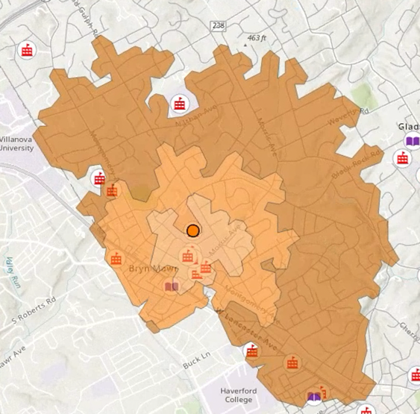

Suppose we want to identify all Montgomery County Libraries that the Blue Bus can reach in 5 minutes from Bryn Mawr. Now that we have run the service area analysis, answering this question is easy! Let’s just use Select By Location, where Input Features is set to MontCo_Libraries_utm, relationship is set to “Intersect,” and Selecting Features is set to “Service Area/Polygons.” Run the operation. You should find three libraries within a 5-minute drive of Bryn Mawr College.

Feel free to explore more of the Service Area Layer if you have time. What happens if you run the analysis using lines instead of polygons? What happens if you have multiple facilities? Once you feel comfortable, you can delete the Service Area layer from the map and move on.

8. Performing a Route Analysis
The second type of network analysis we will use is called a Route Analysis. The purpose of a Route Analysis is to generate an “optimized” route between two or more points on a network. By optimized, we mean a route that minimizes cost. For us, this means that routes generated for the pedestrian travel mode will minimize distance, while routes for the bus travel mode will minimize driving time. Let’s add a Route Analysis Layer to the map by going to Analysis, clicking Network Analysis, and clicking Route. You will notice that the Route layer looks very similar to the Service Area layer, except facilities are replaced by “Stops” and Polygons and Lines are replaced by “Routes.”

Suppose we are driving a bus and want to travel from Lower Merion High School to Harriton High School and then finish at Gladwyne Elementary School. We first want to change our travel mode to Bus Travel Mode. Next, let’s add these schools as stops on our routes by selecting them in the Montco_Schools_utm layer, and then opening the Route Layer on the ribbon, clicking “Import Stops,” and inputting the schools. Again, make sure that “Use the selected records” is selected.

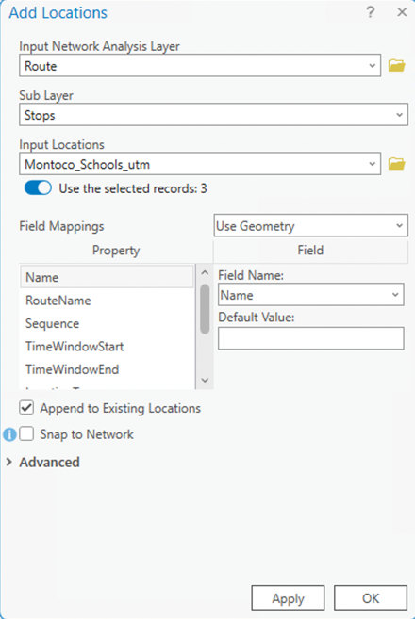
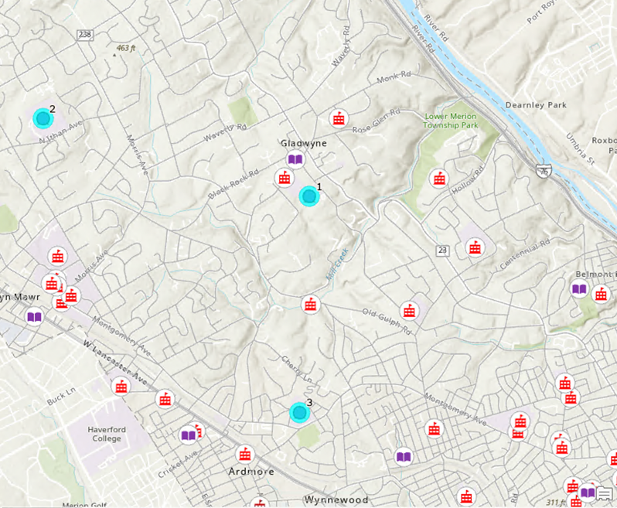
Recall that we want to drive a bus starting at Lower Merion High School, travel to Harriton High School, and then finish at Gladwyne Elementary School. To account for this sequencing, we need to manually change the sequence in the Stops attribute table. Find the Stops feature class in the Contents pane and open the attribute table. Find the “Sequence” field, and ensure that Lower Merion High School is set to 1, Harriton High School is set to 2, and Gladwyne Elementary School is set to 3.

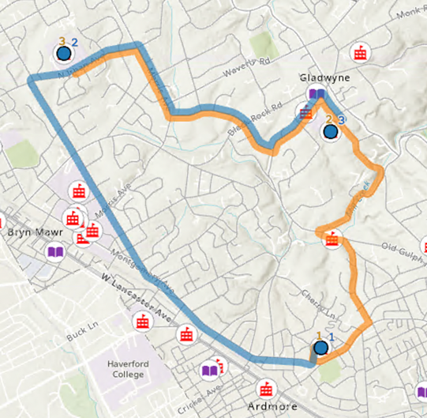
Close the attribute table, and open back up the Route Layer on the ribbon. Click “Run.” You should notice that a route appears on the map that minimizes bus travel time between the schools when we start at Lower Merion High School and end at Harriton High School. You might suspect that this is not really the route that minimizes driving time between the schools overall, as a different routing sequence could produce a quicker route. Let’s try this out by going to the Route Layer and changing “Sequence” from “Use Current” to “Find Best.” Run the analysis, and you will notice that the program changes the sequencing to find the true fastest driving route between the schools. To the right, observe an overlay showing the manual sequencing in blue and the automatic sequencing in orange.

While this new route we generated minimizes driving time, it is not be the shortest route for a pedestrian to walk. To see for yourself, change Mode to “Pedestrian Travel Mode” and keep Sequence as “Find Best.” Run the analysis. You should see that this new route looks quite different than the previous one, which makes sense. Often, the routes that minimize driving time aren’t the routes with the shortest distance.

Feel free to play around more with the route analysis until you feel comfortable. Once you are all set, remove the Route layer from the map.

9. Performing a Closest Facility Analysis
The final type of network analysis we will use is a Closest Facility Analysis. This analysis takes in two sets of points referred to as “Incidents” and “Facilities,” and outputs a line feature class that connects each incident to the nearest facility (or facilities).

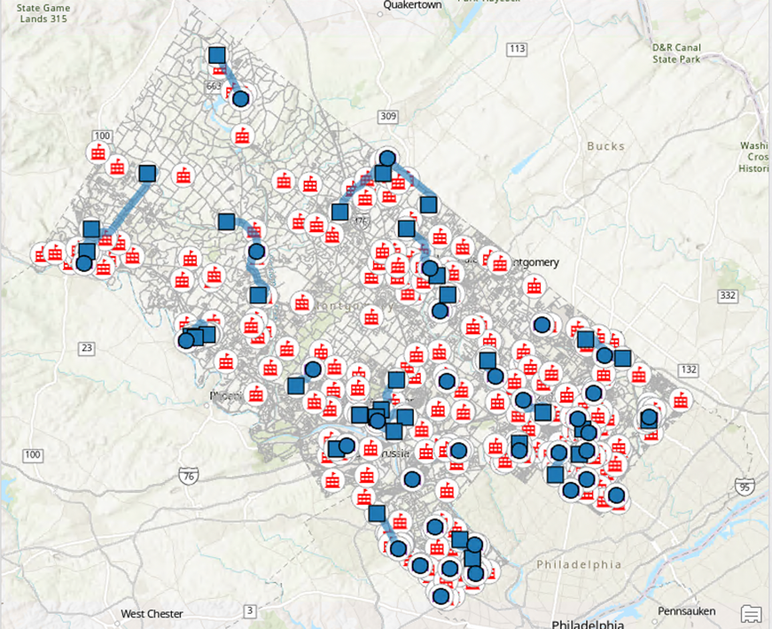
Performing this analysis is very similar to a route analysis. On the ribbon, click “Analysis,” go to “Network Analysis” and create a “Closest Facility” layer. Suppose we want to identify the nearest library by walking distance to every public middle school in Montgomery County. Perform a select by attribute on the schools layer to select only public middle schools. Return to the Closest Facility Layer and go to “Import Incidents.” Since we are creating a route from each public middle school to the nearest library, we treat the public middle schools as incidents. Thus, set Montco_Schools_utm as the input location and ensure that “Use the selected records” is selected. Next, go to Import Facilities and insert Montco_libraries_utm as the input location. Before running the analysis, ensure that “Mode” is set to Pedestrian Travel Mode. If everything looks good, click “Run.”

You should notice that routes are generated from each incident (public middle school) to the nearest facility (library). If you zoom in on denser collections of schools and libraries, you will see much shorter routes come into view.

Feel free to play around more with the closest facility analysis. What happens if you increase “facilities” from 1 to a larger number? Are different libraries identified when we switch to the bus travel mode? Once you feel comfortable, you can delete this layer and move on to the lab.

See assignment instructions on the next page.

ASSIGNMENT

Lab #8 must be a full lab report.

As a member of the Montgomery County board of elections, you want to address low voter turnout among college students in the upcoming election. You notice that colleges furthest away from polling places have low voter turnout. To solve this, you propose renting a bus on election day that will take students from these colleges to the nearest polling place.

Objective
The objective of this assignment is to:
- Identify colleges in Montgomery County that are further than a 1600-meter walk to a voting location.
- Create a single bus route that connects the colleges identified previously to each of their nearest polling locations as determined by bus travel time. This bus route should minimize driving time and should stop at each college and polling location once per loop.
For the purposes of this lab, you can assume that these colleges do, in fact, vote at the nearest polling location.

Deliverables
Turn in a report addressing this objective.

Getting Started
Think about which network analysis layer you need in what order. Which step comes first?

TIPS:
  - This lab requires you to use all three of the network analysis layers used in the pre-lab.

Don’t forget to use the proper travel mode for each network analysis.

  - To make your bus route a “loop,” consider duplicating one of your stops in the Stops attribute table. Then, set that stop and its corresponding duplicate as the first and last stop in the sequence.

Lab 8 will be graded with the following criteria (see General Lab Report instructions for more detail):

FULL REPORT
 | Pass | Good | Excellent
Objective
Clear statement of GIS analysis objective
Analysis Steps
Correct steps & understanding of GIS operations
Results
Clear summary of results that describes the patterns seen
Discussion
Limitations
Extensions
Decisionmaker applications
Tables & Figures
Map has required analysis features
Maps are in UTM projection
Map layout displays qualities identified in Map Design Checklist
Map includes appropriate features
GIS Operations Summary
Table is completed
Other Notes
Notes (see tracked changes below for more)
Grade

