Saving ArcGIS Data with Google Drive

Follow these steps each time you start a lab to ensure that your lab data will be saved properly.

Step 1: Create your lab
Make sure you observe where it is being saved in your File Explorer (you can change this to wherever you would like to temporarily keep the lab).
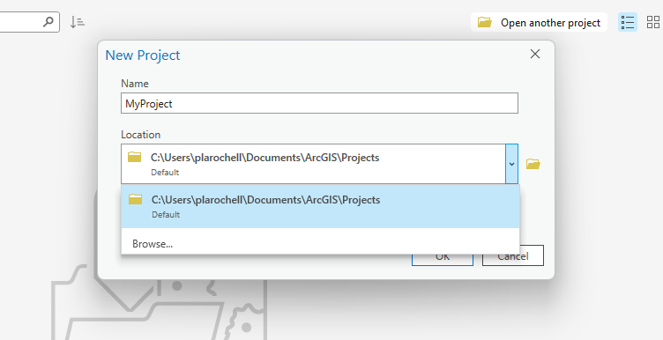

Click “Ok” to create your new lab.
Bonus: Go to your file explorer and find your lab folder. It should look like this:
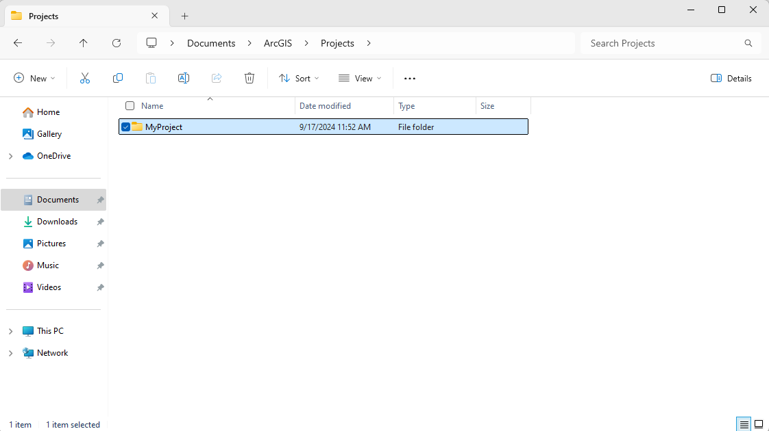
And this is what the inside of the folder looks like:
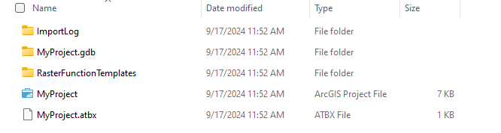

Step 2: Download whatever data you need for your lab.
For many labs, this will be the “201 Lab Data” folder you have already gotten used to using. For other labs, you might download your own data from the internet (such as from the Census). For now, we will perform the steps on the 201 Lab Data folder. Make sure it is a non-compressed file (extract .zip files).
You will likely be able to find this data in your Downloads folder in the file explorer
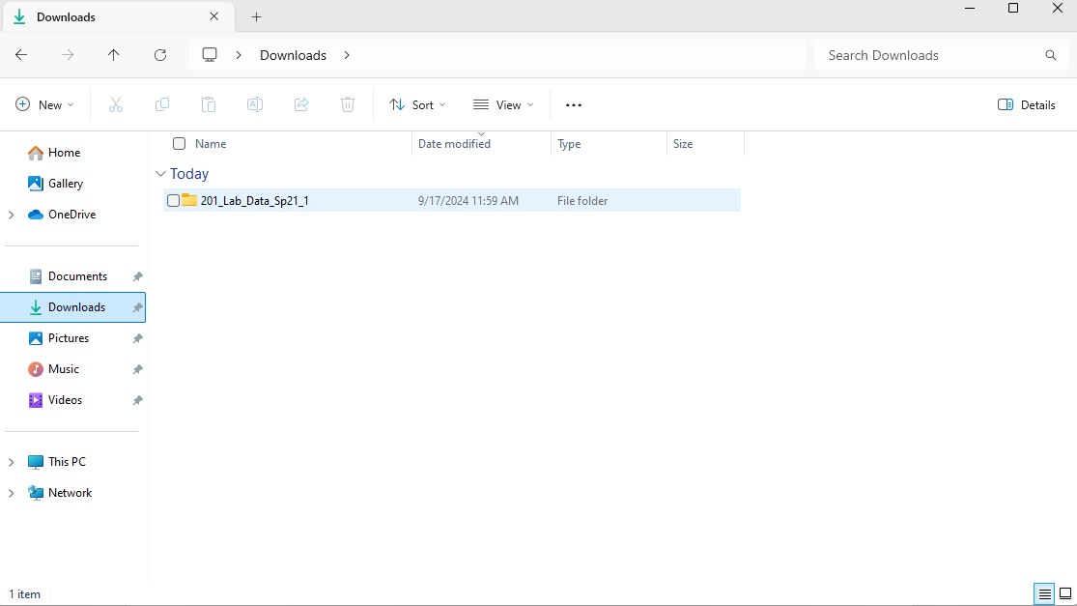

Step 3: Move your downloaded data into the Lab Folder using the File Explorer
Look back at where you saved your Lab Folder, and navigate the File Explorer to drag your downloaded data into this folder.
Now that the data was moved to your lab folder, your lab folder should look like this
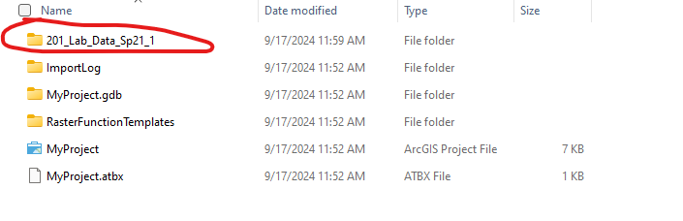
BONUS: Now, if you want to access that data in ArcGIS Pro, just go to your Catalog, open “Folders,” and you should see your data folder in there with everything you need:
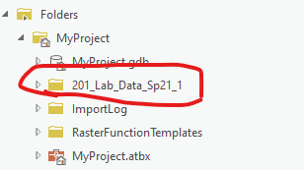

Step 4: Complete your Lab in ArcGIS Pro and Save it when you are finished
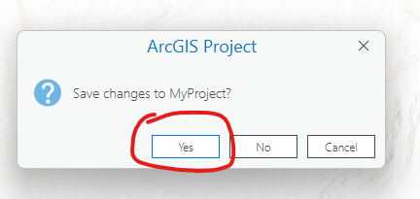

Step 5: Save your Lab Folder to Google Drive
You can do this by going to Google Drive, clicking “New,” then clicking “Folder Upload” and navigating to your Lab Folder.
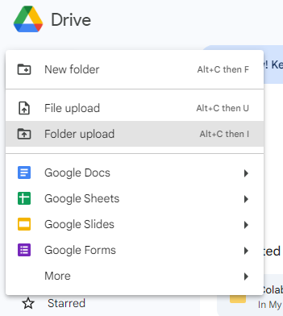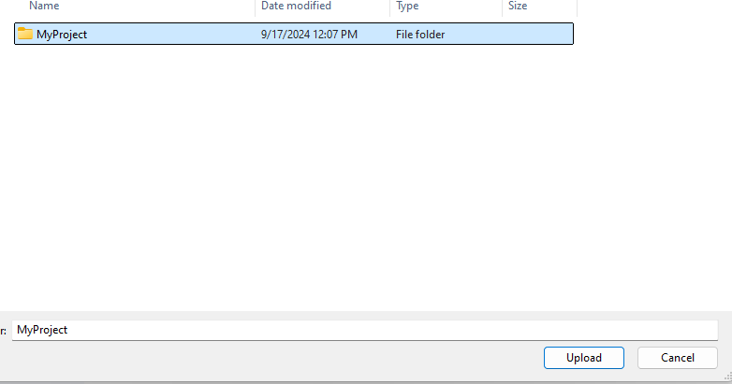

Google Drive will now upload each piece of the folder and save it to a .zip file.
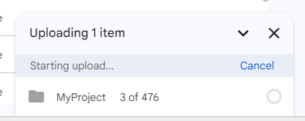

Your data is now saved. You can close your computer and work again on the lab another day.

Redownloading your Data:
When you want to return to your data, simply download your saved folder from Google Drive. It should show up as a .zip file, probably in your “Downloads” folder in the File Explorer.
Navigate to your .zip file in File Explorer and extract everything.
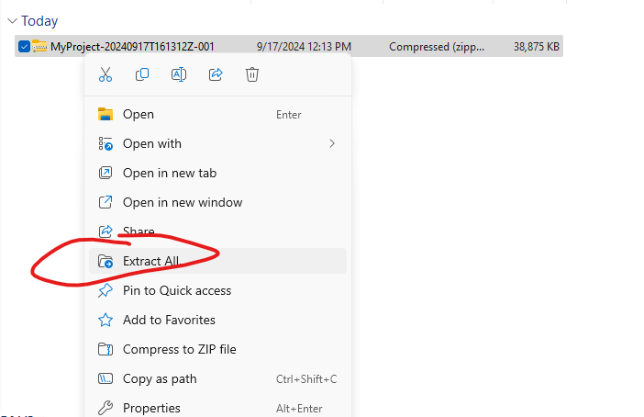

Go to your new, extracted lab folder, and open up your project by clicking on it
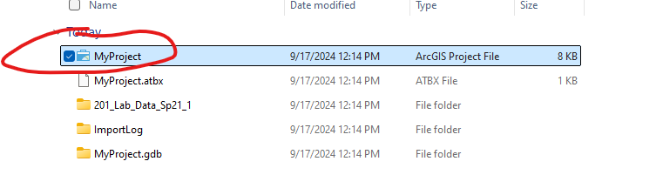
You should now be brought directly to ArcGIS Pro to your lab, and all your data should be there.

