What is Reflective Thinking & Writing?
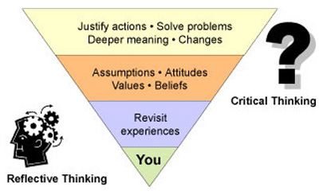
A great deal of your time in college will be spent thinking; thinking about what people have said, what you have read, what you yourself are thinking and how your thinking has changed. It is generally believed that the thinking process involves two aspects: reflective thinking and critical thinking. They are not separate processes; rather, they are closely connected (Brookfield 1987).

Reflection is:
- a form of personal response to experiences, situations, events or new information.
- a 'processing' phase where thinking and learning take place.

The figure above shows that the reflective thinking process starts with you. Before you can begin to assess the words and ideas of others, you need to pause and identify and examine your own thoughts.
Doing this involves revisiting your prior experience and knowledge of the topic you are exploring. It also involves considering how and why you think the way you do. The examination of your beliefs, values, attitudes and assumptions forms the foundation of your understanding.
Reflective thinking demands that you recognize that you bring valuable knowledge to every experience. It helps you therefore to recognize and clarify the important connections between what you already know and what you are learning. It is a way of helping you to become an active, aware and critical learner.

Reflective writing is:
- your response to experiences, opinions, events or new information
- your response to thoughts and feelings
- a way of thinking to explore your learning
- an opportunity to gain self-knowledge
- a way to achieve clarity and better understanding of what you are learning
- a chance to develop and reinforce writing skills
- a way of making meaning out of what you study

Reflective writing is not:
- just conveying information, instruction or argument
- pure description, though there may be descriptive elements
- straightforward decision or judgement (e.g. about whether something is right or wrong, good or bad)
- simple problem-solving
- a summary of course notes
- a standard university essay

Source: https://student.unsw.edu.au/reflective-writing

