Dr. Michael Burri
German 421, Herbst 2026
Office Hours: Tuesdays, 1-2 p.m., Old Library
Classroom: 6 Dalton Hall
Email: mburri@haverford..edu

GERMAN FOR READING KNOWLEDGE

DESCRIPTION
This course is designed to prepare students to read sophisticated and scholarly prose in German. It presents an intensive examination of basic German grammar and syntax, together with strategies that will enable students to read and understand German texts essential for advanced study or learning in disciplines across the arts, social sciences, and the humanities. Previous experience in German is an asset, but not a course prerequisite.

COURSE GOAL
Prepare students to read sophisticated and scholarly prose in German.
Course Objectives
- Work through the standard professional textbook on German language acquisition for academic and advanced study, Jannach, German for Reading Knowledge (sixth edition).
- Address more difficult questions of German language structure and reading comprehension through handouts and other supplemental materials.
- Practice translating short German texts written for an academic audience in the discipline of archaeology, classical studies, art history, and sociology, among others.
- Practice translating short German texts written for an educated public.
- Build skills and confidence in reading and understanding German text through in-class quizzes and take-home tests.
- Prepare students for standard Masters-level language exam in reading by simulating testing environment, by practicing the translation of texts of similar difficulty, and by discussing student translations of these texts.

BOOK
- Richard Alan Korb, Jannach's German for Reading Knowledge, 6th Edition (required)

WEBSITE (free)
- www.cengage.com/german/korb

ONLINE DICTIONARY
- dict.leo.org
- linguee.de

REQUIREMENTS (GRADUATE)
Quizzes and take-home tests are recommended. Completing homework and class participation are assessment tools for final course grade of “S” (Satisfactory) or “U” (Unsatisfactory). Sitting for the simulated Masters-level reading exam is highly recommended.

REQUIREMENTS (UNDERGRADUATE)
Final exam, four take-home tests, five in-class quizzes, regular completion of homework in advance of class, class participation. No retakes on take-home tests, quizzes, or exams due to an unexcused absence. An absence for which the student does not contact the instructor in advance of the class will be considered unexcused.

GRADING CRITERIA (UNDERGRADUATE)
25% final exam; 20% take-home tests; 20% homework (completing and submitting on-time); 15% midterm practice exam; 10% in-class quizzes; and 10% seminar skills.

CANADAY LIBRARY
Christine Boyland, the Senior Educational Technology Specialist and liaison for students of foreign languages, can help with questions about research and technology. Please reach her at cboyland@brynmawr.edu, 610-526-7448.

ACCESS SERVICES: Bryn Mawr College is committed to providing equal access to students who need academic accommodations and have registered with Access Services. Students can call 610-526-7516 to make an appointment with the Coordinator of Access Services, Deb Alder, or email her at dalder@brynmawr.edu to begin this confidential process. Once registered, students should schedule an appointment with the professor as early in the semester as possible to share the verification form and make appropriate arrangements. Please note that accommodations are not retroactive and may require advance notice to implement. More information can be obtained at the Access Services website. (http://www.brynmawr.edu/access_services/)

MOODLE
This syllabus, together with supplemental course material, can be found on Moodle.

ACADEMIC INTEGRITY
Consistent with the course goal of individual mastery of skills in reading German, please aim to complete as much of the assigned coursework as possible on your own. However, English translations, answer keys, and other assistance may be used and are available for all class assignments.

KURSPLAN (Änderungen vorbehalten -Subject to change)

Datum  (Date) | Im Unterricht: Themen & Sprachliche Strukturen  (Topics & Linguistic Structures)
Erste Woche  September 1 |  Introduction: the sounds of German, German vowels, anatomy of a dictionary entry, decoding compound nouns.  Prepare Kapitel 1  Review Gender of Nouns (1.2); Present and Past Tenses of the Verb sein (to be) (1.3); Interrogatives (1.4)  Practice Übungssätze 1-20, S. 9-10  Translate "Aller Anfang ist schwer," S. 11-12

Zweite Woche
September 8 |  German case: nominative, accusative, dative, genitive; meaning and conjugation of the present tense and simple past of weak verbs, discussion of homework.  Prepare Kapitel 2-3  Review Case (2.1, 3.1, 3.2); Present and Past Tenses of the Verb haben (2.4); Plural of Nouns (3.3, 3.4); Past Tense of Weak verbs (3.6)  Submit Übungssätze 1-10, S. 19-20; Übungssätze 1-10, S. 30-31  Submit Translate “Johann Sebastian Bach: Seine Musik und Seine Familie,”S. 21-22  Submit Translate “Apelt, Jugendstil” (.pdf available on Moodle)  In-class Quiz #1: Present and simple past of sein, haben, and werden.

Dritte Woche
September 15 | Stem-vowel change verbs (strong verbs), prepositions, declension of adjectives, word order, discussion of homework  Prepare Kapitel 4-5  Review Indefinite articles (4.1); Compound words (4.5); Ordinal Numbers (4.6) Der- words (5.1); Simple Past of Strong Verbs (5.2); Word Order (5.5).  Submit Übungssätze 1-15, S. 41; Übungssätze 1-15, S. 51-52  Submit Translate “Kurze Geschichte der deutschen Hochschulen,” S. 42-43  Submit Translate Schliemann, “Über die Ausgrabungen in Trojia,” S. 77-78 (.pdf available on Moodle)  Optional Prepare “Practice Test #1” (.pdf available on Moodle; to be reviewed in class, if interest and time permits)  Take-Home Test #1 (optional):“Deutschland: Die Geschichte,” S. 56-57, Wiederholung 1. Translate first, second, and last paragraphs. Summarize entire article in 3-4 sentences. Type summary and translation, due 22. September.

Vierte Woche
September 22 |  Declension of adjectives, adverbs, separable and inseparable prefixes, recognizing plural and singular nouns, discussion of homework  Prepare Kapitel 6-7  Review Prepositions (6.1); Idiomatic and Special Meanings (6.3) Adjective endings (7.1); Information from Adjective Endings (7.2)  Submit Übungssätze 1-10, S. 65-66; Übungssätze 1-10, S. 74-75  Submit Translate “Die Romantik,” S. 75-76  Submit “Sucht aus der Tasse,” (.pdf available on Moodle)  Optional Prepare “Bremer Stadtmusikanten” (.pdf available on Moodle; to be reviewed in class, if time permits)  In-Class Quiz #2: Declension of adjectives and verb prefixes.

Fünfte Woche
September 29 |  Perfect tenses, identifying the infinitive from the perfect tense, uses of participles, discussion of homework  Prepare Kapitel 8-9  Review Adverbs (8.1); Verbs with Inseparable and Separable Prefixes (8.2); Recognizing Singulars and Plurals of Nouns 8.3); Perfect Tenses (9.1); Past Participles (9.4)  Submit Übungssätze 1-10, S. 83-84; Übungssätze 1-10, S. 94-95;  Submit Translate: Dioramenmaler: „Der nicht so gut bekannte Schinkel,” S. 85-86  Submit Translate Hoelscher, “Victoria Romana,” Teil I (.pdf available on Moodle)

Sechste Woche
Oktober 6 |  |  Comparative and superlative, passive, future, and the uses of “werden” , reading a table of contents in German, discussion of homework.  Prepare Kapitel 10-11  Review Present Participle (10.1); Participles Used as Nouns (10.5) Comparison of Adjectives and Adverbs (11.1); Exceptional Comparisons (11.2); Comparatives and Superlatives Used as Nouns (11.5)  Submit Übungssätze 1-10, S. 102-103; Übungssätze 1-10, S. 117-18  Submit Translate “Die Bewohner Österreichs,” S. 107-108, Lines 33-70  Submit Zwierlein, “Lucans Caesar in Troia”  In-Class Quiz #3: Superlatives used as nouns, uses of werden.  Take-Home Test #2

Herbstferien / Fall Break, den 12. Oktober – 16. Oktober

Siebte Woche
Oktober 20 | 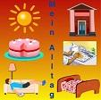 Passive, future, and the uses of werden, suffixes, discussion of homework  Prepare Kapitel 12-13  Review Future Tense (12.1); (12:3) Future Tenses Used to Express Probability; Passive Voice (13.1); Three Uses of Werden (13.3)  Submit Übungssätze 1-10, S. 126-27; Übungssätze 1-10, S. 134-35  Submit Translate: “Die Welternährungskrise,” S. 128-29  Submit Translate “Zur Einheit der Metamorphosen des Apuleius”  In-Class Quiz #4:

Achte Woche

Oktober 27 | 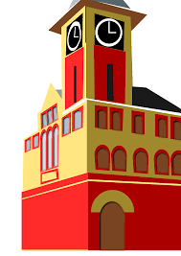 Reflexive pronouns, suffixes, modal auxiliaries, discussion of homework.  Prepare Kapitel 14-15  Review Perfect Tenses of the Passive Voices (14.1); Suffix -er, -in (14.5-6); Reflexive Pronouns (15.1); Suffixes (15.4)  Submit Übungssätze 1-10, S. 142-43; Übungssätze 1-10, S. 151-52  Submit Translate “Frauen werden verzweifelt gesucht,” S. 145  Submit Translate “Ölbaumgiebel” (Moodle)  Midterm Practice Exam: Text to be supplied.

Neunte Woche
November 3 | Modals, Double Infinitives, uses and meanings of modals, conjunctions, false friends, discussion of homework.  Prepare Kapitel 16-17  Review Modal Auxiliaries (16.1); Modals and the Dependent Infinitive (16.3); Perfect Tenses of Modals (17.1); Objective versus Subjective Meanings of Modal Auxiliaries (17.3)  Submit Übungssätze 1-10, S. 162; Übungssätze 1-10, S. 170-71;  Submit Translate “Was ist Aufklärung,” S. 163-64  Submit Translate “Kellner, Gürtelbleche aus Urartu,” (.pdf available on Moodle)  Take-Home Test #3

Zehnte Woche
November 10 | 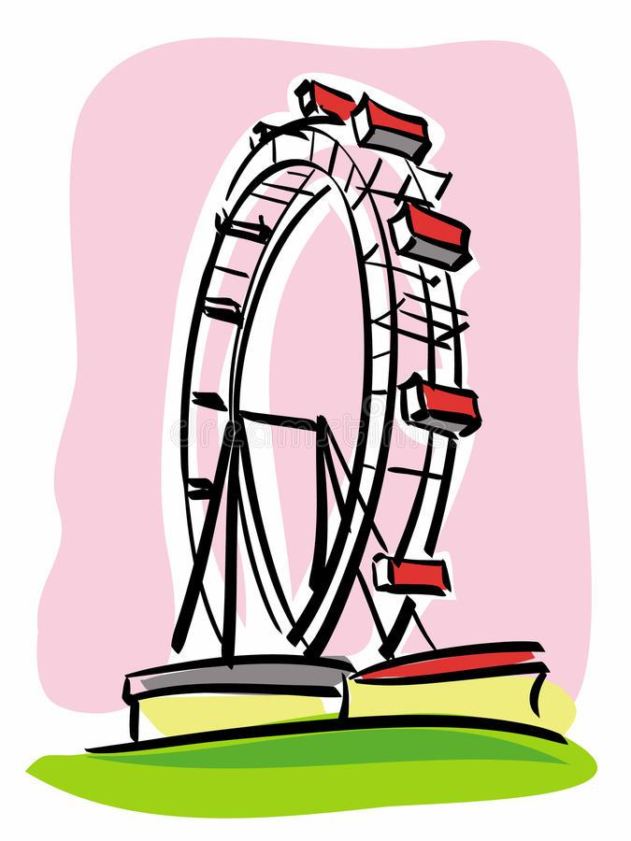Relative pronouns, relative clauses, demonstrative pronouns, other demonstratives, suffixes, discussion of homework.  Prepare Kapitel 18-19  Review Coordinating Conjunctions (18.1); Subordinating Conjunctions (18.2); Relative Pronouns (19.1); Recognizing Relative Clauses (19.2)  Submit Übungssätze 1-10, S. 180-81; Übungssätze 1-10, S. 188-89;  Submit Translate “Karl Mays Amerikabild und -reise,” S. 190-91  Submit Translate “Der sogenannte Berliner Apostelkopf,” (.pdf available on Moodle)  In-Class Quiz #4

Elfte Woche
November 17 | 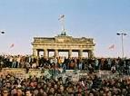 Interrogative and relative pronouns, word order in questions and imperatives, suffixes, infinitives, idiomatic phrases, discussion of homework.  Prepare Kapitel 20-21  Review Demonstrative Pronouns (20.1); Suffixes (20.3)Wer and Was used as Interrogative and Relative Pronouns (21.1); Verb-First Constructions (21.2); Suffixes (21.3)  Submit Übungssätze 1-10, S. 196-97; Übungssätze 1-10, S. 196-97  Submit Translate “Robert Schumanns Partitur wiedergefunden,” S. 209-10  Submit Translate Zwierlein, “Lucan's Caesar in Troia,” Teil I (.pdf available on Moodle)  In-Class Quiz #5

Zwölfte Woche
November 24 |  Extended adjective construction, translating extended adjective construction, discussion of homework.  Prepare Kapitel 22-25  Review Infinitives with zu (22.1); Prepositional Phrases (22.2); Extended-Adjective Constructions (23.1); Translating Extended-Adjective Constructions (23.3); Other Types of Extended Adjective Constructions (24.1); Additional Extended-Adjective Constructions (25.1)  Submit Übungssätze 1-10, S. 208; Übungssätze 1-10, S. 224-225  Submit Translate “Carl Ossietzky, Vom Idealismus getragene Leidenschaft,” S. 231-32  Submit Translate Zwierlein, “Lucan's Caesar in Troia,” Teil II (.pdf available on Moodle)  Take-Home Test #4

Dreizehnte Woche
Dezember 1 |  | 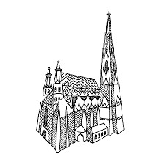 Da- wo-, hin-, her- compounds compounds, Formation of subjunctive II, Interrogative and relative pronouns, word order in questions and imperatives, suffixes, infinitives, idiomatic phrases.  Prepare Kapitel 26-30  Review Da(r)- compounds (26.1); Adverbs of Direction in Prepositional Phrases (26.4); Subjunctive II (27.1); Suppositions of Conditions Contrary to Fact (27.3); Subjunctive I (28.1); Special Uses of Subjunctive I (29.1); Idiomatic Meanings of Subjunctive Mode (30.1)  Submit Übungssätze 1-10, S. 229-30; Übungssätze 1-10, S. 196-97; ; Übungssätze 1-10, S. 208  Submit Translate “Das Attentat zu Sarajewo,” S. 259  Submit Practice Sentences (.pdf available on Moodle)
Fünfzehnte Woche
Abschlussprüfung (Final Exam)
The Final Exam consists of a simulated Masters-level reading exam.

