For: Thursday
Paul Cezanne
Additional Resources

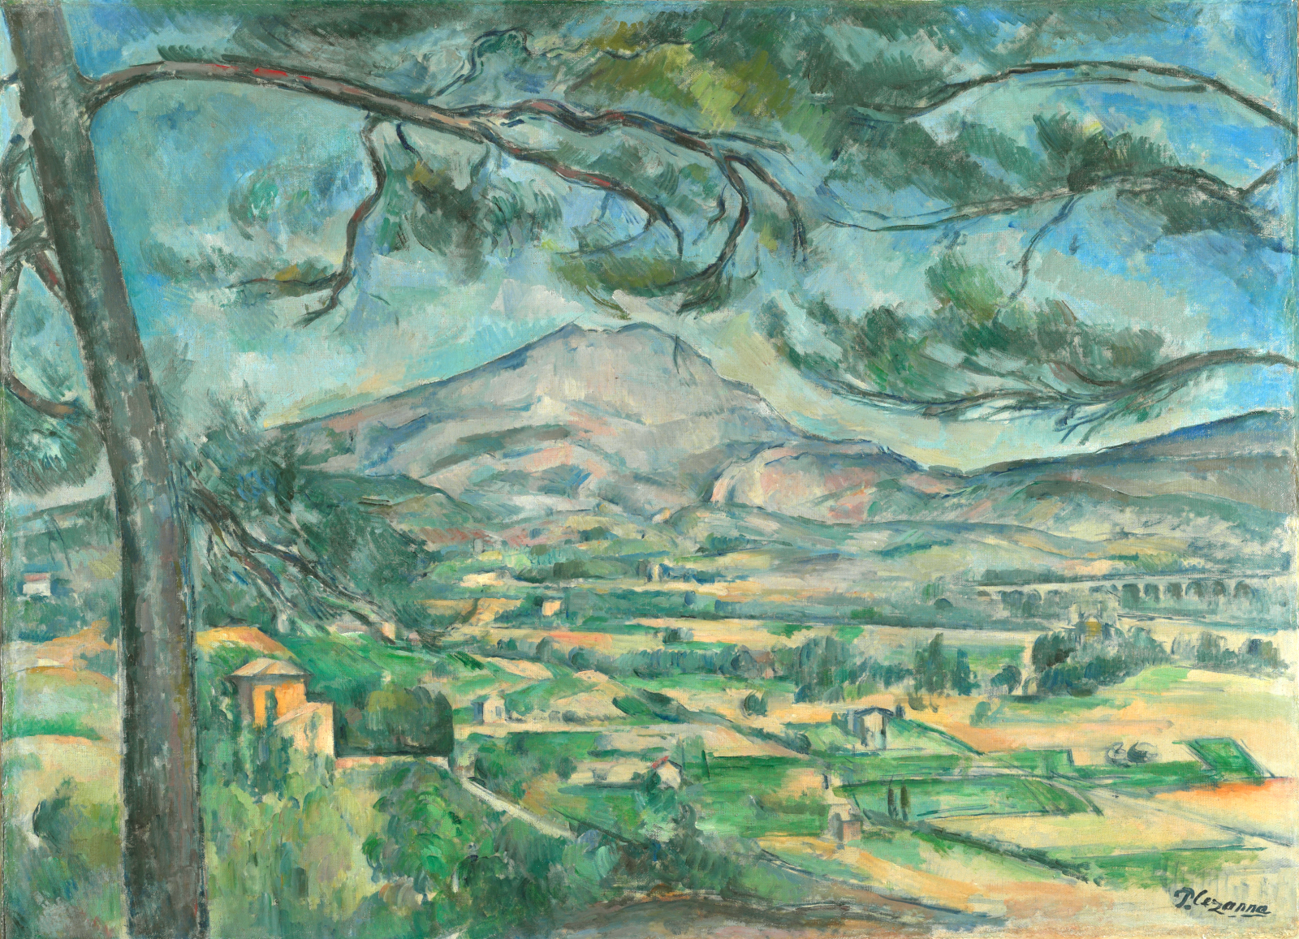
Paul Cézanne(1839-1906), Montagne Sainte-Victoire with Large Pine, 1887 (circa)

Step 1: Please consult the following web resources.
Heilbrunn TimeLine of Art History: Paul Cezanne
https://www.metmuseum.org/toah/hd/pcez/hd_pcez.htm
Philadelphia Museum of Art http://www.philamuseum.org/collections/permanent/104464.html?mulR=1488290774|16
http://www.philamuseum.org/collections/permanent/63135.html?mulR=2004305338|20
Guggenheim
https://www.guggenheim.org/arts-curriculum/topic/paul-cezanne
https://www.guggenheim.org/artwork/783
https://www.guggenheim.org/artwork/785
https://www.guggenheim.org/artwork/786

Step 2: Select one of Cezanne’s paintings and post it to the discussion board on moodle.

Step 3: List the ways in which the painting that you have selected displays the essential qualities of Cezanne’s approach to painting. Please bring your notes with you to class.

