HART B120 History of Chinese Art
Week 2: Design and Technique

Task 1:
Can you summarize the basic process of piece-mold casting? What are the major steps? How do you properly describe the relationship between design and technique?
Please test your ideas with the following bronze ding cauldron:
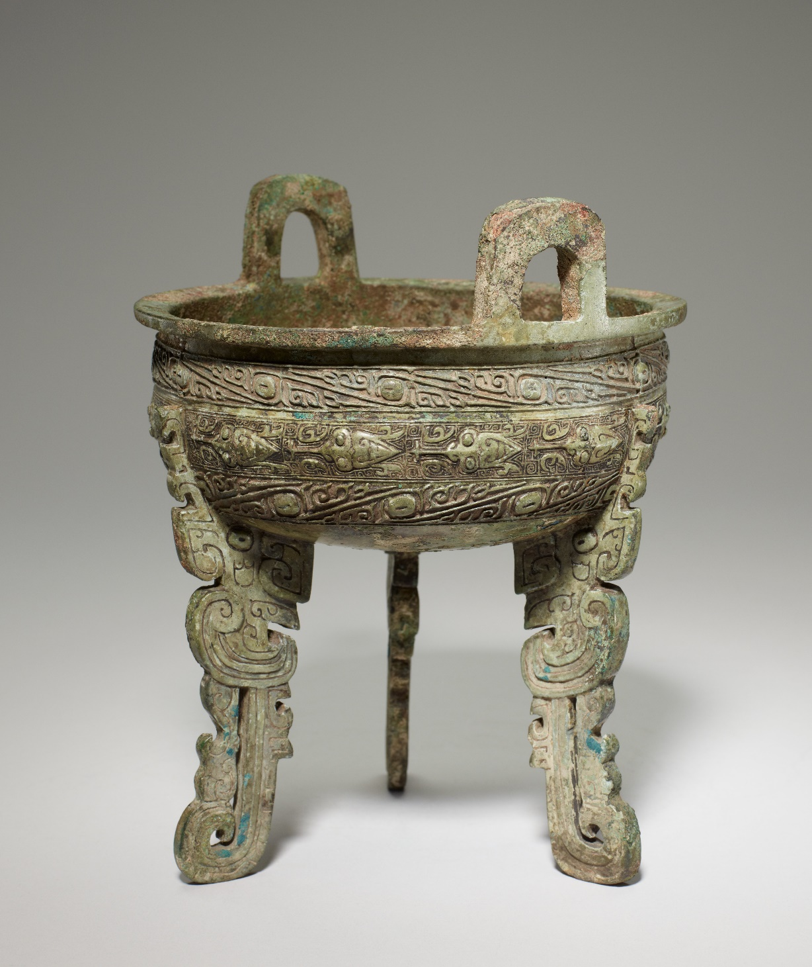
https://collections.artsmia.org/art/816/ding-food-vessel-china
For more details, please check the 3D model of this vessel, see:
https://sketchfab.com/3d-models/ding-food-vessel-11th-10th-century-bce-6d3936d74ab942d48e9ddb985182eeea
Please: (1) Describe the vessel’s shape and ornament. (2) Discuss: What physical traces (evidence) do you find on the vessel that might suggest the use of piece-mold casting technique? And how do these traces reflect the artist's ornamentation strategy?
Please write down your observations below:
(1)

(2)

Task 2:
There is a "metalworking hypothesis," which suggests that before the piece-mold cast technique was adopted, there was an intermediary "metalworking" stage in which Chinese artists imitated earlier metalworked prototypes. Please compare the earlier Erlitou bronze jue cup (17th century BCE) with the later Shang jue cup and explain whether you support this hypothesis or not.
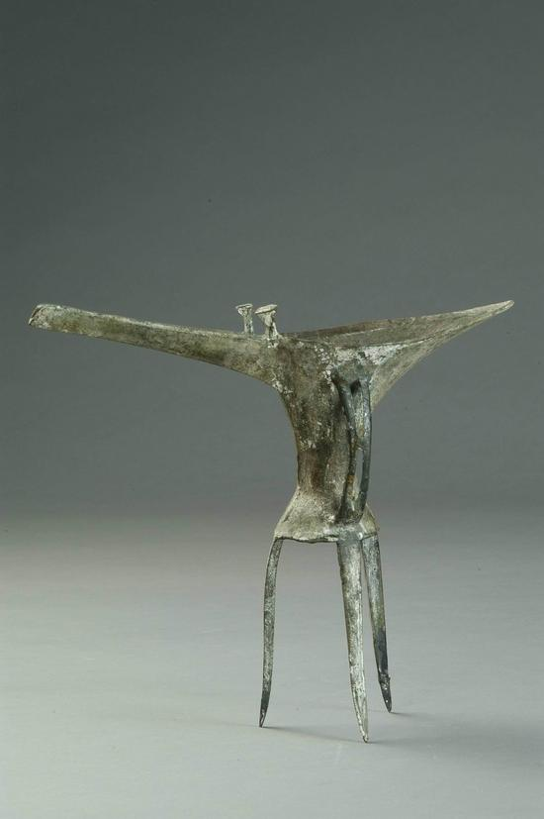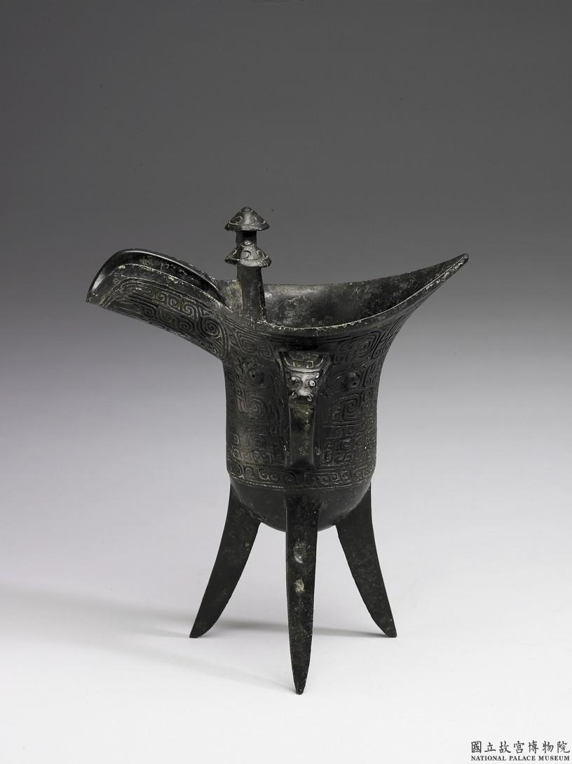
Please write down your observations below:

