Object list
B120 History of Chinese Art
Special Collection, Bryn Mawr College

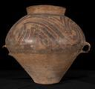 |  | Pot  Pottery  2009.28.14
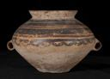 |  | Pot with Two Small Handles  Pottery  2009.28.13
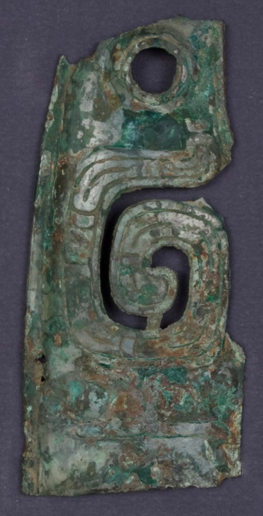 |  | Fragment of a Taotie Mask  Bronze  TN.31
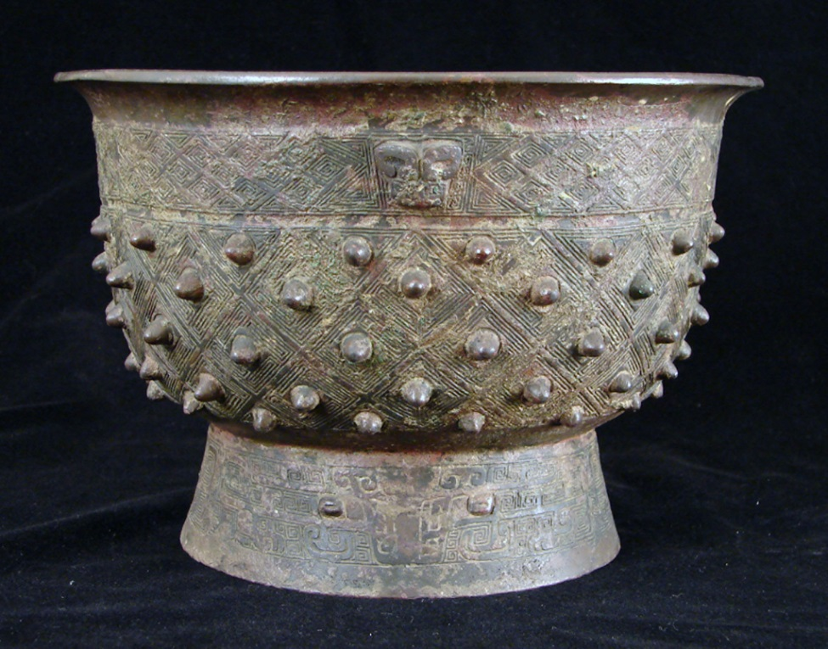 |  | Yu (Ritual Food Vessel)  Bronze  TN.127
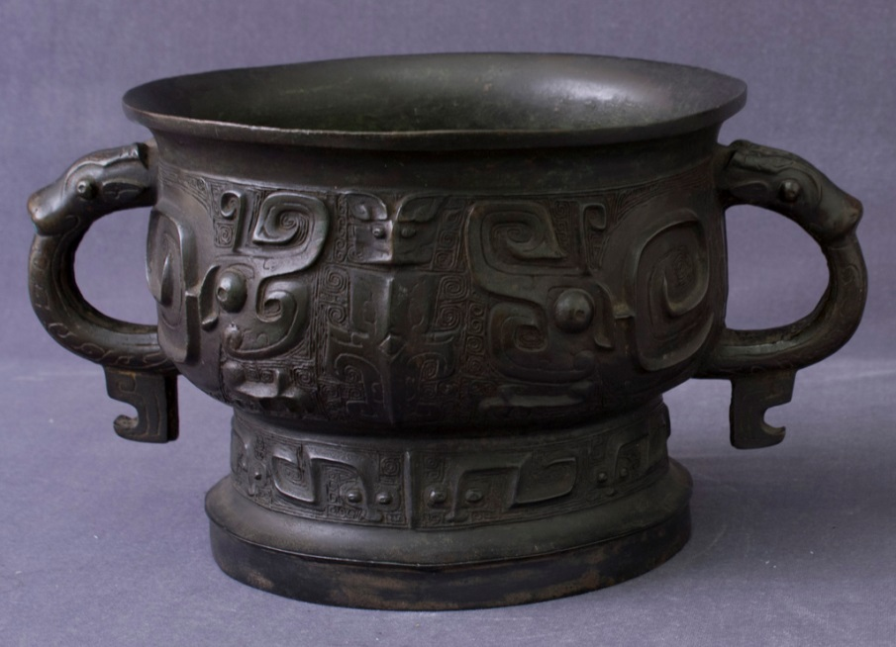 |  |  | Kuei  Bronze  TN.125
  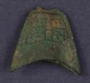 |  | Small Bell  Bronze  32.42
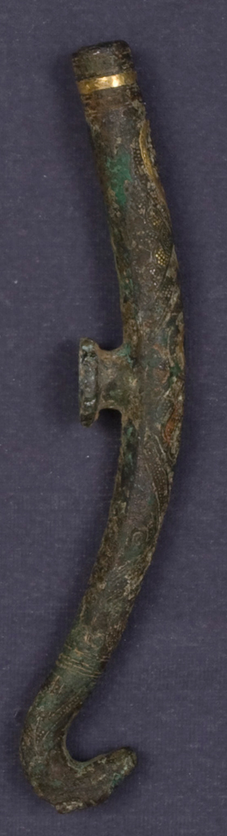 |  |  | Buckle Hook with Inlay  Bronze with gold inlay  47.162
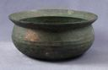 |  |  | Basin  Bronze  TN.128

