HART B 120 History of Chinese Art
Han Bronze Mirror Designing Workshop
Instructions
This session is designed to deepen the understanding of the principles of mirror designing, and more broadly, all artistic designs in Han China related to cosmology.
In order to make a historically right mirror, the designer should understand these following aspects:
- Variable and invariable elements in the design;
- The difference between major and minor motifs;
- The cosmological symbolism of the overall design.
Here is a summary of the basic principles:
- The four major motifs (turtle-snake, dragon, bird, and tiger) respectively represent the four cardinal directions (north, east, south, and west) of the earth, which rotate counterclockwise;
- Minor motifs are those creatures other than the major motifs; they usually contradict the major motifs in orientation and position to form a pair of mirror images;
- The inscription (following the mark “…”) usually begin in the northeast quarter of the mirror and rotate clockwise around the major and minor motifs;
- Inscription and major motifs are synchronized, which means the reading of the text triggers the movement of the other.
A right design should enact the movement of the universe: because the inscription is circularly arranged, when you rotate the mirror around the center boss to read the inscription, the major motifs will rotate in the same direction as the earth does---counterclockwise, and chase one another in a dynamic unidirectional circular movement. The minor motif confronts and counteracts the major motif to maintain a visual balance.
A “wrong” design is not only visually awkward, but also symbolically problematic. To the Han Chinese people, the consequence of a “wrong” design might be disharmony of the universe and misfortune to the world. So be serious when you are designing your mirror!
However, all the other aspects of the design are more or less variable, depending on the designer’s choice. Here you can demonstrate your own taste and interest.

EXAMPLE
[Can you find the major motifs and minor motifs? How does the inscription rotate, and from where? Can you tell in this mirror what elements are variable and what are invariable?]

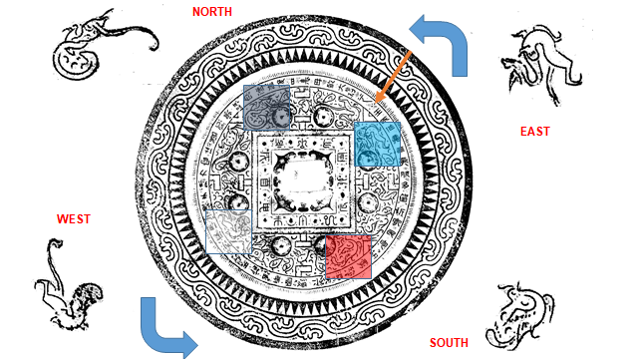

https://digitalscholarship.brynmawr.edu/tlv/

