ANTH B366: Sound, Power, and Resistance
Fall 2026. Wednesdays 1:10-3:30

Professor Amanda Weidman (she/her)
*Please call me “Amanda” or “Professor Weidman,” whichever you are comfortable with.
Email: aweidman@brynmawr.edu
Office: Dalton 212C
Office hours Fall 2026: Tuesdays 11:30-12:30, Wednesdays 11-1, Thursdays 9-10 and by appointment
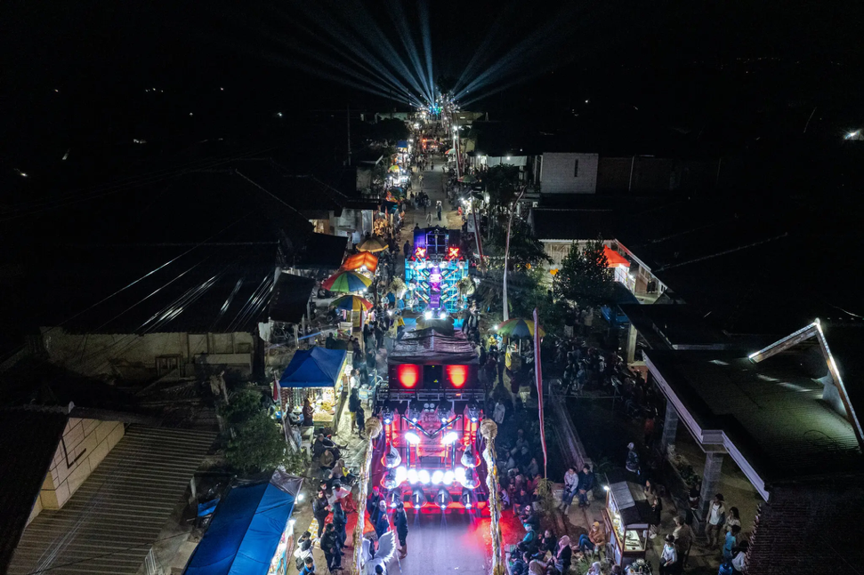
This course builds an anthropological understanding of sound as a product of human creativity, conflict, and interaction with the material world. We will explore the ways that sound is conceptualized and given meaning in different social and political contexts, operating in relation to but distinct from visual forms and media. How has sound been linked to identity and implicated in societal hierarchies? How does sound figure in regimes of governance and political struggles? And how can sound become a claim to space and a call to protest and action? Our critical work will involve listening to ethnographic and artistic sound-based work, and engaging with readings from anthropology, ethnomusicology, and the interdisciplinary field of sound studies. Our creative work will be to experiment with collaborative sound-based ethnographic research and forms of documentation involving recording, sound editing, podcasting, and sound mapping.
A parade with sound horegs (speaker trucks) in Indonesia, 2025
(photo: Ulet Ifansasti, New York Times)

You know, because, we are so blind
We can't see, we cannot see the creator of a tree
The creator of a bee, the creator of you and me
What are you doin' to make things better?
Well, you see – we are scientists of sound
We're mathematically puttin' it down

-Kool and the Gang, “Heaven at Once,” Sept 1973

Readings:
There are three required books for this course, available at the Bryn Mawr Bookshop, on reserve at Canaday Library, and online through Tripod. The other readings and materials will be available through Moodle.
- Sakakeeny, Matt (2013) Roll With It: Brass Bands in the Streets of New Orleans. Duke University Press.
- Goshadze, Mariam (2025) The Noise Silence Makes: Secularity and Ghana’s Drum Wars. Duke University Press.
- Schwenkel, Christina (2025) Sonic Socialism: Crisis and Care in Pandemic Hanoi. University of California Press.

Technology:
There are 3 Zoom H1Essential Handy digital audio recorders, and 3 SonicPresence binaural mic sets that can be used for recording with an iPhone, in the Anthropology department. These can be signed out with me for your use in recording projects. Additionally, there are 5 older-model Zoom H1 digital audio recorders held by LITS that can be signed out from Canaday Library. If you don’t have a good pair of earphones to use with the recorders, these can also be signed out from Canaday Library.

Field trips/activities outside of class time:
(Please let me know of any unsolvable conflicts in advance.)
- visit to sound sculptures/installations in Philly- on your own time between 9/9 and 9/20
- listening session at Jaharis Hall, Haverford College, Monday 9/14, 7-8:30 pm
- sound editing workshop with Philadelphia Sound Museum Collective, TBD maybe week of 11/18
- conversation with author Christina Schwenkel TBD Tuesday 11/10

Assignments and Requirements are detailed at the end of this syllabus.

Course Schedule:
*please do readings before class on the day listed.

9/2 Introduction to the course
- Basic sound concepts (handout)
- Visual representations of sound (waveforms, spectrograms)- links on Moodle
- Developing vocabulary to talk about sound: “bring in” sounds to listen to/discuss
- Short articles/blog pieces, including: [links on Moodle]
  - NYT Feb 17, 2026 “Drones’ menacing whir dominates Beirut life.”
  - NYT Oct 22, 2025 “Around here, it’s not a party without a bone rattling speaker truck.”
  - Jones, Ryan (2022) “Metal’s Circle Dance.”
  - Gupta, Anusree (2022) “Audioscapes of the Platform Economy”

9/9 Sound Ethnography: Concepts and Methods
- Feld, Steven (1984), “Sound Structure as Social Structure”
- Feld, Steven and Don Brenneis (2004), “Doing Anthropology in Sound”
- Shafer, Murray (1977) excerpts from “The Soundscape: Our Sonic Environment and the Tuning of the World” (Introduction, “Classification,” “Listening,” and “Glossary”)
- Akiyama, Mitchell (2015) “Unsettling the World Soundscape Project.” https://soundstudiesblog.com/2015/08/20/unsettling-the-world-soundscape-project-soundscapes-of-canada-and-the-politics-of-self-recognition/#comment-330391
- Peterson, Marina and Vicki Brennan (2020), “A Sonic Ethnography: Listening to and with Climate Change.”
- Bitter, Joella (2022) “Ten Ways to Listen.” https://www.anthropology-news.org/articles/ten-ways-to-listen/
- Guttierez, Amanda (2016) “What is a Sound Walk?” https://sensoryethnographygroup.wordpress.com/2016/10/13/what-is-a-soundwalk/
- (optional) Palmese, Michael (2022) “The World Ear Project (1970-87): Soundscapes, Politics, and the Genesis of Acoustic Ecology.”
- orientation to recording equipment in class

*Between 9/9 and 9/20: visit at least one of these sound exhibits/installations in Philly:
- Museum Without Walls
https://www.associationforpublicart.org/program/mww-audio/#
- Let Freedom Ring (thru Sept 27; artist talk Sept 23 6-8 pm)
https://www.associationforpublicart.org/let-freedom-ring/
- Ellen Reid Soundwalk
https://www.ellenreidsoundwalk.com/philadelphia

*Monday, Sept 14, 7:00-8:30 pm: Listening Session: works by Ernst Karel, Alvin Lucier, Steven Feld (session will be held in Jaharis Recital Hall, Haverford College)
9/16 Recording Workshop with Philly Sound Music Collective
- Lane and Carlyle, eds (2011) In the Field: The Art of Field Recording (pick 1 interview to read)
- Makagon and Neuman, “Sonic Compositions” in Recording Culture
- Smiley, Sam (2015) “Field Recording or Field Observation? Audio meets Method in Qualitative Research.”
- listening: Feld, Turnbull, Schwartz recordings

9/23 Sound, Spatial Politics, and Social Inequality
- Martin, Alison (2021) “Plainly Audible: Listening Intersectionally to the Amplified Noise Act in Washington DC.”
- Martin, Alison (2019) “Hearing Change in the Chocolate City.” https://soundstudiesblog.com/2019/08/05/hearing-change-in-the-chocolate-city-soundwalking-as-black-feminist-method/
- Veeraraghavan, Lee (2020) “What is ‘Heard” at a Pipeline Hearing?: The Gerrymandering of Aurality in British Columbia, Canada.”
- Bates, Elliot (2012), “What Studios Do.”
- Sterne, Jonathan (1997) “Sounds like the Mall of America: Programmed Music and the Architectonics of Commercial Space.”
- Eisenlohr, Patrick (2021) “Atmospheric Citizenship: Sonic Movement and Public Religion in Shi’i Mumbai.”

9/30 Sound, Spatial Politics, and Social Inequality, cont’d
- Sakakeeny, Matt (2013) Roll With It
- (Optional) Sakakeeny, Matt (2010) “Under the Bridge: An Orientation to the Soundscapes of New Orleans.”
- Recording assignment 1: quiet sounds/loud sounds

10/7 Amplification, Space, and Place
- Karel, Ernst (2003) “Loudspeaker Broadcasts and the Social Construction of Space.”
- Gerety, Finian (2017) “The Amplified Sacrifice: Sound, Technology, and Participation in Modern Vedic Ritual.”
- Larkin, Brian (2014), “Techniques of Inattention: The Mediality of Loudspeakers in Nigeria.”
- Goshadze, Mariam (2025) The Noise Silence Makes, Intro pp 1-10, chp 1
- Recording assignment 2: indoor/outdoor sounds

Fall Break

10/21 Amplification, Space, and Place, cont’d
- Goshadze, Mariam (2025) The Noise Silence Makes, chps 2, 3, 5, 6
- Eisenberg, Andrew (2019), “Resonant Voices and Spatial Politics: An Acoustemology of Citizenship in a Muslim Neighborhood on the Kenyan Coast.”
- In class: visit from Andrew Eisenberg

10/28 Affective and Embodied Experiences of Sound
- Lorea, Carola (2021) “Singing as Method and the Epistemology of Singing Across Bengali Esoteric Lineages.”
- Heller, Michael (2015), “Between Silence and Pain: Loudness and the Affective Encounter.”
- Novak, David (2013) chp 1 and selection from chp 5 (pp 139-148) from Japanoise: Music at the Edge of Circulation.
- Tatro, Kelley (2014), “The Hard Work of Screaming: Physical Exertion and Affective Labor among Mexico City’s Punk Vocalists.”
- Henriques, Julian (2003), “Sonic Dominance and the Reggae Sound System.”
- 9/11 memorial “Tower of Voices”
  - https://www.nps.gov/media/video/view.htm?id=F138C110-5F52-4B9D-AE59-53D62543D07A
  - https://www.popsci.com/sonic-memorial-september-eleventh/
  - https://www.nps.gov/flni/planyourvisit/tower-of-voices.htm

11/4 Public Space and the Politics of “Noise”
- Hsieh, Jennifer (2021) “Noisy Coexistence: Contestations of Renao and Zaoyin amidst Taiwan’s Noise Control System.”
- Sykes, Jim (2015), “Sound Studies, Religion, and Urban Space: Tamil Music and the Ethical Life in Singapore.”
- Cardoso, Leonardo (2018), “Sound Politics in Sao Paolo: Noise Control and Administrative Flows.”
- Peterson, Marina (2021), chp 3 “Environmental Imaginaries” in Atmospheric Noise
- Recording assignment 3: soundwalk

*Friday November 6: written component of your soundwalk due

* Tuesday November 10 (To be confirmed) conversation with author Christina Schwenkel

11/11 Sonic Governance
- Schwenkel, Christina (2025) Sonic Socialism
- Guy, Nancy (2021) “Listening to Taiwan’s Musical Garbage Trucks.”
- In class: brainstorming for final project

11/18 Sound and Image
- Chion, Michel (1994) excerpts from Audio-Vision: Sound on Screen (see also notes to Chion)
- Nakassis, Constantine, and Weidman, Amanda (2018) “Vision, Voice, and Cinematic Presence.”
- Maurice, Alice (2002) “Cinema at its Source: Synchronizing Race and Sound in the Early Talkies.”
- Hunt, Nancy Rose (2008) “An Acoustic Register, Tenacious Images, and Congolese Scenes of Rape and Repetition.”
- Group audio-visual analysis project in class
- Conversation with Monique Scott about audio in museum exhibits

*Date TBD: Sound editing workshop with Philly Sound Music Collective

11/25 No Class Meeting (Thanksgiving Break) Sound Mapping Projects and Ethics
- Please sign up for one of the sound mapping projects listed on the google doc to explore and present briefly to the class on 12/2.
- Ethics notes- look over. We will discuss in class 12/2.
- Rosenblum, Ely (2016), “Auditory Ethics”
- Cook, Ian (2020) “Critique of Podcasting as an Anthropological Method.”

12/2 Sound in Protest
- English, Lawrence (2020) “Voices, Hearts, and Hands: How the Powerful Sounds of Protest Have Changed Over Time.” The Conversation.
- Srivastava, Vinita (2022) “How Powerful Sounds Amplify Resistance.” The Conversation.
- Cities and memory protest sound map https://citiesandmemory.com/protest/
- Tausig, Ben (2011) “Bangkok is Ringing” (podcast, 6 episodes, each about 12 mins—listen to at least 2 episodes)
- King, Homay (2012) “Antiphon: The People’s Microphone.”
- Kunreuther, Laura (2018), “Sounds of Democracy: Performance, Protest, and Political Subjectivity.”
- Vadasaria, Shaira (2023) “Sensory politics of return: Hearing Gaza under Siege.”
- (Optional) Eckstein, Justin (2025) Sound Tactics: Auditory Power in Political Protests (chps 3, 4, or 5)

12/9 Wrapup, work on collaborative class project
- Recording Assignment 4: raw audio footage for final project

*Friday, December 18: Final project due

Requirements and Assignments:
Your work in this class will involve reading, writing, listening, discussing, and sound-based ethnographic and creative work. Further guidelines for assignments will be posted on Moodle.

Participation in discussion 5 points
Reading/listening journal 40 points
Short recording assignments 10 points
Soundwalk with written piece 15 points
Final project with written paper 30 points

Sound-based work (further guidelines to be posted on Moodle)
- In the first half of the semester, there are two ungraded recording assignments to help hone your awareness and recording skills, using the recording equipment to experiment with recording quiet and loud sounds (due 9/30) and indoor and outdoor sounds (due 10/7). You will get credit for doing these (each 5 points; 10 points total).
- In the second half of the semester, you will create a short soundwalk from somewhere in the city of Philadelphia, with a written accompaniment (due 11/4, 8 points). We will discuss these soundwalks in class and you can use your soundwalk recording to learn/experiment in the sound editing workshop.
- The final project will be your sonic “story” or “portrait” of a particular site, space, place, or event in the city, which we will aim to integrate into a collaboratively produced “sound map” of Philadelphia (raw recording due 12/9, edited soundpiece due 12/18,15 points).

Reading and Written work (further guidelines to be posted on Moodle)
- Journal. You will be keeping a reading/listening journal throughout the semester. For 10 of the weeks between week of 9/9 and the week of 12/2, please write a reading/listening response of 250-300 words that addresses at least two of the readings/materials for that week. Your responses do not have to be “essays.” You can respond to something you found interesting, raise a question, note connections or parallels from other readings or from your experience, and/or bring in points that arose in our class discussion. You may also include responses to audio pieces or films from our listening material. Please establish a running google doc for this and provide me with the link (10 entries, due 11:59 pm on Wednesdays, each worth 4 points; 40 points total)
- Written accompaniment to your soundwalk (250 words max., due 11/6, 7 points)
- Written paper to accompany your final sound project (4-5 pp, due 12/18, 15 points)

Class Policies:

*This is a small seminar in which discussion and collaborative work are essential. Regular attendance is expected. One absence will be excused. After that, your final grade will be marked down by two points (eg. 4.0 becomes 3.8) for each subsequent absence. If you are too contagious to attend class, but able to attend via zoom, please let me know and I will provide a link.

*Devices. Please honor your commitment to be fully present during class time. Laptops or ipads may be used for notetaking and looking at readings when the class is specifically directed to look at a text you may not have printed out. I may sometimes ask you to close or turn them off during class discussion so that you can give your full attention to the others present.
*Social Media. The Department of Anthropology envisions our classrooms as spaces where both students and faculty can freely exchange ideas and voice opinions on a range of topics. Please do not post on social media things you hear or observe in our classes that are explicitly attributed or could be tracked back to a fellow student or faculty member.
*AI. Please do not use generative AI to produce writing or to produce notes or summaries of readings. Please do not rely on AI overviews when conducting online searches.

