Exhibition Critique: “Picasso Sculpture”
Over Thanksgiving break I was able to see the “Picasso Sculpture” exhibition at the Museum of Modern Art in New York City. This highly talked about show seeks to expand visitor’s knowledge of Picasso’s repertoire. Pablo Picasso (1881-1973) has an extensive body of work and is praised for being the founder of the Cubist movement at the turn of the century. Many people associate Picasso with Cubist paintings like Les Demoiselles d’Avignon (1907), The Old Guitarist (1904) or The Weeping Woman (1937); however, Picasso created a massive collection of cubist sculptures that are not recognized as frequently. The MoMA “Picasso Sculpture” exhibition attempts to rectify that. This exhibition is particularly notable because it is the first time a show like this will be displayed in the United States in over fifty years. There are very high expectations for this show and for how MoMA accurately presents the substantial collection.
The Museum of Modern Art partnered with the Musèe Picasso to create an exhibition that features over 100 of Picasso’s unusual cubist sculptures. Like the corresponding cubist paintings, Picasso’s sculptures are mostly comprised of sharp angles and quirky shapes. Sculptures like Woman in the Garden (1929-30) (Figure 1) and The Bathers (1956) (Figure 2) are two pieces in this exhibition that visitors are immediately drawn to for their bold lines and unique pieces and parts that seem to be suspended in mid-air. Overall, these are the types of Picasso sculptures they will be exposed to in the show. For visitors like me, who know very little about Picasso as a sculptor, the exhibition displays a broad range sculptures of various sizes, mediums and time periods in Picasso’s life. Although the exhibition is loosely organized in a chronological manner, the eleven rooms that the pieces are displayed in allow for careful examination, interpretation and comparison.
The exhibition, which will run from September 14th until February 4th, is certainly a blockbuster event in New York City and the show is clearly designed to accommodate a large audience. In anticipation of the crowds, MoMA has instituted a time ticketing process that allows groups into the space on the hour and these tickets seemed to be selling out quickly during the holiday season. The museum has other ways of accommodating the heavy foot traffic. Held in a special exhibition space on floor four of the museum, the show is formatted in a way that allows for large crowds to move through the space with ease. Since I visited the exhibition on the day after Thanksgiving, the massive crowds made it more difficult to maneuver regardless. However, I can imagine that most other days there is a more regular flow of foot traffic that the layout would be conducive to a larger degree of movement. The key curatorial decision that I found most notable was that the freestanding sculptures were arranged closer to the center of each room. Not only did this encourage visitors to continuously move throughout the space, it also allowed for a 360 degree view of each piece. Sculptures are three-dimensional by their very nature and so it is imperative that they are seen from all angles to better understand the piece overall. In every room of this exhibition, there were at least two or three sculptures that were placed on pedestals, bringing the pieces up to eye level. This was a very effective way of ensuring that visitors could view every detail of the sculpture, which is particularly important for Picasso’s works because there are so many various pieces and parts to be noticed, and made the exhibition more interactive. There is something quite alienating about masterpieces on a museum wall and, while the visitors obviously cannot physically engage with the sculptures, I found that the works were more accessible when they were visible from every angle. I also appreciated that the sculptures were spread out enough in each room to make the exhibition appear less overwhelming. When I initially examined the guide and noticed that there eleven rooms with 100 pieces, I was concerned that the show would feel too long. However, the chronological arrangement of various pieces made it seem like I was experiencing the show in smaller portions. There was a large repertoire for MoMA to exhibit and the curatorial decisions made truly enhanced my engagement with the material being presented.
Aside from the physical placement of the sculptures, the environment and atmosphere also enhanced the visitor experience. The sculptures themselves are generally made out of metal, wood or other nondescript materials. Based on that aesthetic, I anticipated that there would be more color and drama added to the walls, text or lighting as a contrast to the art. However, there was a very monochromatic color scheme in the exhibition. Initially, I was underwhelmed by overall look of the show but I realized the simplicity of the design worked in harmony with the many complicated and intricate details of the sculptures. Additional colors would have distracted from Picasso’s Cubist style. The lighting was also effective in its ability to highlight the special features of each piece. Each freestanding sculpture was lit by an a few track lights on the ceiling. This lighting technique provided ample illumination for the exhibition overall and it created a halo effect on the wall surrounding each piece. The simple exhibition display was just dramatic enough to mirror the drama of the sculptures without overwhelming them.
Another interesting design element was the lack of individual labels on the walls and very little wall text overall. Each visitor was given a small guidebook (Figure 3) when they entered the exhibition that served as a bank of labels for the sculptures. This exhibition guide featured simple outlines of each sculpture and a corresponding number with the general information (date, title, material, etc.) next to it. Again, I was somewhat disappointed when I saw that the information would not be readily available on the walls. However, I soon realized that because of the size of the collection and the massive crowds it would have been impossible to create wall text for every piece and expect visitors to stop and read each one. For me, this was a more non-traditional solution to size of the show and it was very effective in keeping visitors moving through the space at a reasonable speed without rushing them through and not providing any information.
In theory these booklets are a perfect solution. However, as I walked through the exhibition I tried to observe how frequently visitors were actually referring to their guidebooks and I noticed that it was about evenly divided between visitors using it and not. It could be that visitors prefer to have the information more accessible on the wall itself or they were too focused on formally analyzing the sculptures. This did make me wonder whether or not visitors were leaving the exhibition with all of the information that the museum wanted to provide. I also found it interesting that there was a section for notes in the back of the guidebook. I very much appreciated this forum for observation and critique because I believe that it is really important to respect the visitor’s various opinions of the art they are being exposed to, even if they have no previous knowledge of the subject. Again, I tried to take note of people’s usage of this section of the booklet and only saw one visitor actively writing. It may be that this note section went unseen by many visitors, especially if they were not using the guidebook in the first place. Also, there were no writing instruments given to visitors, which prevented them from jotting down their observations if they did not have their own writing instruments. Overall, the concept of the booklet was strong; however, I am not sure if it was being utilized in the intended way.
There were introductory wall text panels for every room that gave a general explanation of the contents of the room and how they related to the timeline of Picasso’s life. Because these panels were the only way visitors could access more comprehensive information, it was difficult to get past the crowds to read each panel. However, the information I was able to gather was sparse, as though certain aspects of Picasso’s life and artistic inspiration were being excluded. The more controversial information about Picasso did not seem to be addressed. Of course, this may not be the forum to present such information about the artist and, since there is so much literature published on Picasso, it may have seemed unnecessary to go too in depth. These panels just seemed to act as a skeletal structure of information for the exhibition; they supported with contextual facts but did not provide extensive analysis.
Although the textual information was lacking, there is a focus on educational programming to compensate for that. These programs are not explicitly advertised in the actual exhibition space; however, there are extensive descriptions on the museum’s website. While the history associated with Picasso’s sculpture might be geared towards a more specific, generally older audience, the museum has made sure that the programs available are accessible to people of all ages. The programs that the general public has access to include sculpture workshops for ages 4 and above, evening tours, gallery discussions about Picasso’s process and materials, and drawing sessions. I was very interested to discover how the museum is attempting to accommodate people with disabilities who are attending these programs. There are specific programs for visitors with hearing or vision disabilities, for senior visitors and those in need of a sign language translator.
I think the hands on sculptures classes for children and the gallery discussion seem the most interesting. While Picasso’s sculptures lack the bright colors or patterns that might be engaging for children, the quirky shapes and whimsical pieces and parts are mostly likely fascinating to a younger audience. Allowing children to form their own Picasso- inspired work of art is a great way to encourage a younger audience to connect and truly enjoy the sculptures they are exposed to. I also think that the more academic gallery discussions about Picasso’s materials and artistic process are good supplements for the lack of textual information provided in the exhibition space.
Overall, the public has positively received the Picasso Sculpture exhibition. Critics are raving about how seeing this show is the opportunity of a lifetime. The size of this particular Picasso exhibition, with pieces coming from all around the world, is a landmark moment for the Museum of Modern Art and would be for any American institution. Various news outlets have reviewed the show and created a substantial web presence for it. In a complimentary review done by Sandy Kenyon for ABC7NY, the exhibition is described as being a “once-in-a-lifetime event.” Reviews like this create a large amount of hype, which only increases the likelihood of large crowds but is fantastic press for the museum. Another review from The Guardian claims that the exhibition design of this show feels like a “new museum that has unearthed a new Picasso.” It seems that it is not just the subject of Picasso as a sculptor that is thought of highly. The simplified design and lack of text on the walls is being perceived as revolutionary and refreshing for museum visitors. A majority of the reviews that are available online greatly admire the exhibition and encourage their audiences to experience the show before it is too late.
There are not many changes I would make to this exhibition. Overall, it is a very powerful show that reinvents Pablo Picasso, presenting what seems like a completely new and contemporary repertoire to the public. One of my only concerns includes the size of the exhibition. I would argue that 100 sculptures might be somewhat excessive and by the time I reached the final room I felt slightly desensitized to what I was seeing. Decreasing the size of the collection that is displayed might allow visitors to go more in depth with the pieces. Another change I might make is having one or two staff members explain how the booklets may be helpful in the exhibition or distribute small writing utensils so visitors can use the guidebook to their advantage during their time in the museum. I understand that this may be difficult because of the large crowds but there must be a way to keep visitors engaged with the art while still walking away with contextual information. Finally, I would suggest that there be a program added specifically for college students. As we discussed during the semester, it is very difficult to create educational programs that appeal to a variety of audiences. It might be interesting if MoMA created a night devoted to college students and this exhibition, much like the Barnes Foundation’s “Open Arts College Night.” An evening of music and performances with a guided tour of the Picasso Sculpture exhibition might be a nice way to engage with the college communities in New York City. Aside from those minor alterations, I believe that MoMA’s “Picasso Sculpture” exhibition is certainly a special event that I would highly recommend. The overview of Picasso’s repertoire was truly eye opening and the Museum of Modern Art’s display of this exhibition is a refreshing take on a popular subject.

Bibliography
Farago, Jason. "Picasso Sculpture Review-A Dumbfounding Triumph." The Guardian.
11 Sept. 2015. Web. <http://www.theguardian.com/artanddesign/2015/sep/11/picasso-sculpture-moma-review>.
Kenyon, Sandy. "Once-In-A-Lifetime Picasso Sculpture Exhibit at the MoMA."
Eyewitness News ABC7. 7 Oct. 2015. Web. 17 Dec. 2015. <http://abc7ny.com/entertainment/once-in-a-lifetime-picasso-sculpture-exhibit-at-the-moma/1021616/>.
"Picasso Sculpture." Museum of Modern Art. Web.
<http://www.moma.org/calendar/exhibitions/1505>.
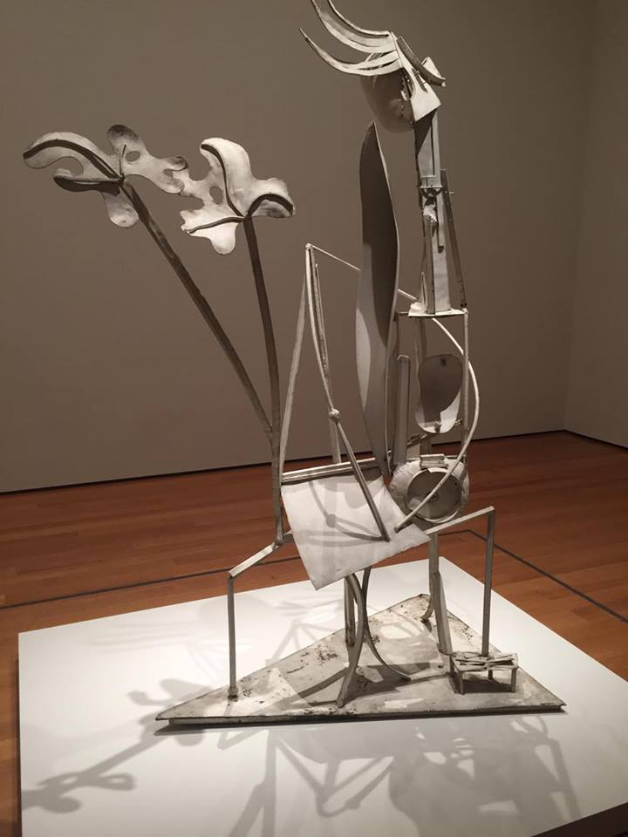
Figure 1. Pablo Picasso, Woman in the Garden. 1929-30. Welded and painted iron. Musée Picasso- Paris.
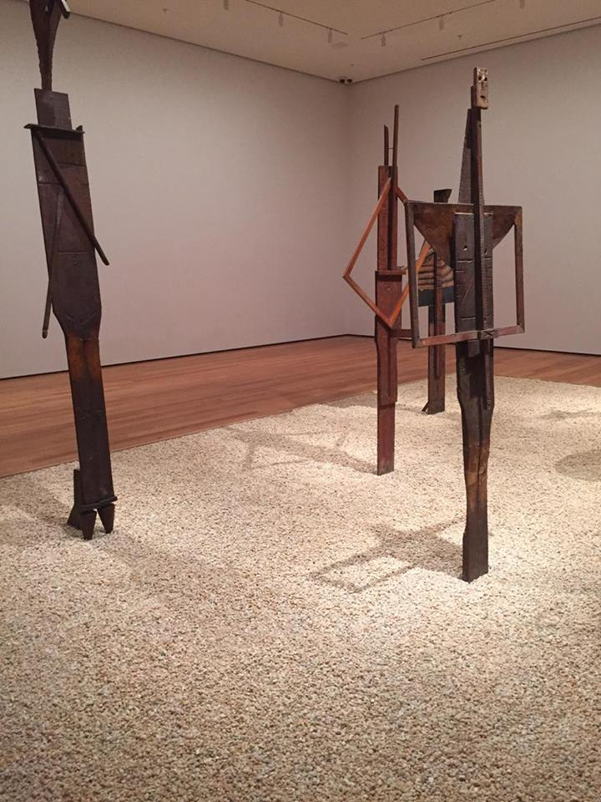
Figure 2. Pablo Picasso, The Bathers. 1956. Musée Picasso- Paris.

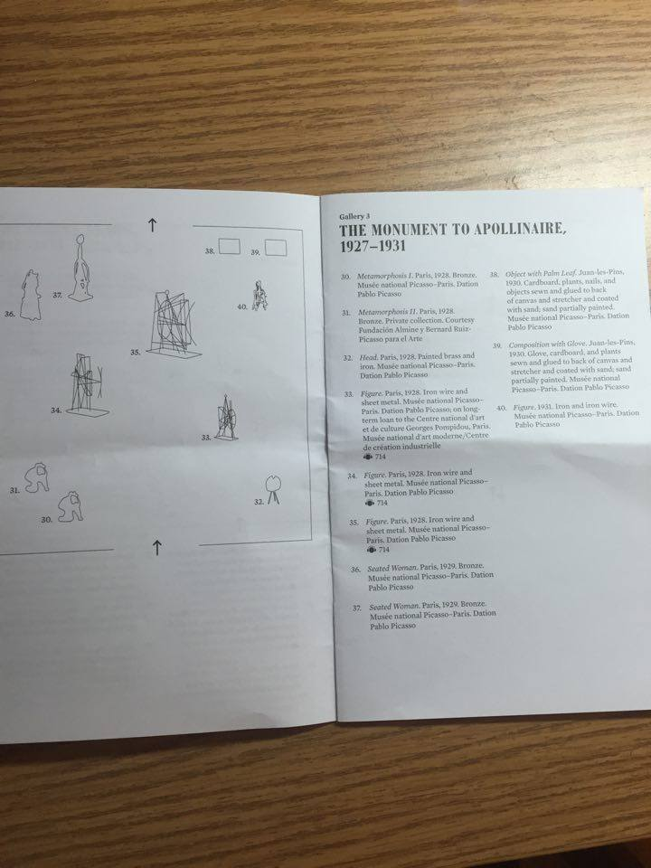
Figure 3. Exhibition Guidebook

General Exhibition Information: "Picasso Sculpture." Museum of Modern Art. Web. <http://www.moma.org/calendar/exhibitions/1505>.
Kenyon, Sandy. "Once-In-A-Lifetime Picasso Sculpture Exhibit at the MoMA." Eyewitness News ABC7. 7 Oct. 2015. Web. 17 Dec. 2015. <http://abc7ny.com/entertainment/once-in-a-lifetime-picasso-sculpture-exhibit-at-the-moma/1021616/>.
Farago, Jason. "Picasso Sculpture Review-A Dumbfounding Triumph." The Guardian. 11 Sept. 2015. Web. <http://www.theguardian.com/artanddesign/2015/sep/11/picasso-sculpture-moma-review>.

