INTRODUCTION TO GIS
FOR SOCIAL AND ENVIRONMENTAL ANALYSIS

C I T Y 201 | B R Y N M A W R C O L L E G E | FALL 2026

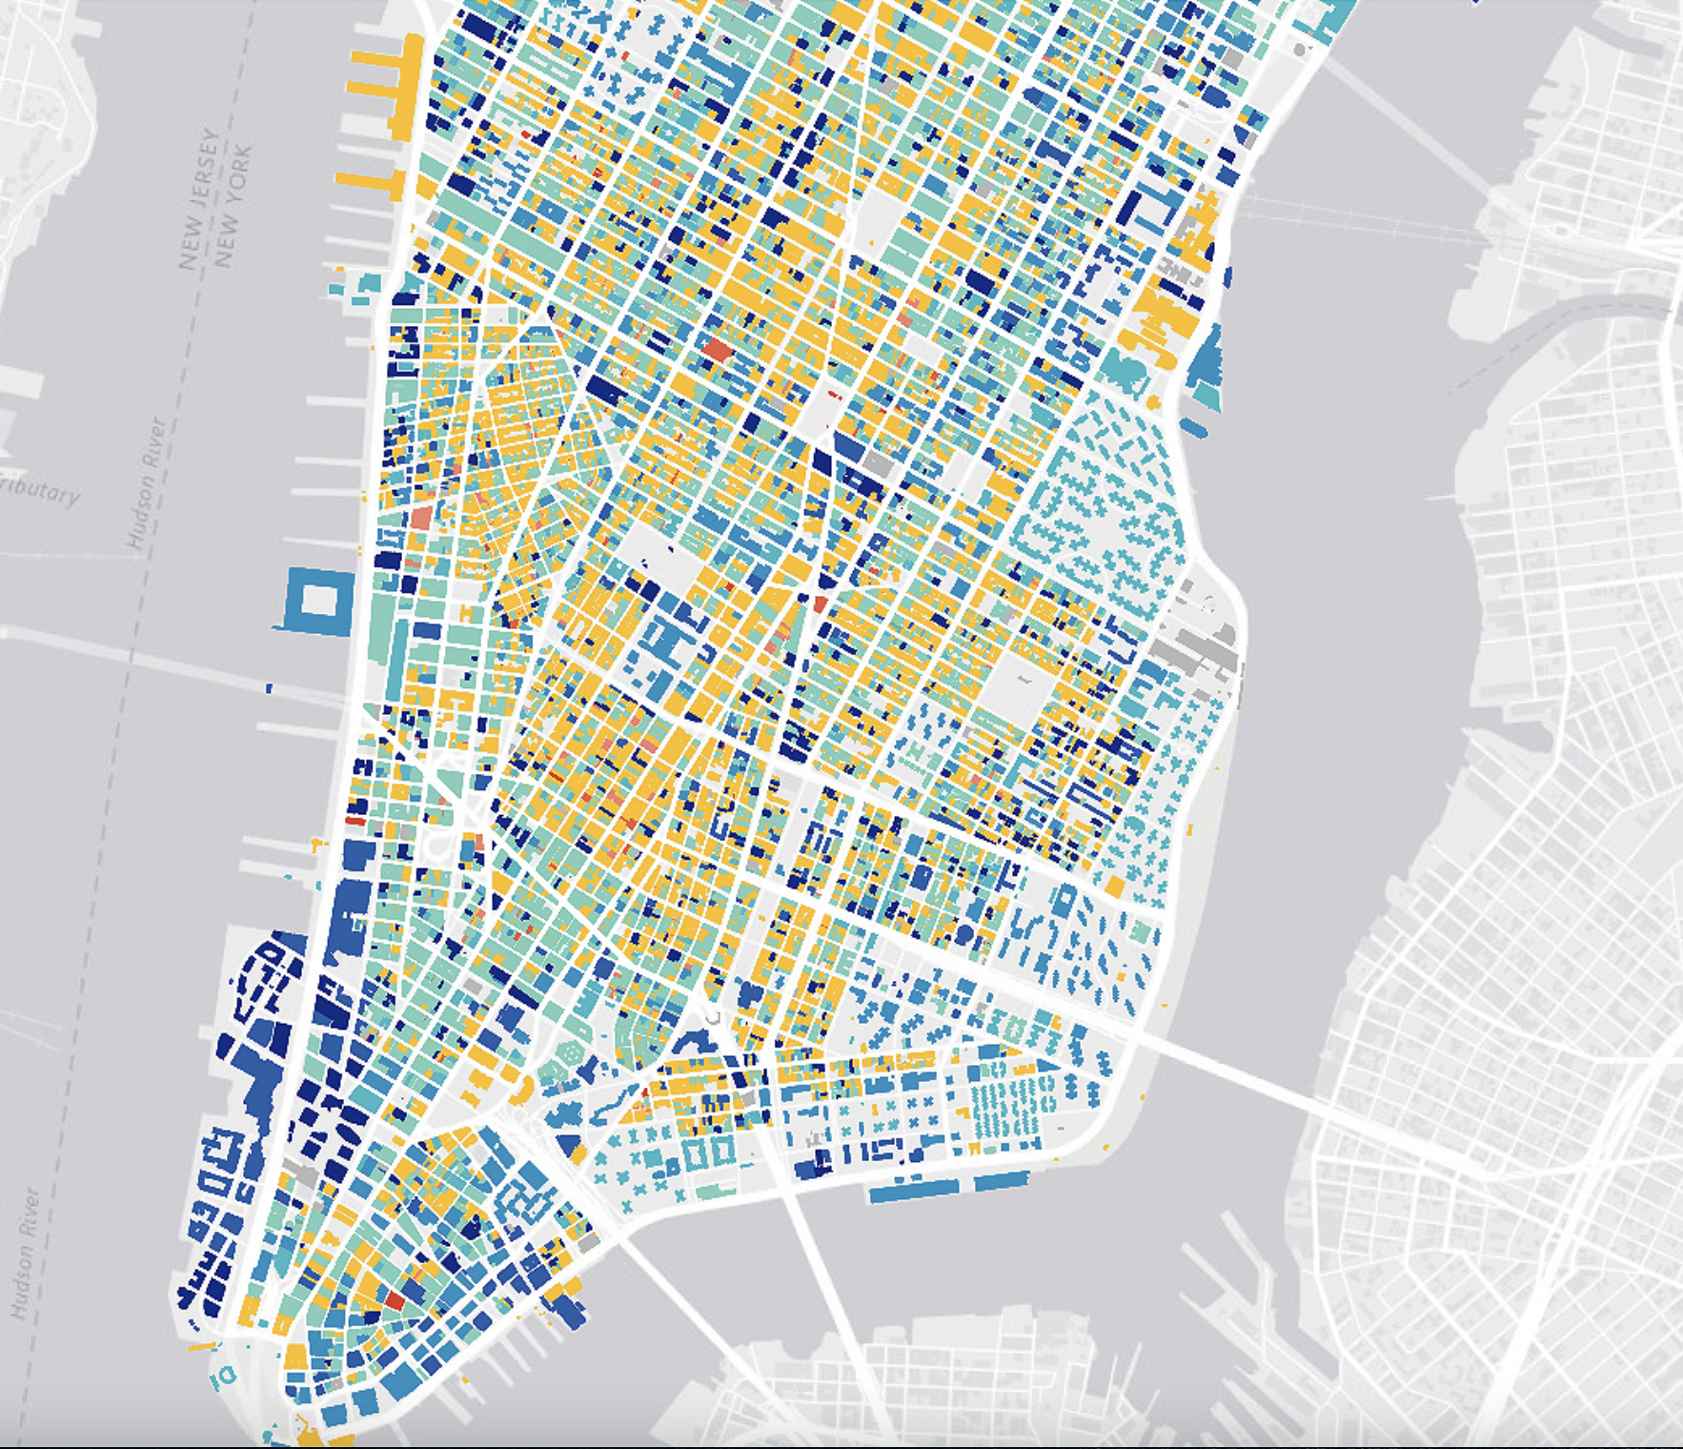

Instructor: Dirk Kinsey
E-mail: dkinsey@brynmawr.edu
Class meeting times and locations and Office Hours times and locations are on course Moodle

C O U R S E D E S C R I P T I O N

This course is designed to introduce the foundations of Geographic Information Systems (GIS) with emphasis on applications for social and environmental analysis. It deals with basic principles of GIS and its use in spatial analysis and information management. Key components of the course include computer representation of geographic information, the construction of GIS databases, spatial analysis with GIS, application areas of GIS, and social and management issues related to GIS.

L E A R N I N G G O A L S

At the end of the course, students are expected to have an understanding of elementary GIS theory, working knowledge of ArcGIS Pro, and the ability to develop GIS-based solutions to geographic analysis tasks.

Please note that this is not 'just' a software training course! You will indeed finish the course with skills in a specific GIS software package (i.e. ArcGIS). However, broader learning objectives for this course include general scientific literacy, basic cartographic and geographic theory, methodology in spatial analysis, as well as further developing your critical thinking skills. You will be a more critical consumer of maps, spatial data and geospatial technologies, and you will be knowledgeable enough to know how to find resources to keep learning.

C O U R S E F O R M A T

Our course meets twice a week and consists of lectures and a strong lab component. A portion of class time will be devoted to lecture and in-class exercises. The lecture is intended, as much as possible, to be an interactive environment. Please feel free at any time during lecture to ask a question or make a comment. I also expect you to respond to discussion questions asked in class. A substantial portion of class time will be devoted to lab. During lab, students work on lab assignments that provide practical experience in applying the concepts learned in lecture. The lab portion of the course will use the commercial GIS software package ArcGIS, created by Environmental Systems Research Institute, Inc. (ESRI). ArcGIS is common in academic, government, and industry settings.

COURSE SCHEDULE

WEEK 1  9/1-9/3 | - Intro to Course & GIS  - Read Bolstad, Chapter 1  - Excel mini lab (Optional)
WEEK 2  9/9-9/11 | - Principles of Mapping & Representation  - Read Bolstad, Chapter 4 (focus on Building a GIS Database [pp. 147-156] & Output: Maps, Data, and Metadata [181-190])  - Lab 1: Getting Oriented in ArcGIS
WEEK 3  9/16-9/18 | - Projections & Coordinate Systems  - Lab 2: Projections, Choropleth Maps, Layouts
WEEK 4  9/22-9/24 | - Attribute Tables and Working With Census Data  - Lab 3: Attribute Data
WEEK 5  9/29-10/1 | - GIS for Environmental Research Topics and Vector Data Models  - Lab 4: TBD
WEEK 6  10/6-10/8 | Lab 5: Vector Models
FALL
BREAK
WEEK 7  10/20-10/22 | - Feminist GIS and Vector Operations 2  - Lab 6: Census Data Join
WEEK 8  10/27-10/29 | - Vector Operations 3
WEEK 9  11/3-11/5 | - Raster Data Model  - Lab 7: Raster Analysis
WEEK 10  11/10-11/12 | - Geospatial Technologies and Carceral Geographies  - Read Predictable Policing: Jefferson (2018)“Predictive Crime Mapping and Geographies of Policing and Race”  - Lab 8 – Network Analysis
WEEK 11  11/18-11/20 | - GIS Day 11/19  - Lab
WEEK 12  11/24 | - Lab Session
WEEK 13  12/2-12/4 | - GIS Ethics  - Read More than Arrows, James Chesire
WEEK 14  12/2-12/4 | - Final Lab “Presentations”

E X P E C T A T I O N S

PREREQUISITES

There are no course prerequisites or prior GIS experience required. However, I expect a working knowledge of Windows and basic file management skills.

ATTENDANCE

There is no class participation grade in this course, so there is no need to seek an “excused” absence if you cannot attend class for any reason. However, class time is heavily used to provide core instruction, work with students to problem-solve issues they are having with lab assignments, and to give feedback about common problems appearing in lab reports. Students tend to work at their own pace on assignments – some need a lot of attention from the instructor and some prefer to work by themselves. I am here to support you and help you learn GIS whatever type of learner you are. Note, however, that the labs are sometimes written without detailed instructions purposefully so that students are required to solve analytical GIS problems using their own knowledge. It is nearly impossible to complete the lab assignments without some guidance from the instructor. Thus, you are unlikely to be successful in this course if you miss more than a few classes.

PRIVACY

To ensure a safe and supportive learning environment for all, please respect confidentiality and privacy with regards to social media postings pertaining to class. If class lectures and structured activities are held on Zoom, they will be recorded. However, the lab portion of class will not be recorded.

A S S I G N M E N T S A N D G R A D I N G

Lab Assignments 1-8 80%
Paper Presentation 5%
Final Lab 10%
Class Participation 5%

* If you are a graduate student, an independent project worth 20% of your final grade is required.

L A B I N F O R M A T I O N

GENERAL

Some portion of class time will be devoted to 'lab' where you will be expected to complete a lab assignment using ArcGIS. You will also need to work on these assignments outside of class, but lab time during class gives you the chance to get immediate help when you run into problems. There are three options for you to access ArcGIS, and details about all three options are on the course Moodle:
- Use LabStats or Apporto to connect to lab computers to use ArcGIS
- On campus computers
- Student License to use on your own computer - $100 for 1 year

LAB ASSIGNMENTS

Each lab contains an assignment that you are expected to complete. This assignment will be focused on an analysis task. For each lab assignment you must hand in a brief report saved as a Word file via Moodle. Do not email me your report and do not submit PDFs or links to Google docs. I will grade and make comments on your report where applicable. You can access your grade and feedback via Moodle. Full lab report instructions are in the Lab Assignment Instructions available on Moodle.

DUE DATES & EXTENSIONS

Due dates are indicated on Moodle. You will have at least one week to complete your lab assignments. Extensions on lab submissions require prior approval. To request an extension, complete my extension request form before the deadline, propose a revised deadline, and explain how it fits in with your other work and obligations. Extensions on lab assignments past two weeks will not be granted without Dean involvement.

GRADING

Each lab will be graded on a rough version of the Bryn Mawr 4.0 scale, where 2 (pass), 3 (good), and 4 (excellent) are typical grades. Labs will be graded based not only on whether you ‘get the right answer’, but also on your ability to express yourself in a coherent fashion through both writing and graphics (i.e. maps).

For labs 1-4, detailed feedback will be provided to individual students via Moodle feedback files. For labs 5-6, detailed feedback will be provided only to students who score <3. For labs 7-8, feedback will be provided through classwide feedback only. Final Lab will have written feedback. Paper presentations will have a grade only with no written feedback.

WORKING WITH OTHER STUDENTS

I encourage students to work together on lab assignments and assist each other in understanding the course material. However, all contents of each student's lab reports (text and graphics) must be authored solely by that student. Please include a line at the beginning of your lab report that indicates who you worked with on the lab.

DATA

Each lab assignment will indicate how to access data for that lab assignment. Labs always take longer than one class period to complete, so you will need to save incomplete labs and continue to work on them at another time. It is the student's responsibility to understand how data and projects are saved, and to manage and back up their own data and assignments. Please keep records of all of your lab assignments for future reference. Later labs may re-use data from an earlier lab, so it is to your benefit to maintain good data organization.

C A M P U S R E S O U R C E S

HONOR CODE

The Honor Code embodies the ideals and values according to which both academic and social life at Bryn Mawr ought to be conducted. The Honor Code assumes that students are trustworthy, that they will live and work with integrity. This assumption confers a number of privileges upon students. The most tangible of these are unproctored self-scheduled and take-home exams; a less tangible but more far-reaching privilege has to do with an environment of self-governance, mutual trust, and dialogue. Clearly, such privileges carry with them enormous responsibility: to live with integrity, to speak honestly to others even when to do so is not easy, to hear what others are saying when that, too, is not easy (from https://www.brynmawr.edu/deans/academic-and-community-integrity). The full text of the Honor Code is available here: https://sga.blogs.brynmawr.edu/honor-board/honor-code/

AI POLICY
AI programs (e.g., ChatGPT) can be useful to help generate ideas, brainstorm, and simplify tasks. You should, however, note that the material generated by these programs may be inaccurate, incomplete, or otherwise problematic. Please be aware that the use of AI may also stifle your own independent thinking and creativity. You may not submit any work generated by an AI program as your own. If you include material generated by an AI program, it should be cited like any other reference material (with due consideration for the quality of the reference, which may be poor). Any plagiarism or other form of cheating via AI will be considered a violation of the Bryn Mawr Honor Code.

ACCESS SERVICES

Bryn Mawr College is committed to providing equal access to students with a documented disability. Students needing academic accommodations for a disability must first register with Access Services. Students can call 610-526-7516 to make an appointment with the Coordinator of Access Services, Deb Alder, or email her at dalder@brynmawr.edu to begin this confidential process. Once registered, students should schedule an appointment with the professor as early in
the semester as possible to share the verification form and make appropriate arrangements. Please note that accommodations are not retroactive and require advance notice to implement. You can
get more information at the Access Services website. http://www.brynmawr.edu/access_services/

THE Q PROJECT

The Q Project supports students who want to work on their quantitative problem-solving and reasoning skills. You can find out more at https://www.brynmawr.edu/academics/q-project.

WRITING CENTER

The Bryn Mawr College Writing Center offers free, individual writing tutorials. The Writing Center is great resource and any writer can benefit from working with a trained tutor. For more information and to make an appointment, please refer to the Writing Center’s website.
http://www.brynmawr.edu/writingcenter/

ACADEMIC AND STUDENT SUPPORT SERVI CES

Bryn Mawr College offers a wide array of resources to help students be successful. The support services listed below can help Bryn Mawr students to:
• Thrive academically
• Manage stress
• Maintain mental health
• Learn about services for students with disabilities
To learn more, go to http://www.brynmawr.edu/academicsupport/StudentSupportServices.html

COUNSELING SERVICES

The Counseling Service provides assessment, treatment, education, consultation, and referral services to support the well-being and functioning of BMC students. There are no financial barriers for needed counseling visits. Bryn Mawr's counseling staff members are trained to help with issues commonly affecting college students. No concern is too small. For more information, please refer to the Counseling Services’ website. https://www.brynmawr.edu/healthcenter/counseling-services

