City 201
Intro to Excel

By the end of this mini-lab, you will know these core functions in Excel:

- Important vocabulary used when working with Excel | - How to insert, delete, and resize r/c/c, how to clear contents
- How to select, deselect, hide, unhide, and move r/c/c (rows/colums/cells), | - How to freeze and unfreeze a row (header)
- How to set print margins – and refresh on formatting skills you probably know in Word | - What is a formula and the formula bar
- What are your cell properties and how to change them | - How to create new worksheets for your clean data set

You will also get experience cleaning real-world data (it’s as glamorous as it sounds!)

Note that the specific instructions in this minilab were created using the Mac 2011 version of Excel. Different Mac/PC versions of Excel have minor differences about where things are located, so if you are using a different version of Excel, you might have to hunt around for where things are. These instructions will at least give you the language so that you can Google more specific instructions for the exact version you are using.

If you do not understand the vocabulary on the right, start with this Introduction to Excel: The Basics for Absolute Beginners video:  https://www.youtube.com/watch?v=VqiDnEoM0_w | - Rows  - Columns  - Cells  - When to use a row v. column  - Worksheet  - Workbook (vs spreadsheet)
Open the Excel file: | Sample Data Muscle4u.xlsx
MOVE COLUMNS  Now, let’s practice selecting and moving a column. Let’s say you want to visually examine gender and muscle gain right next to each other to ‘feel out’ your data. How do you do it by moving the columns? | Play around with moving columns 2 ways:  - Selecting and dragging  - Copying and pasting  If you are having trouble figuring it out, this site might help:  https://www.ablebits.com/office-addins-blog/2014/01/23/swap-excel-columns/
HIDE/UNHIDE  Now, what if you want to see them together by momentarily hiding columns between them?  You can do this with rows, too. | Format > Column > Hide  Format > Column > Unhide  Before you move on, make sure all of your columns are Unhidden
FREEZE OR SPLIT  Wait, once I hit row 50, I can’t remember what these values are. Can I ‘freeze panes’ to keep a header row for convenience? Yes! Try a split, to keep both the top row and the left column in place. | Try different methods:  Select Row 2 (the one just below the column names)  Window > Split  Window > Remove Split  Window > Freeze Panes  Window > Unfreeze Panes  BTW, these work on columns too.  Now select a single cell, say C10, instead of the whole row.  Window > Split  See how this is different than using the split when you have a row selected?  Before you move on, make sure you have no splits or frozen panes.  Note that if you try to copy and paste or sort while panes are frozen or split, you can really create problems for yourself.
BORDERS & MARGINS  What if I want to make it more printer-friendly? Well, you have to add a border and set nice print margins. | File > Page Setup  Check the different options for margins etc on the different tabs in this dialog box  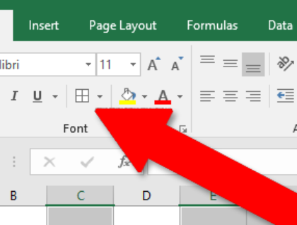  For borders, look on the tool ribbon for a button with borders and play around with the different options
FORMAT NUMBERS  Ok, this all looks nice. Except that I don’t like seeing decimals when I know my muscle gain values are percentages. Do I have to change the cell properties by hand?!? | Format > Cells > Number > set the number of decimals  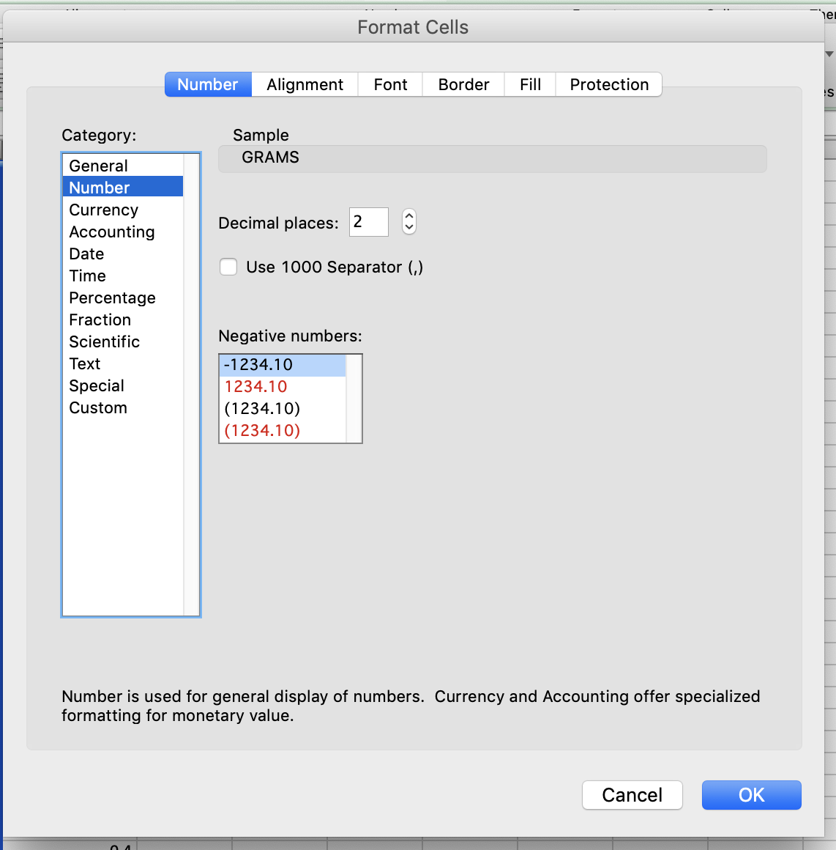  Or, you can use the decimals button on the tool bar to increase or reduce the number of decimals  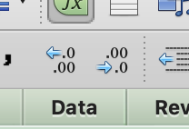
FORMULAS  I understand the basics of how this car runs, but I want to get under the hood and really see it in action. Tell me a bit about the difference between text and formulas… what is the formula bar? How do I switch between entering text and entering a formula? | See what happens when you enter a “=” at the beginning of the cell, with a formula using cell references:  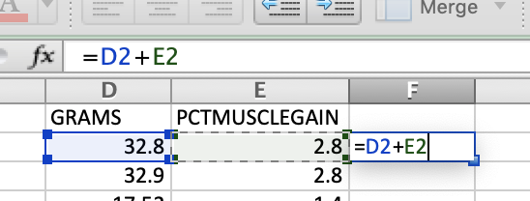  When you hit return, Excel calculates the results!
Holy cow… that is powerful. | Yes, it is!
So you’re saying that I can convert this data using a basic formula – and change from grams to ounces with only about 10 seconds of work? | 1 gram = .035 oz (approx)  In a new column, enter a formula to convert grams to ounces, and then use the “Fill down” command to fill the formula down the whole column to the end of the dataset.
CONVERT FORMULA TO VALUES  What if I want numerals in my column instead of formulas?  Sometimes you calculate a formula, but then you want the column to have actual numbers in them instead of formulas (like when you want to import the table into ArcGIS). | Here’s another great Excel trick. Select the column with our calculated value and then select copy. Now go to Edit > Paste Special, and select Values. Click ok. Looks the same, right? But now put your cursor in one of the cells where you had calculated the values. Wow! No more calculations – just numbers.
CLEAN DATA | Now that I have scrolled down to the bottom of my data, I see that I have an extra number: Row 102 has no other data, but there is a 0.5 in the PCTMUSCLEGAIN column. This number is just a leftover artifact of something and not really part of our dataset, so delete it.
SORT  Our data now is organized by case ID. But I’d like to visually inspect the data broken down by gender. Can I sort the cases by a different variable – say, all female first, then all male? | Date > Sort  Make sure “My list has headers” is clicked, and then choose options to sort your data  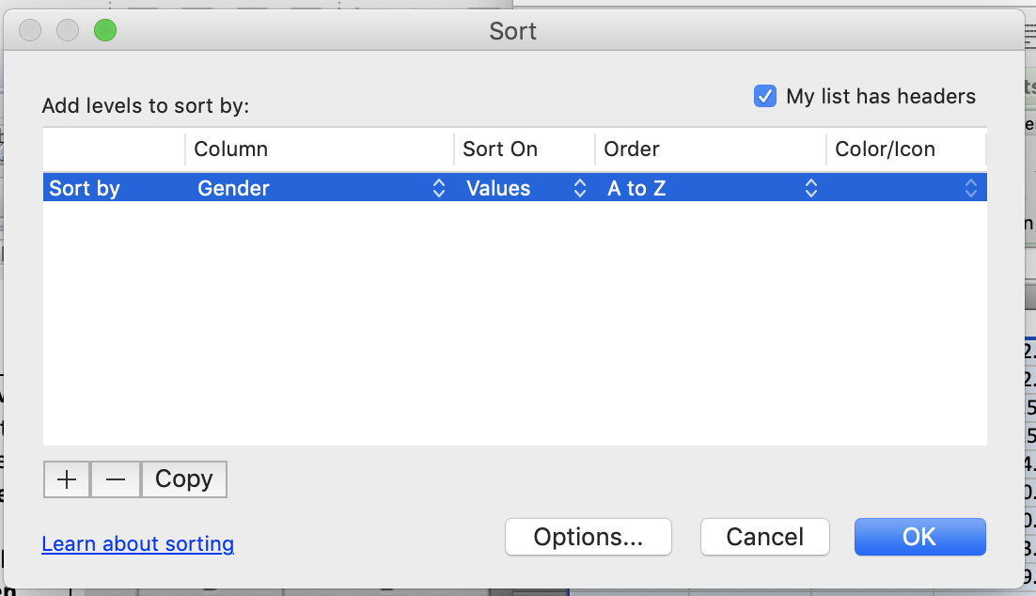  Be careful with sorting – make sure Excel has selected your full dataset and not left out any columns or rows.
FILTER  Actually, I’m only interested in female weightlifters. Can I filter my data to make the men go away? (Have they really ‘gone away’?) | Data > Filter  See those little arrows that popped up? Click on the arrow on your Gender column and choose options so that just Female is showing.
I really, honestly do NOT want men in my dataset. How can I create a new worksheet with only the data I want? | Warning: don’t delete data! Just re-compile it.  Hint: There are multiple ways of doing this, but here’s what I think is easiest:  - Duplicate the sheet  - Rename the copied sheet to “Female”  - Sort the data by gender on the new Female worksheet  - Delete the Male rows  Now you have a worksheet with only female data, but you still have a copy of the original full dataset.
TRANSPOSE  This table is actually set up the right way, where each row is a separate “case” with an ID number. But sometimes you get a dataset where the cases are in columns and the variables are in rows, and you want to swap them. In Excel terms, that’s called “Transpose.” | We’ll try it out:  First, select all of your data (JUST your data – not any extra rows or columns) (5 columns x 101 rows). Use your control keys or the drop-down menus to Copy, then place your cursor in a single cell under your existing data (separated by a few rows to make it easy to see). Now select Edit > Paste Special. In the dialogue box select Transpose and then click ok.  Presto! Now your rows and columns have flipped!
Keep this for reference: | Sometimes you will need to export a table from ArcGIS to Excel. This page has instructions for several different ways to do that:  https://support.esri.com/en/technical-article/000021825

