HOMEWORK: Bar & Column Charts

In the Data_Viz_Homework file, click on the "Bar & Column Charts" tab and complete the following:
1) Create a Clustered Column chart to show Citizen Population, Registered Voters and Confirmed Voters by state, for the Top 10 states by population. Adjust formatting to match the chart below:
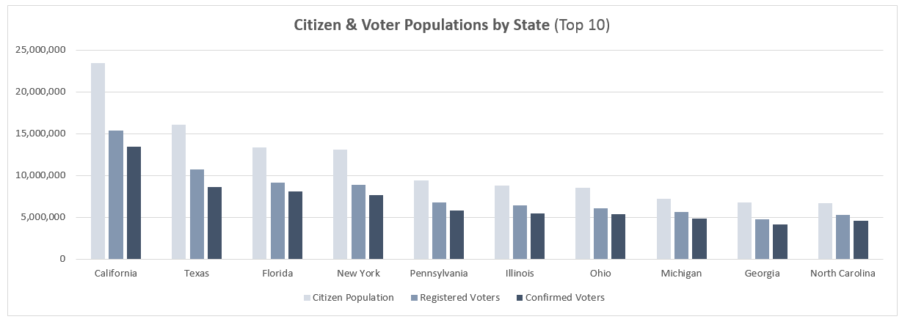
2) Create Bar Charts to show Citizen Population and Confirmed Voters for the same 10 states, and adjust formatting to match the examples below:
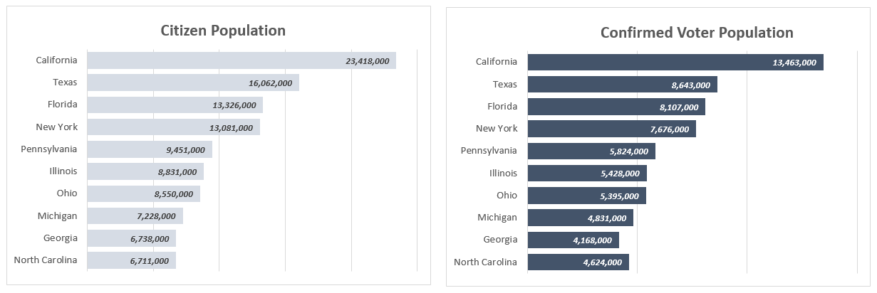

HOMEWORK: Histogram & Pareto Charts

In the Data_Viz_Homework file, click on the "Histogram & Pareto Charts" tab and complete the following:
1) Create a Histogram to show the distribution of Total Pay (k), with a fixed bin width of $10k. Which bin represents the largest portion of the sample?
2) Copy and paste the chart, and change the chart type to a Pareto Chart. Adjust formatting to match the examples below:
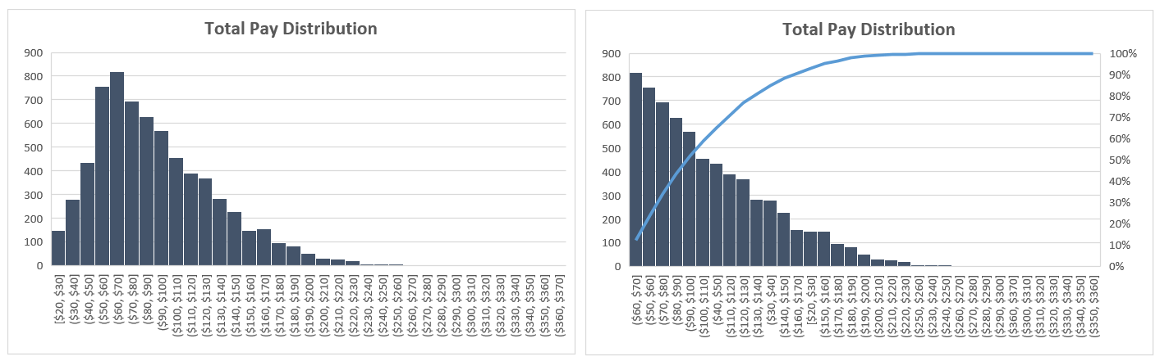

HOMEWORK: Line Charts & Trendlines

In the Data_Viz_Homework file, click on the "Line Charts" tab and complete the following:
1) Insert a Line Chart to show Mean Temp (F) by day for the entire data sample, and add a Polynomial Trendline (Order = 2). How does the mean temperature change over the course of the year?
2) Create a second Line Chart to show Mean Wind Speed (MPH) by day for the entire data sample, and add a Polynomial Trendline (Order = 2). How does the mean wind speed change over the course of the year?
3) Adjust formatting to match both charts below:
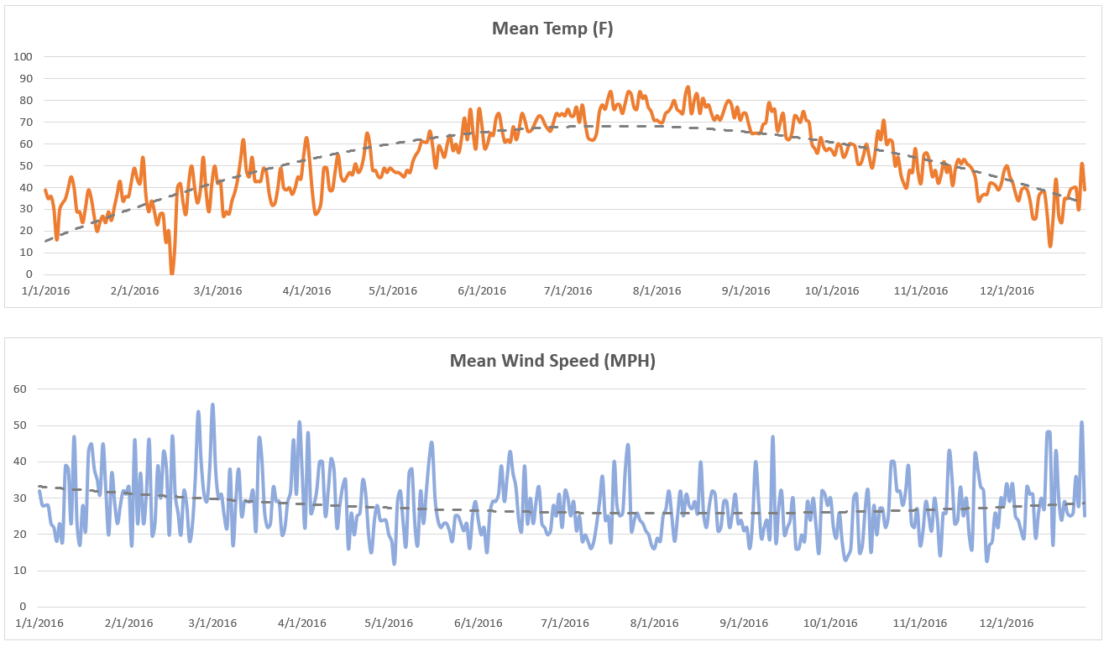
HOMEWORK: Area Charts

In the Data_Viz_Homework file, click on the "Area Charts" tab and complete the following:
1) Rearrange data in columns A-C to show Gross Revenue by Year (as columns), with one row for each Rating (G, PG, PG-13 & R)
2) Using your restructured data, insert a Stacked Area Chart to show Gross Revenue trending by year, by Rating. Update the chart style to match the chart below (hint: it's a standard option):
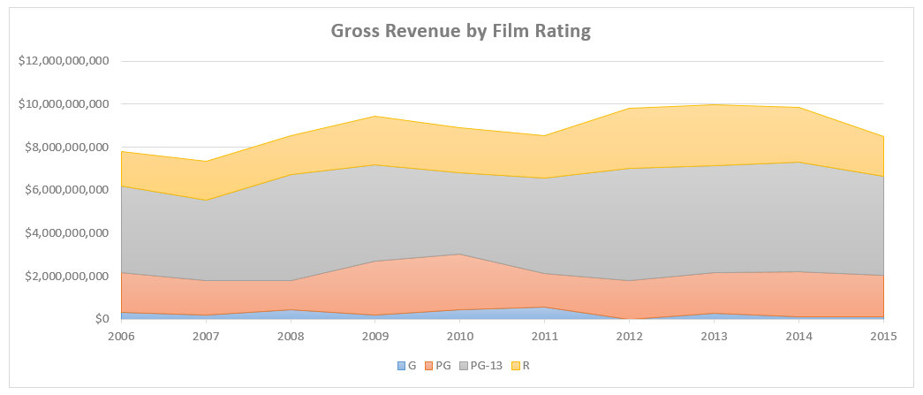

HOMEWORK: Pies, Donuts & Race Tracks

In the Data_Viz_Homework file, click on the "Pie & Donut Charts" tab and complete the following:
1) Create Pie Charts to show the # of Posts and Post Engagements by time of day (Morning, Afternoon, Evening & Late Night)
2) Create Donut Charts to show the # of Posts and Post Engagements by post type (Photo, Video, Link & Event)
3) Adjust formatting to match the Pie and Donut charts below:
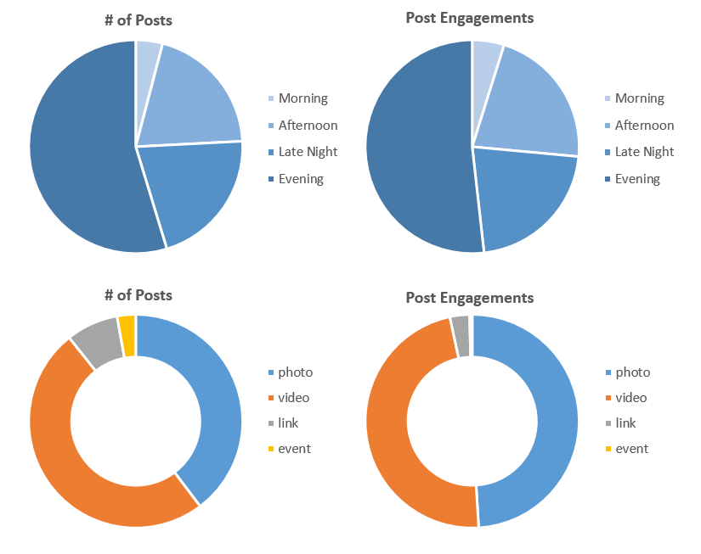
BONUS: Calculate the number of total post engagements (across all post types or times of day), and create source data to make a gauge chart showing progress towards a total engagement goal of 500,000. Adjust formatting to match the example below:
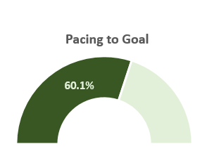

HOMEWORK: Scatter Plots & Bubble Charts

In the Data_Viz_Homework file, click on the "Scatter Plots & Bubble Charts" tab and complete the following:
1) Create a Scatter Plot showing Salary on the X-axis and Wins on the Y-axis, and add a Logarithmic Trendline with the R-squared value displayed on the chart.
2) Duplicate the chart and adjust to show Homeruns on the X-axis instead of Salary. Which metric is more highly correlated with Wins; Salary or Homeruns? (Hint: The higher the R-squared values, the higher the correlation)
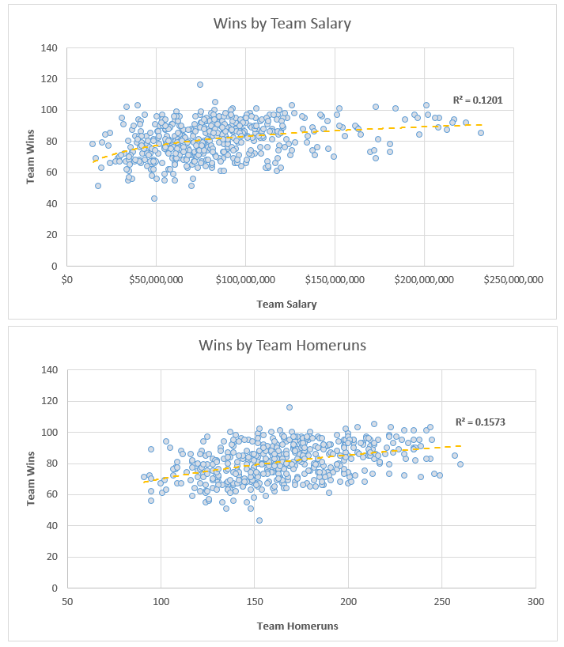

3) Convert your chart from #2 above to a Bubble Chart, update your data ranges to include 2015 only, and make the size of the bubbles a function of Salary. Scale the bubble size to 40, set the transparency to 50%, and add data labels to show the TeamID inside of each bubble:
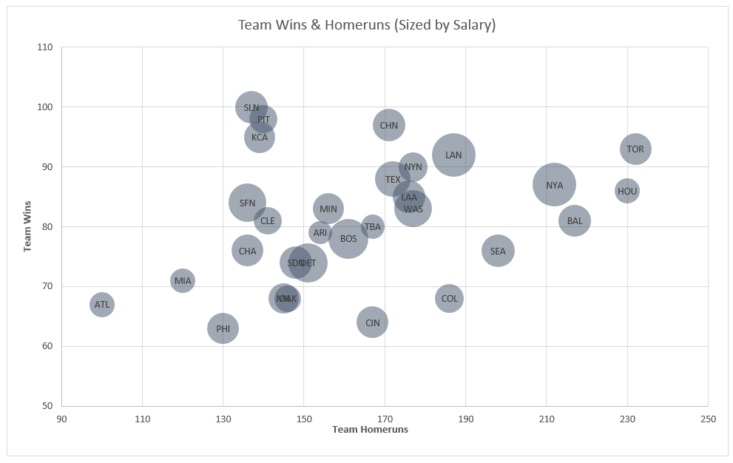

HOMEWORK: Box & Whisker Charts

In the Data_Viz_Homework file, click on the "Box & Whisker Charts" tab and complete the following:
1) Insert a Box & Whisker chart based on the data in columns B and C to show Gross Revenue comparisons across Genres. Your chart should look like the following example:
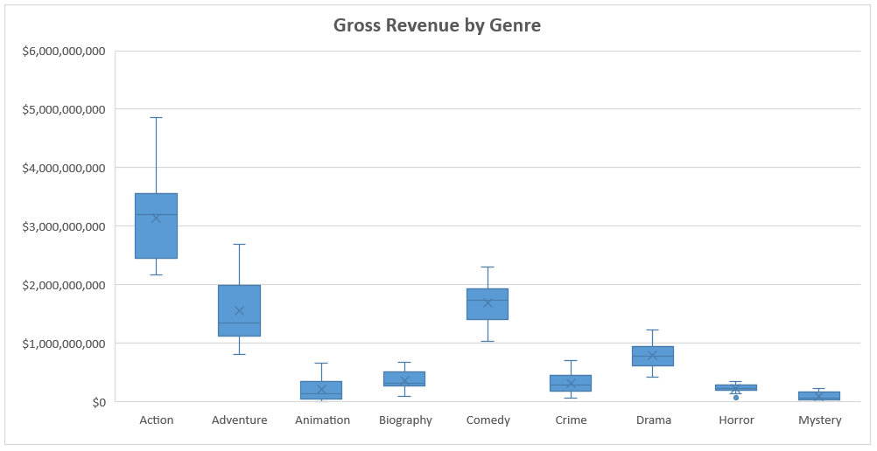

2) Do you see any outliers in the chart? Which genre has the second-highest mean value for Gross Revenue?
(Answers below... No cheating!)

* There is one outlier, noted by a round dot on the chart: Gross Revenue for Horror films in 2002 ($64,933,022). Comedy films have the second highest mean value for Gross Revenue.

HOMEWORK: Tree Maps & Sunburst Charts

In the Data_Viz_Homework file, click on the "Tree Maps & Sunburst Charts" tab and complete the following:
1) Using the Product data in columns A-C, create a Tree Map to show the distribution of orders by Product Category and Product Sub-Category. Duplicate the chart and change to a Sunburst, then adjust formatting (if necessary) to match the examples below:
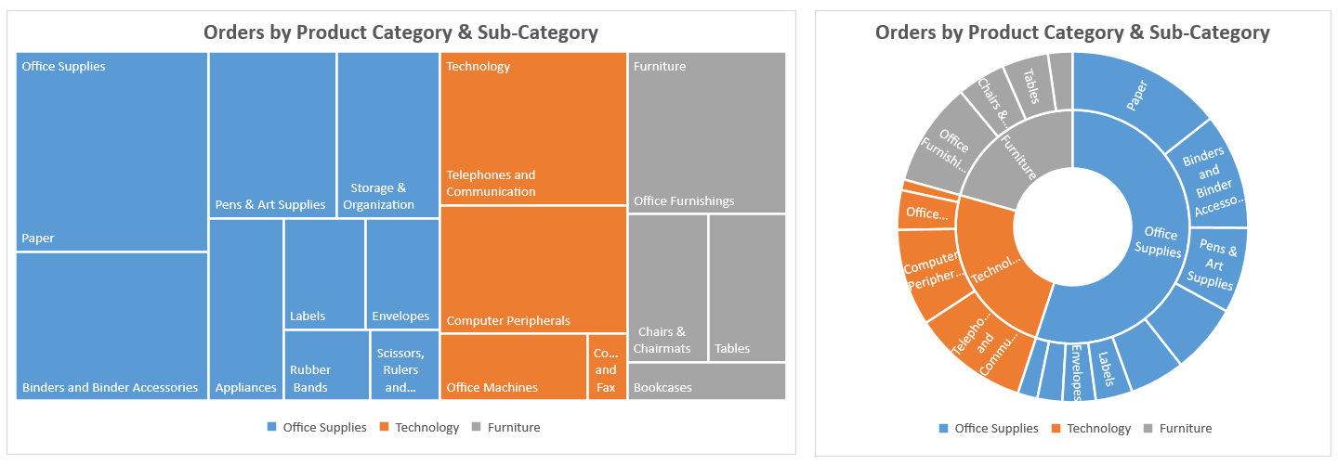

2) Create the raw source data (from scratch) to produce the Sunburst chart below (bonus points if you can match the formatting exactly):
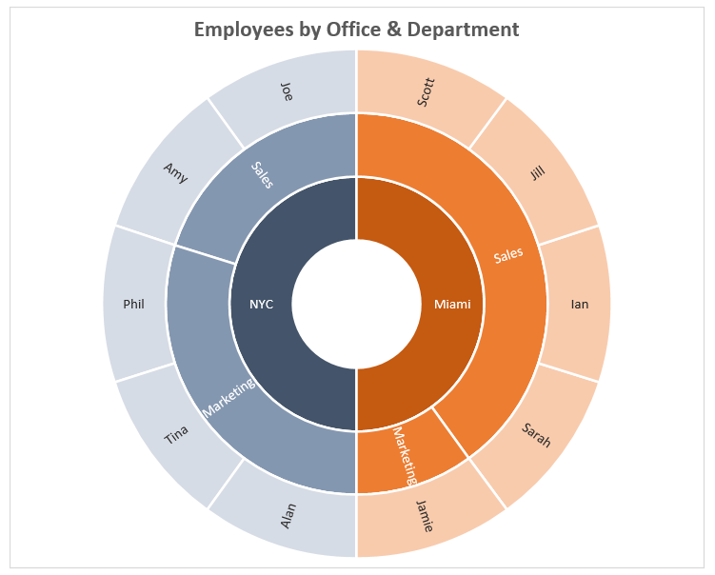

HOMEWORK: Waterfall & Funnel Charts

In the Data_Viz_Homework file, click on the "Waterfall & Funnel Charts" tab and complete the following:
1) Insert a Waterfall Chart based on the financial data in columns A-B, and set Gross Revenue, Gross Profit, Operating Income and Net Income as totals:
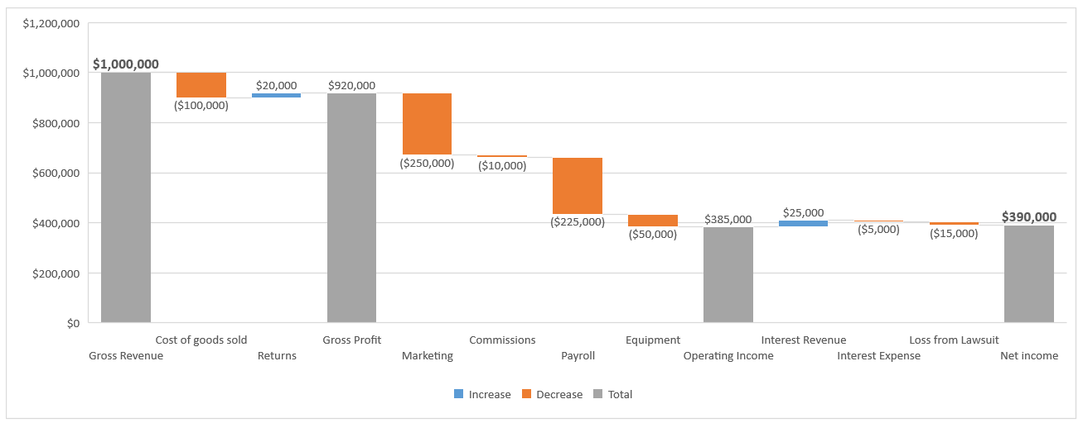
2) You just posted a job opening, and a total of 100 people applied. Of the 100 applicants, you invited 45 to interview. 15 declined, but among those who interviewed 50% were invited to a second round. 5 people from round two were invited to a final interview, and only 1 was eventually offered the job.
Create a Funnel Chart to visualize the number of people who progressed through each of the stages above (initial applicants, first interview, second interview, final interview, etc). You should end up with something like this:
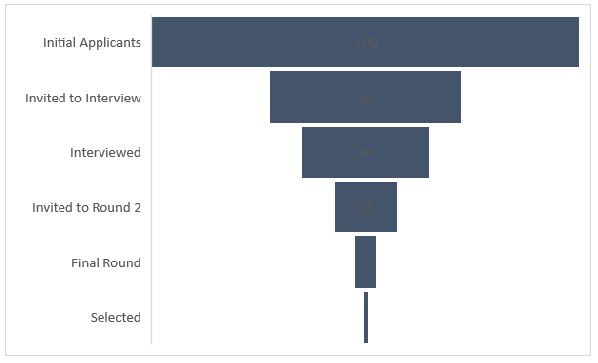

HOMEWORK: Radar Charts

In the Data_Viz_Homework file, click on the "Radar Charts" tab and complete the following:
1) Insert a Radar Chart to visualize the number of shark attacks occurring each month in Australia, South Africa, and the USA.
BONUS: Create a second source data range to convert the numbers into a 1-100 scale. What do you notice about when shark attacks occur in the USA compared to Australia or South Africa?
Hint: Use the following formula to create the new 1-100 scale:
NEW_VALUE = NEW_MIN + (OLD_VALUE - OLD_MIN) * (NEW_MAX - 1) / (OLD_MAX - OLD_MIN)
Your chart should end up looking like this:
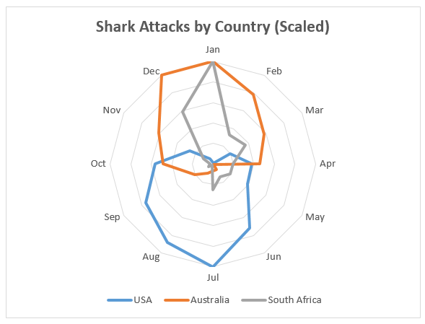

HOMEWORK: Stock Charts

In the Data_Viz_Homework file, click on the "Stock Charts" tab and complete the following:
1) Select all of the Google stock price data in columns B-G and insert a Stock Chart (Volume-Open-High-Low-Close).
2) Select only columns D-G and insert a second Stock Chart (Open-High-Low-Close)
3) Adjust the X-axis and secondary Y-axis to match the format below (hint: you may need to change your X-axis type):
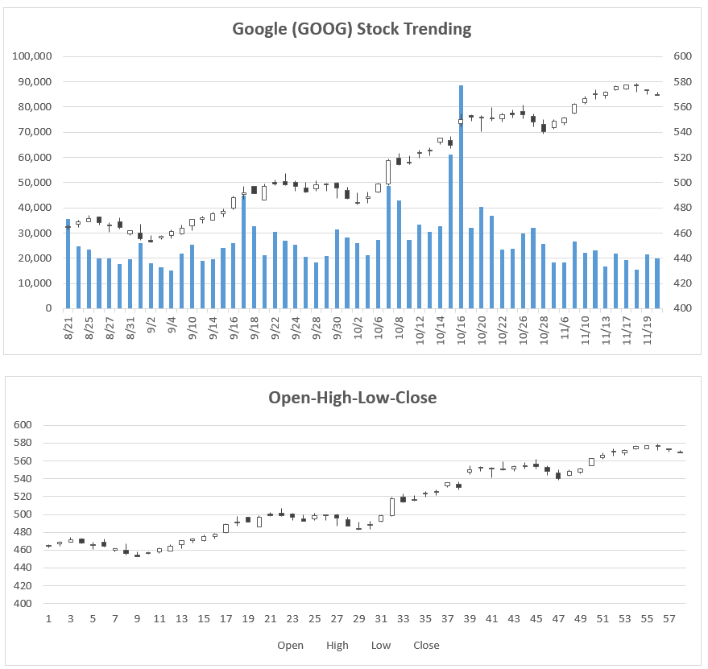

HOMEWORK: Heat Maps

In the Data_Viz_Homework file, click on the "Heat Maps" tab and complete the following:
1) Apply a Red-White-Blue Color Scale to column B to show cooler temperatures in blue and hotter temperatures in red. When do temperatures start warming up, and when do they cool back down?
2) Apply a Green-White Color Scale to column C to show days with no/little precipitation in white and days with a lot of precipitation in green. Which weeks had the highest precipitation totals?
BONUS: Apply a custom number format (;;;) to hide the text and only show the color scales. Your final heatmap should look like this:
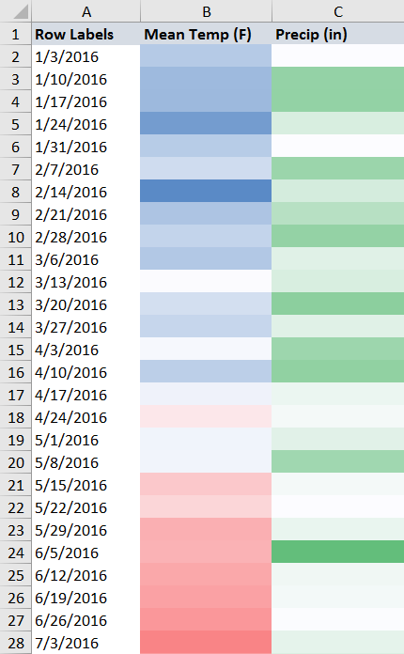

HOMEWORK: Surface & Contour Charts

In the Data_Viz_Homework file, click on the "Surface Charts" tab and complete the following:
1) Insert a 3-D Surface Chart to visualize the average temperature data in columns A-M. Adjust the color formatting for each band to match the example below, where cooler temperatures are shown in blue/green and warmer temperatures are shown in yellow/orange/red (hint: bands can be formatted by clicking on each item in the legend):
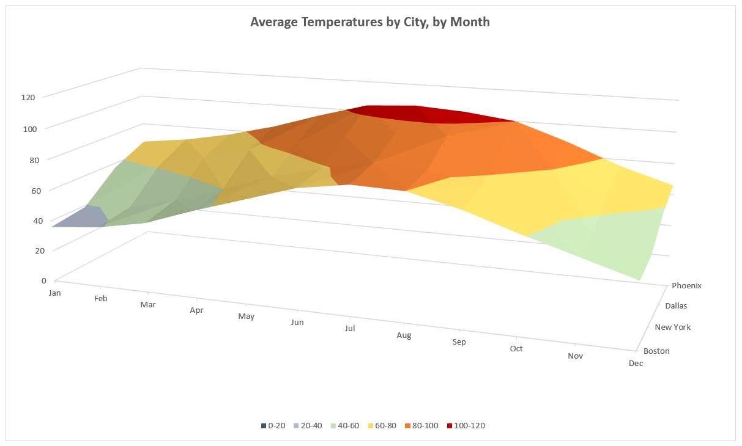
2) Create a duplicate and change the chart type to a Contour Chart (formatting is optional):
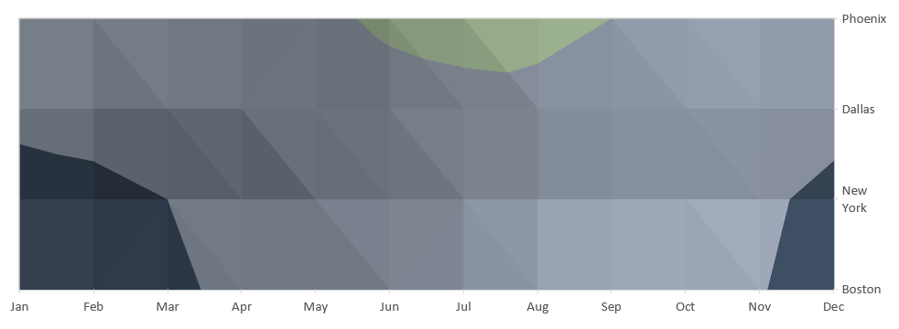

HOMEWORK: Power Map

In the Data_Viz_Homework file, click on the "Power Map" tab and complete the following:
1) Select the accident data in columns A-D, and launch Power Map
2) Customize the settings to show the sum of Auto Accidents as a heat map based on longitude/latitude, with a filter to show locations with at least 5 accidents. The resulting map should look like the following:
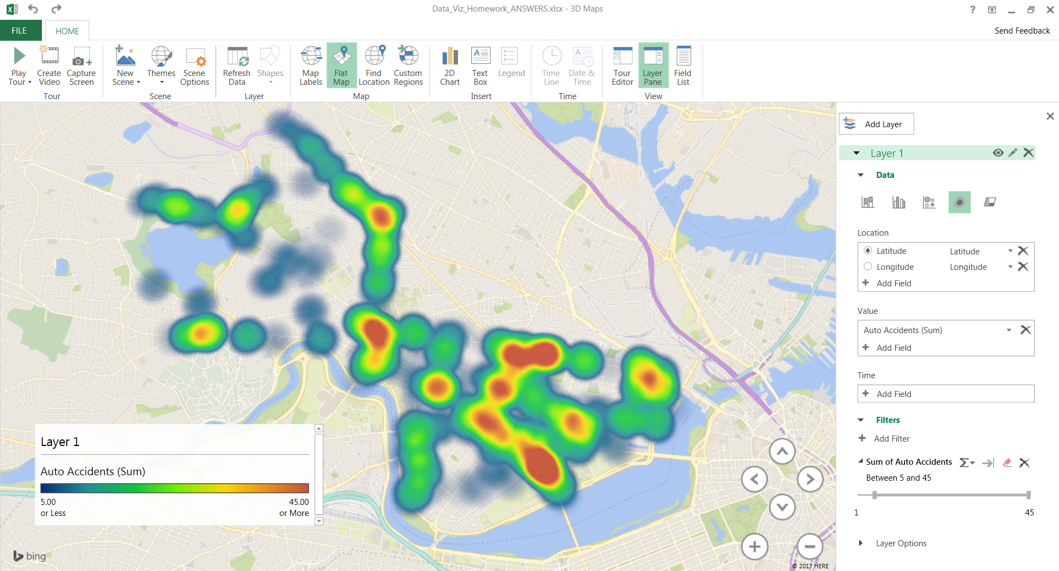

HOMEWORK: Combo Charts

In the Data_Viz_Homework file, click on the "Combo Charts" tab and complete the following:
1) Create a Combo Chart showing Wins as columns and Win % as a line, and adjust formatting to match the example below:
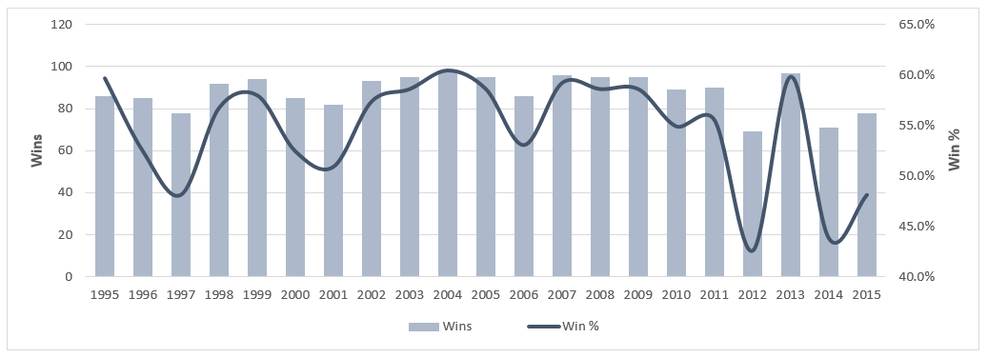

2) Create a second Combo Chart showing Runs Scored as an area and Batting Avg as a line, and adjust formatting to match the example below:
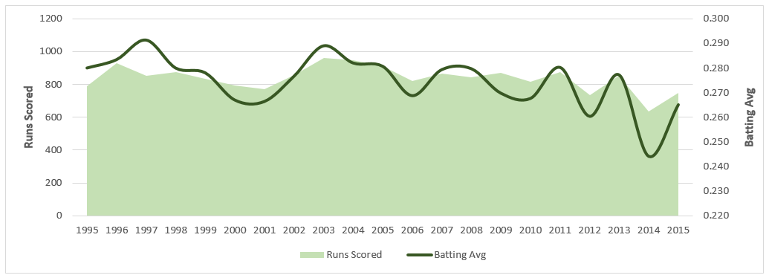

3) Create a third Combo Chart showing Runs Scored and Runs Allowed as a 100% Stacked Column and ERA as a line, and adjust formatting to match the example below:
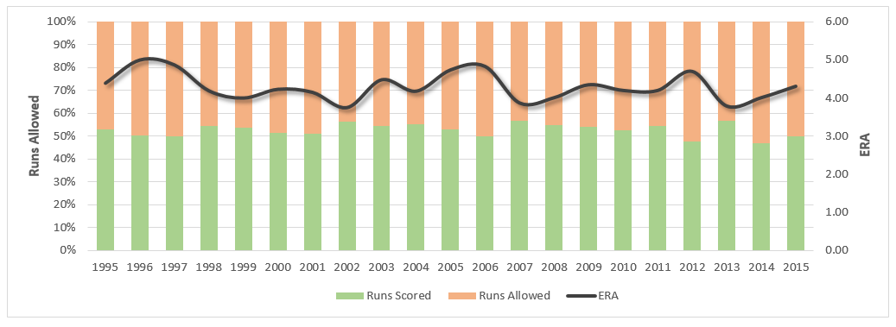

HOMEWORK: Sparklines

In the Data_Viz_Homework file, click on the "Sparklines" tab and complete the following:
1) In column F, insert Sparklines as lines to show the accident totals by time of day, with a marker to show the high point
2) In row 9, insert Sparklines as columns to show the accident totals by day of week, with a marker to show the high point
The resulting sparklines should look like the following example:
