Worksheet

- Something bad might happen, so I am like you know what I should save more for the future? If everyone does that, how does it affect you? how does it affect everyone else?

- You decide to open a coffee shop in Bryn Mawr and imagine you can source all the goods from local farmers and producers and hire students to be baristas at the café. The only economic activity in the area for the month is supporting the café. You purchase a coffee machine from A for $1000. You buy beans from farmer B for $200. You hire 2 students, C and D, and pay them $1000. At the end of the month, you end up selling 600 cups of coffee and charged on average, $4 a cup. What is the total income in this economy?

Can you identify the intermediate and final goods?

- What is the definition of GDP? Take hints from Question 2. What are three ways to think about GDP? What is the underlying assumption or equality we are assuming? Can you draw the assumption?

- Angus the sheep farmer sells wool to Barnaby the knitter for $20. Barnaby makes two sweaters, each of which has a market price of $40. Collete buys one of them, while the other remains on the shelf to be sold later. What is the GDP here?
- $40
- $60
- $80
- $100

- After graduation, an American college student moves to Japan to teach English. Her salary is include
- Only in US GDP
- Only in Japan’s GDP
- In Japan’s GDP and US’s GNP
- In both Japan’s GDP and US’s GDP

- Which of the following does NOT add to US GDP?
- Boeing manufactures and sells a plane to Air France
- General Motor builds a new auto factory in North Carolina
- The city of New York pays a salary to a policeman.
- The federal government sends a Social Security check to an elderly.

- An American buy a pair of shoes made in Italy. How do the US national income accounts treat the transaction?
- Net exports and GDP both rise.
- Net exports and GDP both fall.
- Net exports fall, while GDP does not change.
- Net exports do not change, while GDP rises.

- GDP for year 1 is $200,000, and for year 2 is $200,000. Has this country grown? How will you think about figuring out an answer to this question?

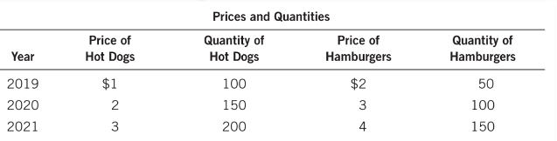

- Calculate the nominal GDP

2019

2020

2021

- Calculate the Real GDP using 2019 as the base. That is, using 2019 price to compute the GDP for 2020 and 2021

2019

2020

2021

- GDP Deflator: $\frac{Nominal GDP}{Real GDP} ×100$

2019

2020

2021

- Find the inflation rate in 2020 and 2021

- 2019 to 2020

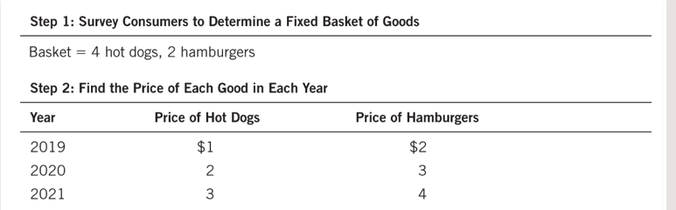

- Computer the cost of the basket of goods in each year
2019

2020

2021

- Let’s select the base year to be 2019. Calculate CPI
2020

2021

- Compute the inflation.
2019-2020

