History 102
INTRODUCTION TO AFRICANA CIVILIZATIONS
FALL 2026
T/TH, 10:10-11:30 AM/ DALTON 6

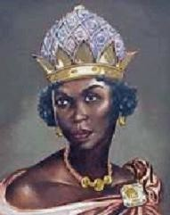
Queen Nzinga of Ndondo and Matamba, Angola (1583-1663)

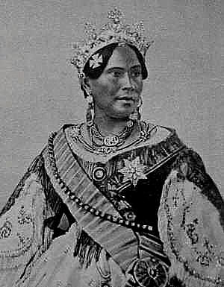
Queen Ravanalona III, The Last Monarch of Madagascar (1778-1861)



Bamoun Royal Palace, at Foumban (Cameroun)

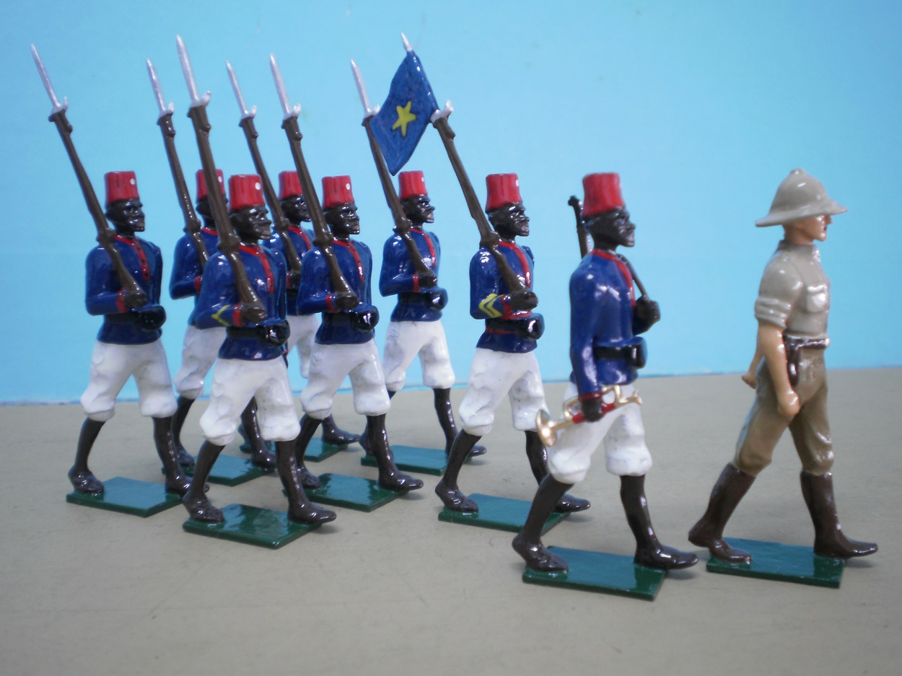
The “Force Publique”, Colonial Conscripts in the Belgian Congo, 1885-1960

Instructor: Dr. Kalala Ngalamulume
(Africana Studies and History, Bryn Mawr College)
204 Great Hall, BMC
610-526-5042
kngalamu@brynmawr.edu
Office Hours: M/TH 1-2 PM OR by appointment

Classes meet at Bryn Mawr College, Tuesday & Thursday, 10:10-11:30 AM.

This is one of the requirements for students who plan to complete a major or minor in
History (taken preferably before the junior year), and/or one of the foundation courses for Concentrators (Haverford) and Minors (Bryn Mawr) in the Bi-College Africana Studies Program.

Course Description:

The course is designed to introduce students to the history of African and African Diaspora societies, cultures, and political economies. We will discuss the origins, state formation, external contacts, and the structural transformations and continuities of African societies and cultures in the context of Islam, Christianity, the slave trade, colonial rule, capitalist exploitation, urbanization, and westernization, as well as contemporary struggles over authority, autonomy, identity, and access to resources. Case studies will be drawn from across the continent.

The course will also introduce students to the methods (and problems) of history as a discipline through an examination of some scholarly works and primary sources. The course seeks to help students think critically about the range of topics of historical inquiry, the questions professional historians (and others) try to answer, the sources they use and their qualities, the way they organize the evidence to tell the story, and various interpretations of a changing past. We will also explore other key issues such as objectivity, history and memory, agency and structures, and the uses and abuses of history. The reading assignments will introduce students to different types of history and to different social formations. Texts are various, including scholarly analysis, narratives, fiction, films and videos.

The course is suitable for first year students but is open to all students who want some exposure to societies and cultures of Africa and the Diaspora. The course raises questions explored in greater depth in other courses offered in the Bi-College Africana Concentration.

Objectives and Learning Outcomes

Objectives
- To understand history as a process, society as a process, and how actors and narrators contribute to the construction of the social reality and the production of historical narratives;
- To read primary and secondary sources and understand how historians develop their arguments and interpretations;
- To develop qualities of critical thinking and objectivity.

Learning Outcomes
- To explain the processes of the formation and development of African societies and cultures and their transformation in Africa and in the African Diasporas;
- To account for different legacies (indigenous, Islamic, colonial, and recent) and to explain the historical roots of contemporary problems in Africa.

Course Requirements:

The course is designed to function as a reading and discussion seminar. You are required to attend and participate in class discussions. 30% of your final grade will depend on your in-class performance: attendance, country project, informed participation, and presentation of written assignments. There will be a take-home midterm, worth 25% on Thursday, October 22, covering the assigned readings, discussions, and other visual materials. You will also write a 5-page paper on the 1879 Anglo-Zulu War: select at least four primary sources (eyewitness accounts) available in the Special Collections in Bryn Mawr’s Canaday Library and listed below. Analyze the causes of the 1879 Anglo-Zulu War. How do you account for different interpretations? The paper is worth 20% of your grade and is due Dec. 3, as an email attachment. You will also have a final take-home examination worth 25% during the examination period, December 13-18.

Readings to be purchased: Books, all paperback, are available in the Bryn Mawr College Bookstore.

Required Reading:

Aimé Césaire, DISCOURSE ON COLONIALISM
Chinua Achebe, THINGS FALL APART.
Todd J. Moss, AFRICAN DEVELOPMENT: MAKING SENSE OF THE ISSUES AND ACTORS.
D.T. Niane, SUNDIATA, AN EPIC OF OLD MALI.
Tosh, Jon, THE PURSUIT OF HISTORY (ON TRIPOD)
Ngugi Wa Thiongo, WEEP NOT, CHILD.

Recommended Texts: John Hope Franklin and Evelyn Brooks Higginbotham, From Slavery to Freedom: A History of African Americans, Philip Curtin, et.al., African History: From Earliest Times To The Present.; and Jan Vansina, Paths in the Rainforests: Toward a History of Political Tradition in Equatorial Africa; Walter Rodney, How Europe Underdeveloped Africa.

***All other course readings will be available electronically on Moodle.

*** Watch the video before class time

ACCESSIBILITY: Bryn Mawr College is committed to providing equal access to students with a documented disability. Students needing academic accommodations for a disability must first speak with Access Services. Students can email accessservices@brynmawr.edu to request an appointment to begin this confidential process. If eligible for accommodations as per Access Services, students should schedule an appointment with the professor as early in the semester as possible to share their verification form and make appropriate arrangements. Please note that accommodations are not retroactive and require advance notice to implement. More information can be obtained at the Access Services website. (http://www.brynmawr.edu/access-services/)

TITLE IX

Bryn Mawr/Haverford College is committed to fostering a safe and inclusive living and learning environment where all can feel secure and free from harassment. All forms of sexual misconduct, including sexual assault, sexual harassment, stalking, domestic violence, and dating violence are violations of Bryn Mawr/Haverford’s policies, whether they occur on or off campus. Bryn Mawr/Haverford faculty are committed to helping to create a safe learning environment for all students and for the College community. If you have experienced any form of gender or sex-based discrimination, harassment, or violence,
know that help and support are available. Staff members are trained to support students in navigating campus life, accessing health and counseling services, providing academic and housing accommodations, and more.

The College strongly encourages all students to report any incidents of sexual misconduct. Please be aware that all Bryn Mawr/Haverford employees (other than those designated as confidential resources such as counselors, clergy, and healthcare providers) are required to report information about such discrimination and harassment to the Bi-College Title IX Coordinator.

Information about the College’s Sexual Misconduct policy, reporting options, and a list of campus and local resources can be found on the College’s website:

Bryn Mawr Sexual Misconduct Policy
Haverford Sexual Misconduct Policy

Generative AI and Other Form of AI: Use of any text-generating software (such as ChatGPT, iA Writer, Marmot or Botowski) is not permitted, and use of this software on graded assignments will be treated as plagiarism.

COURSE SCHEDULE AND SYLLABUS

Week 1

Sept. 01 T Introduction: Discussion of goals, requirements of course.
Africa and the Diaspora: Charting the Historical and Thematic Landscape
An Overview of the Course

Reading: “Kenyan Journalist Reports on US Election Like Americans Report on other Elections,” https://boingboing.net/2020/11/08/kenyan-journalist-reports-on-us-election-like-americans-report-on-other-elections.html

03 TH Historical Awareness. Uses of History. Mapping the Field

Required reading: Jon Tosh, The Pursuit of History, chaps. 1-3.

Week 2

08 T Using Sources, Writing, and Interpretation

Required reading: Jon Tosh, The Pursuit of History, chaps. 4-6.

10 TH Limits of Historical Knowledge. History and Social Theory. – The Cultural Turn

Required reading: Jon Tosh, The Pursuit of History, chaps. 7-9.

Week3

15 T Gender History. Oral History. Public History

Required reading: Jon Tosh, The Pursuit of History, chaps. 10-13.

17 TH Images of Africa and of Blackness

Reading: Bohannan/Curtin, Myths and Facts, 6-15

Reading: Chinua Achebe, “An Image of Africa: Racism in Conrad’s Heart of Darkness,” 1-20

Reading: Blanchard/Bancel/Lemaire, “From Scientific Racism to Popular and Colonial Racism in France and the West,” in Human Zoos: Science and Spectacle in the Age of Colonial Empires, eds. Blanchard et al., trans. Teresa Bridgeman (Liverpool University Press, 2008), 104-113.

Video: CNN, “A Look at Race Relations through a Child’s Eyes” 9:30

Video: “Confessions of a D Girl: Colorism and Global Standards of Beauty/ Chika Okoro/ TEDxStanford 10:02

Video: PBS, “Anti-Bias Lessons Help Preschoolers Hold up a Mirror to Diversity” 7:14

Discussion question: 1) How did the Europeans construct difference? For what purpose and function? 2) Is the account reliable? Is it the product of direct knowledge or is it learned at second hand? Is it anything more than a gossip? 3) What influenced the author (intention and deep-seated prejudice of the writer)? Is the bias historically significant? 4) Explain the intellectual and social contexts in which it was written.

Inventing a Social Order: Production, Social Reproduction, Socialization, Explanations (Cosmogonies, Cosmologies, Religions), Practices/Norms, Institutions, and Traditions

Week 4

22 T Discussion of the Video, Basil Davidson, "Africa," episode 2 "Mastering the Continent." (57 m.) ONLINE. Watch the video before class time.

Reading: Philip Curtin et al., African History, chap. 4 MOODLE

Reading: R.O. Faukner, “The Pregnancy of Isis,” The Journal of Egyptian Archaeology (1968); JSTOR

Video : “Au pays des Dogons” (Marcel Griaule, 1931)
Video: “Theories des Dogons …”

24 TH Authority, Society and Culture

Civilizations and “Small-Scale” Societies

Reading: Chinua Achebe, chapters 1-14
Discussion question: Discuss the social norms about kinship, women, marriage and residential pattern, socialization of children, and age groups.

Recommended Reading: African History, chaps. 1, 8

Discussion question: How are traditions, cultures, and identities invented and reproduced? Including gender and sexuality.

Week 5

Political Tradition in Equatorial Africa

29 T Required reading: Jan Vansina, Paths in the Rainforests: Toward a History of Political Tradition in Equatorial Africa, chaps. 3-4 (Tripod)

Oct. 01 TH States and Societies in West Africa: The Mali Empire

Reading: D.T. Niane, "Sundiata Epic" (Mandekalou), 1-47

Discussion questions: What is the process of state formation? Compare and contrast the pregnancy of Isis and that of Sogolon.

Week 6

06 T Memory and Actuality

Reading: Hale, "Griottes: Female Voices from West Africa."

Reading: Conrad, “Oral Traditions & Perceptions of History from the Manding Peoples,” MOODLE

Video: "Keita! The Heritage of the Griot." view before coming to class. See TRIPOD. Watch before class time

Discussion question: What is the place of women in African societies?

The Institution of Slavery and the Creation of the African Diaspora

08 TH Slavery in Africa

Reading: Curtin et al., African History, Chap. 7 “The West Coast in the Era of the Slave Trade”
Reading: Paul Lovejoy, Transformations in Slavery, chap. 1, 1-22
Reading: Joseph Miller, “Queen Nzinga of Matamba in a New Perspective,” Journal of African History 16.02 (1975), 201-216

Discussion question: What were the different forms of slavery in Africa?

FALL BREAK, Oct. 9-19

Week 7

20 T The Atlantic Slave Trade

Reading: Daniel Mannix, “The Middle Passage”

Video: “Traces of the Trade” 43 min. Watch before the class meeting

Discussion question: Explain the process of transformation from captive to slave. Discuss slavery as a mode of production

22 TH The Saint-Domingue Revolution

Reading: Paul Farmer, “Many Masters: The European Domination of Haiti"

Reading: John K. Thornton, “I am the Subject of the King of Congo”: African Political Ideology and the Haitian Revolution,” Journal of World History 4.2 (Fall, 1993), 181-214 Online/Databases

Discussion question: What factors contributed to the success of the Saint-Domingue Revolution?

MID-TERM EXAM DISTRIBUTED IN CLASS

Week 8

27 T The Saint-Domingue Revolution: Video and Discussion/Primary Source Analysis

Required reading: George Eaton Simpson, “The Belief System of the Haitian Vodun,” The American Anthropologist 47.1 (1945), 35-59.

Required reading: Haitian Declaration of Independence
https://today.duke.edu/showcase/haitideclaration/declarationstext.html

Video: “The Haitian Revolution: A Documentary” (2009) 55:23’ YouTube
Watch before class time.

Suggested reading: Julia Gaffield (ed.), The Haitian Declaration of Independence: Creation, Context, and Legacy (University of Virginia Press, 2016).

29 TH The Haitian Revolution: History and Memory

Required reading: Trouillot, Michel-Rolph, Silencing the Past: Power and the Production of History, chaps. 1-2.

Mid-term Exam Due as an email attachment to the instructor by 11:59 PM

Nov.

Week 9

03 T Legacy of Slavery in Brazil

Reading: Rosario, “The Ladies of the Water: Iemanja, Oxum, Oia and a Living
Faith,” Wagadu, Online

Video: “Bahia”

European Colonialism and Its Impact on African Societies

The First Scramble for Africa

05 TH Reading: Chinua Achebe, Chapters 15-end

Reading: Matthew Craven, “Between Law and History: The Berlin Conference
of 1884-1885 and the Logic of Free Trade,” London Review of International Law 3.1 (2015), 31-59. Online. https://doi.org/10.1093/lril/lrv002

Suggested reading: Sir Reginald Bacon, BENIN: THE CITY OF BLOOD, 1897 (Online)

Discussion question: How did Africans respond to European imperialism? What initiatives did they take to protect their societies or to take advantage of the new opportunities?

Week 10

10 T Reading: Wa Thiongo, Weep Not, Child

Discussion question: What was the impact of European colonial rule on African societies?

Video: “End of Empire (1985): chapter 12: Kenya” 1:03:32’

12 TH African Nationalism

Reading: Frantz Fanon, “Concerning Violence” and African History, chap. 18

Video: Basil Davidson: “The Rise of African Nationalism”

What argument is Frantz Fanon making concerning violent resistance?

Week 11

17 T Reading: Walter Rodney, How Europe Underdeveloped Africa, Chap. 6

Discussion question: Identify Walter Rodney’s main arguments.

19 TH Reading: Aime Cesaire, Discourse on Colonialism (entire book)

Discussion question: Identify Aime Cesaire’s main arguments

Week 12

24 T Reading: Boahen, “The Colonial Impact” in African Perspectives on Colonialism
Reading: Todd Moss, African Development, chap. 2.

Discussion question: In your overall assessment, was colonial rule beneficial or detrimental to African economies, societies, and cultures?

Video: “Africa: States of Independence – the Scramble for Africa” 44:54’

Thanksgiving, Nov. 25-30

Week 13

Dec. 01 T The Challenge of Nation Building in Africa

Reading: Todd Moss, African Development, chap. 1, 3-5

Discussion of Internal and External Factors of Nation Building

Video: “The New Scramble for Africa/Empire” 47:32

3 TH The Challenge of Nation-Building

Required reading: African Development, chaps. 6-10, 11-13

Video: “The Looting Machine: Warlords, Oligarchs, Corporations, Smugglers, and the Theft of Africa’s Wealth” YouTube (2015) 52’26’’

Hard-Copy of 5-page Research Paper on the British-Zulu War due in class; also send a copy to the instructor as email attachment.

Week 14

08 T Chinese Influence in Africa

Required reading: TBA

10 TH Concluding Remarks

13-18 Final Exams

Send your exam to the instructor as email attachment without code permission features (Times New Roman 12)

C’est fini. That is all folks. Have a good Winter Break!
Anglo-Zulu War Books in the Bryn Mawr

Special Collections
Fall 2026

Books on the Anglo-Zulu War of 1879 (Special Collections Floor 2, Canaday Library)

British rule in South Africa: illustrated in the story of Kama and his tribe, and of the war in Zululand. Holden, William Clifford. London: Wesleyan Conference Office, 1879 (DT1875 H65 1879)

Further correspondence respecting the affairs of South Africa: in continuation of [C. 2374] [sic] of July 1879: presented to both Houses of Parliament by command of Her Majesty August 1879.

Great Britain. Parliament. London: Printed by George Edward Eyre and William Spottiswoode ... for Her Majesty's Stationery Office, 1879 (DT1875. F87 1879 f)

The Zulus and Boers of South Africa: a fragment of recent history. Mann, Robert James, 1817-1886. London: Edward Stanford, 1879. (DT1875 .M36 1879)

In Zululand with the British throughout the war of 1879. Norris-Newman, Charles L. London: W.H. Allen, 1880 (DT1877 .N65 1880)

Cetshwayo's Dutchman; being the private journal of a white trader in Zululand during the British invasion. Vijn, Cornelius., Colenso, John William, 1814-1883. London, Longmans, Green, and Co., 1880 (DT1877. V55 1880)

History of the Zulu war and its origin. Colenso, Frances E. (Frances Ellen), 1849-1887. London: Chapman and Hall, 1880 (General) (DT777.C58 1880)

The ruin of Zululand: an account of British doings in Zululand since the invasion of 1879. Colenso, Frances E. (Frances Ellen), 1849-1887. London: W. Ridgway ,1884-85. (DT878.Z9 C9 1884 v.1-2)

A lady's life and travels in Zululand and the Transvaal during Cetewayo's reign. Wilkinson, Mrs. London: J.T. Hayes, 17 Henrietta Street, Covent Garden , 1882. (DT878.Z9 W55 1882)

Cetywayo and his white neighbours: or Remarks on recent events in Zululand, Natal, and the Transvaal. Haggard, H. Rider (Henry Rider), 1856-1925. London: Trübner, 1890 (General) (DT1848.C4 H34 1890)

The Transvaal trouble: how it arose, being an extract from the biography of the late Sir Bartle Frere. Martineau, John, 1834-1910. London: Murray, 1896. (DT1848 .M37 1896)

