0 = null | 10 = zehn
1 = eins | 11 = elf
2 = zwei | 12 = zwölf
3 = drei | 13 = dreizehn
4 = vier | 14 = vierzehn
5 = fünf | 15 = fünfzehn
6 = sechs | 16 = sechzehn
7 = sieben | 17 = siebzehn
8 = acht | 18 = achtzehn
9 = neun | 19 = neunzehn

20 = zwanzig | 30 = dreißig
21 = einundzwanzig | 40 = vierzig
22 = zweiundzwanzig | 50 = fünfzig
23 = dreiundzwanzig | 60 = sechzig
24 = vierundzwanzig | 70 = siebzig
25 = fünfundzwanzig | 80 = achtzig
26 = sechsundzwanzig | 90 = neunzig
27 = siebenundzwanzig | 100 = (ein)hundert
28 = achtundzwanzig | 101 = (ein)hunderteins
29 = neunundzwanzig | 1000 = (ein)tausend
Beispiel
Wie alt sind Sie? Ich bin … Jahre alt.
Die Währung (currency)
Germany, Austria, and most other European countries use the Euro (der, €), which is broken into 100 Cent, while Switzerland has retained the Franken (der, SFr), broken into 100 Rappen.
Note that German speakers use a comma to indicate decimal points and a period or a space to set off thousands: 1.000,50 € & 1 000,50 € = one thousand euros and fifty cents.
Beispiel:
- 10,15 €
- Betrag in Buchstaben zehn Euro fünfzehn Cent

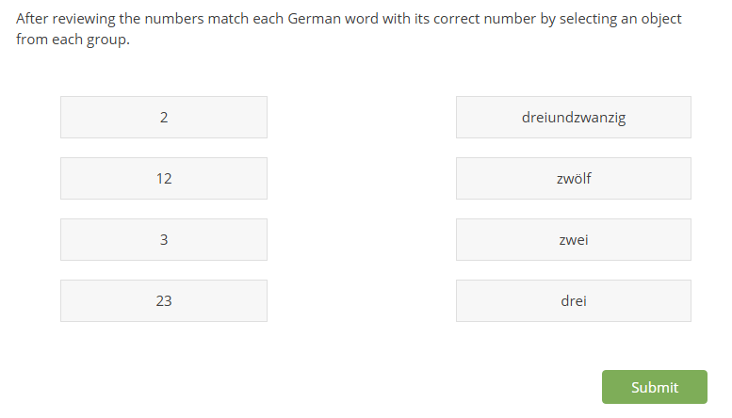

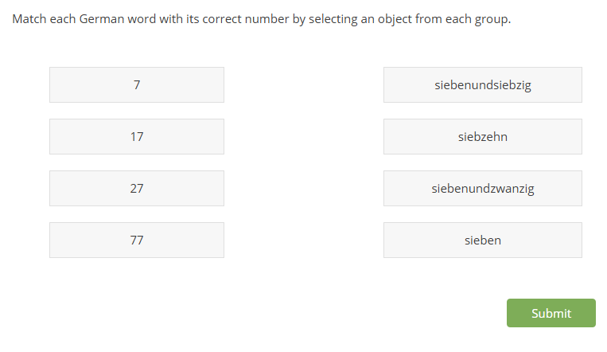
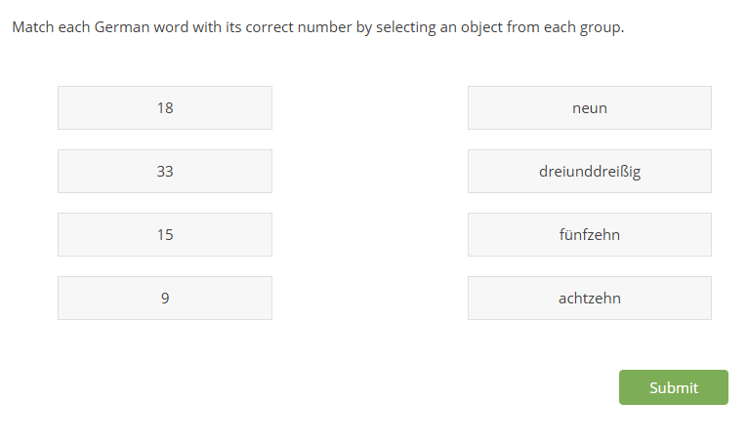

Die Währung (currency)
Germany, Austria, and most other European countries use the Euro (der, €), which is broken into 100 Cent, while Switzerland has retained the Franken (der, SFr), broken into 100 Rappen.
Note that German speakers use a comma to indicate decimal points and a period or a space to set off thousands: 1.000,50 € & 1 000,50 € = one thousand euros and fifty cents.
Beispiel:
- 10,15 €
- Betrag in Buchstaben zehn Euro fünfzehn Cent

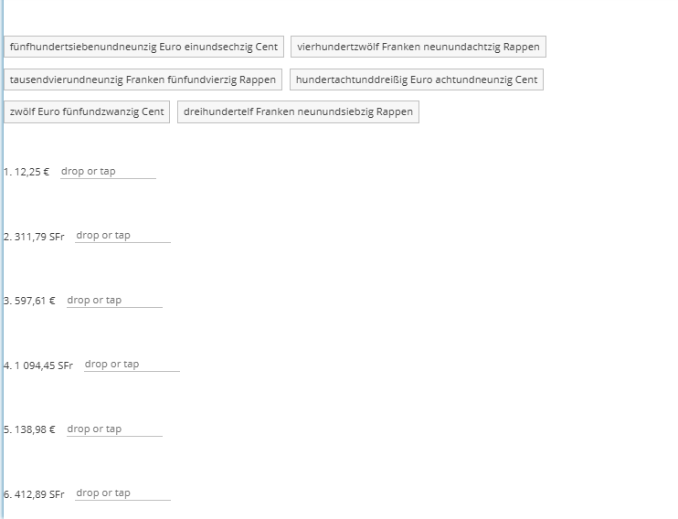

What is the next logical number in the sequence?

Eins, drei, fuenf…..

Zwei, vier, sechs….

Zehn, zwanzig, dreissig…

Fuenf, zehn, fuenfzehn, zwanzig….

Einundvierzig, einundfuenfzig, einundsechzig

Sieben, vierzehn, einundzwanzig….

