**City 185 Assignment 1.4 – Adding Data to your Map**

In this assignment, you will create 2-4 maps showing the larger area around your neighborhood (the whole city or region, or at the very least several neighborhoods). Develop at least 1 map showing physical features and 1 map showing socio-economic data.

**Get an Arc GIS Online account**

Sign up for a free ArcGIS Online Public Account here: <https://www.arcgis.com/sharing/rest/oauth2/signup?client_id=arcgisonline&redirect_uri=http://www.arcgis.com&response_type=token>

**Begin a map**

You'll begin your map by signing in to ArcGIS Online and navigating to your town or city.

1. **Sign in to [ArcGIS Online](https://www.arcgis.com/home/signin.html" \t "_blank).**
2. **On the ribbon, click Map.**

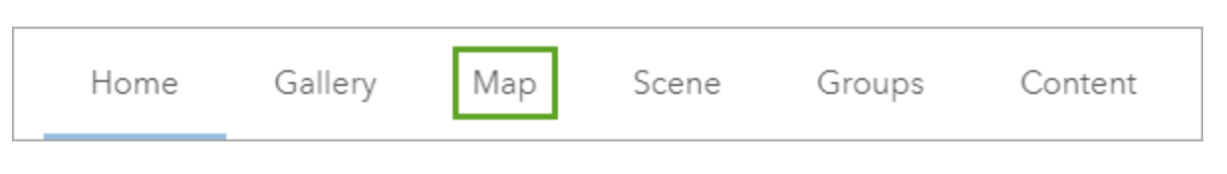

A new map opens.

**Tip:**

If you're in a new session, clicking Map will open a new map. Otherwise, it will open an existing map (the last map you were using). If an existing map opens, click New Map.

Above the map is the ribbon. To the left side of the map is the Details pane, which provides information about the map and its layers. Next, you'll navigate to your area of interest.

1. **On the ribbon, in the search box, type the name of your city or town. In the list of suggested locations, click the best match.**

The map zooms to your location. A Search result pop-up confirms the location.

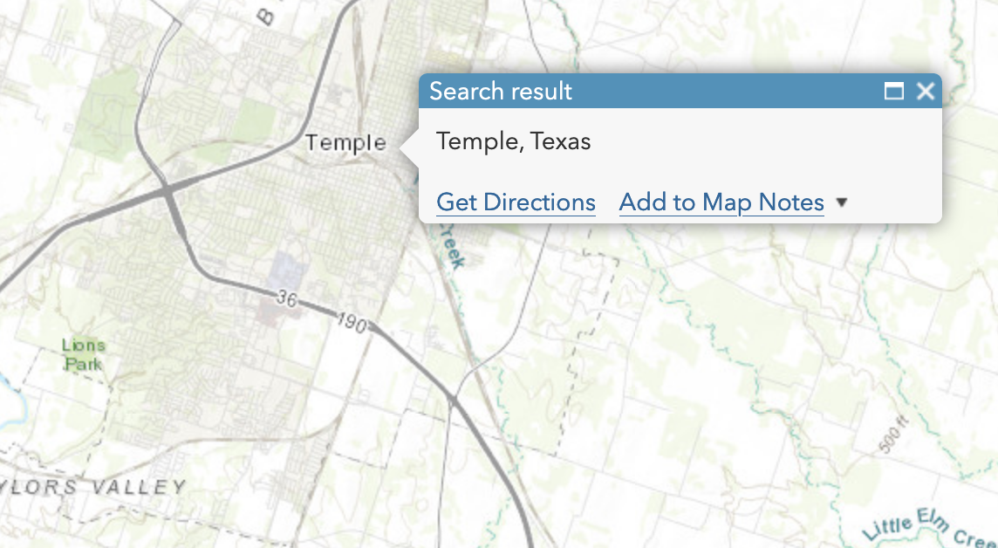

1. **Close the Search result pop-up.**
2. **Explore Basemaps**

Your map's appearance varies based on your account or organizational settings and your browser window size. It may show the United States, the world, or another extent. The only layer on the map is the basemap, which provides geographic context such as water bodies and political boundaries. The default basemap is Topographic, but your map may have a different basemap depending on your organization's settings.

On the ribbon, click on the Basemap. Different options for your basemap will pop up.

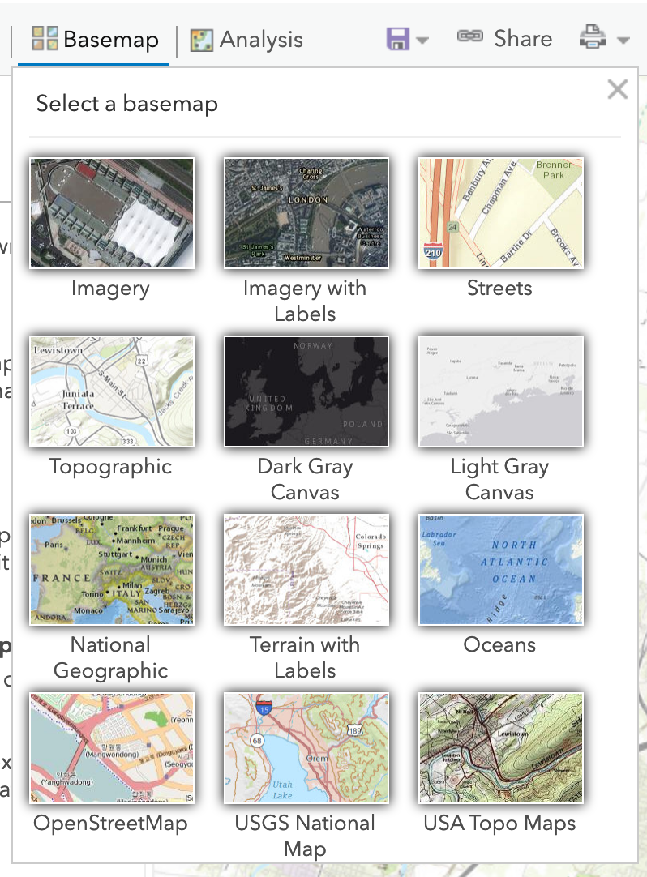

Click through these options to see how they vary. Note that all of these basemaps focus on physical features, some natural features (topography, water, vegetation) and some built (streets, buildings).

Choose a basemap to start with.

1. **Save your map**

On the ribbon, click save and choose save as

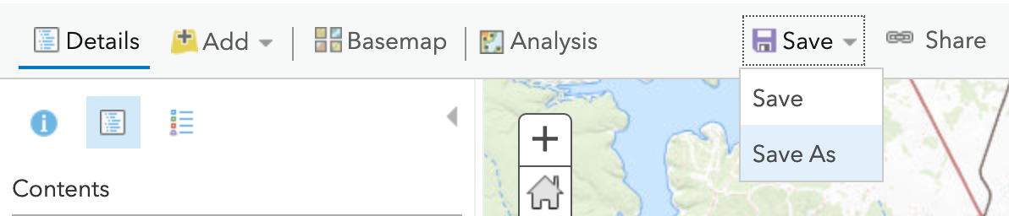

A save dialogue box will pop up. Enter a name for your map and at least 1 tag (Arc requires at least 1 tag), then click Save Map.

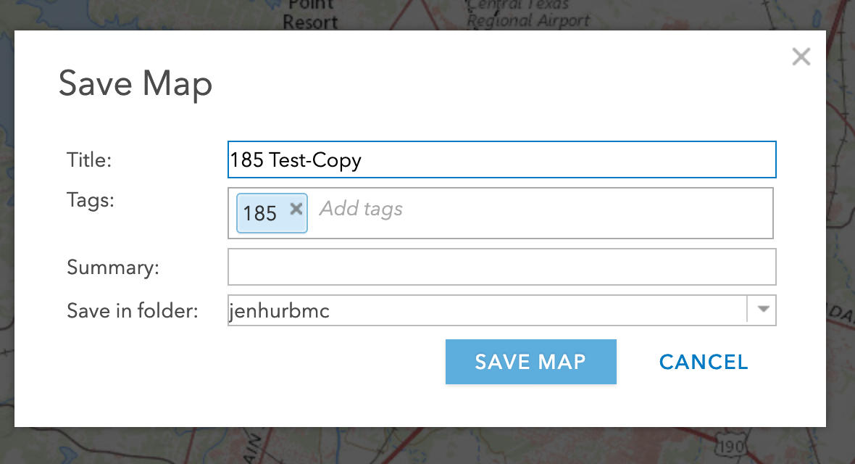

**Add data layers to your map**

ArcGis Online includes thousands of data layers available for use. Some of these layers are available for the entire world; others only cover a small geographic area. Some layers are developed and hosted by ESRI (the company that makes the software); others are created and hosted by governments or other organizations. Let’s start with Living Atlas, the collection of files hosted by ESRI.

1. **Open the Living Atlas Browser and search for data layers**

On the toolbar, click Add, and select Browse Living Atlas Layers.

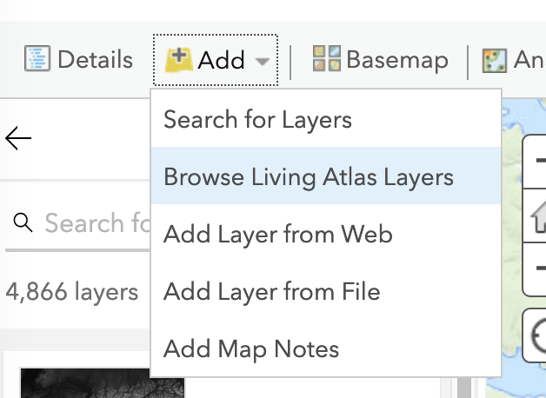

The Living Atlas Browser opens up, with different data layers listed down the left side of the page. Click on one of the layers, and another window will pop up to the right with information about that data layer.

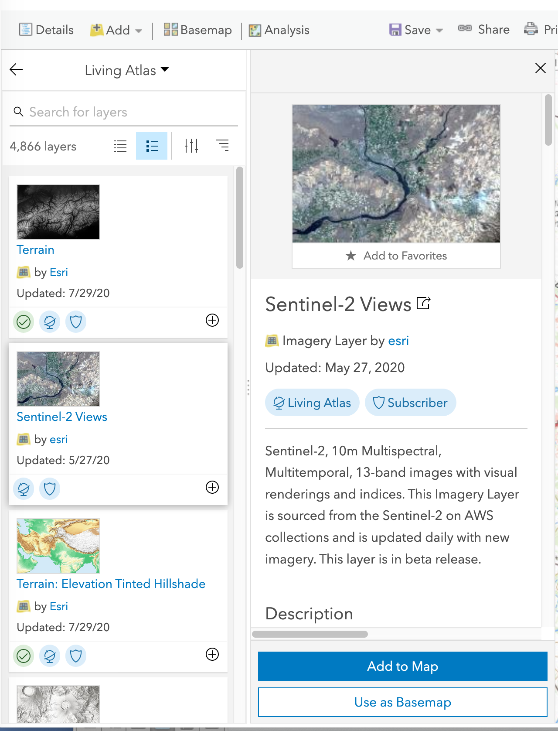

Buttons at the bottom let you add layers to your map. Once you see how that layer appears in your map extent, you can leave it on your map or click Remove from Map.

Scroll through and find at least one layer that tells you something about the physical features in your area (either natural or built features).

1. **Use the search function to find layers on a specific topic**

At the top of the Living Atlas browser, there is a Search box

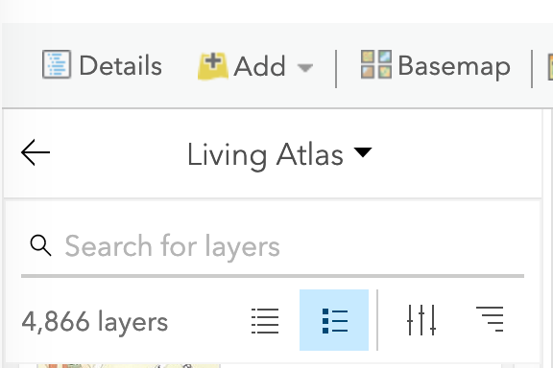

Enter “population density” into the search box and click enter. Select “World Population Density Estimate 2016” and add it to your map.

**Adjust map layers**

Now that you have added at least 2 layers to your map, we are going to see how to change the order of layers, change their appearance, delete layers, and turn layers on and off.

1. **Change the order of layers**

On the ribbon, click Details

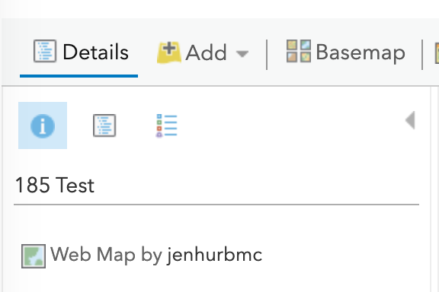

Three buttons appear under the world “Details.” Click each one to see what pops up.

Click on the middle button, and you will see the layers of your map listed. The one at the bottom is your “basemap,” and you can’t move any of the other layers below your basemap. Hover over one of the layers, and you will see several icons pop up under the name of the layer. Click on each one to see what they do.

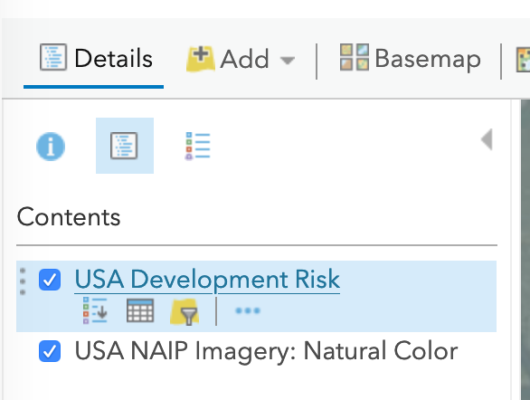

Hover over the 3 vertical dots on the left side, and you will see a cross-mark appear. Now you can click and drag to re-order the layers. How does your map change when you re-order the layers?

1. **Change the appearance of layers**

Sometimes you might want to change the colors, lines, transparency, or other features of your layer. This time, click on the 3 horizontal dots under the right side of the layer name, and a new pop-up window will come up. Note that this pop-up has lots of options, but the two you will probably want most are Transparency (which lets you set how opaque your layer is) and Image Display (which lets you change colors of your layer).

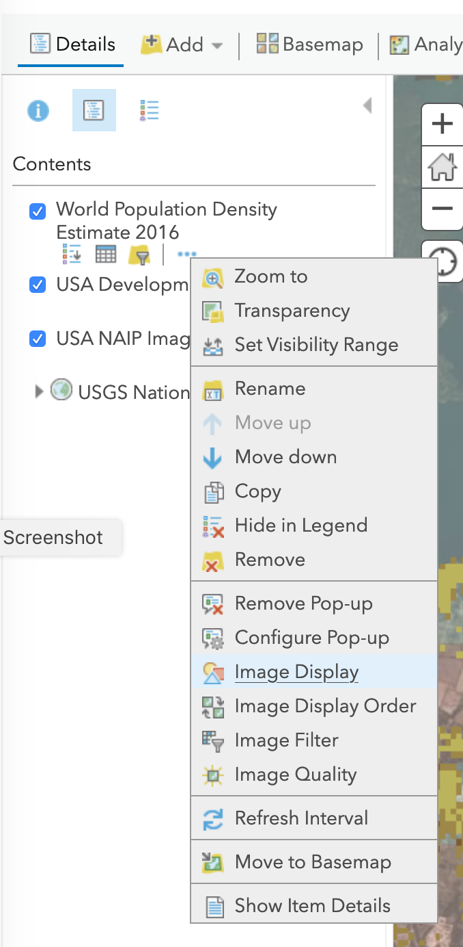

Select Image Display. Play around with the options here to see how you can change the way your map layer appears.

1. **Delete a layer**

Now that you have explored settings, you might decide that you don’t actually want one of the layers you put on your map .Select the layer you want to remove from your map. Then, on that same pop-up window from the 3 horizontal dots, click Remove.



Now your layer is gone.

1. **Turn map layers on and off**

Sometimes you want to stop seeing a layer temporarily, but you don’t want to remove it from your map. In the middle button window that lists the layers, you can turn map layers off (making them not show up on your map) without removing them by clicking the check mark in the little blue box. To turn the layer back on, just click the box again.



**Finding Layers for Assignment 1.4**

Now that you know the basic tools, you can look for layers that help you understand your city or region. Remember that we want you to create 2-4 maps with at least 1 map showing physical features and 1 map showing socio-economic data.

Use the search tool under Add > Browse Living Atlas Layers to look for layers that might help you understand the physical structure or social/economic patterns in your city. Below are some ideas for search terms. There is no right or wrong answer here—we want you to use this tool to explore different ways of looking at a place.

Different parts of the world have different data layers available for them, so you will have to explore and see what is available for your area. Also, different layers are set to be visible at different scales, so as you zoom in and out on your map, some layers may become invisible or visible.

**Data Layer Search Term Ideas**

(in no particular order, and just ideas to get you started – there are many, many others: pick some topics that interest you)

|  |  |  |
| --- | --- | --- |
| **Physical Features - Natural** | **Physical Features - Built** | **Socioeconomic & Political Data** |
| Air quality  Water quality  Vegetation  Topography  Elevation  Slope  Tree  Species  Watershed  Water  Streams | Buildings  Parks  Land cover  Hospitals  Schools  Pollution  Hazardous Waste  Streets  Historic | Population density  Race  Income  Poverty  Household size  Age  Education  Occupation  Social vulnerability index  Boundaries  Food |

**Finish and Save Your Maps**

Once you have found the layers that interest you, you may want to save them all in one map, and just turn layers on and off to see different things, or you may want to save a few different maps. You can use the Save As option under Save to save multiple versions with different names.

1. **Save image file to put in your paper**

When you are ready to save an image file of your map that you can include in your paper, select Print from the toolbar and then select Map with Legend.

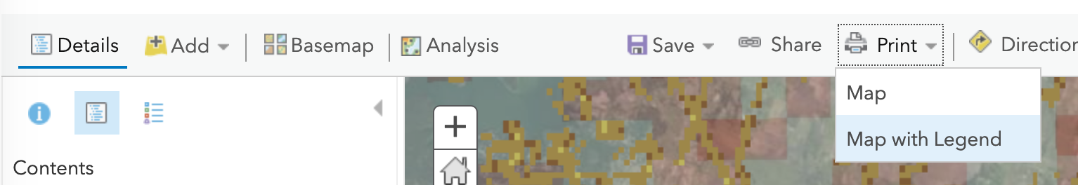

This will open a new browser tab with your map in a layout that has the map image, title, and a legend, along with a list of all the source data. Now you can take a screen shot to save this image. The instructions for taking a screenshot are different for Macs and PCs, so if you don’t know how to do that, Google it.

**Write about Your Maps**

The last step in this assignment is to write 1-2 pages interpreting what these maps tell us about your place. What divisions or connections do you see? What, if any, relationship do you see between the physical features and social divisions? What surprises you?