Kayla Baquiran
Professor Gary McDonogh and Jennifer Professor Hurley
City 185
Assignment 1.3: Exchange Place PATH Station
For Activities 1.2 - 5, I have elected to study the Exchange Place PATH Station in Jersey City. I plan on focusing on the general area around the specific entrance I used when commuting to and from school. Because I do not have a driver’s license and public transportation was never personally convenient to get home, I spent a considerable amount of time doing homework and waiting to be picked up by one of my parents in this area.
This entrance to the transportation hub is an edge space, located on the Hudson River Waterfront. As shown in Figure 3, the Exchange Place PATH station has two lines; the green line indicates the Hoboken - World Trade Center line and the red line indicates the Newark - World Trade Center line. From the World Trade Center, you can transfer to any of the subway stations in or near the Oculus.
There are two other means of public transportation in the area. There is a bus stop near the intersection of Montgomery Street and Greene Street (see Figure 2 for approximate location), and two light rail tracks along Hudson Street (see Exchange Place Platform on Figure 3). I was unable to find more information about what buses stop in the area and what locations they can connect you to. However, I know that the light rail can connect you to any of the following cities: Bayonne, Hoboken, Weehawken, Union City, and North Bergen.
Right next to the Exchange Place PATH Station is a small promenade with tables and different seating options. There are a number of chain coffee shops and restaurants in the area. For example, it is conveniently located near a Gregorys Coffee and a Starbucks (see Figure 1 and 3). Some afternoons, there are Halal food trucks parked near the Katyn Memorial (see Figure 1). Additionally, there are office spaces, banks and ATMs, a parking garage, and hotels in the area. St. Peter’s Preparatory School, a private Jesuit boys’ school which both my brothers attend, is two blocks and four avenues away from the PATH station (see Figure 3).
Despite all the public transportation options in the area, many of the people I know prefer driving if possible. From what my brothers have told me about their classmates at St. Peter’s Preparatory School, the students that use public transportation to get to school live the farthest away. They take the PATH train from New York or the light rail from Bayonne, Hoboken, Weehawken, Union City, or North Bergen. Even then, the students who can afford to drive to school do, with the exception of New York commuters. That being said, I suspect that the choice of public transportation vs. private automobile in the area is divided by class. I would be interested in researching the demographics of people who use the PATH trains, buses, and light rails (and the parking garage shown in Figure 1).
In “The City Image and its Elements”, Kevin Lynch observes:
In Jersey City, the waterfront was also a strong edge, but a rather forbidding one. It was a no-man’s land, a region beyond the barbed wire . . . Most of the Jersey City regions were class or ethnic areas, discernible only with difficulty for the outsider.
Indeed, the Jersey City waterfront has only recently become a desirable place to live and work. Additionally, it is clear how white the general Downtown Jersey City area is compared to the city’s other regions. Gentrification was a catalyst for the shift in the area’s classification from a “no-man’s land” to a more becoming (and white) district. I wonder how, if at all, the transportation in the area exacerbates this shift.
The physical makeup of the Exchange Place Station area allows for a high concentration of “necessary activities” and “low intensity contacts” as defined by Jan Gehl. You can observe working adults and students commuting to and from New York City during rush hours. When the weather is nice, some “optional activities” take place, namely people visiting the Waterfront to enjoy the view of New York City’s skyline. Sometimes you can observe some working adults and high school students having their meals outside, but it is not that common. More common, however, is the PATH Station being used to get to New York City to do optional activities.
Because New York City was an epicenter of COVID-19 during the spring, the Exchange Place PATH station area was quite empty for some time. With everyone trying to adjust to a “new normal”, I am sure that, to some degree, necessary activities are taking place again, and there may be some increase in optional activities in the area. I would like to research what groups of people took the public transportation in the area at the height of COVID-19 cases. By studying the demographics of these groups, I hope to infer something about Jersey City’s socioeconomic and racial divisions.
I personally find the Exchange Place Station area very pleasant and enjoyed spending many afternoons there. Besides the promenade, however, there isn’t much room for optional activities. I wonder how and why the physical development in the area has obstructed the opportunities for optional activities.
Figure 1: Drawn Map of Exchange Place Station
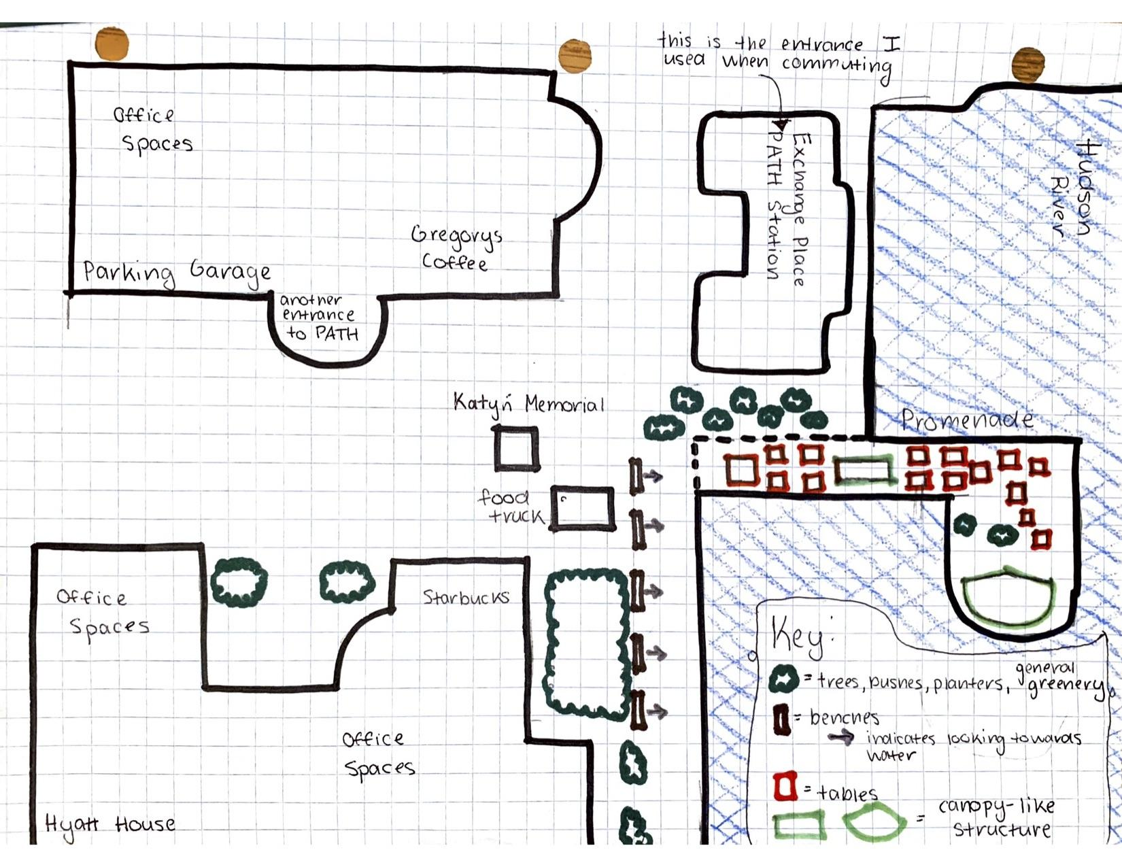
This is the map I drew for Assignment 1.2. It is unfortunately missing scale and direction.
Figure 2: Wide Screenshot Capture of Chosen Area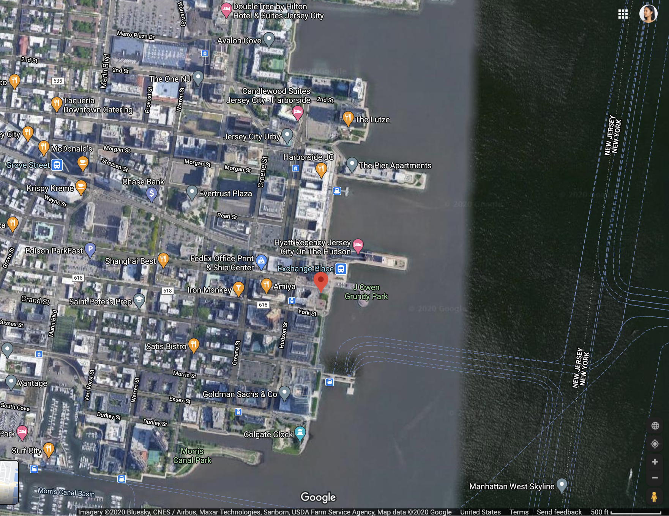
Figure 3: More Focused Screenshot Capture of Chosen Area