Elizabeth Tompkins
Professors Hurley and McDonogh
Urban Culture
October 1st, 2020
Assignment 1.3: Putting Veteran’s Memorial Park into Context
In Assignment 1.2 I presented an overview of what Veteran’s Park is and a brief introduction of its role in the community in addition to some of its flaws. In this assignment, I aim to provide a deeper understanding of the context of the park. For example, I will analyze the location of the park and aim to answer questions like: is it convenient for residents to access, what is it surrounded by, is it apart of a neighborhood or located in a neighborhood but not a part of one? In order to do so I will use the works of Perry and Plater-Zyber as well as maps to support my claim that Veteran’s Park is a vital part of the neighborhood that it is found in (see figures 1-8).
To begin in the analysis of Veteran’s Park, one must consider the location of the park with the rest of the community (figs. 1,3,5,7). As we have discussed in class location is greatly influential in determining who uses a space, how it is accessed, and most significantly the way space interacts with the community it serves. Veteran’s Park is located in Orangeburg, NY with a population of just under 5,000, but is open to all residents of the neighboring towns of Tappan, Sparkill, and Piermont, NY which do have smaller-scale green spaces, but none similar in size to Veteran’s Park. These neighboring towns also share a high school as seen in figure 4 which is located on the same main road as the park. Also, Veteran’s Park is located across the street from private fields that often rent out the park fields as overflow for their sports tournaments (Figure 1). This particular area of the neighborhood between the private sports complex and the Park serve as large sports hubs for both youth and adult leagues of a wide variety of sports. Consequently, the surrounding towns are void of sports venues so Veteran’s Park and the sports complex it’s in association with I argue can be considered a node of the neighborhood. A restriction of the park is a node of the neighborhood would be the lack of public transportation that frequents the area, the only way to get to the park is to drive or walk which limits those who are without a vehicle outside a walking radius. However, while the park is inaccessible to some because of lack of transportation, Veteran’s Park is also bordered by a largely residential neighborhood as seen in figure 3, which makes the park within a mile radius of hundreds of homes. This layout of a neighborhood is very similar to the way that Perry, an open space enthusiast, had planned his ‘Neighborhood unit’, in fact, “He proposed locating a business district on the edge of the neighborhood unit so that neighborhood residents could reach it on interior streets and through traffic could reach it on arterials. In addition to the school and playground, street system, and residential areas” which we can see here with the adjacent neighborhood as well as the industrial/business complex that is located behind Veteran’s park as depicted in Figure 3(Perry pg. 487). Both Perry and Plater-Zyber in their works depict this ideal layout of a neighborhood in which business/industry, green space, and residences are all located in close vicinity to homes with arterial vein-like roads such as Orangeburg Road as seen in figure 4 that serve as transportation to and from other neighborhoods. Veteran’s Park and its surrounding area models this idea of the ‘ideal’ neighborhood layout so much that when comparing Figure 4 to Plater-Zyber’s illustration there are notable similarities in the industry, residential, school, and retail zones that are within close vicinity to Veteran’s Park. Because of the structure of the surrounding area and by Plater-Zyber’s ‘ideal’ neighborhood definition that “the neighborhood has a balanced mix of activities: shopping, work, schooling, recreation, and all types of housing.” I argue that Veteran’s park is located within a solid example of a neighborhood (Plater-Zyber pg.110). Within this neighborhood the park plays a vital role in community engagement and sports activities which further demonstrates the parks fitness for the title of neighborhood node.
Overall based on location and the surrounding features of Veteran’s Park along with the analysis of the ‘neighborhood unit’ by Perry and Plater-Zyber there are clear similarities between the models that Plater-Zyber and Perry describe and the Veteran’s Park area. When analyzing the park and the key features that contextualize it, there are elements such as business districts, schools, and residencies that all compliment the park and can help define the role it plays in the neighborhood. The main role I chose to highlight in this assignment was the role of the sports that classifies it as a neighborhood node. In the coming assignments, I would like to focus my work toward those who occupy the park (i.e. those who can afford sports leagues/parking passes) and why the park, a public space, serves a deeply ingrained role in some of the area but also can serve to be exclusive to others.

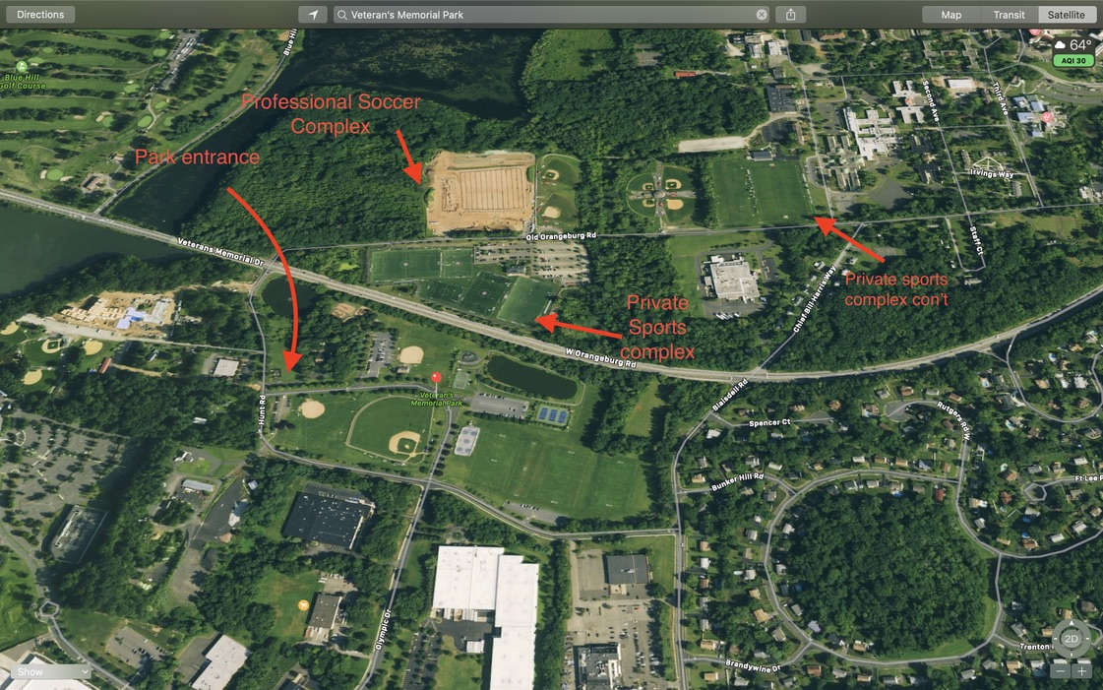
Figure 1. Demonstrating how close in vicinity Veteran’s Park is to a private sports complex that often rents out the park’s fields when hosting large events.

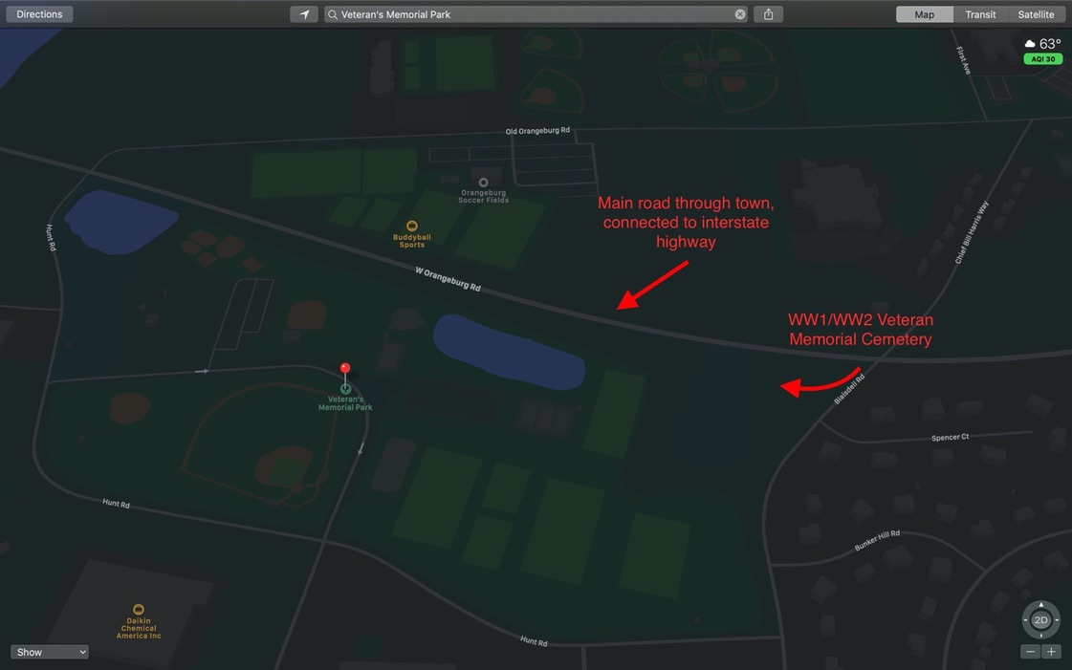
Figure 2. This view demonstrates how the park is located directly off an artery road of the town which could categorize the park of a node of the town.
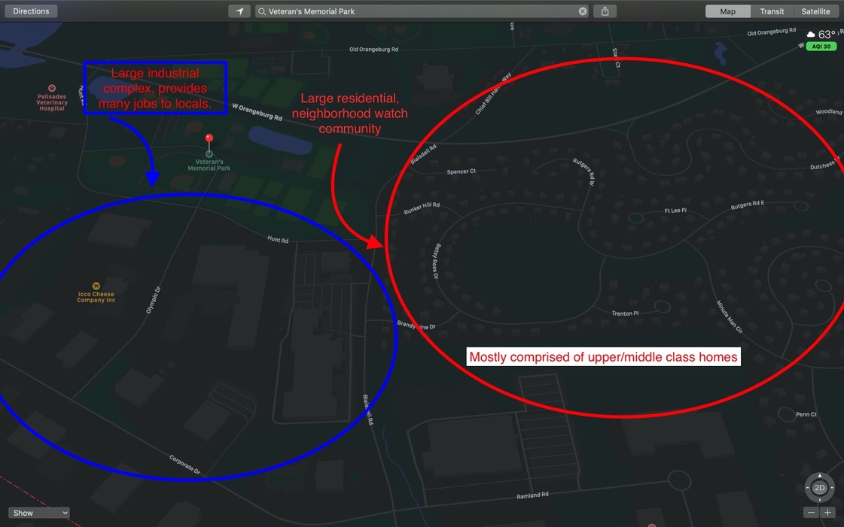
Figure 3. Shows that the park is not only bordered by an arterial road, it is also bordered by a large residential community as well as an industrial complex.
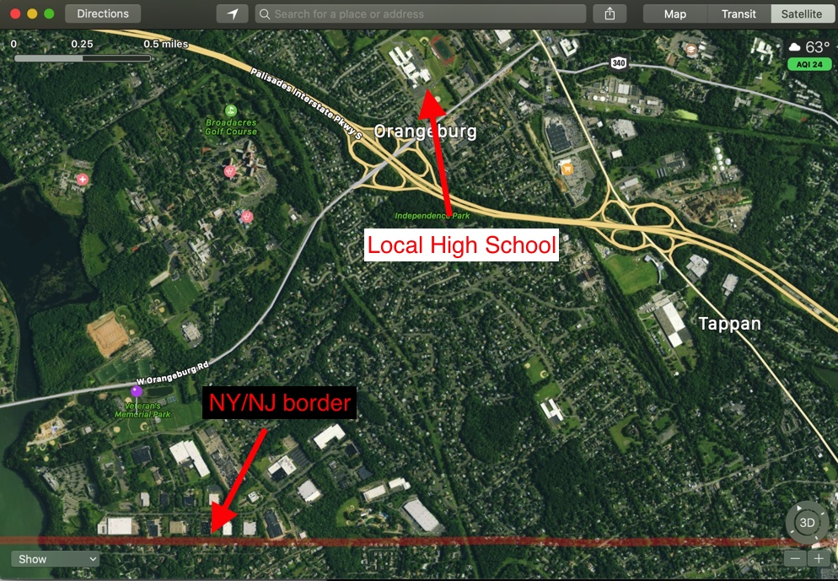
Figure 4. Shows the towns large residential structure as well as its close vicinity to the state border, which often causes conflict as the park is only open to town residents. Also depicts the local high school which is an important part of the community.
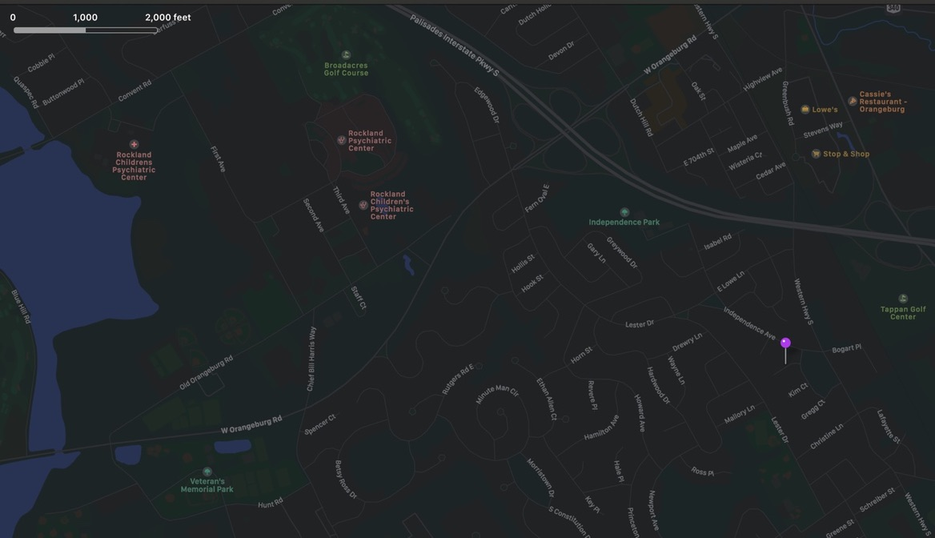
Figure 5. A street map view of the surrounding area of the park showing how little public green space there is available to residents.

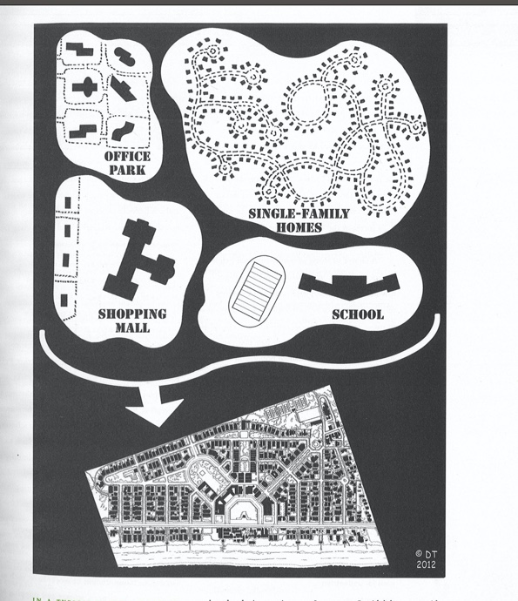
Figure 6. Note the similarity between Plater-Zyber’s depiction of the ideal neighborhood unit and the neighborhood surrounding the park(Plater-Zyber pg. 111). 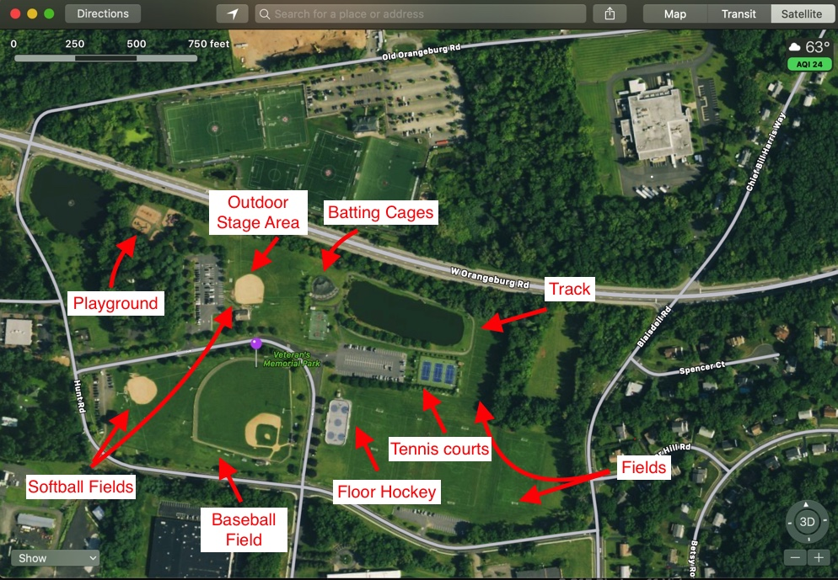
Figure 7. A labeled arial view of the park to further describe the parks purpose. Note the lack of designated seating areas that do not correspond to sporting events. 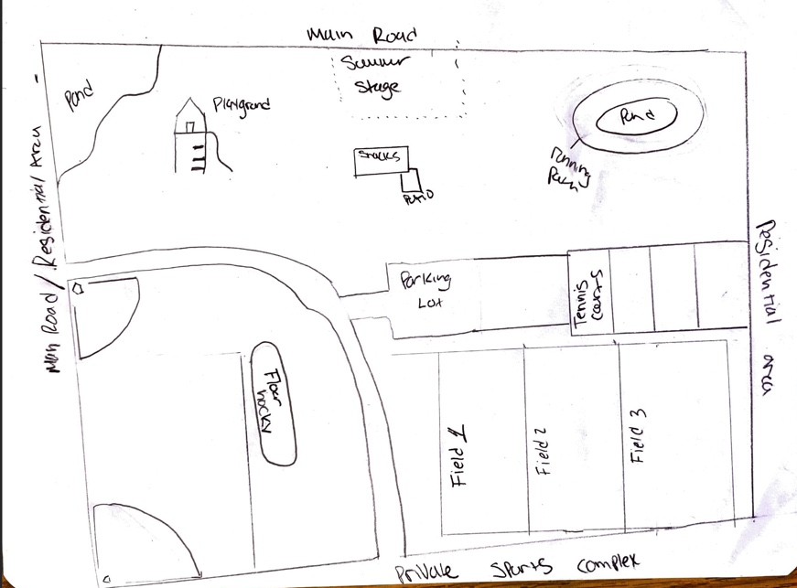
Figure 8. My personal drawn map of the park from assignment 1.2.

