Corinne Hartshorne 1.3

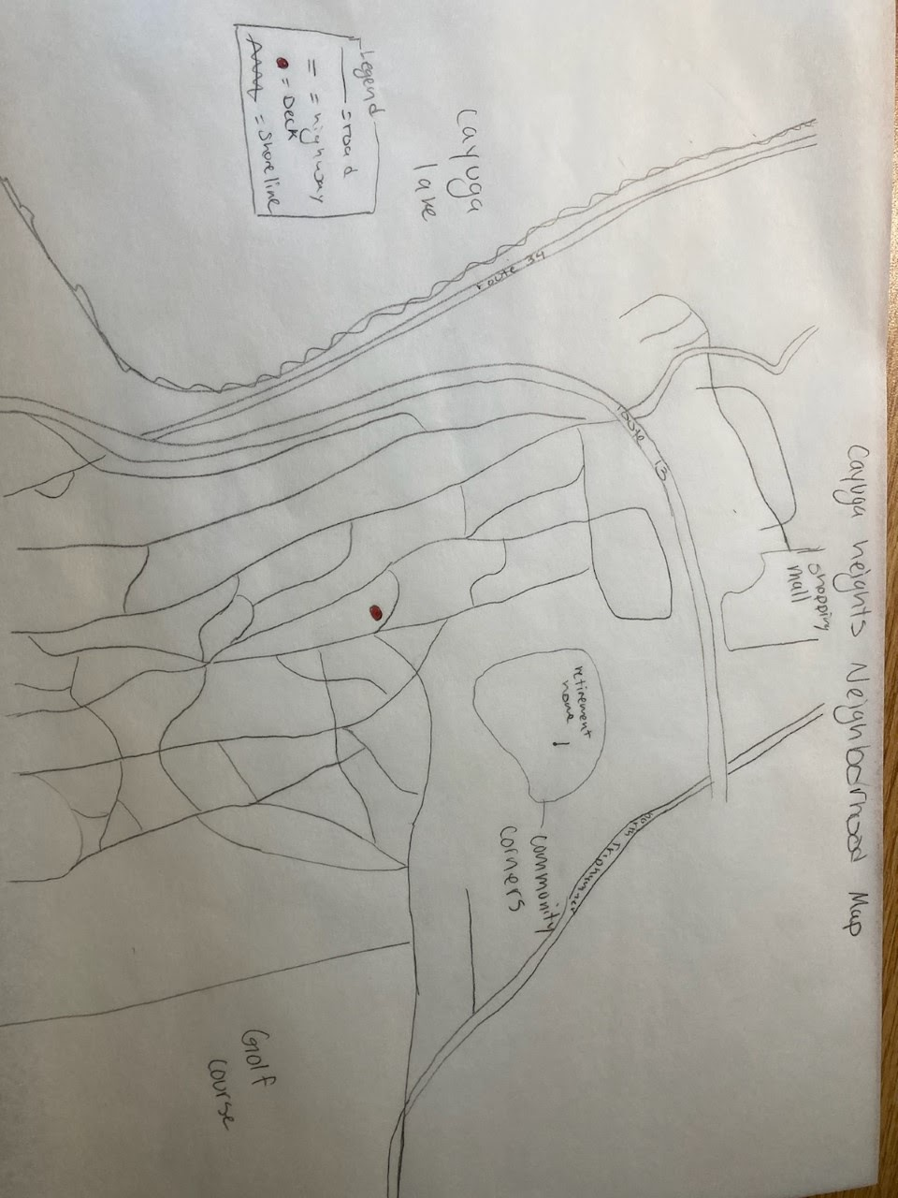

Deck Map:

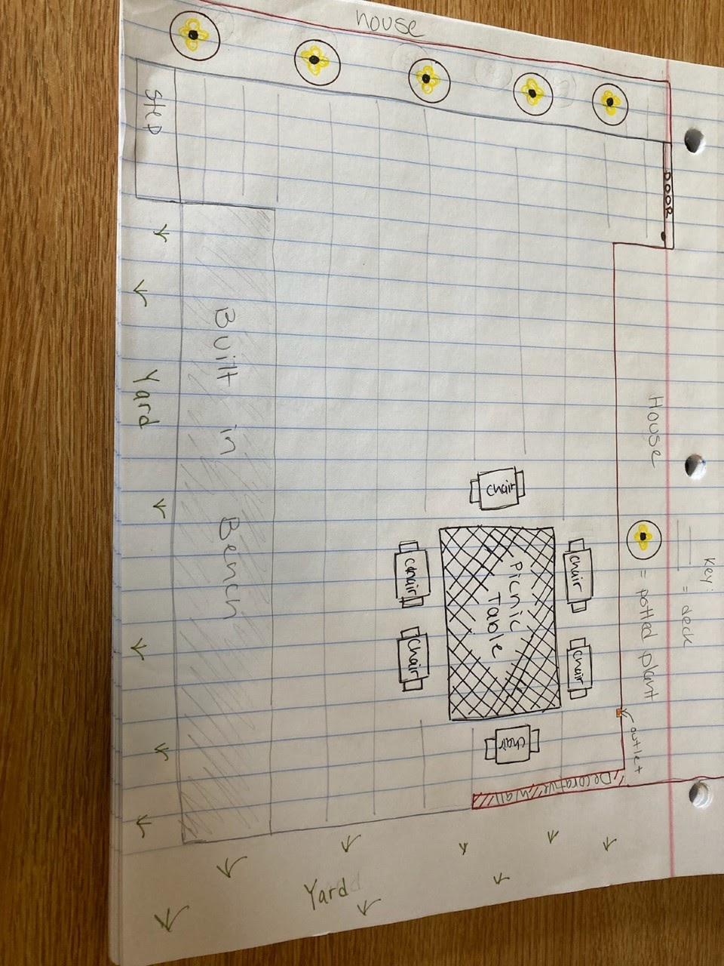

The deck attached to my house is a private space within my neighborhood. It is connected to my house but the porch is next to the road allowing neighbors and passersby to interact with those on the deck as they . The deck is a social space attached to a private home that allows for impromptu meetups with neighbors we haven’t seen in a while, making dinner plans with friends as they walk by, greeting new neighbors. From the deck we can see the driveway which is where the tenants park. This allows for conversations with the tenants as they return home. We are able to see the neighbors house and yard which allows us to catch up with the neighbors as they play with their dog or tend to their garden. The deck is about half a mile from the mall and from an area of shops called Community Corners, an area that includes the police and fire stations as well as a local pizza place. The deck is near public but disconnected by a few streets of residential neighborhoods that the public spaces feel farther than they are in actuality.

The deck is easy to get to from Community Corners(the center of my Neighborhood). If you turn right off of North Triphammer and then take the second right, the deck will be immediately visible. The close location to the main road contributes to the deck being an ideal place for seeing familiar neighborhood faces as well as strangers passing by.

Similar to the Pottinger reading, within my neighborhood there was a condominium built following World War II as was done in places like ardmore. Like in the readings these condominiums were at first perfect for lower income families but soon, as is the case in the Main Line Neighborhoods, they became a place for young white families to move into the neighborhood, pushing out previously minority groups from the neighborhood. There are similarities between my suburban neighborhood and the Main Line. The main similarity is that the taxes in my neighborhood are much higher due to larger houses and properties than in the city my neighborhood is outside of. This leads to the elementary school in my neighborhood receiving a lot of funding for not very many students, as many attend Montessori and Waldorf schools. Similar to Philadelphia, the schools in my city have more students attending and less funding, which allots fewer resources to more students as is the case in Philadelphia.